1. Performance of services
- Introduction

- Highlights
- This chapter presents performance and expense information on key service delivery areas, including trends over time and comparisons with other Australian jurisdictions.
- It reports past performance on health, education, transport, public order and safety, and family and community services, including:
- measures that report on the current wellbeing status of the NSW community, and
- historical performance information on the outcomes.
- It also spotlights some key areas of NSW community wellbeing—housing and energy— and provides selected information and analysis on the distribution of outcomes, and service delivery efficiency.
- This chapter adopts a transitional approach to performance reporting, noting the government’s intention to shift from an agency outcomes focus toward a broad set of wellbeing and performance measures.
- This chapter provides information on key service delivery areas against selected interim measures.

Reporting on expenses trends and the performance and efficiency of services aids government transparency and accountability, supporting better decision-making.
This chapter supplements the economic and financial information provided elsewhere in these budget papers by presenting information on historical expenses and performance of services across the general government sector. It provides information on performance in key service delivery areas as required by the Government Sector Finance Act 2018 (GSF Act).
Information in this chapter is presented against key service delivery areas of the NSW Government, as established under the Classification of the Functions of Government (COFOG-A) expense by purpose framework used by the Australian Bureau of Statistics (ABS) as detailed in Box 1.2. This enables comparison of data with other Australian jurisdictions and supports longer-term expense reporting that is more resilient to changes in government agency structure and responsibilities. Where expense information is presented in real terms (2022-23 dollars) figures have been deflated using the ABS Final Demand Producer Price Index.

- Classifications of the Functions of Government – Australia (COFOG-A)
COFOG-A is the Australian application of an international classification that supports the reporting of government expenses according to the purpose for which the funds are used. COFOG-A has several levels of detail, the highest being: General Public Services; Defence (not relevant to NSW); Public Order and Safety; Economic Affairs; Environmental Protection; Housing and Community Amenities; Health; Recreation, Culture and Religion; Education; Social Protection; and Transport.
The ABS publishes general government expense data by purpose in April each year for the previous financial year as part of the Government Finance Statistics Annual release.

Although strongly correlated for key agencies such as health or education, COFOG-A expense data does not necessarily align with NSW Government agency budgets reported elsewhere in these budget papers. This is because key service delivery areas may fall across two or more agencies, or an agency may perform functions across different service delivery areas. For example, the Department of Planning and Environment has functions both in environmental protection and in housing and community amenities. Moreover, the figures are eliminated to remove the double counting effect of transactions between agencies, and do not reflect capital expenditure, although they include consumption of capital through depreciation.
- NSW Government expenses trends
In 2022-23, the NSW Government spent $116.3 billion on the provision of services including health, education, public order, the environment, transport, economic affairs, housing, recreation and culture, and social protection. In 2022-23, expenses were down from $121.4 billion in the previous year (2022-23 dollars) (Chart 1.1). This, however, followed a significant increase in expenses in 2021-22 due to lagged COVID-19 measures and flood repair, which began to unwind in 2022-23. The last such step-down in expenses was in 2010-11 with the winding back of stimulus programs following the Global Financial Crisis. From 1998-99 to 2021-22, NSW Government expenses have grown at an average annual rate of 4.0 per cent a year in real terms.
- NSW expenditure, by COFOG-A
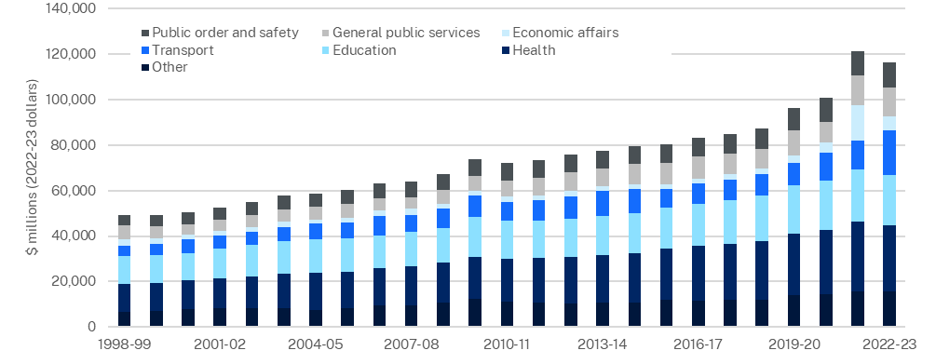
Source: ABS, 2023 and NSW Treasury, 2023
Note: Other includes Social Protection, Environmental Protection, Housing and Community Amenities, and Recreation, Culture and Religion
In 2022-23, health accounted for 24.9 percent of the NSW Government’s overall expenses, followed by education at 18.9 per cent and transport at 16.9 per cent. Public order and safety accounted for 9.5 per cent, and social protection (family and community services) 8.0 per cent, of the total 2022-23 expenses. The combined share of environmental protection, housing and community amenities, and recreation and culture, was 5.5 per cent.
In 2021-22, economic affairs accounted for 12.7 per cent of overall NSW Government expenses, a significant increase from the long-run pre-COVID-19 average of 3.5 per cent. In 2022-23, economic affairs accounted for 5.3 per cent of total NSW Government expenses. General public services expenses accounted for 11.0 per cent of total expenses in 2022-23, of which 44.3 per cent was directed towards public debt transactions, including interest payments.
- Health

Introduction
The NSW Government delivers the largest public health system in Australia, including a range of health services in public hospitals, emergency services, non-hospital and community-based care, and preventative and population health services.
New South Wales expenditure on health is focused on delivering positive outcomes to patients and carers, safe care across all settings, and ensuring that people are healthy.

Health in New South Wales
The most recent estimates of life expectancy at birth for a person born in New South Wales is 81.4 years for males and 85.4 years for females—in line with the national average. Outside of Greater Sydney, people can expect to live an average of 2.8 years less than for Greater Sydney (ABS, 2019-2021). Those living in regional areas have lower life expectancies on average due to a range of factors including more limited access to health services, economic and social disadvantage, access to educational and employment opportunities, and income. Moreover, those living in regional and remote areas have higher rates of physical injury, diabetes, obesity, smoking and alcohol consumption (Australian Institute of Health and Welfare (AIHW), 2023).
The gap in life expectancy between NSW Aboriginal and Torres Strait Islander and non-Indigenous people has narrowed between 2005-07 and 2015-17, from 10.5 years to 9.3 years for males, and 8.6 years to 7.6 years for females. Aboriginal and Torres Strait Islander people have a life expectancy at birth of 70.9 years for males and 75.9 years for females in New South Wales (period 2015-17) (ABS, 2018).
Obesity is a significant public health challenge in New South Wales. In 2022, 58 per cent of adults were overweight or obese, an increase of 12.1 percentage points over 20 years (from 45.9 per cent in 2002) (HealthStats NSW, 2023). At the same time, the share of children who are overweight or obese has been relatively stable in New South Wales over the past 10 years, being 23 per cent in 2022, for children aged 5-16 years (HealthStats NSW, 2023).
There has been a long-term decline in smoking in New South Wales. The proportion of adults that smoke daily has more than halved in 20 years (from 17.1 per cent in 2002, to 8.2 per cent in 2022). Consequently, the number of smoke-free households has increased from 79.4 per cent in 2002, to 93.6 per cent in 2022. More people living in outer regional and remote areas are daily smokers (16.3 per cent), than in major cities (7.0 per cent). In recent years, however, there has been an increase in use of e-cigarettes, from 1.3 per cent in 2014, to 6.4 per cent in 2022 (HealthStats NSW, 2023).
Since 2013, self-reported levels of psychological distress have increased in New South Wales. In 2021, 16.9 per cent of adults experienced high, or very high, levels of psychological distress (14.2 per cent of males, and 19.5 per cent of females). The percentage of people reporting high, or very high, levels of psychological distress increased from 9.8 per cent in 2013, to 17.7 per cent in 2019, easing to 16.9 per cent in 2021. In 2021, the rate of high, or very high, levels of psychological distress was 27.8 per cent among those aged 16-24 years (19.0 per cent in males, and 37.2 per cent in females). By contrast, only 9.1 per cent of NSW adults aged 75 years and over reported high, or very high, levels of psychological distress. For Aboriginal and Torres Strait Islander adults in New South Wales, 28.3 per cent reported high, or very high, psychological distress in 2021, an increase of 12 percentage points from 2013 (HealthStats NSW, 2023).

Emergency care
Since the onset of COVID-19 in 2020-21, the proportion of patients receiving Category 2 (emergency) or Category 3 (urgent) treatment, with treatment commencing on time, has declined. Across this period, Category 2 has decreased 5.8 percentage points, from 80.5 per cent to 74.6 per cent, and Category 3 has decreased 7.5 percentage points from 76.7 per cent to 69.2 per cent (Chart 1.2).
- Patients commencing treatment on time in emergency, NSW
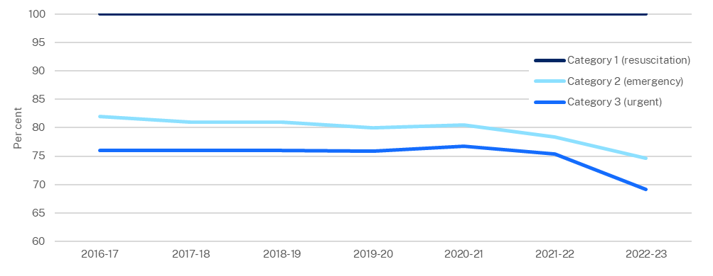
Source: NSW Health, 2023
Note: Category 1 (resuscitation) requires treatment within 2 minutes; Category 2 (emergency) within 10 minutes; Category 3 (urgent) within 30 minutes.

Hospital performance

Surgery performance
Each year in New South Wales, over 320,000 people have undergone planned, or emergency, surgery in public hospitals. The restrictions on non-urgent planned surgery due to the COVID-19 pandemic contributed to a delay in completions. As a result, the proportion of semi-urgent and non-urgent surgeries completed on time declined from over 97 per cent in 2018-19 (pre-COVID-19), to 73.1 per cent and 67.1 per cent respectively in 2022-23 (Chart 1.3).
- Planned surgeries completed within clinically recommended time frames, NSW
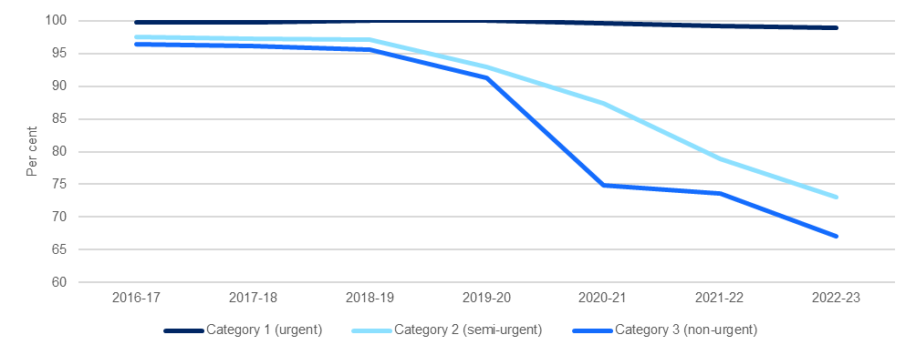
Source: NSW Health, 2023 and AIHW, 2023
Note: Urgent cases are recommended for treatment within 30 days; semi-urgent cases are recommended for treatment within 90 days; and non-urgent cases are recommended for treatment within 365 days.
Planned surgeries were also impacted by COVID-19 in other Australian jurisdictions. On-time completions for semi-urgent planned surgeries were 14.2 percentage points higher in New South Wales compared with the rest of Australia. For New South Wales the proportion of semi-urgent on-time completions declined by 18.1 percentage points from 2018-19 (pre-COVID-19). Since COVID-19, New South Wales performance for on-time completion of non-urgent cases has fallen below the rest of Australia and was 8.2 percentage points lower in 2021-22 (73.6, and 81.7 per cent, respectively) (Chart 1.4).
- Category 2 and 3 planned surgeries completed on-time
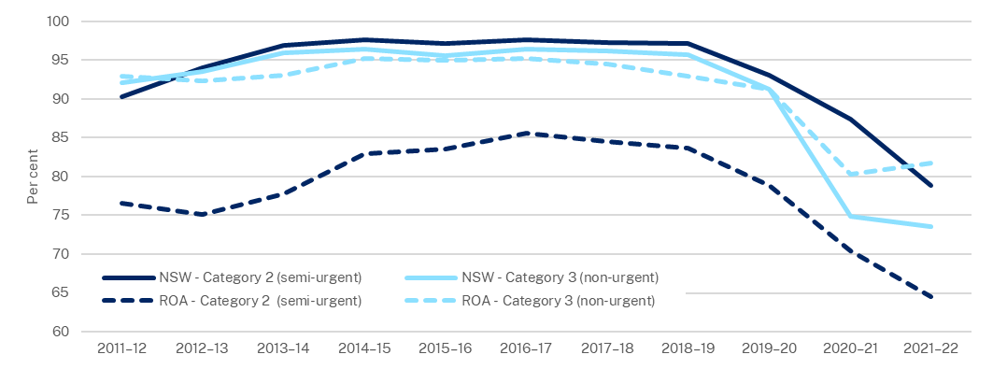
Source: AIHW, 2023

Average Length of Stay
The average length of stay for all overnight episodes was 6.3 days, as measured for April to June 2023 (Bureau of Health Information, 2023), 12.5 per cent higher than pre-pandemic levels. This measure has remained above pre-pandemic levels since mid-2021.
This increase has principally been driven by two factors: a COVID-19 diagnosis during a patients’ hospital stay; and the discharged of patients to residential aged care. Patients with a COVID-19 diagnosis had an average length of stay twice as long as those without. For patients discharged to residential aged care without a COVID-19 diagnosis, the average length of stay increased by 19.6 per cent from 2021 to 2022.
- Education

Introduction
The NSW Government provides and funds education and training services, including early childhood education, government and non-government schools, with the NSW Education Standards Authority (NESA) as the regulator, and vocational education and training (VET), including TAFE NSW as the public provider.

Education in New South Wales
New South Wales spending per public school student increased by 17.8 per cent over the past 10 years (2011-12 to 2020-21), equivalent to a real average growth of 1.8 per cent a year. From 2011 to 2022, the level of Year 12 attainment has increased but the National Assessment Program – Literacy and Numeracy (NAPLAN) results have been mixed. Programme for International Student Assessment (PISA) scores across reading, mathematics and science have trended downward since 2000, both for New South Wales and Australia (Organisation for Economic Cooperation and Development (OECD), 2020).

Attainment
Educational attainment has trended upwards over the past ten years. In 2022, 90.4 per cent of 20-24 year-olds had attained Year 12 or an equivalent level of education (completed Year 12 or obtained a Certificate level III qualification, or above). This is above the national average of 90.1 per cent (Chart 1.5).
- Attainment of Year 12 or equivalent, 20-24 year-olds
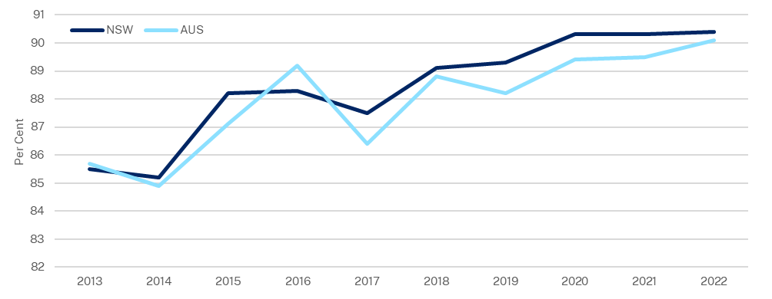
Source: ABS, 2022

Public school attendance
There was a downward trend in the public secondary school attendance rate from 84.4 per cent, to 71.0 per cent, between 2014 and 2022, or 13.4 percentage points as shown in Chart 1.6. The public primary school attendance rate has steadily declined over the same period from 91.5 per cent to 78.7 per cent, or 12.8 percentage points. The attendance rates are below the 2022 national public primary and secondary school average of 80.8 per cent and 77.9 per cent respectively (Australian Curriculum, Assessment and Reporting Authority (ACARA), 2023).

- Attendance rates at NSW Government schools
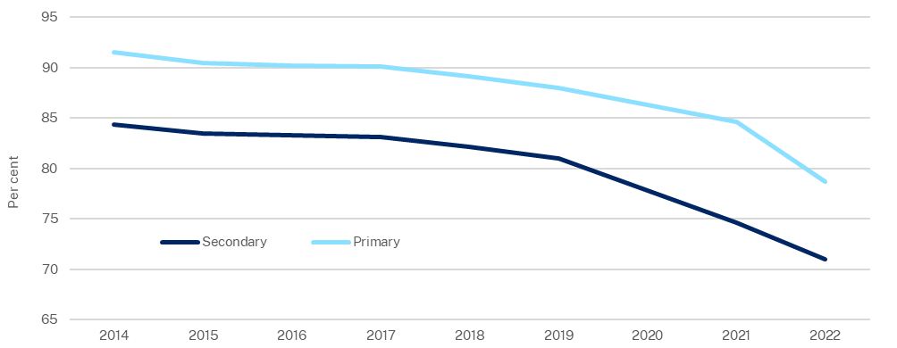
Source: ACARA, 2022

Early Childhood Education and Care (ECEC)
Children who participate in early childhood education programs are more likely to arrive at school equipped with the social, cognitive, and emotional skills they need to engage in learning. Government support has helped to drive up enrolment rates.
In 2022, 82.5 per cent of all NSW 4 year-olds, and 25.3 per cent of 5 year-olds, were enrolled in preschool programs. Of children enrolled, 96.6 per cent were enrolled for at least 600 hours in the year before school in 2022 (ABS, 2022).
For many years, all levels of government have made substantial funding commitments to help overcome access and affordability barriers to ECEC. The average weekly long-day care attendance (about 80 per cent of the ECEC market) has increased by about four hours per week over the six years to 2022 (Chart 1.7).
- Average weekly hours of ECEC attendance, NSW
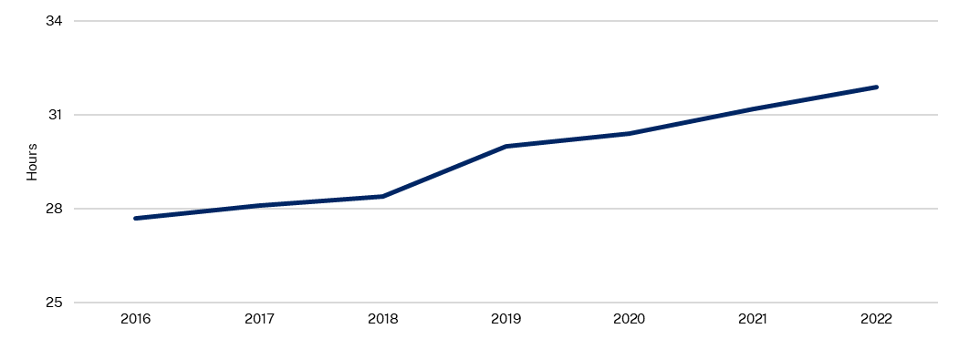
Source: NSW Department of Education, 2023 and RoGS, 2022

Schools
The NSW Government supports both government and non-government schooling in primary and secondary education. The NSW Government is the largest provider of public education in Australia with responsibility for educating two-thirds of NSW school students.

Student to teacher ratio
Student to teacher ratios in NSW public schools had remained steady until 2018, with the primary and secondary classrooms ratio increasing by 1.4 and 1.6 students per teacher respectively in 2019. Since 2019, the student-teacher ratio for secondary schools has eased but remains above pre-2019 levels (ABS, 2023).
Compared to the national average, student to teacher ratios in New South Wales were marginally higher than the national average up to 2019. That is, NSW classrooms have more students per teacher on average. For secondary classrooms, ratios remained about the same up to 2019. From 2019, ratios were higher for both primary and secondary classrooms. In 2022, student to teacher ratios in NSW schools were 15.0 and 13.0 for primary and secondary schools respectively compared with 14.3 and 12.3 nationally as shown in Chart 1.8 (ABS, 2023).
- Student to teacher ratio
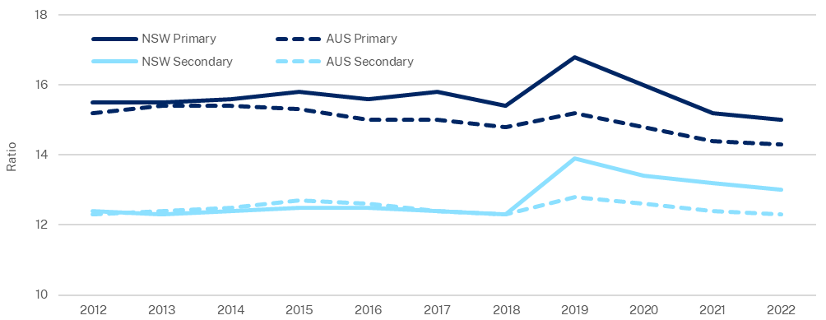
Source: NSW Productivity Commission, 2022; RoGS, 2022

Primary and secondary schools’ performance: NAPLAN
NAPLAN, reported by the ACARA, measures student performance in aspects of literacy and numeracy and tests whether national minimum standards are being met. Commencing from 2023, ACARA has realigned NAPLAN measures, introducing earlier NAPLAN testing and proficiency standards. Results from 2023 onwards can therefore not be directly compared with results between 2008 and 2022 (ACARA, 2023), although relative comparisons between jurisdictions remain valid.
In 2023, male students outperformed females in numeracy, with average scores of 422.8 versus 408.7 in Year 3, and 580.2 versus 570.4 in Year 9. Female students outperformed males in reading, with average scores of 419.8 versus 402.9 in Year 3, and 574.0 versus 559.4 in Year 9 (ACARA, 2023). Female students also outperformed males in writing, with average scores of 437.8 versus 415.4 in Year 3, and 586.3 versus 554.6 in Year 9 (ACARA, 2023). These gaps between male and female students have been consistent over the past decade for both Australia and New South Wales.

For New South Wales, Year 3 NAPLAN results for reading improved between 2011 and 2022, from an average score of 423.1 in 2011, to 444.7 in 2022. NSW writing scores also improved recently from an average score of 429.2 in 2011, to 432.7 in 2022. NSW numeracy scores have remained stable, with similar scores between 2011 and 2022. National trends followed a similar pattern.
Year 9 NAPLAN results for numeracy and reading in New South Wales and Australia improved through the 2010s, peaking in 2017–2018 but by 2022 were back around 2011 levels. Over the same period writing scores improved (Chart 1.9) both for New South Wales and Australia.
In 2023, New South Wales ranked second among the states and territories for numeracy and writing skills. For reading, however, New South Wales fell from third in 2011, to fourth in 2023 (ACARA, 2023).
- Year 9 NAPLAN results
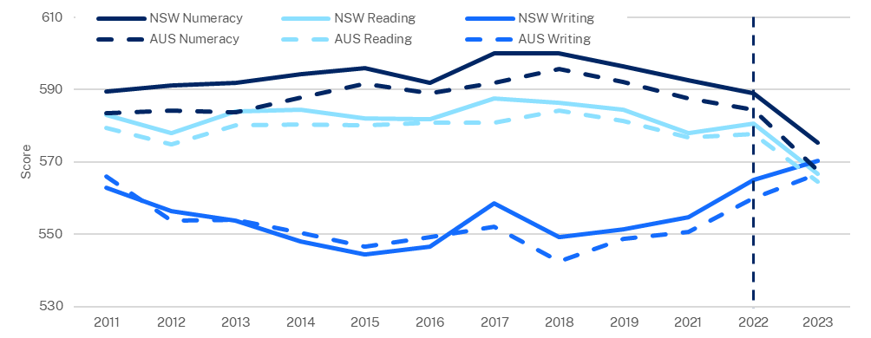
Source: ACARA, 2023
Note: Results after 2022 onwards are not directly comparable to past years.

Secondary schools’ performance: PISA
PISA is an international assessment that measures the application of knowledge to real-world situations through scientific, reading, and mathematical literacy among 15 year-old students. PISA scores for New South Wales and Australia has trended down since 2000 in all three areas (Chart 1.10). In 2018, New South Wales fell toward the bottom of the state rankings.
Australian students' ranking in reading has declined since 2000, from a ranking of 4th in 2000, to 16th in 2018. Australian students ranking in mathematics also declined, from a ranking of 10th in 2003, to 29th in 2018, and in science, from 8th in 2006, to 17th in 2018 (PISA, 2019).

- PISA results
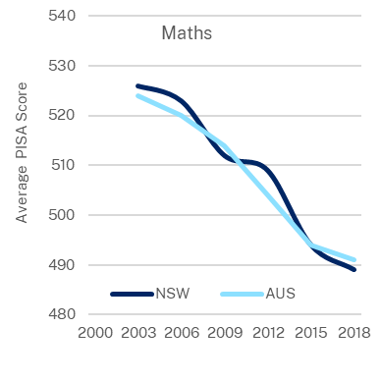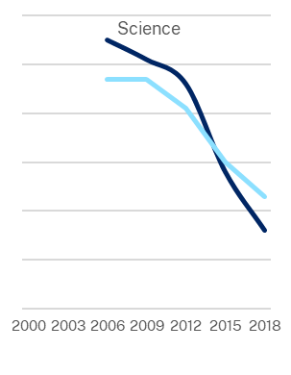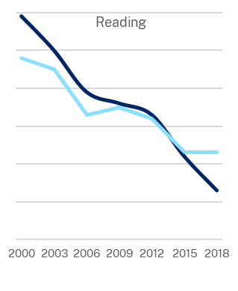Source: ACER, 2019 and Parliament of NSW, 2020

NSW Government performance of services: Vocational education
The NSW Department of Education supports the delivery of a skilled and employable workforce through post-school vocational education and training (VET) and higher education. VET provides students workplace skills and technical knowledge combined with practical experience, meeting the skill requirements of the NSW economy.
In late 2022, The National Skills Commission found 47 per cent of technicians and trades workers occupations were in shortage.

VET completions and apprenticeships
The number of apprentices enrolled has grown in New South Wales since 2016. However apprenticeship completion rates are lower, with 30,985 completions in 2022, compared to 59,415 in 2013 (Chart 1.11).
- NSW apprenticeships in training and completions
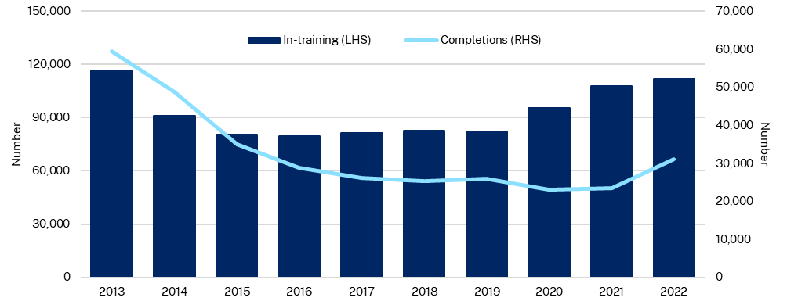
Source: NCVER, 2022
Note: Completions is the aggregate of the year, in-training figures are for December quarter of each year

Aboriginal and Torres Strait Islander student education and training outcomes
Through 2020-21, the NSW Government is estimated to have spent 9.0 per cent of the total secondary education budget allocation on Aboriginal and Torres Strait Islander students. Young people account for a significantly greater proportion of the NSW Aboriginal and Torres Strait Islander population (42.0 per cent 0-18 years), when compared to the non-Indigenous population (22.2 per cent 0-18 years). Aboriginal and Torres Strait Islander young people account for 7.6 per cent of the total 0-18 year-old population in NSW (ABS, 2021).
In recent years the COVID-19 pandemic and changes to schooling including online learning have broadly impacted educational outcomes. Since 2020, there has been an 8 percentage point reduction in NSW Aboriginal and Torres Strait Islander students attaining the Higher School Certificate, down from 46 per cent in 2020, to 38 per cent in 2022 (NSW Department of Education, 2023).
Notably, Year 12 attainment is increasing at a faster rate within the Aboriginal and Torres Strait Islander community when compared with their non-Indigenous counterparts, but from a lower base (42.5 per cent compared to 78.1 per cent in 2001). Over the decade to 2021, the proportion of Aboriginal and Torres Strait Islander people aged 20-24 years who had completed Year 12 or equivalent (Certificate III or above) increased by 15.8 percentage points (53.5 per cent in 2011, to 69.3 per cent in 2021) (ABS, 2021). This compares favourably with a 5.4 percentage point increase for non-Indigenous students over the same period (Chart 1.12).
- Share of NSW people 20-24 years who completed Year 12 or equivalent
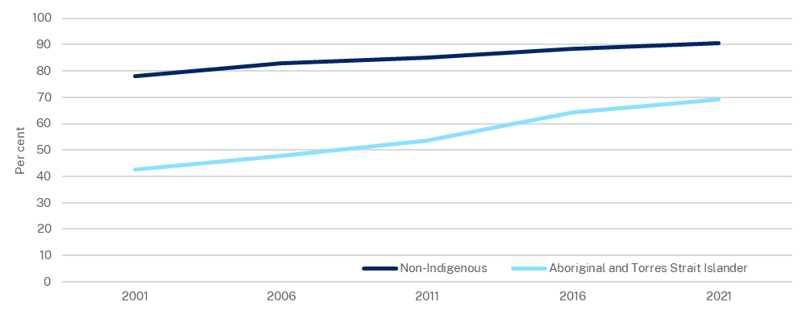
Source: NSW Productivity Commission, 2021.
- Transport

Introduction
The NSW Government is committed to developing a transport network that connects passengers with communities across New South Wales. To achieve this outcome, Transport for NSW (TfNSW) manages roads, waterways, and active transport assets. It also delivers and regulates key transport services including trains, buses, ferries, light rail, point to point transport connections and freight.

Trips and travel times
In New South Wales, public transport is delivered through train, bus, light rail, metro, ferry, point to point transport vehicles and on demand services. The NSW road network is over 180,000 kilometres in length and local councils are responsible for maintaining more than 85 per cent of this network (TfNSW, 2023).
At the onset of COVID-19, pandemic restrictions saw the number of average weekday train and bus trips fall by 81.7 per cent and 78.3 per cent respectively from April 2019 to April 2020 as shown in Chart 1.13.
As the economy returns to pre-COVID-19 norms, average weekday trips made on trains and buses have gradually increased but remain 28.0 per cent and 27.0 per cent below pre-pandemic levels, respectively (measured from the months of July 2019 to July 2023). This can be attributed to increased working from home, service disruptions and reliability issues (TfNSW, 2023).
- Public transport trips by mode
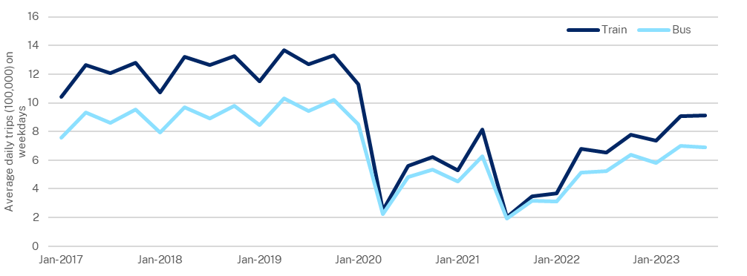
Source: TfNSW, 2023

The COVID-19 pandemic also influenced travel patterns in private transport. Average Greater Sydney (including the Central Coast) weekday kilometres for vehicle drivers were down 5.8 per cent in 2020-21 (87.7 million kilometres) compared with 2019-20 (93.1 million kilometres) as shown in Chart 1.14.
- Average weekday vehicle driver distance travelled in Greater Sydney
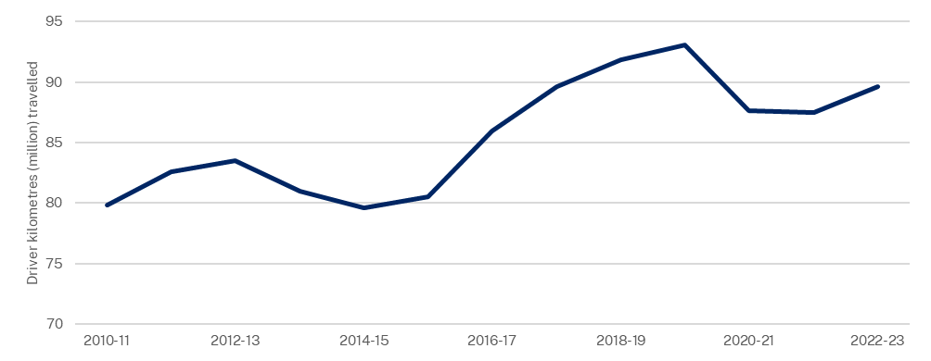
Source: TfNSW, 2023

Punctuality performance for trains
In 2022-23, punctuality of Sydney Trains and NSW TrainLink Intercity services declined from 94.3 per cent in 2020-21, to 84.4 per cent in 2022-23 (Chart 1.15). A train trip is defined as punctual if it arrives within five minutes of its scheduled time for Sydney Trains, and six minutes for TrainLink Intercity services.
The Independent Sydney Trains Review has found that recent poor performance can be attributed to events such as COVID-19, industrial action, and underinvestment in regular rail maintenance following the introduction of the 2017 timetable.
The Rail Repair Plan, initiated by the NSW Government has identified more than 1,900 high priority defects across the Sydney Trains network and has commenced work to complete approximately 3,700 repairs and upgrades to restore reliability to the network.
- Sydney Trains and NSW TrainLink (Intercity) punctuality performance
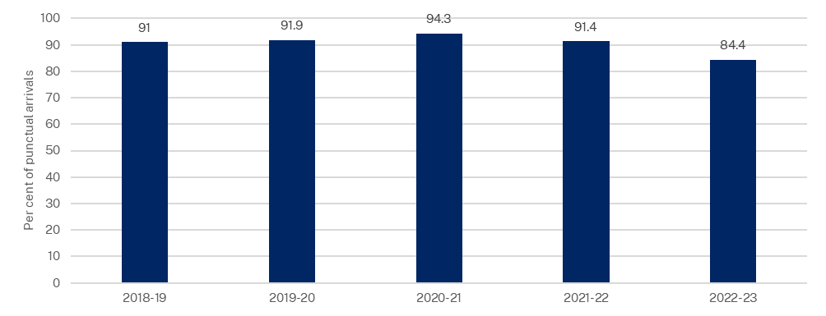
Source: TfNSW, 2023

Customer satisfaction
Between 2021 and 2023 customer satisfaction with bus, train and light rail services declined but satisfaction with ferry and metro services remained relatively stable (Chart 1.16).
The most recent results for November 2022 showed less satisfaction with the timeliness and frequency of services, consistent with a period of disruptions, on the Greater Sydney network including industrial action, staff shortages, maintenance needs and inclement weather.
- Customer satisfaction by public transport mode
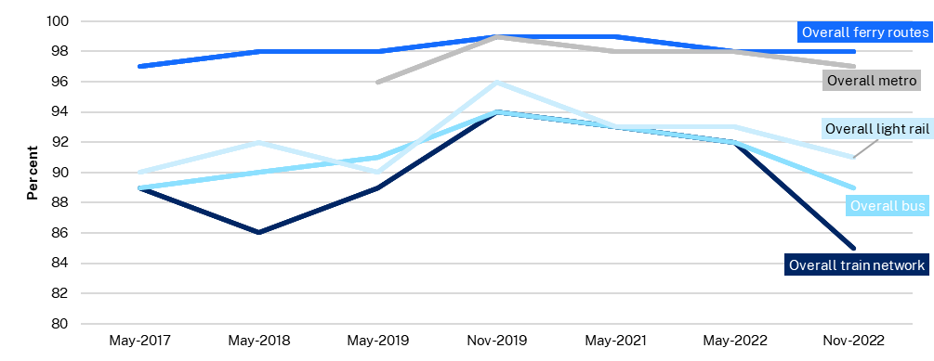
Source: TfNSW, 2023

Active transport
Between 2019-20 and 2022-23, the proportion of trips taken by walking and cycling has increased from 18.3 per cent, to 19.9 per cent (Chart 1.17). Walking remains the predominant mode of active transport (18.6 per cent of all trips).
The Customer Satisfaction Survey in November 2022 showed overall customer satisfaction with active transport has increased for pedestrians (up 1 percentage point to 89 per cent from May 2022) but slightly decreased for cyclists (down 3 percentage points from the record high rating of 90 per cent in May 2022 to 87 per cent).
- Mode share for trips taken by walking or cycling
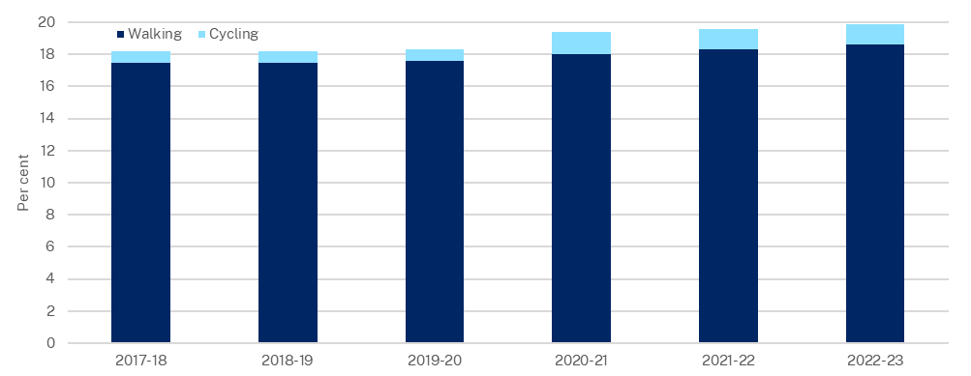
Source: TfNSW, 2023

Road fatalities and injuries
Between calendar years 2017 and 2022, NSW road fatalities per 100,000 population declined by 27.5 per cent, likely related to reduced kilometres travelled due to COVID-19 restrictions. In a period of easing restrictions, between 2021 to 2022, there was a 5.7 per cent increase in road fatalities (Chart 1.18).
The number of NSW fatalities per billion vehicle kilometres travelled (VKT)—a ratio less impacted by COVID-19 restrictions as it accounts for reductions in road use—declined steadily from 5.05 to 3.71 per billion VKT between 2017 and 2021, then increased from 3.71 to 4.28 fatalities between 2021 and 2022.
In 2022, speed contributed to 36 per cent of fatalities. Passenger and pedestrian fatalities increased by 14 (from 29 to 43 passengers) and 10 (from 41 to 51 pedestrians) fatalities respectively between 2021 and 2022 (Bureau of Infrastructure and Transport Research Economics (BITRE), 2013-2022).
- Road fatalities and fatalities per billion vehicle kilometres travelled
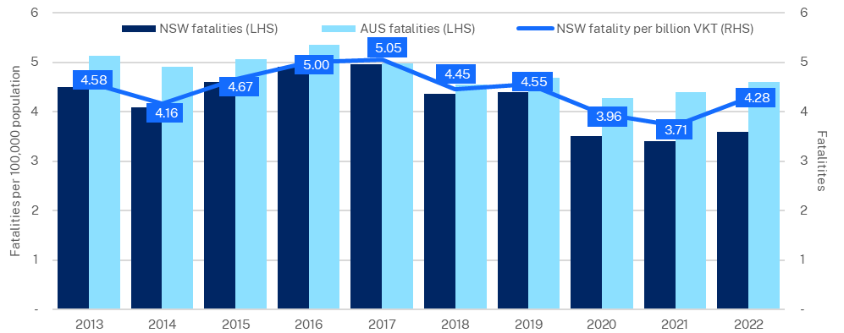
Source: BITRE, 2022
- Public order and safety

Introduction
The NSW Government provides services to achieve a safe, just, and inclusive New South Wales by operating an effective legal system and promoting public safety. Services that aim to keep people and communities safe include policing, courts and tribunals, natural disaster and emergency services, and programs to reduce reoffending.

Sexual violence and intimate partner violence
Victimisation surveys show a recent increase in sexual violence and intimate partner violence, while experiences of other types of physical assault are trending downwards. The survey results can differ from reported crime data because not all incidents of victimisation are brought to the attention of the police. Victimisation surveys capture a broader range of experiences, including those that victims might not report to law enforcement. In 2021-22, 3.2 per cent of people aged 15 and over experienced physical, or threatened, assault in New South Wales in the previous 12 months, compared to the national average of 4.0 per cent (Chart 1.19). Aboriginal and Torres Strait Islander people were 3.1 times more likely than non-Indigenous people to be victims of assault, accounting for 11.2 per cent of all assault victims.
- Physical or threatened assaults, people aged 15 years and over
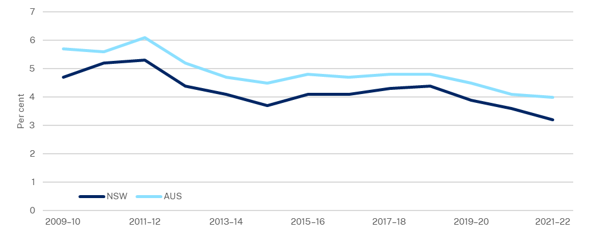
Source: ABS, 2021-22

In 2022, 3.6 per cent of NSW women aged 18 years and over indicated that they had experienced sexual violence in the two years prior, an increase of 1.3 percentage points from 2006 (Chart 1.20).
- Victimisation experiences in the last two years, adult women, NSW
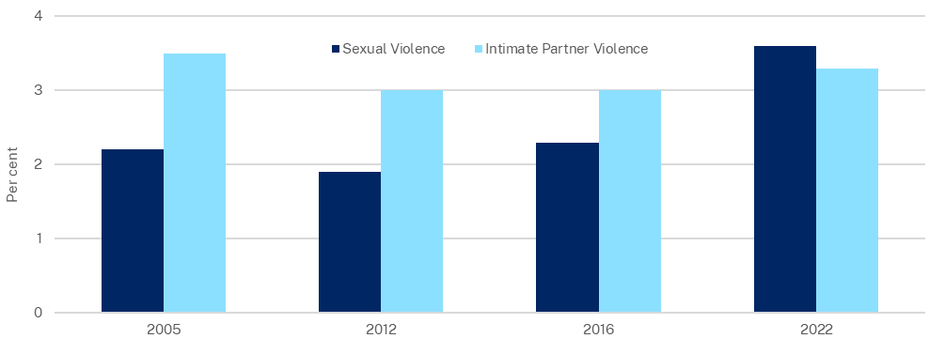
Source: ABS, 2021-22

Cybercrime
Cybercrime includes cyber-enabled fraud, identity theft, cyber-enabled abuse, online image abuse, and device offences such as malware and ransomware. NSW cybercrime has increased by 42 per cent in the three years to June 2022 (Bureau of Crime Statistics and Research (BOCSAR), 2023). Over this period, there were 39,494 reports of cybercrime and over $404 million reportedly lost. Within this, cyber-fraud increased by 95 per cent, identity crime by 35 per cent, and device-related offenses by 117 per cent (Chart 1.21).
- Incidents of reported cybercrime, NSW
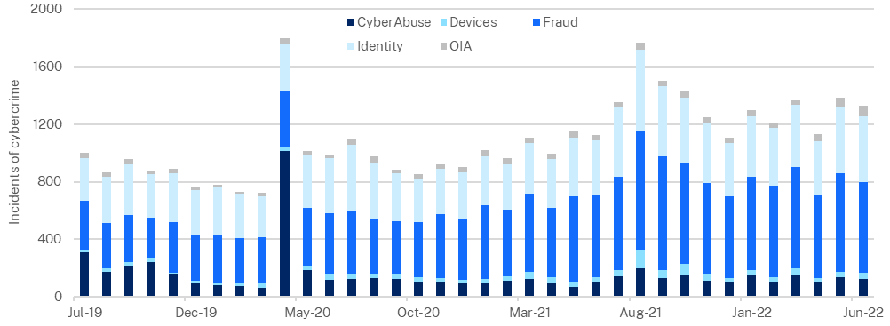
Source: BOCSAR, 2023

People aged over 55 are more likely to be victims of cyber abuse, device, and fraud offences. Most victims of online image abuse were young—37 per cent being between 18 and 24 years (BOCSAR, 2023).

Crime rates
Overall the rate of crime reported to the police has fallen between 1995 and 2022, however reporting has increased for some offences including sexual assault, domestic assault, and other sexual offences (Chart 1.22).
Between 1995 and 2022, for every 100,000 people in New South Wales, reported incidents of sexual assault increased from 38 to 96, other sexual offences increased from 72 to 92, and assault increased from 599 to 787. The rate of non-domestic assault is below 1995 levels, indicating that the driver of increased police reported assault numbers is domestic assault (BOCSAR, 2023).
Reporting of most other types of crime has declined. The homicide rate declined from 1.98 to 0.71 homicides per 100,000 people between 1995 and 2022.
- Reported crime, NSW
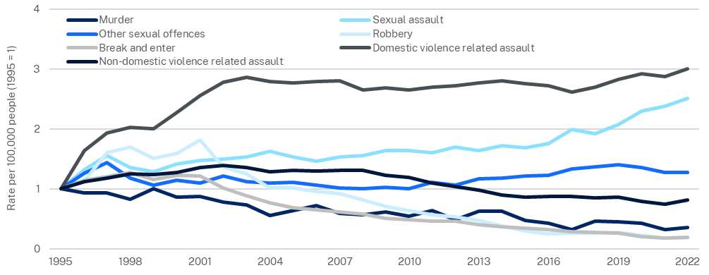
Source: BOCSAR, 2023

Many crimes fell during the COVID-19 lockdowns of 2020 and 2021. For example, from March 2020 to May 2020, stealing from retail stores offences fell by 25 per cent and break and enter dwelling offences fell by 38 per cent (BOCSAR, 2023).

Courts

District Court finalisations
Expedited court processes can provide better outcomes for the community as cases are resolved more rapidly and justice is delivered efficiently. Investment in additional judges and legislative changes, including encouraging early appropriate guilty pleas, have reduced demand and increased efficiency in the NSW District Court.
From 2020 to 2022, the share of District Court cases finalised within 12 months increased from 76.2 per cent in 2019-20, to 80.9 per cent in 2021-22, due to a focus on non-jury matters, a deferral of trials, and a reduction of serious crime during the COVID-19 lockdowns. In 2022-23, the 12-month finalisation rate fell to 74.4 per cent as previously deferred matters were addressed (Chart 1.23).
- Share of District Court criminal cases finalised, NSW
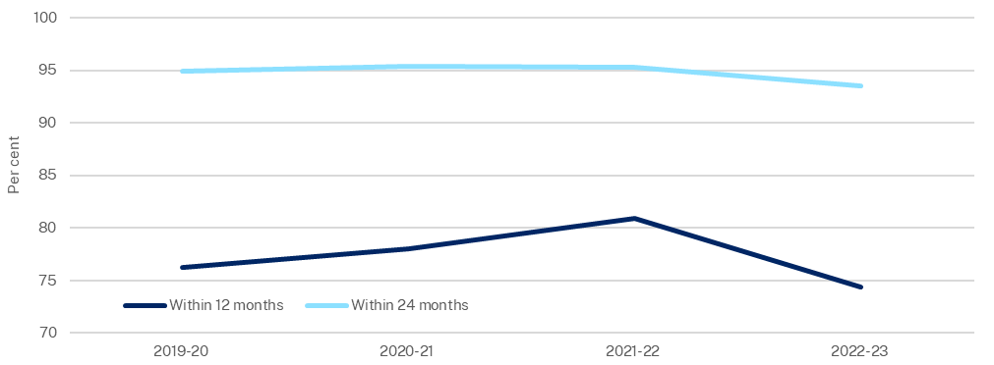
Source: BOCSAR, 2023

Criminal Court finalisations
A higher case finalisation rate is an indicator of effective caseload management and prompt delivery of court services within time standards. Compared to the average court finalisations per 100,000 people across Australia, New South Wales consistently finalises fewer cases. In 2021-22, New South Wales averaged 2,424 court finalisations per 100,000 people within all criminal courts, compared to the Australian average of 2,655 (Chart 1.24).
- Finalisations, all criminal courts
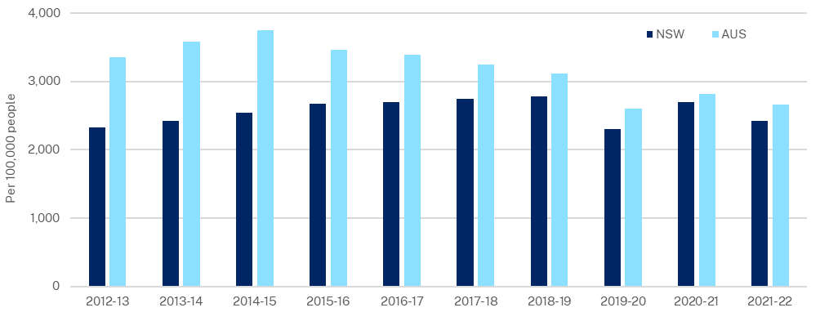
Source: RoGS, 2022; ABS, 2022

Corrective services
Corrective services provided by the NSW Government aim to manage offenders and prisoners commensurate with their needs and the risks they pose to the community, by providing:
- a safe, secure and humane custodial environment
- appropriate management of community corrections orders
- programs and services that address the causes of offending, maximise the chances of successful reintegration into the community and encourage offenders to adopt a law-abiding way of life.

Incarceration rate
Over the past nine years the NSW incarceration rate has increased from 172 people per 100,000 adults in 2012-13, reaching a high of 217 in 2017-18. In 2021-22, the incarceration rate was 195 people per 100,000 adults (Chart 1.25). Aboriginal and Torres Strait Islander people were 13.5 times more likely to be incarcerated than their non-Indigenous counterparts, as measured by the 2021-22 incarceration rates (ABS, 2022). Factors impacting incarceration rates include crime rates, crime clearance rates, court finalisations and sentencing trends. New South Wales remains below the Australian average of 205 people incarcerated per 100,000 adults.
- Incarceration rate
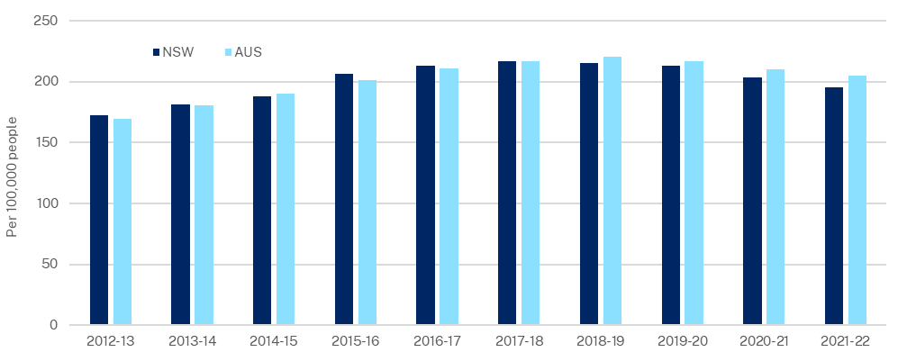
Source: ABS, 2022

Reoffending rates
Reoffending rates measure the extent to which individuals who have interacted with the criminal justice system are rearrested or return to corrective services (either prison or community corrections). Low or decreasing rates of reoffending may indicate a safer and more secure community environment and the promotion of a more law-abiding life, however, higher rates may also indicate more effective policing and detection of offences.
The BOCSAR independently report on the proportion of adult reoffenders released from custody who commit a new proven offence in the 12 months following release. The most recent results show that the percentage of adults released reoffending within 12 months of discharge has increased from 34.0 per cent in 2011, to 42.4 per cent in 2021. The reoffending rate remains below 2000 levels where 46.4 per cent of adults released reoffended within 12 months of release from custody (Chart 1.26).
- Share of reoffenders, NSW
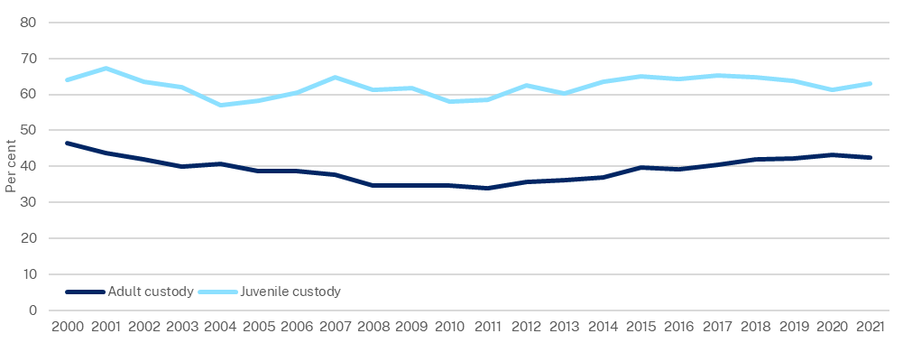
Source: BOCSAR, 2021

Fire and Emergency

Response time to structure fires
The time taken for 90 per cent of the first responding fire crew to arrive at the scene of a structure fire has improved to 14.0 minutes in 2022-23, down from 14.7 minutes in 2021-22 (RoGS, 2023). Response time includes call taking, mobilisation and travel time (Chart 1.27).
Due to lower population densities in regional areas, greater reliance on on-call and volunteer responders and longer distances, average response times are significantly higher than in major cities. Travel times can be impacted by road traffic volumes, road works and mobilisation of NSW Rural Fire Service (NSW RFS) members and on-call Fire and Rescue NSW (FRNSW) staff. Large scale incidents such as major floods also reduce the availability of FRNSW crews in their base fire stations, particularly in regional areas with on-call crews.
- 90th percentile response time to structure fires, FRNSW and NSW RFS
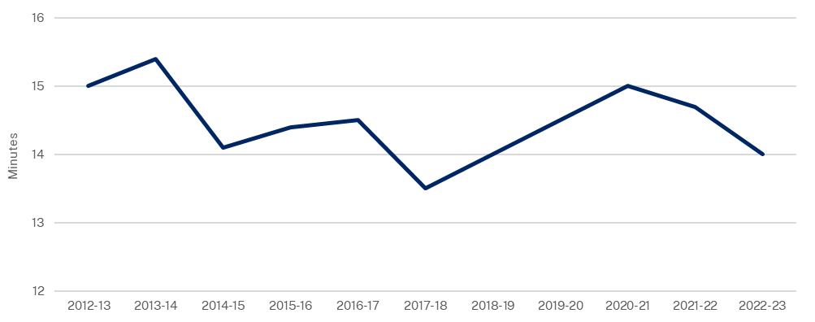
Source: RoGS, 2023

State Emergency Services
During the catastrophic flood season that began in September 2020 and extended into the 2022-23 financial year, NSW State Emergency Service (NSW SES) experienced a surge in demand for flood rescue services, conducting 2,645 flood rescues in 2021-22, and 1,545 flood rescues in 2022-23 (NSW SES, 2023). A decline in incident response is seen as the La Nina cycle has abated and is reducing rainfall.
NSW SES had 10,778 volunteers in 2023 (a small increase from 10,710 in 2022) (NSW SES, 2022 and 2023). Volunteer interest tends to spike during periods of significant operational activity, such as the recent floods, at a time when units are more limited in their capacity for recruitment and onboarding.
- Family and community services (Social protection)

Introduction
The NSW Government provides services to protect families and children and support vulnerable people. Services include child protection, social housing provision, homelessness services and disability support.

Child protection and domestic and family violence in New South Wales
The NSW Government delivers and supports initiatives to protect our most vulnerable children and reduce domestic and family violence (DFV), with a priority to address the over-representation of Aboriginal and Torres Strait Islander children and families in the child protection system.
DFV happens when a partner, former partner or family member tries to scare, intimidate, hurt or control. DFV has broad government service impact including child protection, youth justice, police, courts, corrections, physical and mental health, and homelessness. This section focuses on DFV in the child protection context.

NSW Government performance of services: Child protection and domestic and family violence in New South Wales

Risk of Significant Harm (ROSH) reporting
The Department of Communities and Justice has statutory responsibility to respond to child protection reports and to assess whether a child or young person needs care and protection.
A ROSH assessment identifies whether there is reasonable cause to believe a child has been, is being, or is likely to be abused, neglected, or otherwise harmed. In 2021-22, 108,697 children were reported as at risk (where a ROSH assessment has resulted in a ‘substantiation’). This represents a 14.3 per cent decline from 2020-21. This decline could be explained in part to the COVID-19 pandemic, noting that there has subsequently been a 3.6 per cent increase in the 12 months to March 2023 (Chart 1.28). Out of all children investigated (30,015), 51.9 per cent (or 15,582 children) had the ROSH substantiated.
- Children reported at ROSH, NSW
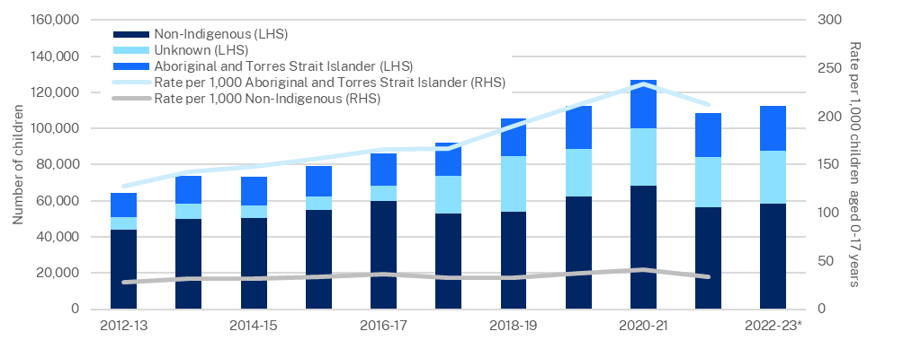
Source: (1) AIHW, 2022 (2) ABS, 2022 (3) Department of Communities and Justice, 2023
* Note: (1) 2022-23 data reflects the rolling 12 months to March 2023 (2) Rate per 1000 children data is not available for 2022-23 as at 31 August 2023.

Out-of-Home Care (OOHC)
OOHC is provided to children and young people who are unable to live with their own families due to child safety concerns. Carers (foster carers and relative/kinship carers) take on the responsibilities of a parent for a period to provide a safe family environment for children and young people needing care. Children and young people stay in care until they can be safely restored with their family or other permanency arrangements are finalised.
The number of children in OOHC as at 30 June 2022 has fallen by 12.4 per cent compared with 30 June 2018, and is at the lowest it has been in a decade. As of 30 June 2022, there were 15,223 children in OOHC in New South Wales, representing 8.5 per 1,000 children in the population. Aboriginal and Torres Strait Islander children remain overrepresented in OOHC, relative to their share of the population.
- Children 0-17 years in OOHC, NSW
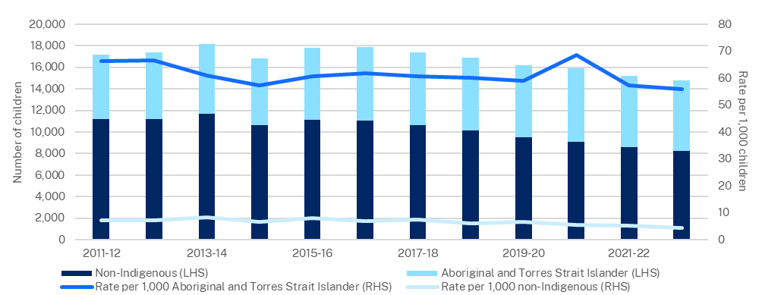
Source: AIHW, 2022; ABS, 2022; NSW Department of Communities and Justice, 2023
Note: 2022-23 data are as at 31 March 2023

Permanency
Permanency refers to children and young people who exit OOHC and are either restored with their families, placed with a permanent legal guardian, or adopted. Restoration is defined as children being reunified with their parents, although differing definitions also include other family members or guardians, particularly if the child was living with these adults prior to entry into care.
During 2020-21, in New South Wales:
- 375 children and young people (including 142 Aboriginal and Torres Strait Islander children) exited from OOHC to guardianship, a 7.4 per cent increase since 2018-19
- 422 children and young people (including 157 Aboriginal and Torres Strait Islander children) were restored to their parents, a 25.8 per cent decrease since 2018-19
- 89 children were adopted, a 33.6 per cent decrease since 2018-19.
The NSW restoration rate for non-Indigenous and Aboriginal and Torres Strait Islander children from OOHC in 2020-21 was 9.2 per cent and 8.3 per cent respectively, which was the lowest of any jurisdiction (Chart 1.30).
- Children in OOHC (aged 0-17) who were restored in 2020-21
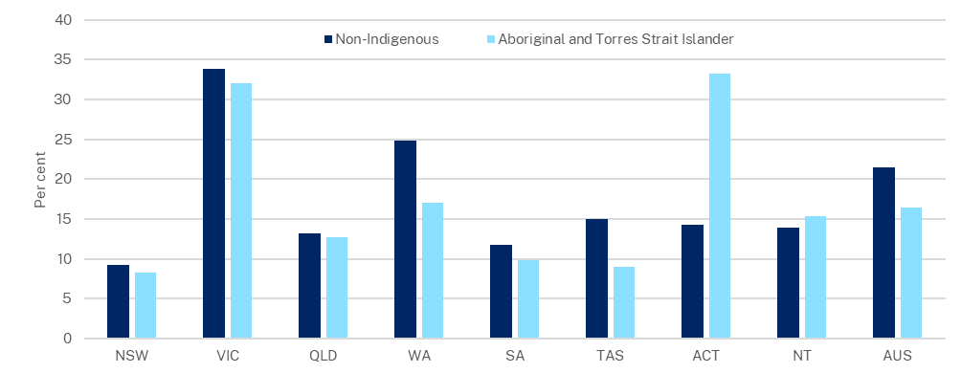
Source: AIHW, 2022
The New South Wales rates of successful restoration (92.8 per cent for non-Indigenous children and 85.2 per cent for Aboriginal and Torres Strait Islander children) in 2019-20 was, however, comparable to other jurisdictions (Chart 1.31). Note: there is a one-year lag on this data when compared to restoration.
- Children restored from OOHC in 2019-20 and did not return within 12 months
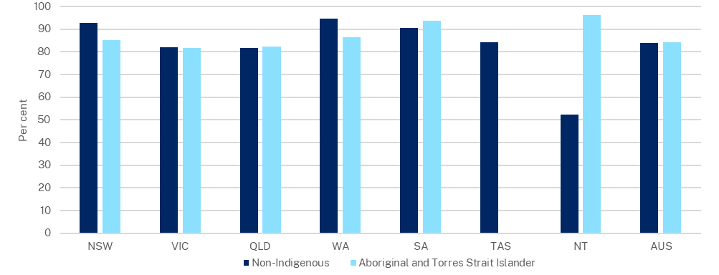
Source: AIHW, 2022
Note: ACT and TAS Indigenous status data is not available, due to small numbers.

The NSW Permanency Support Program (PSP) is a service reform designed to give every child a loving home for life, whether that be with parents, extended family, or kin, or through a guardianship or open adoption for non-Indigenous children. A recent evaluation of the program found “there is little evidence that receipt of a PSP package substantially improved children’s safety, permanency, stability, and wellbeing, when compared to historical comparison groups” (Department of Communities and Justice, 2023).

Experience of physical or sexual abuse
In 2021-22, an estimated 2.8 million Australians aged 18 years and over (14 per cent) had experienced physical or sexual abuse by an adult before, the age of 15. In the same period, women in New South Wales were more likely than men to have encountered such experiences, with 16.8 per cent of women aged 18 years and over having experienced physical and sexual abuse by an adult, before the age of 15 (Chart 1.32).
- Adult women, experiences of physical or sexual abuse, before the age of 15
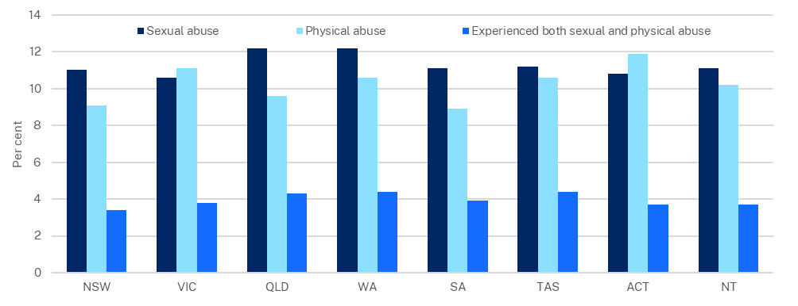
Source: ABS, 2022

Witnessed parental violence
In 2021-22, an estimated 2.6 million Australians aged 18 years and over (13 per cent) witnessed violence towards a parent by a partner, before the age of 15. Violence in this context refers to physical assault only. Women were more likely than men to have witnessed parental violence. In New South Wales, 15.6 per cent of women witnessed partner violence towards their mother or father, before the age of 15 (Chart 1.33).
- Adult women, experiences of domestic violence witnessing, before the age of 15
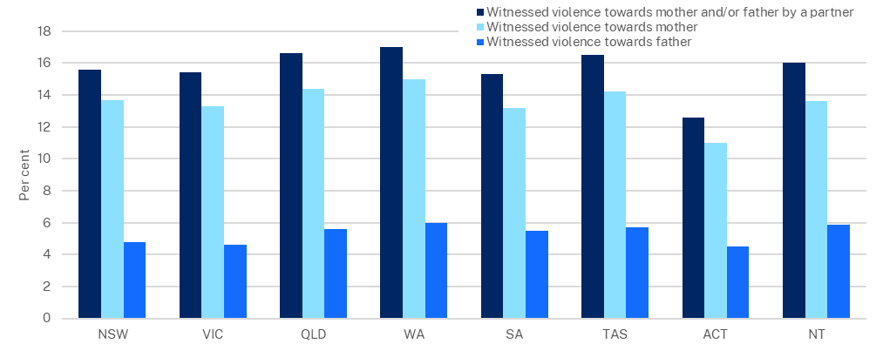
Source: ABS, 2022

Social housing and homelessness
Social housing is delivered to assist people who are unable to access or maintain appropriate accommodation. Current housing market conditions, a constrained rental market and rising rental costs have presented increased challenges for social housing tenants to successfully transition to market housing.
The NSW Government is supporting initiatives targeting reduced homelessness. It is coordinating with specialist homelessness services including Aboriginal and Torres Strait Islander organisations and local community groups to help break the cycles of homelessness by balancing prevention and early intervention with crisis responses.

Supply of social housing
There are three types of social housing:
- public housing, owned and managed by the NSW Government
- community housing, managed and often owned by registered not-for-profit organisations
- Aboriginal and Torres Strait Islander housing, managed by both the NSW Government and Aboriginal housing providers, including registered Aboriginal community housing providers.
As at 30 June 2022, New South Wales had 160,628 social housing dwellings comprising 96,712 public housing, 54,292 community housing, 5,504 Aboriginal Community Housing, and 4,120 State Owned and Managed Indigenous Housing as shown in Chart 1.34 (AIHW, 2023).
Growth of the NSW social housing stock has been 1.0 per cent a year over the past 10 years. The composition of social housing stock has shifted away from public housing towards community housing.

On a per capita basis, New South Wales had approximately 1,970 social housing dwellings per 100,000 people in June 2022. By comparison, the Northern Territory had approximately 5,040 social housing dwellings per 100,000 people, and Victoria had 1,240 social housing dwellings per 100,000 people.
- Number of social housing dwellings, NSW
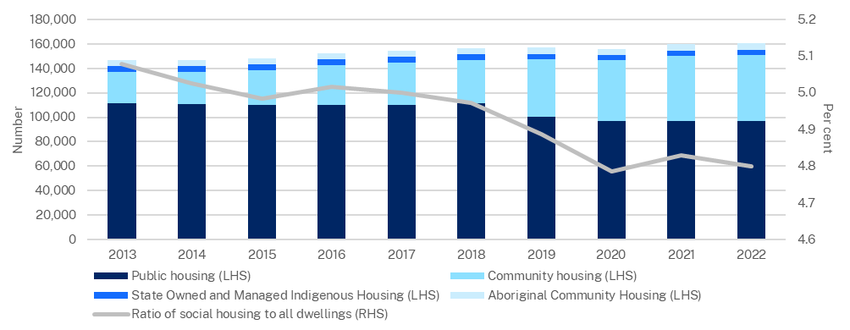
Source: AIHW, 2022, ABS 2021 and NSW Treasury

Demand for social housing
With a constrained private rental market and a rising cost of living, demand for social housing has increased markedly. As at 30 June 2023, 55,880 households were on the NSW Housing Register. Among those, the priority waitlist for those assessed to be most in need grew from 6,519 in June 2022, to 7,573 in June 2023 (Chart 1.35). The median wait time of newly housed priority applicants was 3 months in 2022-23, up from 2.4 months in 2021-22.
Priority waitlist data from regional areas in 2022-23 shows strong growth in demand, with approximately 49 per cent of applicant households coming from regional or rural New South Wales in 2022-23 (compared with 35 per cent in 2014-15).
- Priority social housing applicants and median wait time, NSW
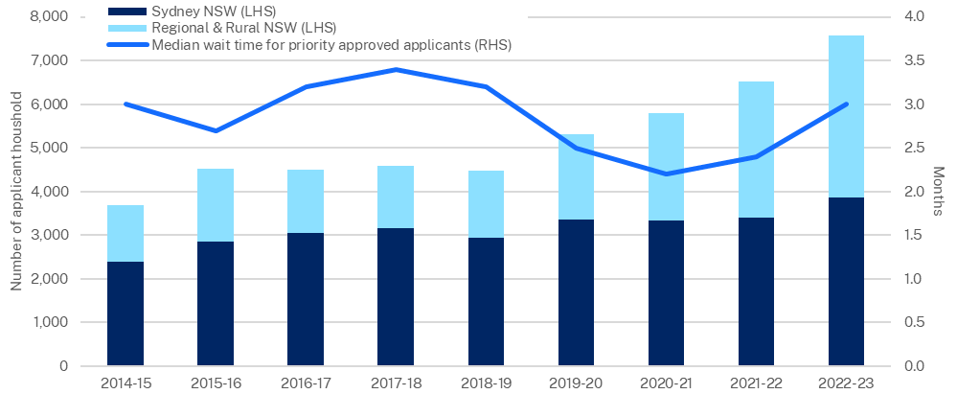
Source: NSW Department of Communities and Justice, 2023

Of all newly housed applicants in 2021-22, 91.3 per cent were previously homeless, or at risk of homelessness.

Number of homeless persons
The ABS estimates 963 people were living in improvised dwellings, tents, or sleeping out on the 2021 Census night in New South Wales. The unique circumstances of the COVID-19 pandemic in 2021 means this estimate is unlikely to be an accurate reflection of the extent of street homelessness, as it is well down on the 2016 Census estimate of 2,588 people.
The February 2023 NSW Street Count, which uses a different counting method to the Census, identified 1,623 people sleeping rough. This is a 34 per cent increase compared to February 2022, and the second consecutive year that the street count has increased (Chart 1.36).
- NSW street counts
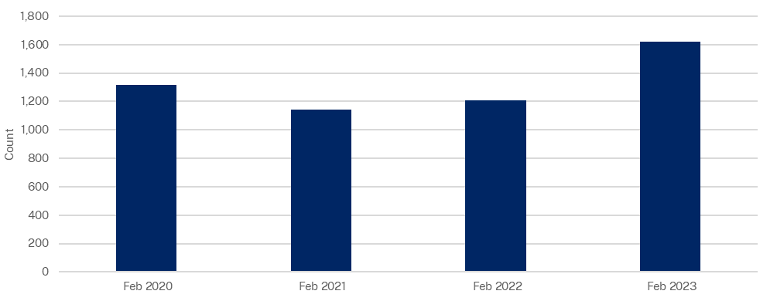
Source: Department of Communities and Justice, 2023

There is a disproportionate need for social housing and homelessness support within Aboriginal and Torres Strait Islander communities.
- Spotlight on some NSW measures of wellbeing
In addition to direct service delivery, the NSW Government regulates and participates in a breadth of activities that contribute to the wellbeing of the NSW community.
This section spotlights a selection of wellbeing measures including housing and energy. Underlying this analysis is the understanding that wellbeing, and the impacts of government investment, regulation, and policies, are experienced differently across different groups.
Further, the impacts of current economic pressures including, inflation, energy prices, interest rates, and rents, are unevenly distributed within the community. This can have a compounding effect on existing stressors such as housing affordability, which has declined since the start of the COVID-19 pandemic, driving up demand for social and low-cost housing (see Social Protection section).

Overview
Income and wealth distribution are examples of potential wellbeing measures.
The Gini Coefficient is a broadly understood and accepted measure of how wealth and income is shared among a population, and ranges from 0 for perfect equality, to 1 for absolute inequality. Wealth inequality is more difficult to quantify but can be a more complete measure of overall individual welfare, as it can better reflect lifetime consumption capacity.
The ABS periodically publishes the income Gini Coefficient, which for New South Wales was 0.33 in 2019-20, close to the level in 2011-12. The Gini Coefficient for New South Wales, however, remains above the national (Chart 1.37).
- Gini Coefficient mean weekly disposable household income
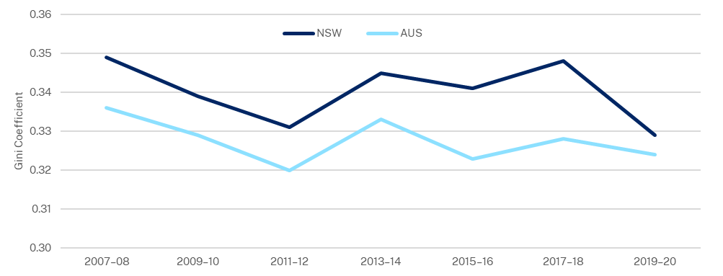
Source: ABS, 2020

Housing
The NSW Government is responsible for policies, projects, and regulations that influence the availability of housing and community amenities, including through planning, zoning, and planning for the provision of public infrastructure including water, drainage, street lighting, green space, and cemeteries.
Renewed population growth (since international borders have re-opened), rising interest rates, subdued residential construction, and a shift toward smaller household sizes (NSW Productivity Commission, 2023), has made housing less affordable.
Per capita demand for housing has risen with real incomes, and a demographic trend towards smaller household sizes (Coates, 2022; Grattan Institute, 2016; McDonald & Temple, 2013; Gitelman & Otto, 2012).

Cost of housing
Constrained housing supply continues to place upward pressure on housing costs. In addition, cash rate increases since early 2022 (0.10 per cent in April 2022, to 4.10 per cent in August 2023) have significantly increased mortgage servicing costs. In June 2023, the cost of servicing a new 30 year mortgage was above 30 per cent of average disposable income, the highest share since 1991 (Chart 1.38) (NSW Productivity Commission, 2023).
- NSW mortgage servicing costs as a share of average household income
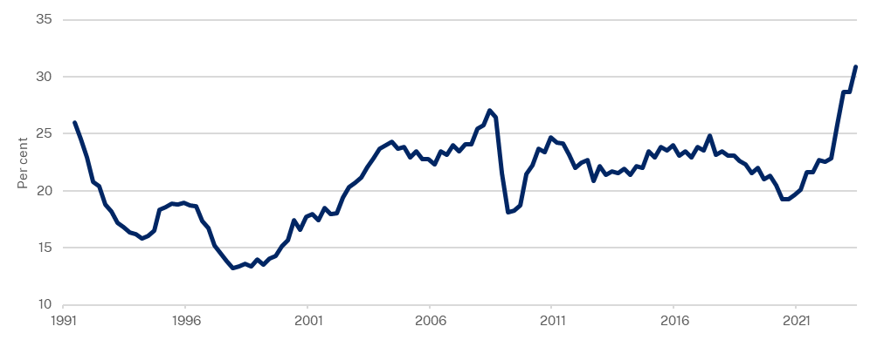
Source: CoreLogic, 2023; ABS, 2022; NSW Productivity Commission, 2022

Rates of home ownership for young people
There has been a long-term decline in NSW home ownership rates, particularly for young people. For the age cohort 25-29, home ownership rates have declined from 49.9 per cent in 1981, to 32.1 per cent in 2021 (Chart 1.39). For the age cohort 30-34, rates have declined from 65.7 percent in 1981, to 45.1 per cent in 2021 (AIHW, 2023).
- NSW home ownership by age
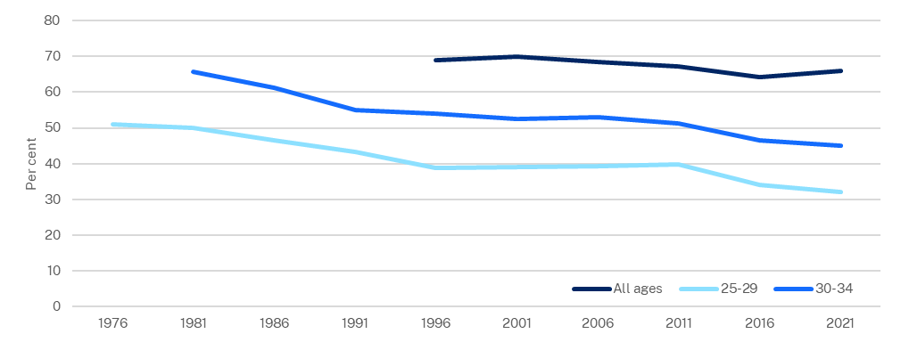
Source: AIHW, 2023

Rental price growth
In the calendar year to December 2022, rental vacancy rates averaged 1.8 per cent in Greater Sydney and 0.9 per cent in regional New South Wales (SQM Research, 2023), well below the 3.0 per cent benchmark indicating a balanced market. In June 2023, the median cost of renting in Greater Sydney was $778 and $688 per week for houses and units respectively. In the year to June 2023, Greater Sydney median unit rents increased by 18.8 per cent (CoreLogic, 2023) (Chart 1.40).
- Advertised NSW residential rental price growth, year-ended
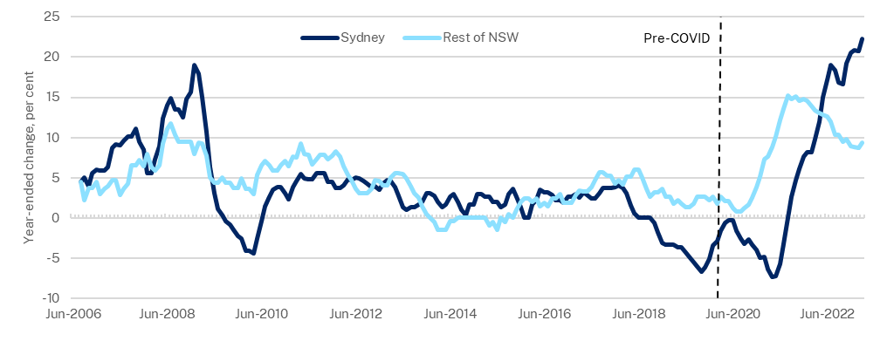
Source: CoreLogic, 2023; NSW Productivity Commission, 2023

NSW Government performance of services: Housing

Development application approvals
Long assessment times for development applications are likely to be contributing to housing supply shortages and impacting housing affordability. The average time to determine development applications was 107 days in 2022-23, compared with 83 days in 2021-22 (Department of Planning and Environment, 2023).

Building completions
Housing supply takes time to respond to increased demand, and delays in development applications as well as supply side constraints—such as shortages of construction materials or skilled trades—will lengthen delays. If supply does not respond quickly enough, the pressure on renters and homebuyers will continue to build. Housing supply in New South Wales has been less responsive to demand, compared to Victoria and Queensland (NSW Productivity Commission, 2023).
Since 1992, New South Wales has built around six dwellings per 1,000 people each year, on average, compared with eight to nine dwellings per 1,000 people in Victoria and Queensland (NSW Productivity Commission, 2023). Since 1992, New South Wales has generally recorded lower dwelling completions annually per 1,000 people compared with both Queensland and Victoria (Chart 1.41).
- Annual dwelling completions per 1,000 people
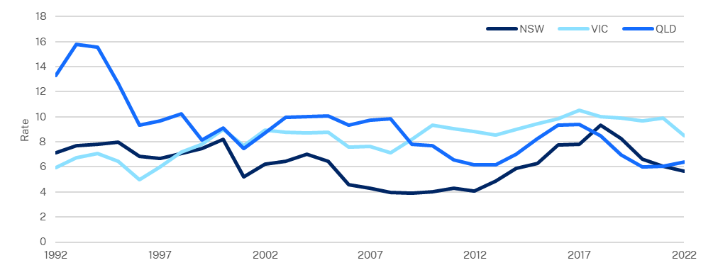
Source: ABS, 2023
Housing completions are influenced by market demand, land availability, construction capacity, and by approval processes. In the year to the June quarter 2023, residential construction costs increased by 9.9 per cent in New South Wales (ABS, 2023). The rate of annual dwelling approvals per 1,000 people dropped from 7.9 per 1,000 people in 1992, to 6.6 in 2022 (Chart 1.42). Since the early 1990s, Victoria and Queensland have consistently outperformed New South Wales in terms of annual dwelling approvals per 1,000 people.
- Annual dwelling approvals per 1,000 people
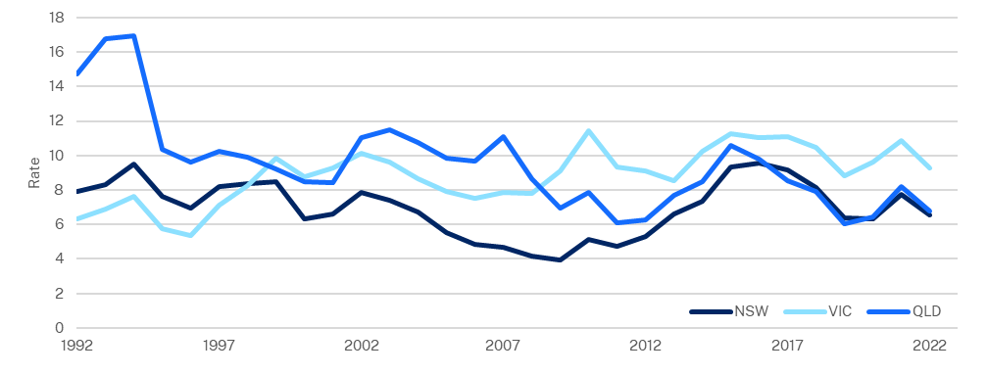
Source: ABS, 2023

Energy
The NSW Government is accelerating the renewable energy transition to ensure that all communities in New South Wales have a reliable supply of clean, affordable, and renewable electricity.
Energy prices are important for households and businesses as energy is an input into almost every activity in the economy. Between 2017-18 and 2020-21, New South Wales’ wholesale electricity prices fell from $85 to $72 per megawatt hour (Chart 1.43). Victoria and Queensland experienced a similar downward trend. During this period, large-scale solar, wind generation, and grid-scale batteries were introduced into the market (Australian Energy Regulator, 2020).
More recently, NSW wholesale prices rose from $72 to $157 per megawatt hour from 2020-21 to 2022-23. Both Queensland and Victoria experienced similar rises over the same period. The price rise across these regions can be attributed to a range of factors, including a global energy crisis that saw a spike in coal and gas prices, supply constraints such as thermal generation outages and fuel supply concerns (Australian Energy Regulator, 2023).

- Wholesale electricity prices
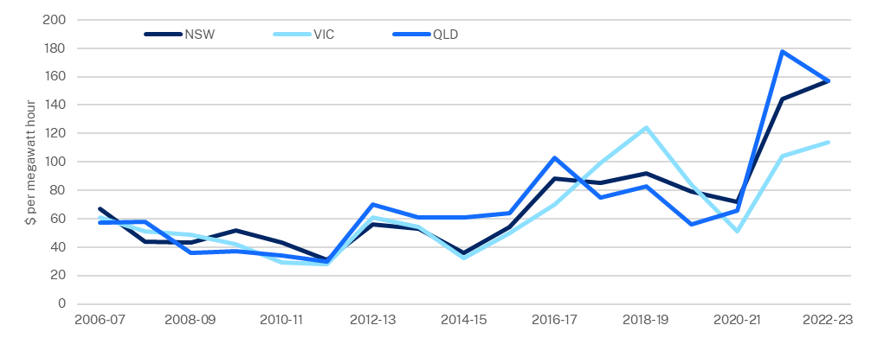
Source: Australian Energy Regulator, 2023
Note: Prices are volume weighted annual averages - the average is weighted against demand for electricity.

The NSW Government has committed to net zero emissions by 2050 with an interim target of 50 per cent reduction in emissions by 2030, compared with 2005 levels. Since 2004-05, net NSW CO2 equivalent emissions have reduced from 161,114 gigagrams to 132,049, or 18.0 per cent (Chart 1.44). This is less than the Australian average reduction of 24.6 per cent over the same period, which decreased from 616,293, to 464,771 gigagrams.
- Net CO2 equivalent emissions
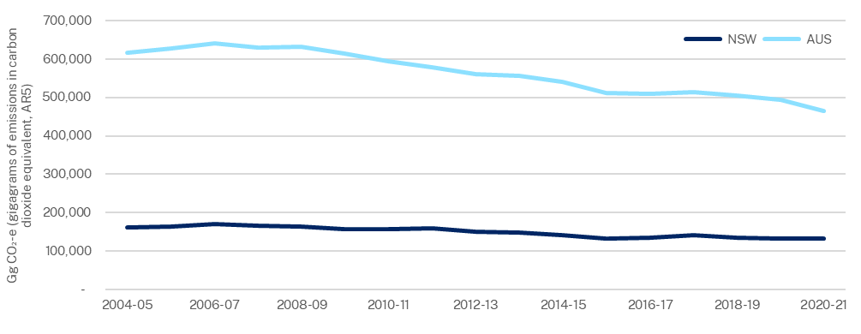
Source: Department of Climate Change, Energy, the Environment and Water, 2023

Note that many of the outcomes relate to polices of previous governments.
See section 4.3(f) which requires the budget papers to contain information in the form determined by the Treasurer about the performance and activities of GSF agencies.
To support interstate comparisons this chapter uses ABS data up to the latest available (2021-22), and unpublished Treasury data for 2022-23, hence there may be some minor inconsistencies between these years for some series.

