2. EDUCATION CLUSTER

Introduction
 | $19.9  billion | Recurrent  Expenses  2020-21
 | $2.8  billion | Capital  Expenditure 2020-21
The Education Cluster administers and delivers lifelong education and training services for NSW students, workers and industry. This spans the early childhood education and care sector, government and non-government schools, and the vocational education and training sector.

State Outcomes to be delivered by the Education Cluster
State Outcomes  What the Cluster is delivering for people and business |  | Example Programs^{(a)}  underway to support delivery of Outcomes
1. Best start in life for young children  A sustainable, accessible, high-quality early childhood education sector.  2020-21 investment: $667.6 million recurrent expenses |  | - Start Strong  - Regulatory and support services aiming to deliver access to quality early childhood education
2. Educational foundations for success  A high standard of education for all children and young people in public and non-government schools.  2020-21 investment: $16.4 billion recurrent expenses & $2.5 billion capital expenditure |  | - Teaching and learning in public schools aiming to improve student outcomes  - Construction of new schools and major upgrades  - Non-government school funding
3. Skilled and employable workforce  A highly skilled and adaptable workforce that contributes to the State’s prosperity and productivity.  2020-21 investment: $2.7 billion recurrent expenses & $280.1 million capital expenditure |  | - Smart and Skilled  - Skilling for Recovery fee-free training courses  - Regulatory and support services aiming to deliver a viable and high-quality vocational education and training sector
4. High-quality standards for schooling  High-quality standards for schooling in New South Wales through the regulation of schooling, accreditation of early childhood, primary and secondary teachers, and provision of quality curriculum, assessment and certification by the NSW Education Standards Authority.  2020-21 investment: $171.5 million recurrent expenses & $45.9 million capital expenditure |  | - Assessment standards  - Curriculum standards  - Teacher standards  - School standards

- Note that Programs are being further refined as the outcome and performance framework continues to mature.

Overview of Cluster expenses by State Outcome
A summary of expenses by State Outcome is provided in the charts below.
- Recurrent expenses by Outcome 2020-21 (dollars and %)
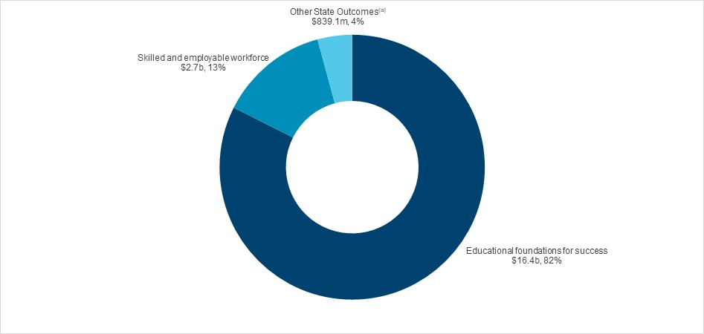

Note: The sum of percentages does not equal one hundred due to rounding.

- Grouped for presentation purposes, “Other State Outcomes” comprises:
- Best start in life for young children
- High-quality standards for schooling in NSW.

- Capital expenditure by Outcome 2020-21 (dollars and %)
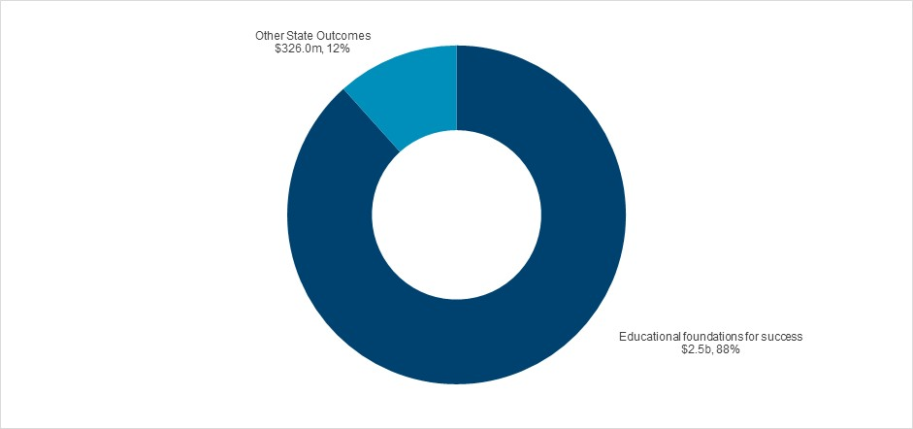
(a)
- Grouped for presentation purposes, “Other State Outcomes” comprises:
- High-quality standards for schooling in NSW
- Skilled and employable workforce.

Outcome 1: Best start in life for young children
 | $667.6 million | Recurrent  Expenses  2020-21

State Outcome overview and 2020-21 investment
Investments under this State Outcome support a sustainable, accessible, high-quality early childhood education sector.
Children who participate in a quality early childhood education program are more likely to arrive at school equipped with the social, cognitive and emotional skills they need to engage in learning. The NSW Department of Education monitors, supports and regulates early childhood education services in New South Wales, and works to ensure the delivery of quality early childhood education services for children in the years before school.

2020-21 State Outcome Budget highlights
In 2020-21, the Education Cluster will invest $667.6 million in this Outcome, including:
- the Start Strong program to support preschool education across New South Wales, in both community preschools and long day care centres. Funding support is delivered for all three and four-year-olds in community preschools to provide universal access to two years of early childhood education, and continuing a commitment made in the 2018-19 Budget
- continued funding to support the COVID-19 free preschool program for community and mobile preschools in Terms 3 and 4 in 2020, and up to $120.0 million for the extension of the COVID-19 free preschool program for community and mobile preschools through to the end of 2021, providing fee relief for families and certainty for the NSW preschool sector to respond to the impact of the COVID-19 pandemic
- $6.0 million over two years to deliver the Working Towards Quality Support Program in conjunction with the Australian Children’s Education and Care Quality Authority
- continuation of capital works funding to support the creation of additional community preschool places.

Key performance insights
This section provides analysis and insights on key Outcome Indicators for this State Outcome.

Children enrolled in an early childhood education program in the year before school
This Outcome Indicator is consistent with benchmarks under the National Partnership Agreement on Universal Access to Early Childhood Education, with an enrolment target of 95 per cent by 2022.
Performance against this indicator has improved and is on track to meet the target. Participation in early childhood education for 600 hours in the year before school increased to 94.5 per cent in 2019. This is the State’s highest-ever result against this indicator and is the largest increase since 2016 compared to other jurisdictions.
The NSW Government’s Start Strong program is a needs-based funding investment aimed at making 600 hours of preschool participation more affordable in the year before full-time school. Support is also available for three-year-olds, with a focus on children from Aboriginal and low-income families and children with a disability.

- Proportion of children who are enrolled in an early childhood education program for at least 600 hours in the year before school

Note: Data sourced from Australian Bureau of Statistics (ABS), Preschool Education, Australia.

Early childhood education services rated as meeting or exceeding the National Quality Standard
The NSW Department of Education monitors compliance with legislative requirements, investigates complaints and responds to incidents.
Performance against this indicator is on track to meet the target. Since the introduction of the National Quality Standard (NQS) in 2012, there has been an overall quality improvement in the sector in New South Wales. In June 2020, the proportion of services meeting or exceeding the NQS increased to 77.2 per cent.
To support ongoing service quality improvement, the Department is delivering a number of programs including the Working Towards Quality Support Program and the Quality Ratings Initiative, which will improve family awareness of service quality through a visual ratings display.
- Proportion of early childhood education services rated as meeting or exceeding the National Quality Standard

Note: Data sourced from the Australian Children’s Education and Care Quality Authority (ACECQA).

Performance indicators for this Outcome
Outcome Indicators | Units | 2019-20 | 2020-21
 |  | Actual | Forecast
Proportion of children who are enrolled in an early childhood education program for at least 600 hours in the year before school^{(a)} | % | 94.5 | 94.6
Proportion of enrolled Aboriginal children who are enrolled in an early childhood education program for at least 600 hours in the year before school^{(a)} | % | 93.8 | 93.9
Proportion of enrolled vulnerable and disadvantaged children who are enrolled in an early childhood education program for at least 600 hours in the year before school^{(a)} | % | 91.4 | 92.5
Proportion of early childhood education services rated as meeting or exceeding the National Quality Standard^{(b)} | % | 74.3 | 77.4

Notes
(a) 2019-20 actuals and 2020-21 forecasts refer to the 2019 and 2020 school years, respectively. Data sourced from Australian Bureau of Statistics (ABS), Preschool Education, Australia.
(b) Data sourced from the Australian Children’s Education and Care Quality Authority (ACECQA). 2019-20 actual as at December 2019.

Outcome 2: Educational foundations for success
 | $16.4 billion | Recurrent  Expenses  2020-21
 | $2.5 billion | Capital  Expenditure  2020-21

State Outcome overview and 2020-21 investment
Investments under this State Outcome support a high standard of education for all children and young people in public and non-government schools.
The NSW Department of Education is the largest provider of education in Australia. It delivers high-quality public education through its network of 2,215 public schools and ensures that school infrastructure continues to meet the needs of the State’s growing population. The Department also works closely with the non-government school sector to ensure the delivery of a high-quality and equitable education for all students.

2020-21 State Outcome Budget highlights
In 2020-21, the Education Cluster will invest $18.9 billion ($16.4 billion recurrent expenses and $2.5 billion capital expenditure) in this Outcome, including:
- $14.9 billion recurrent funding to support the delivery of primary and secondary education in government schools in 2020-21, in line with the State’s commitment under the National School Reform Agreement (NSRA)
- $1.5 billion to support non-government schools in 2020-21, including funding for non-government school essential capital works under the Building Grants Assistance Scheme
- $544.6 million over two years for shovel-ready new and accelerated capital works across schools to create jobs and stimulate local economies
- $365.8 million capital funding over two years for the Rural Access Gap Direct Intervention program to deliver improved access to digital teaching, learning aids and collaboration tools to rural and remote schools
- $337.0 million over the 2021 school year for intensive tutoring in all NSW government and some non-government schools to support students in making up lost learning time as a result of COVID-19 impacts and shutdowns in early 2020
- $240.0 million over two years of government co-contributions to both regional and metropolitan schools to support the accelerated delivery of community funded projects and initiatives across government schools
- funding to pilot deployment of solar PV systems, batteries, demand response initiatives and electric vehicle charge points in NSW Government schools
- an ongoing commitment under the NSRA for 2019 to 2023 to deliver needs-based funding to government and non-government schools. Under the NSRA, New South Wales has committed to implement national policy initiatives, and a series of state-based reforms to improve student learning, teaching and school improvement across government and non-government schools.

Key performance insights
This section provides analysis and insights on key Outcome Indicators for this State Outcome.
NSW Department of Education’s is developing an outcomes-based improvement framework, to replace the existing performance frameworks. The improved framework will be underpinned by ambitious targets for all schools, providing more support to the schools that need it the most, and develops processes for sharing best practice.

Public school students in the top two NAPLAN bands for reading and numeracy
The NSW Premier’s Priority is to increase the proportion of public school students in the top two NAPLAN bands for literacy and numeracy by 15 per cent by 2023. This would be equivalent to increasing the proportion of students in the top two bands to an average of 36.4 per cent.
Performance against this Premier’s Priority is on track to meet the target. In 2019, average results were 32.2 per cent, which is 0.6 percentage points higher than the baseline.
The NSW Department of Education Bump It Up program is being expanded state-wide, setting tailored targets in every public school. The Department is releasing additional assessments to help teachers determine students’ learning progression and expanding professional learning to build teacher knowledge of literacy and numeracy development, the effective use of data and the implementation of evidence-based classroom practices.
- Proportion of public school students in the top two NAPLAN bands for reading and numeracy

Note: Data sourced from NSW Department of Education, annual NAPLAN results. Note that Education Ministers made the decision to cancel NAPLAN in 2020 due to the impact of the COVID-19 pandemic. This means that comparative data may not be available for 2020.

Aboriginal students attaining Year 12
The Premier’s Priority is to increase the proportion of Aboriginal students attaining Year 12 by 50 per cent by 2023, while maintaining their cultural identity. This will be equivalent to increasing the proportion of Aboriginal students attaining the HSC to 69 per cent.

Performance against this Premier’s Priority is on track to meet the target. Interim results for 2019 indicate that 45 per cent of Aboriginal students in New South Wales have achieved the HSC.
This will be further improved through additional focus on performance with all public secondary schools now having targets in support of the Premier’s Priority. The Department has also developed five initiatives in collaboration with the NSW Coalition of Aboriginal Peak Organisations to support Aboriginal students through their final years of school.
- Proportion of Aboriginal students attaining Year 12, while maintaining their cultural identity

Note: Data sourced from NESA and NSW Department of Education. This Indicator refers to all Aboriginal students in NSW (i.e. both government and non-government schools). See footnote (c) in Outcome Indicator table below for further information about the calculation of attainment rates.

Performance indicators for this Outcome
Outcome Indicators^{(a)} | Units | 2019-20 | 2020-21
 |  | Actual | Forecast
Academic Achievement
Proportion of public school students in the top two NAPLAN bands for reading and numeracy ^{(b)} | % | 32.2 | 33.5
Proportion of public school students above the national minimum standard for reading and numeracy | % | 79.5 | 83.5
Proportion of NSW public school students achieving expected growth in reading and numeracy^{(b)} | % | 56.4 | 64.4
Student Wellbeing
Proportion of public school students reporting a sense of belonging, expectations for success and advocacy at school^{(g)} | %
% of public school primary students |  | 85.7 | 85.0
% of public school secondary students |  | 64.8 | 67.3
Proportion of public school students attending school at least 90% of the time^{(e)} | %
% of public school primary students |  | 78.5 | 80.7
% of public school secondary students |  | 64.0 | 67.3
Student Equity (Aboriginal Students)
Proportion of Aboriginal students attaining Year 12, while maintaining their cultural identity^{(c)} | % | 45 | 46
Proportion of Aboriginal students in public schools in the top two NAPLAN bands for reading and numeracy^{(b)} | % | 10.3 | 12.5
Proportion of Aboriginal students in public schools above the national minimum standard for reading and numeracy | % | 56.1 | 60.6
Reduce the gap between Aboriginal and non-Aboriginal students in public schools reporting a sense of belonging, expectations for success and advocacy at school^{(g)} | %
Gap between Aboriginal and Non-Aboriginal public primary school |  | 3.0 | 3.1
students
Gap between Aboriginal and Non-Aboriginal public secondary school |  | 13.2 | 13.7
students
Student Equity (Disadvantaged Students)
Reduce the gap between the highest and lowest socio-economic status students in public schools in the top two NAPLAN bands for reading and numeracy^{(b)(h)} | % | 42.4 | 38.1
Reduce the gap between the highest and lowest socio-economic status students in public schools above the national minimum standard for reading and numeracy^{(h)} | % | 32.1 | 29.3
Reduce the gap between the highest and lowest socio-economic status students in public schools reporting a sense of belonging, expectations for success and advocacy at school^{(h)(g)} | %
Gap between low-and high-SES public primary school students |  | 10.1 | 10.0
Gap between low-and high-SES public secondary school students |  | 20.7 | 22.7
Independence
Proportion of public school students continuing to Year 12 and the proportion of public school students' HSC results in the top two achievement bands^{(f)} | %
% of public school HSC results in top two bands |  | 33.4 | 35.2
Apparent retention rate |  | 72.3 | 75.3
Proportion of all recent school leavers (who left school the previous year) participating in higher education, training or work^{(d)} | % | 88.5 | 90.6

Notes
(a) 2019-20 actuals and 2020-21 forecasts refer to the 2019 and 2020 school years, respectively.
(b) Data sourced from NSW Department of Education, annual NAPLAN results. The baseline is the average of 2017 and 2018 results. "Expected growth" is based on the growth achieved by students in reading and numeracy from one NAPLAN assessment to the next (two years later). Note that Education Ministers made the decision to cancel NAPLAN in 2020 due to the impact of the COVID-19 pandemic. This means that comparative data may not be available for 2020.
(c) Data sourced from NESA and NSW Department of Education. This target refers to all Aboriginal students in NSW (i.e. both government and non-government schools). Attainment rates are estimated by calculating the number of students awarded their HSC expressed as a percentage of the potential Year 12 population. The potential Year 12 population is an estimate of a single-year age group that could have attended Year 12 that year and is derived from administrative records for Year 9 and Year 10 enrolments in earlier years. The results for Year 12 in 2019 are interim. A number of these students will complete their HSC over three years, which will be captured as revisions.
(d) Data sourced from the NSW Department of Education's NSW Post-School Destinations and Expectations Survey.
(e) Sourced from NSW Department of Education's mid-year census. 2019 actuals are as at July 2019. 2020 attendance data will be significantly affected by COVID-19.
(f) Sourced from the NSW Department of Education's mid-year census and from NESA. The apparent retention rate is defined as the number of full time equivalent (FTE) students in Year 12 as a proportion of the cohort enrolment two years prior (when in Year 10). Retention rates are “apparent” as they do not track individual students through to their final years of secondary schooling. Care should be taken in the interpretation of apparent retention rates because the method of calculation does not take into account a range of factors including migration, interstate movement of students, transfers to and from non-government schools, part-time schooling, students repeating a year of schooling, and students pursuing other education and training pathways.
(g) Sourced from the NSW Department of Education's Tell Them From Me student survey. These measures are the average of three survey metrics. The primary school measure is sourced from surveys of students in Years 4 to 6. Measures for secondary school students are for Years 7 to 12. Note that 2020-21 forecasts refer to actual results from the 2020 TTFM survey. Participation in the student survey has been impacted by COVID-19 and has affected 2020 results for this indicator.
(h) High socio-economic status students are those whose parents have a bachelor’s degree or above. Low socio-economic status students are those whose parents achieved a Year 11 or below school education level and do not have any non-school education. This information is self-reported and results should be interpreted with caution.

Outcome 3: Skilled and employable workforce
 | $2.7 billion | Recurrent  Expenses  2020-21
 | $280.1 million | Capital  Expenditure  2020-21

State Outcome overview and 2020-21 investment
Investments under this State Outcome support a highly skilled and adaptable workforce that contributes to the prosperity and productivity of New South Wales.
The NSW Department of Education drives participation and retention in quality VET by managing the Smart and Skilled contestable training market, including the apprenticeship and traineeship system in New South Wales. The Department also provides direct funding to TAFE NSW, the State’s comprehensive public provider of VET.

2020-21 State Outcome Budget highlights
In 2020-21, the Education Cluster will invest $3.0 billion ($2.7 billion recurrent expenses and $280.1 million capital expenditure) in this Outcome, including:
- $318.6 million over two years for Skilling for Recovery, a key component of the State’s COVID-19 Recovery Plan to help job seekers retrain or upskill, and support school leavers to enter the workforce for the first time. The NSW Government has committed almost $160.0 million to match Commonwealth JobTrainer funding and offer more than 100,000 training places
- $100.0 million ($20.7 million recurrent and $79.3 million capital) for asset replacement and maintenance, and new teaching plant and equipment for TAFE NSW to deliver quality training
- $57.4 million over four years for a Trades Skills Pathways Centre to address skills shortages in the NSW economy, by recognising trades skills, establishing new trades pathways and improving skilled employment opportunities for women
- $20.0 million for the Australian Government Revitalising TAFE Campuses across Australia Program ($10.0 million from the NSW Government and $10.0 million from the Commonwealth Government). The program will deliver new connected learning teaching spaces and upgrade specialist teaching facilities for at least 26 TAFE NSW campuses
- providing up to 20,000 training places to skill people working in aged care to support the growing needs of the sector and $2.5 million to develop a strategic business case for a dedicated TAFE Aged Care Centre of Excellence training facility.

Key performance insights
This section provides analysis and insights on key Outcome Indicators for this State Outcome.

NSW government funded VET graduates who are employed after training
The NSW Government is committed to ensuring that government-funded training delivers the skills and capabilities needed to gain employment.
Performance against this indicator has declined slightly in recent years. In 2019, 70 per cent of graduates were employed after training. Many factors contribute to the likelihood of gaining employment after VET, including the broader economic landscape and student characteristics.
To improve performance, the NSW Department of Education funds and manages the Smart and Skilled contestable training market in New South Wales and is reviewing and optimising the NSW Skills List to focus on in-demand qualifications and better post-training outcomes. Ongoing engagement with industry will assist in identifying which skills are most in demand across NSW businesses.
Mr David Gonski AC and Professor Peter Shergold AC are leading an ongoing review into the NSW VET system, looking at reform options needed for NSW to remain nationally and internationally competitive, and for VET education in NSW to be regarded as a genuine and desirable pathway for school leavers.
- Proportion of NSW government funded VET graduates who are employed after training

Note: Data sourced from the Australian Bureau of Statistics, Education and Work, Australia. See footnote (b) in Outcome Indicator table on page 13 for further information.

Young people in education, training and employment
Engagement in education, training or employment is essential for young people to fully realise social and professional opportunities and avoid dependence on welfare.
Performance against this indicator is on track to meet targets. In 2019, 79.2 per cent of 15 to 29 year-olds were fully engaged in employment or study and more young people than ever were going to university.
To support ongoing performance, the Department is increasing its support for school leavers and young people to engage with quality education, training and employment opportunities. Skilling for Recovery will deliver a rapid increase in fee-free training places for school leavers, young people and job seekers in areas of identified skills and employment growth.
- Proportion of young people in NSW who are in education, training and employment

Note: Data sourced from the National Centre for Vocational Education Research (NCVER) Government-funded student outcomes. See footnote (d) in Outcome Indicator table on page 13 for further information.

Employer satisfaction with VET training
In order to grow a highly skilled and adaptable workforce, it is essential that the training delivered in New South Wales meet the needs of local industries.
Performance against this indicator has declined slightly in recent years, consistent with national trends. In 2019, an average of 77.4 per cent of employers reported that VET training met their skills needs.
To address these issues, the Department has introduced a new quality framework for training providers which focuses on student outcomes of training. The Department is increasing real-time monitoring of training outcomes, as well as undertaking in-depth research to better understand the expectations and experiences of employers.
- Proportion of NSW employers satisfied with VET training meeting their skill needs

Note: Data sourced from the National Centre for Vocational Education Research (NCVER) Survey of Employer Use and Views of the VET System. See footnote (a) in Outcome Indicator table on page 13 for further information.

Performance indicators for this Outcome
Outcome Indicators | Units | 2019-20 | 2020-21
 |  | Actual | Forecast
Proportion of NSW employers satisfied with VET training meeting their skill needs^{(a)} | %
Average |  | 77.4 | 78.7
Employers using Nationally Recognised Training (NRT) |  | 79.1 | 81.2
Employers VET job requirement |  | 74.5 | 75.0
Employers with apprentices and trainees |  | 78.6 | 79.7
Proportion of NSW government funded VET graduates who are employed after training^{(b)} | % | 70.0 | 72.4
Proportion of NSW working age population with qualifications at or above Cert III^{(c)} | % | 64.0 | 66.8
Proportion of young people in NSW who are in education, training and employment^{(d)} | %
15-19 years |  | 87.7 | 93.4
20-24 years |  | 78.2 | 78.2
25-29 years |  | 73.6 | 74.1
Average |  | 79.2 | 80.2

Notes
(a) Sourced from the National Centre for Vocational Education Research (NCVER) Survey of Employer Use and Views of the VET System. This survey is conducted every two years, and 2019-20 actuals are based on results published in October 2019. The average is derived from the average of the three categories, not raw numbers.
(b) Sourced from the Australian Bureau of Statistics, Education and Work, Australia. 2019-20 actuals are based on data for May 2019 (published in November 2019). Includes graduates only, not subject completers.
(c) Sourced from the Australian Bureau of Statistics, Education and Work, Australia. 2019-20 actuals are based on data for May 2019 (published in November 2019).
(d) Sourced from the National Centre for Vocational Education Research (NCVER) Government-funded student outcomes. 2019-20 actuals are based on results published in December 2019. "Fully engaged" covers persons who are engaged in full-time work (at or above 35 hours per week) or study, or who combine any hours of work with any hours of study. The average is derived from the raw numbers for the three cohorts.

Outcome 4: High quality standards for schooling
 | $171.5 million | Recurrent  Expenses  2020-21
 | $45.9 million | Capital  Expenditure  2020-21

State Outcome overview and 2020-21 investment
Investments under this State Outcome support high quality standards for schooling in New South Wales through the regulation of schooling, accreditation of early childhood, primary and secondary teachers, and provision of quality curriculum, assessment and certification by the NSW Education Standards Authority (NESA).

2020-21 State Outcome Budget highlights
In 2020-21, the Education Cluster will invest $217.4 million ($171.5 million recurrent expenses and $45.9 million capital expenditure) in this Outcome, including:
- $8.8 million to undertake an ambitious curriculum reform program, streamlining and strengthening what is taught in NSW schools over the next four years
- $2.5 million for teacher accreditation authorities to ensure that professional teaching standards are applied fairly and consistently
- $2.3 million towards providers of initial teacher education and professional learning courses to better meet the needs of the profession
- $1.9 million towards teachers seeking to progress to the Highly Accomplished and Lead Teacher accreditation levels.

Key performance insights
NESA has developed two Outcome Indicators in line with the agency’s major reform initiatives.

Proportion of teachers with a clear understanding of curriculum requirements
NESA is leading a major program of curriculum reform, and this new Outcome Indicator will demonstrate that NESA is effectively supporting teachers as the reform program progresses.
An increasing proportion of teachers with a clear understanding of curriculum requirements will demonstrate that NESA is providing teachers with the support required to teach syllabus content effectively. Understanding the degree to which teachers are clear about NSW curriculum requirements is an important measure that will guide NESA in how it goes about developing syllabus content, communicating syllabus requirements to teachers, and developing curriculum support resources.

Proportion of teachers and schools with a clear understanding of school regulation and teacher accreditation requirements
This new Outcome Indicator will demonstrate NESA’s performance in responding to customer needs. An increasing proportion of teachers reporting a clear understanding of school regulation and teacher accreditation requirements will reflect that NESA is continuously streamlining regulatory requirements and communicating clearly to teachers and school leaders about what teachers need to do to meet the requirements.
It will also reflect that NESA is reducing the administrative burden on schools, through simpler and clearer processes and reducing the time required for teachers and school leaders to engage with NESA change initiatives.

NESA is developing surveys to establish baseline performance and targets for each indicator as part of the implementation of NSW curriculum reform, school regulation and teacher accreditation programs. Preliminary data will be available in 2021, from which baseline and target performance will be set.

