3. HEALTH CLUSTER

Introduction
 | $26.4  billion | Recurrent  Expenses  2020-21
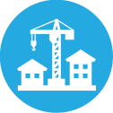 | $2.9  billion | Capital  Expenditure 2020-21
The Health Cluster works to protect, maintain and improve the health and wellbeing of residents in New South Wales.
The Health Cluster has been on the front line of the Government’s response to the COVID-19 pandemic, providing a world-class public health response to keep our communities safe.
Since March 2020, the NSW Government has committed more than $3.0 billion to help transform our healthcare system to increase its capacity and ensure it is well placed to manage the ongoing impacts of COVID-19, and respond to any future crises.
Ensuring capacity in our hospitals:
- Quadrupling Intensive Care Unit (ICU) capacity and purchasing additional ventilators
- Significant investment and rapid expansion of telehealth
- Partnering with private hospitals and increasing public hospital capacity to fast track elective surgeries.
Supporting and protecting our frontline workers:
- Substantial investment in personal protective equipment (PPE)
- Expanding our healthcare and hospital security workforce
- Providing ICU training to upskill healthcare staff to support increased ICU capacity.
Keeping our citizens safe:
- World-leading pathology testing and contact tracing, including establishing pop-up testing sites across the state
- Door screening at health sites across the State to rapidly identify symptomatic visitors, protecting our communities and staff
- Hotel quarantine including health managed hotels for symptomatic travellers and a dedicated presence at Sydney Airport
- Funding to fast-track state-wide research and clinical trials to tackle the global COVID-19 pandemic and reduce its impact on the community.
Boosting mental health support:
- Expansion of community-based mental health clinical support and emergency nurse consultants
- Increased availability of virtual mental health services
- Funding to Lifeline and the Mental Health Line to support those in need.

State Outcomes delivered by the Health Cluster
State Outcomes  What the Cluster is delivering for people and business |  | Example Programs^{(a)}  underway to support delivery of Outcomes
- People receive high-quality, safe care in our hospitals  When people are admitted to a hospital in New South Wales they can expect world-class medical and surgical care within clinically recommended timeframes, with NSW Health operating the largest public hospital system in Australia.  2020-21 investment: $14.2 billion recurrent expenses & $1.9 billion capital expenditure |  | - Acute Services  - Sub-Acute Services  - Mental Health Services  - Aged Care Services
- People can access care in out of hospital settings to manage their health and wellbeing  Healthcare extends beyond the hospital and connects across settings to reduce the burden of chronic disease, assist people with conditions to live well and avoid complications, support people to recover from illness and injury, and prevent avoidable hospitalisations. NSW Health services include non-admitted and community-based services, sub-acute services, hospital in the home, and dental services.  2020-21 investment: $6.4 billion recurrent expenses & $471.4 million capital expenditure |  | - Community Based Services  - Mental Health Community Based Services  - Aged Care Community Services  - Drug & Alcohol Services  - Non-Admitted Services
- People receive timely emergency care  NSW Health is responsible for managing and operating ambulance and emergency services, which are often the first point of contact for people needing emergency healthcare.  2020-21 investment: $3.5 billion recurrent expenses & $408.1 million capital expenditure |  | - Emergency Departments  - Ambulance Emergency Services
- Keeping people healthy through prevention and health promotion  Preventive and population health measures are critical to keeping people healthier. It covers a range of functions including to promote public health, control infectious diseases, reduce preventive diseases and death, help people manage their own health including mental health, and promote equitable health outcomes in the community.  2020-21 investment: $1.3 billion recurrent expenses & $20.0 million capital expenditure |  | - Dental Services  - Health Protection Services  - Health Prevention Services  - Specific Health Screening Services
- Our people and systems are continuously improving to deliver the best health outcomes and experiences  A skilled workforce with access to world-leading education and training, and a system that harnesses research and digital innovation essential to continuously improve outcomes and experiences of care across the system.  2020-21 investment: $1.1 billion recurrent expenses & $18.4 million capital expenditure |  | - Teaching, Training & Research  - Medical Research Support Program  - Research and Commercial Capacity Building Initiatives  - Health Care Complaints Commission  - Mental Health Commission of New South Wales

- Note that Programs are being further refined as the outcome and performance framework continues to mature.

Overview of Cluster expenses by State Outcome
A summary of expenses by State Outcome is provided in the charts below.
- Recurrent expenses by Outcome 2020-21 (dollars and %)

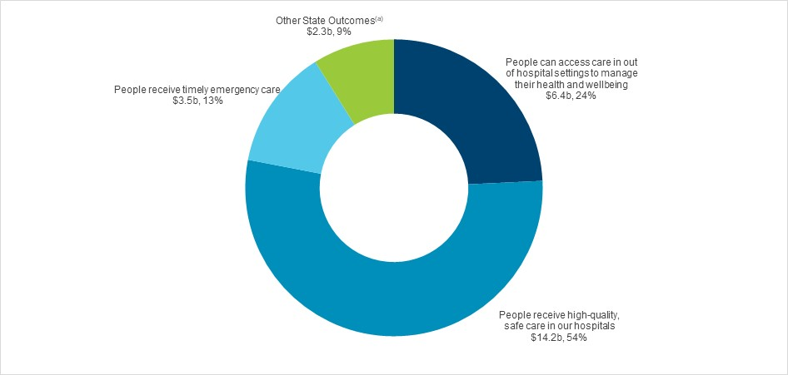
(a) Grouped for presentation purposes, “Other State Outcomes” comprises:
• Keeping people healthy through prevention and health promotion
• Our people and systems are continuously improving to deliver the best health outcomes and experiences.
- Capital expenditure by Outcome 2020-21 (dollars and %)

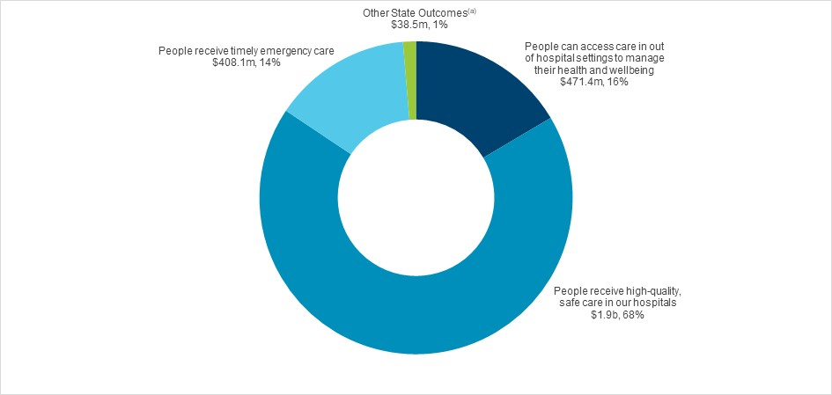
Note: The sum of percentage does not equal one hundred due to rounding.
(a) Grouped for presentation purposes, “Other State Outcomes” comprises:
• Keeping people healthy through prevention and health promotion
• Our people and systems are continuously improving to deliver the best health outcomes and experiences.

Outcome 1: People receive high-quality, safe care in our hospitals
 | $14.2  billion | Recurrent  Expenses  2020-21
 | $1.9 billion | Capital  Expenditure  2020-21

State Outcome overview and 2020-21 investment
When people are admitted to a hospital in New South Wales, they can expect world-class medical and surgical care within clinically recommended timeframes, with NSW Health operating the largest public hospital system in Australia.

2020-21 State Outcome Budget highlights
In 2020-21, the Health Cluster will invest $16.1 billion ($14.2 billion recurrent expenses and $1.9 billion capital expenditure) in this Outcome, including:
- $458.5 million in 2020-21 in response to the COVID-19 pandemic to fast track elective surgeries, focusing on surgery delayed by COVID-19
- $72.1 million in 2020-21 (part of a $673.3 million investment) for the Tweed Hospital and Integrated Ambulatory Services Redevelopment
- $55.9 million over four years to enhance palliative care, including 5,000 additional non-clinical End of Life Support Packages, specialist allied health professionals, education and training as well as improved bereavement and psychosocial support services
- $49.6 million in 2020-21 to give patients access to innovative new CAR-T cell therapies that provide world leading, lifesaving treatments
- $35.0 million in 2020-21 (part of a $142.4 million investment) to commence four new hospital car parks at Concord, Dubbo, Maitland and Tweed Hospitals
- $21.5 million in 2020-21 (part of a $385.0 million investment) to commence work on the St George Hospital Integrated Ambulatory Care Precinct
- $16.3 million in 2020-21 (part of a $750.0 million investment) to accelerate the redevelopment of the Royal Prince Alfred Hospital
- $15.0 million in 2020-21 (part of a $608.0 million investment) to commence work at the Sydney Children’s Hospital Network, Randwick Stage 1 Comprehensive Children’s Cancer Centre
- $15.0 million in 2020-21 (part of a $450.0 million investment) to commence Stage 2 of the Nepean Hospital Redevelopment
- $10.1 million in 2020-21 (part of a $698.6 million investment) for the new Shellharbour Hospital to be built on a greenfield site with an expanded scope
- $10.0 million in 2020-21 (part of a $200.0 million investment) to commence the Eurobodalla Health Service Redevelopment
- Implementation of a Real Time Prescription Monitoring system to track prescribed medicines associated with a high risk of causing harm, dependence or misuse
- Implementation of an integrated state-wide Laboratory Information Management System for NSW Pathology to provide seamless ordering, processing and reporting of over 70 million tests per year across NSW Health
- Acceleration of work at Cowra, Glen Innes, Manning (stage 2) and Shoalhaven
- Progress planning for health infrastructure commitments at Forster-Tuncurry, Grafton, Gunnedah, Ryde and Moree.

Key performance insights
This section provides analysis and insights on key Outcome Indicators for this State Outcome.

Overall patient experience index – adult admitted patients
Patients at NSW public hospitals continue to receive excellent care and treatment, according to NSW Health Adult Admitted Patient Survey 2019.
Performance against this indicator has remained stable for the last few years and is still performing with an organisational score of 8.6 which is over the NSW target of 8.5 out of 10.
- Overall patient experience index - adult admitted patients

Performance indicators for this Outcome
Outcome Indicators | Units | 2019-20 | 2020-21
 |  | Actual | Forecast
Elective surgery patients treated on time | %
Elective surgery patients treated on time Category 1 |  | 99.9 | 100
(urgent surgery)
Elective surgery patients treated on time Category 2 |  | 92.9 | 97.0
(semi-urgent)
Elective surgery patients treated on time Category 3 |  | 91.2 | 97.0
(non-urgent)
Fall-related injuries in hospital | no. | 5.1 | <5.1
Overall patient experience index - adult admitted patients | no. | 8.6 | ≥8.5
Unplanned hospital readmissions within 28 days of separation for all admissions | % | 6.0 | <6.0

Outcome 2: People can access care in out of hospital settings to manage their health and wellbeing
 | $6.4 billion | Recurrent  Expenses  2020-21
 | $471.4 million | Capital  Expenditure  2020-21

State Outcome overview and 2020-21 investment
Healthcare extends beyond the hospital and connects across settings to reduce the burden of chronic disease, assist people with conditions to live well and avoid complications, support people to recover from illness and injury, and prevent avoidable hospitalisations. NSW Health services include non-admitted and community-based services, sub-acute services, hospital in the home, and dental services.

2020-21 State Outcome Budget highlights
In 2020-21, the Health Cluster will invest $6.9 billion ($6.4 billion recurrent expenses and $471.4 million capital expenditure) in this Outcome, including:
- $66.5 million in 2020-21 ($63.0 million expenses and $3.5 million capital expenditure) to support mental health and wellbeing during the COVID-19 pandemic, including:
- providing additional mental health clinicians and peer workers to enhance community mental health services and support vulnerable populations
- expanding the Police Ambulance and Clinical Early Response model to 10 Police Area Commands and two Police Districts
- enhancing therapeutic activities in acute inpatient units
- increasing capacity and responsiveness of the Mental Health Line and expanding virtual mental health services to improve access to care
- $66.2 million over three years from 2021-22 to continue the additional specialist mental health clinicians to significantly enhance the capacity of community mental health services to appropriately manage mental health clients in the community. This will include specific expansion of youth mental health services, with a particular focus on urgent assessment and suicide prevention
- $50.4 million over three years from 2021-22 to provide technology-enabled workforce support options, including remote video conferencing and expanding telehealth services and related infrastructure, to enable more access to mental health support for people in immediate crisis
- $46.8 million over four years to support student wellbeing by recruiting an additional 100 wellbeing and in-reach nurses in vulnerable regions to provide wellbeing and health checks and referrals in schools
- $45.0 million in 2020-21 to expand programs in the community as part of the response to the COVID-19 pandemic, including those that provide non-clinical care and services and support to patients out of hospital
- $17.0 million over two years to pilot a package for in-home care for pregnant women suffering from hyperemesis gravidarum (severe morning sickness) to better understand and treat the condition
- $10.2 million over four years to fund Tresillian and Karitane to extend access to virtual residential parenting services and evaluate service delivery outcomes and experience
- $7.5 million over four years to establish a drug and alcohol rehabilitation centre in Dubbo, providing an eight-bed detoxification unit and a 15-bed residential service to address substance abuse issues
- $6.0 million over three years to establish 12 Mental Health and Community Wellbeing Collaboratives in communities across the State
- $5.0 million in 2020-21 towards the establishment of the Emmaus Memory Support Community Centre in Port Macquarie to provide residential care for elderly people living with dementia.

Key performance insights
This section provides analysis and insights on key Outcome Indicators for this State Outcome.

Reduce preventable visits to hospital by caring for people in the community
This is a Premier’s Priority focused on improving outpatient and community care.
Performance against this indicator has exceeded the target with integrated approaches to care resulting in demonstrated reductions in unnecessary hospital visits.
Focusing on preventative health care in the community helps people stay as healthy as possible for as long as possible, while ensuring the hospital system operates as efficiently as possible. NSW Health continues to focus on the development of strategies addressing preventable hospital visits.
- Proportion of total days spent in hospital by people with conditions where hospitalisation is potentially preventable

Performance indicators for this Outcome
Outcome Indicators | Units | 2019-20 | 2020-21
 |  | Actual | Forecast
Mental Health acute post discharge follow-up within 7 days | % | 75.7 | 75.0
Reduce preventable visits to hospital by caring for people in the community | % | 21.9 | 22.0

Outcome 3: People receive timely emergency care
 | $3.5 billion | Recurrent  Expenses  2020-21
 | $408.1 million | Capital  Expenditure  2020-21

State Outcome overview and 2020-21 investment
NSW Health is responsible for managing and operating ambulance and emergency services, which are often the first point of contact for people needing emergency healthcare.

2020-21 State Outcome Budget highlights
In 2020-21, the Health Cluster will invest $3.9 billion ($3.5 billion recurrent expenses and $408.1 million capital expenditure) in this Outcome, including:
- $100.0 million over four years to accelerate the implementation of Stage 2 of the Rural Ambulance Infrastructure Reconfiguration, improving access to emergency health services for communities across regional NSW and improve workplace conditions for a significant proportion of NSW Ambulance employees
- $30.0 million in 2020-21 for additional emergency department attendances and ambulance calls in response to the COVID-19 pandemic
- $20.9 million in 2020-21 towards Ambulance emergency telecommunications
- $14.5 million in 2020-21 to recruit more temporary security staff and more patient experience officers to improve patients’ hospital experience at hospitals where there are COVID-19 clinics
- $10.0 million over four years to plan and undertake a NSW stroke ambulance pilot project, to support the rapid diagnosis of strokes and facilitate early access to appropriate treatment pathways. The stroke ambulance will be a mobile referring site of the NSW Telestroke Service.

Key performance insights
This section provides analysis and insights on key Outcome Indicators for this State Outcome.

Triage category 1, 2 and 3 patients commence treatment on time in the emergency department
This is a Premier’s Priority and NSW Health has a strong focus on ensuring people receive timely emergency care.
Performance against this indicator is on track to meet targets, with New South Wales remaining the top performing state in Australia in terms of timeliness of emergency care. In 2019-20, performance in triage category 1 remained on target at 100 per cent while category 2 and 3 performance improved compared to the previous year (1.2 percentage points and 2.2 percentage points respectively).
Performance in 2019-20 has been affected by a temporary reduction in emergency department presentations during and immediately following the peak of the COVID-19 pandemic. It is anticipated that as volumes return to normal levels in 2020-21 and beyond performance on this indicator will reflect pre-COVID-19 trends.

- Percentage of triage category 1, 2 and 3 patients who commence treatment on time in the emergency department

Performance indicators for this Outcome
Outcome Indicators | Units | 2019-20 | 2020-21
 |  | Actual | Forecast
Overall patient experience index - emergency department patients^{(a)} | no. | 8.3 | 8.5
Transfer of care from ambulance to emergency department staff within 30 minutes | % | 88.9 | 90.0
Triage category 1, 2 and 3 patients commence treatment on time in the emergency department | %
Proportion of emergency department patients in NSW seen on time |  | 100 | 100
Category 1 (resuscitation)
Proportion of emergency department patients in NSW seen on time |  | 80.0 | 79.0
Category 2 (emergency)
Proportion of emergency department patients in NSW seen on time |  | 75.9 | 75.0
Category 3 (urgent)

Note
- Score out of 10.

Outcome 4: Keeping people healthy through prevention and health promotion
 | $1.3 billion | Recurrent  Expenses  2020-21
 | $20.0 million | Capital  Expenditure  2020-21

State Outcome overview and 2020-21 investment
Preventive and population health measures are critical to keeping people healthier. It covers a range of functions including to promote public health, control infectious diseases, reduce preventive diseases and death, help people manage their own health including mental health, and promote equitable health outcomes in the community.

State Outcome Budget highlights
In 2020-21, the Health Cluster will invest $1.3 billion ($1.3 billion recurrent expenses and $20.0 million capital expenditure) in this Outcome, including:
- $500.0 million to assist with the response to COVID-19 including:
- support for COVID-19 clinics
- quarantine arrangements, including NSW Health deployment at Sydney Airport
- increased pathology testing and contact tracing
- $385.0 million in 2020-21 to provide additional personal protective equipment (PPE) to keep our frontline healthcare workers safe. This is in addition to the substantial investment in PPE the Government has made to date in responding to COVID-19.

Key performance insights
This section provides analysis and insights on key Outcome Indicators for this State Outcome.

Towards zero suicides
This is a Premier’s Priority to reduce the rate of suicide deaths in New South Wales by 20 per cent by 2023.
Performance against this indicator has remained stable however the COVID-19 pandemic is likely to have impacts on population mental health due to social and economic impacts.
Reducing the rate of suicide requires a collaborative approach across the health system and government. New South Wales is providing a range of mental health initiatives to enhance support during the COVID-19 pandemic. It has implemented new methods to improve detection and reporting of self-harm in emergency departments, and has partnered with the Department of Communities and Justice and NSW Police to establish a suicide monitoring and data management system in New South Wales.

- Number of suicides per 100,000 people

Pregnant women quitting smoking by the second half of their pregnancy
This is a key indicator aligned with NSW Health’s priority to minimise harm associated with tobacco use in pregnancy. NSW Health is working to ensure all pregnant women who smoke are offered cessation support as part of routine pregnancy care provided in public hospitals.
Performance against this indicator has declined in recent years but is expected to improve. Since October 2018, more than 2,000 staff in the public health system have completed training about smoking cessation to support pregnant women quitting smoking, noting COVID-19 has impacted the ability of health services to implement programs this year.
- Proportion of women quitting smoking by the second half of their pregnancy

Performance indicators for this Outcome
Outcome Indicators | Units | 2019-20 | 2020-21
 |  | Actual | Forecast
Breast Screen participation rates (Women Aged 50-74) | %
Breast Screen participation rates (Women Aged 50-69) |  | 52.3 | ≥55
Breast Screen participation rates (Women Aged 70-74) |  | 55.6 | ≥55
Children fully immunised at one year of age | %
Aboriginal children |  | 95.0 | 94.5
Non-Aboriginal children |  | 94.1 | 94.5
Get Healthy Information and Coaching Service - Get Healthy in Pregnancy Referrals | no. | 11,778 | ≥12,000
Pregnant women quitting smoking by the second half of their pregnancy | % | 20.2 | 21.5
Towards zero suicides (per 100,000 people) | no. | 11.4 | n.a.

Outcome 5: Our people and systems are continuously improving to deliver the best health outcomes and experiences
 | $1.1 billion | Recurrent  Expenses  2020-21
 | $18.4 million | Capital  Expenditure  2020-21

State Outcome overview and 2020-21 investment
A skilled workforce with access to world leading education and training, and a system that harnesses research and digital innovation essential to continuously improving outcomes and experiences of care across the system. This expertise is delivered by a range of statutory bodies and system managers.

2020-21 State Outcome Budget highlights
In 2020-21, the Health Cluster will invest $1.1 billion ($1.1 billion recurrent expenses and $18.4 million capital expenditure) in this Outcome, including:
- $20.0 million in 2020-21 to fast-track state-wide research and clinical trials to tackle the global COVID-19 pandemic and reduce its impact on the community.

Key performance insights
This section provides analysis and insights on key Outcome Indicators for this State Outcome.

Increasing the volume of discharge summaries delivered electronically to General Practitioners (GPs)
This facilitates well-coordinated and effective clinical handover between hospitals and primary healthcare providers. Sharing information via electronic means supports patients as they return to the community and can reduce unnecessary hospital visits.
Performance against this indicator is currently exceeding the target. Over the last six months, there has been a continued increase in the percentage of discharge summaries being delivered electronically to GPs.
- Increase the percentage of discharge summaries delivered electronically to GPs

Note: The 2020-21 target reflects a projected return to normal activity levels as COVID-19 restrictions are eased. Performance in 2019-20 significantly exceeded this target due to lower activity volumes induced by COVID-19.

Performance indicators for this Outcome

Outcome Indicators | Units | 2019-20 | 2020-21
 |  | Actual | Forecast
Ethics Application Approvals - By the Human Research Ethics Committee within 45 calendar days | % | n.a. | 80.0
Increase the percentage of discharge summaries delivered electronically to GPs | % | 66.2 | 51.0

The total amount of capital investment in 2020-21 will be $3.0 billion. This includes $185.2 million of capital expensing from the Ministry of Health’s expense budget.

