9. TREASURY CLUSTER

Introduction
 | $13.9 billion | Recurrent  Expenses  2020-21
 | $44.9 million | Capital  Expenditure  2020-21
The Treasury Cluster, as the Government’s principal financial and economic adviser, helps the Government to make New South Wales a great place to live and work. The Cluster comprises several entities, including the Small Business Commission, Destination NSW, Western City and Aerotropolis Authority (to be renamed as the Western Parkland City Authority from December 2020) and the Crown Finance Entity. The Crown Finance Entity reports large expenditures in relation to whole-of-State assets and liabilities. The Treasury, by comparison, represents a smaller proportion of total Cluster expenditure.

State Outcomes to be delivered by the Treasury Cluster
State Outcomes  What the Cluster is delivering for people and business |  | Example Programs^{(a)}  underway to support delivery of Outcomes
- A strong, resilient and diverse economy  Driving whole-of-state economic policy and strategy, creating a competitive business and investment environment, supporting and attracting new and expanding businesses to create jobs for the people of NSW, and growing the visitor economy.  2020-21 investment: $1.5 billion recurrent expenses & $36.6 million capital expenditure |  | - Growing the NSW Visitor Economy  - Delivering the Global NSW Strategy  - Building a Strong and Productive Economy
- A sustainable fiscal environment enabling delivery of outcomes  Managing whole-of-State financial asset and liability activities, as measured by investment and debt performance, and maintenance of the State’s triple-A credit rating. Working towards the State’s objective of full funding of the Defined Benefits Superannuation liability by 2040. Providing informed, evidence-based fiscal, commercial and financial analysis and advice.  2020-21 investment: $12.4 billion recurrent expenses & $6.4 million capital expenditure |  | - Fiscal Planning and Management  - Sector Support and Resource Allocation  - Commercial and Commissioning  - Sector, Procurement Services, Analytics and Systems
- Stewardship of the public sector performance and financial system  Steward and support sector performance to deliver outcomes for citizens, ensure transparency and accountability and the effective use of public funds.  2020-21 investment: $56.1 million recurrent expenses & $1.9 million capital expenditure |  | - Performance and Financial Systems Stewardship  - Digitally Focussed Treasury  - Highly Capable, Collaborative and Diverse Team

- Note that Programs are being further refined as the outcome and performance framework continues to mature.

Overview of Cluster expenses by State Outcome
A summary of expenses by State Outcome is provided in the charts below.
- Recurrent expenses by Outcome 2020-21 (dollars and %)
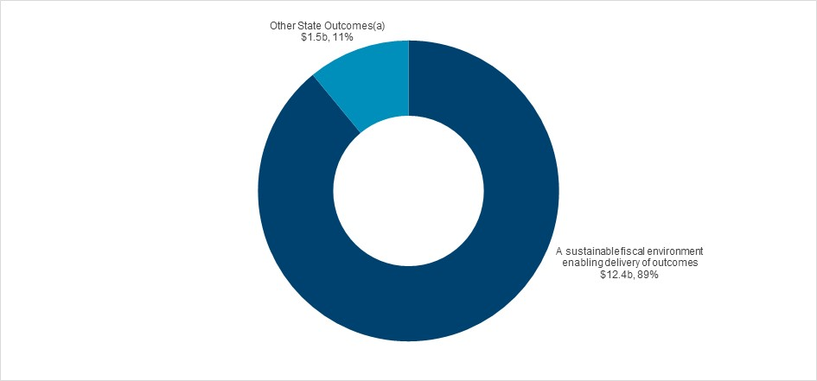

(a) Grouped for presentation purposes, “Other State Outcomes” comprises:
• A strong, resilient and diverse economy
• Stewardship of the public sector performance and financial system.
- Capital expenditure by Outcome 2020-21 (dollars and %)
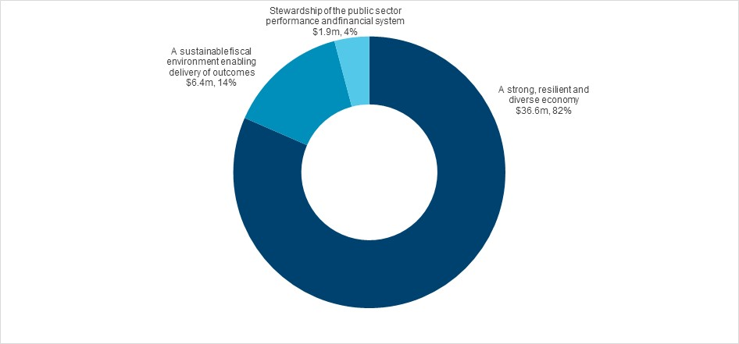

Outcome 1: A strong, resilient and diverse economy
 | $1.5 billion | Recurrent  Expenses  2020-21
 | $36.6 million | Capital  Expenditure  2020-21

State Outcome overview and 2020-21 investment
New South Wales is Australia’s largest state economy, accounting for around a third of the nation’s economic output and home to nearly a third of Australians.
Treasury is the Government’s chief advisor on productivity, economic analysis and development and contributes to a strong, resilient and diverse economy through economic and productivity reform, industry support and investment.

2020-21 State Outcome Budget highlights
In 2020-21, the Treasury Cluster will invest $1.5 billion ($1.5 billion recurrent expenses and $36.6 million capital expenditure) in this Outcome, including:
- $1.0 billion ($2.1 billion revenue forgone over two years) for payroll tax cuts to support businesses and jobs across New South Wales
- $500.0 million for a digital voucher scheme to stimulate local spending in the NSW economy for eligible registered businesses, including restaurants, visitor attractions and performing arts institutions
- $366.0 million in COVID-19 Stimulus funding to support New South Wales’ economic recovery including the Small Business Recovery Grant Scheme, support for international students and quarantine arrangements for international travellers
- $250.0 million for the Jobs Plus Program to drive job creation by supporting businesses and industries seeking to scale and grow in New South Wales
- $200.1 million ($728.0 million over four years) to promote New South Wales tourism through Destination NSW
- $142.0 million ($472.0 million over two years) to provide small and medium sized businesses which do not pay payroll tax with a $1,500 digital voucher to be used towards the cost of any government fees and charges
- $29.8 million for strategic, planning and enabling activities to support the ongoing delivery of the Western Sydney Aerotropolis, which will become a hub for growth industries and provide additional jobs across the Western Parkland City
- $22.4 million ($179.8 million over four years) to support the Global NSW Strategy in growing trade and attracting investment to help job creation and cement the State’s position as a regional economic powerhouse. A key component will be developing NSW industry and innovation capabilities to support future jobs and industries
- $10.6 million ($48.2 million over four years) to establish and support Tech Central at Central-Eveleigh to drive innovation, the creation of new technology and commercialisation of new products and services
- $9.8 million ($39.3 million over four years) for the Business Connect Program which provides professional business advice for small businesses across New South Wales to support them to start, run, adapt and grow
- $6.0 million for the NSW Small Business Commission to deliver increased mediation and advisory services to commercial parties following the measures announced by the Government to provide relief to tenants in financial duress due to COVID-19
- $2.5 million ($10.0 million over four years) for ensuring that registered workers should not bear additional costs to perform the same activity in additional states when they are already registered in their home state
- $0.5 million in 2020-21 ($5.0 million over four years) to further support small businesses increase participation in government procurement of goods and services through requirements for agencies to consider local businesses first for government contracts.

Key performance insights
This section provides analysis and insights on key Outcome Indicators for this State Outcome.

Growth in real GSP per capita (four year moving average)
Performance against this indicator has been challenging given economic impacts of COVID-19. The New South Wales economy contracted sharply over the first half of 2020, with most of the contraction occurring in the June quarter as COVID-19 restrictions were put in place.
Most sectors of the economy have been affected. The closure of international borders has put a halt to international tourism and student arrivals, while household spending was impacted by the trifecta of social distancing restrictions, changes to business operations and major job losses. Business confidence also plunged with the onset of COVID-19, and the introduction of containment measures, as over half of Australian businesses reported reduced revenues since the outset of the pandemic.
As a result, Gross State Product (GSP) is estimated to decline by one per cent in 2019-20. Border restrictions have also slowed the rate of population growth dramatically, although not to the same extent. Consequently, GSP per capita has weakened and data is now expected to show a sharp contraction in 2019-20, resulting in only modest growth in four-year annual average terms.
In addition to a successful reopening of the economy since the June quarter, this budget builds on the Government’s response to the health crisis, and sets out the platform for recovery. The budget aims to kick-start the NSW economy with new stimulus measures, while laying the foundations for enduring prosperity with a concrete plan for major reform (See Budget Paper 1 Budget Statement for details on the Government’s strategy to support the economy).
- Annual real GSP per capita growth (4 year moving average)

Note: 2019-20 actual data is not yet available, and an estimate for 2019-20 has been provided.

Jobs created in New South Wales since April 2019
Performance against this indicator has been challenging due to the impact of COVID-19 spilling over into the labour market. Around 270,000 workers in New South Wales lost jobs between March and May as restrictions to halt the spread of COVID-19 forced many businesses to close or curtail operations. As restrictions have eased, New South Wales has regained around 65 per cent (174,000) of the jobs that were previously lost (between May and September 2020).
Despite the initial rebound from reopening the economy, conditions in the labour market are not expected to fully recover for several years. The recovery will be reinforced by the Government’s strategy of providing temporary and targeted stimulus to support the creation of jobs, the economy, and productivity growth.
- Jobs created in New South Wales since April 2019

Performance indicators for this Outcome
Outcome Indicators | Units | 2019-20 | 2020-21
 |  | Actual | Forecast
Growth in real GSP per capita (4 year moving average) ^{(a)} | % | n.a | -0.4
Jobs created in New South Wales since April 2019 (seasonally adjusted)^{(b)} | no. | -197,000 | -36,000

Notes
- 1.3 per cent is the 4-year moving average growth in 2018-19. 2019-20 growth number will be available in late November 2020. Currently the 4-year moving average growth in 2019-20 is estimated to be 0.2 per cent.
- 2019-20 actual and 2020-21 forecast data are jobs lost since March 2019 quarter and June 2020 and June 2021 respectively.

Outcome 2: A sustainable fiscal environment enabling delivery of outcomes
 | $12.4 billion | Recurrent  Expenses  2020-21
 | $6.4 million | Capital  Expenditure  2020-21

State Outcome overview and 2020-21 investment
In its fiscal management role for the State, NSW Treasury ensures that the people of New South Wales have access to services and infrastructure that deliver social and economic benefits, underpinned by a strong and sustainable economic and financial position.

2020-21 State Outcome Budget highlights
In 2020-21, the Treasury Cluster will invest $12.4 billion ($12.4 billion recurrent expenses and $6.4 million capital expenditure) in this Outcome, including:
- $2.5 billion in 2020-21 ($10.3 billion expenses and $0.7 million capital over four years) to administer the provision of workers' compensation, health and general liability, property and motor vehicle cover to government and its employees, mostly through the Treasury Managed Fund
- management of the Treasury Banking System post the completion of the banking tender to drive efficiencies through new banking arrangements and maximise returns on the State’s centrally managed cash holdings
- managing the State’s core debt portfolio to minimise the market value and cost of debt within specified risk parameters and managing any significant finance risks for the State
- administering Restart NSW, the Social and Affordable Housing Fund and NSW Generations Fund, to maximise returns for investment in productive infrastructure and boost delivery of social and affordable housing across New South Wales
- overseeing the State’s investments, including the retained interests in Ausgrid and Endeavour Energy, as well as administering the residual assets and liabilities of major State asset recycling and long-term lease transactions
- managing the NSW public sector Defined Benefit Superannuation Scheme.

Key performance insights
This section provides analysis and insights on key Outcome Indicators for this State Outcome.

Maintaining the triple-A credit rating and managing fiscal responsibilities
Performance against indicators has been challenging due to the Government’s fiscal strategy to balance short term stimulus with medium-term sustainability. The easing of restrictions, opening up of the economy and targeted stimulus spending will help support economic growth.
Over the medium-term, the Government’s fiscal strategy switches to fiscal repair, with the aim of returning the State’s operating position and debt levels to a more sustainable position. Through fiscal repair measures announced in this Budget the Government is aiming to ensure it manages a fiscal position commensurate with a triple-A credit rating over the medium-term.
- Annual expense growth below long-term revenue growth

Note: For more information, refer to 2020-21 Budget Paper 1 Budget Statement.

Performance indicators for this Outcome
Outcome Indicators | Units | 2019-20 | 2020-21
 |  | Actual | Forecast
Annual expense growth below long-term revenue growth ^{(a)} | % | 9.7 | 11.2
Full funding of the State’s superannuation liability by June 2040 ^{(b)} | $billion | 14.7 | 14.9
Maintaining the Triple-A Credit Rating | no. | Yes | n.a^{. (d)}
Reducing the long-term fiscal gap ^{(c)} | % | 3.5 | n.a.

Notes
- 2019-20 Actual is the calculated result based on General Government results as they currently stand and is subject to final internal and audit approval. Final audit approval will be published with the Total State Sector Accounts 2019-20.
- Full funding of the State’s defined benefit superannuation liability by 2040 is on track in 2020-21. The Government will aim to update the Fiscal Responsibility Act 2012, after a clearer picture of the economic and fiscal outlook emerges. For more information, refer to 2020-21 Budget Paper 1.
- The 2016 Intergenerational Report (IGR) projected the fiscal gap to reach 3.4% by 2055-56. Since then, as a result of budget measures, the fiscal gap is projected to increase by 0.1% by 2055-56 (as at 2019-20 Budget). This projection will be updated and will be same as the forecast figure contained in the 2020-21 Budget Paper 1. The 2021 IGR will be released in 2021 and will extend fiscal gap projections to 2060-61.
- The credit rating agencies review will commence immediately after the 2020-21 Budget which will advise of NSW credit rating.

Outcome 3: Stewardship of the public sector performance and financial system
 | $56.1 million | Recurrent  Expenses  2020-21
 | $1.9 million | Capital  Expenditure  2020-21

State Outcome overview and 2020-21 investment
Under the Government Sector Finance Act 2018, Treasury’s role is to be the performance and financial steward for the NSW Government Sector. This moves Treasury’s role beyond the traditional financial and regulatory function, towards seeking to support Sector performance to deliver outcomes for citizens, ensure transparency, accountability and the effective use of public funds. Under this objective, Treasury aims to build Sector capability and assist agencies to achieve their own performance goals while also meeting all compliance and reporting obligations.

2020-21 State Outcome Budget highlights
In 2020-21, the Treasury Cluster will invest $58.0 million ($56.1 million recurrent expenses and $1.9 million capital expenditure) in this Outcome, including:
- $33.9 million to deliver a comprehensive suite of activities including; embedding of evidence based decision making, embedding of Outcome Budgeting, digitising procurement guidelines and tools, ongoing training and guidance on budgeting and financial reporting systems, commissioning and social impact investment policy guidance, banking best practice support and tools, investment and debt advice and stewardship
- $7.5 million to promote a Digitally Focused Treasury, starting with the replacement of several legacy component products with flexible modern tools to enhance digital design and responsiveness.

Key performance insights
This section provides analysis and insights on key Outcome Indicators for this State Outcome.

No material adverse findings in Audit Office Reports to Parliament
The Audit Office of NSW performs independent review of the sector, including financial audits, performance audits and internal controls reviews. The results are reported to Parliament to ensure accountability to the people of New South Wales.
Performance against this indicator is stable. There have been no qualified financial audit opinions in any of the recent year-ends. Some performance audits have recorded deficiencies that require mitigation by targeted agencies. Treasury is continuing to support the Sector through a range of activities including developing and maintaining appropriate performance and financial management policy instruments and building sector capability to adhere to them.

- No material adverse findings in Audit Office Reports to Parliament

Performance indicators for this Outcome
Outcome Indicators | Units | 2019-20 | 2020-21
 |  | Actual | Forecast
No material adverse findings in Audit Office Reports to Parliament | no. | n.a.^{(a)} | 0
A voice of the customer survey of the support provided by Treasury and the effectiveness of Treasury performance and financial management stewardship | no. | n.a.^{(b)} | n.a.^{(c)}
Provision of effective tools and frameworks (including technology) to enable the sector to strengthen their performance and financial management, and promote efficient, effective and economical use of government resource | no. | n.a.^{(b)} | n.a.^{(c)}

Notes
(a) 2019-20 actual data is not yet available and will be known with the publication of the Total State Sector Accounts 2019-20.
(b) Work is currently in progress to conduct an annual survey for 2019-20 results.
(c) 2020-21 forecast is a positive score but baseline is yet to be established with improvement year on year.

