ABOUT THIS BUDGET PAPER

Purpose and scope
Budget Paper No. 2 Outcomes Statement supports transparency and accountability by reporting how resources have been allocated across Clusters and State Outcomes and how New South Wales is performing against these State Outcomes. Further details on the scope and purpose of this Budget paper is outlined in How to Read the Budget Papers.
Agency financial statements and agency expense summaries, which were previously included in Budget Paper 3, are now presented in Budget Paper 4: Agency Financial Statements.

Outcome Budgeting
The fiscal pressures resulting from COVID-19 increase the importance of a strong framework for scrutinising and prioritising the use of every dollar spent by the State.
Outcome Budgeting is a multi-year reform program that continues to put the needs of people at the centre of investment decision-making across the sector. It improves oversight of total expenditure, as well as providing greater evidence to support and prioritise resource allocation. Sustained over time, Outcome Budgeting improves the way that Government plans and manages resources to deliver outcomes for the people of New South Wales.

The Outcome Budgeting reform journey
The NSW Government announced Outcome Budgeting in 2017-18 and has progressively strengthened the framework and application across the sector. It was one of four pillars of the 2019-20 Budget and has seen significant development over the year.

Figure 1: The reform journey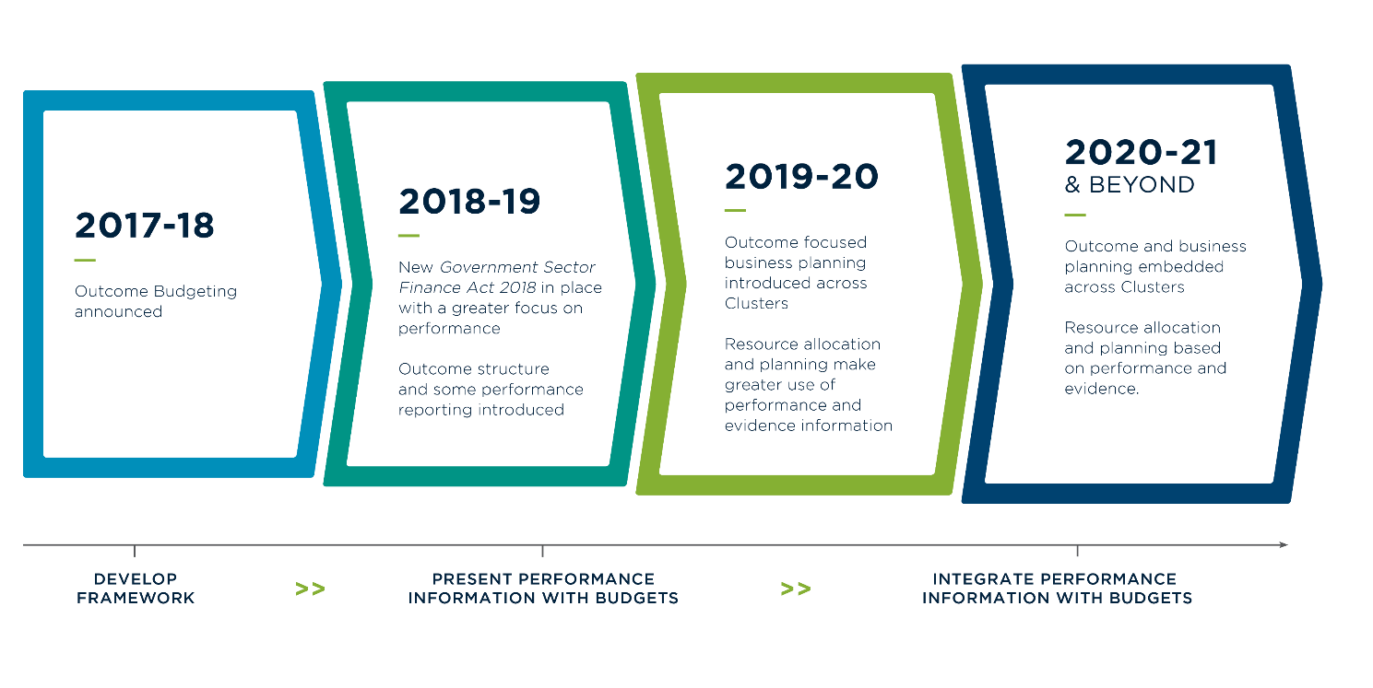

The Outcome and Performance Framework
Outcome Budgeting provides a common outcome and performance framework that clearly links government expenditure, to activities and the outcomes being achieved.
Figure 2: The outcome and performance framework

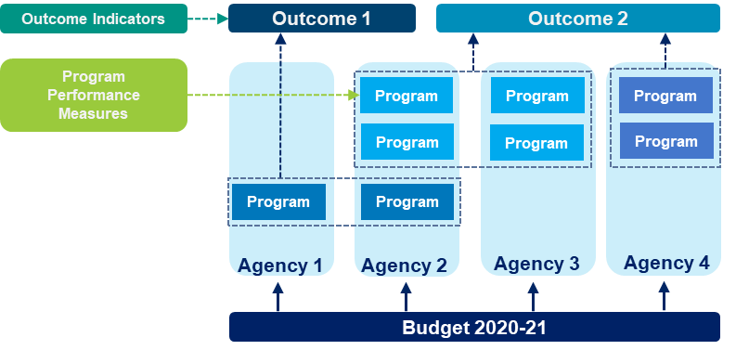

The key components of the framework are as follows:
- State Outcomes which articulate the primary purpose for which public resources are being spent, and the goals that Government is seeking to achieve for its citizens and businesses across all of its activities
- each State Outcome has associated Outcome Indicators that measure progress in achieving these outcomes
- delivery of each State Outcome is supported by Programs that are a collection of Government activities, tasks, divisions or functions to deliver specific objectives towards the State Outcome
- Program Performance Measures which measure performance of each Program and are used to assess efficiency, effectiveness and equity in delivering objectives.
The framework enables ongoing performance monitoring and assessment to ensure resources are well managed and targeted to deliver State Outcomes efficiently and effectively. It promotes consideration of total spend and an emphasis on performance.

Advancement of Outcome Budgeting implementation and reporting for 2020-21
Following the 2019-20 Budget, in the context of machinery of government changes and recent events, the NSW Government further reviewed and refined priorities and agreed to a set of 37 State Outcomes across the nine Clusters.
The 2020-21 Budget represents a significant milestone in the implementation of Outcome Budgeting in New South Wales. All Clusters have developed Outcome and Business Plans to support the delivery of State Outcomes. These Plans outline how Outcomes will be delivered and how performance will be measured and managed within each Cluster. It creates a shared vision within the Cluster, from its Secretary to front-line staff about purpose and performance; it informs Government’s strategic allocation of public resources and budget-decision making processes.
Outcome and Business Plans will be regularly updated and reviewed to inform ongoing planning and management across the suite of State Outcomes. This includes a continued focus on improving performance measurement, ensuring all Outcome Indicators have performance targets and reviewing and refining Programs and Program Performance Measures.
Additional performance information on Clusters and agencies continues to be reported across a range of other sources such as agency website, annual reports and the Productivity Commission’s Report on Government Services.

Delivery of State Outcomes
The 37 agreed State Outcomes are aligned with, and complement, the Premier’s 14 Priorities (each Priority metric is included as an Outcome Indicator under the relevant State Outcome).
Clusters are reporting a high level of delivery against these State Outcomes relative to the significant challenges to service demand and service delivery as a result of recent natural disasters and current pandemic.
These challenges, including drought, bushfires and COVID-19, have had far-reaching impacts across the suite of State Outcomes and have required significant ongoing management and resources to address.
While there have been adverse impacts to several performance indicators for State Outcomes as a result, there have also been significant opportunities to implement innovation and reform. These have been demonstrated through a step change in service delivery across the public sector including implementation of digital innovation in areas such as customer service, health and transport.

Cluster arrangements
Clusters are groups of entities with shared or related policy goals. The Cluster arrangement aims to improve government services and outcomes for the community by:
- pursuing common objectives across agencies
- better integrating services
- helping to allocate resources between areas.
A Cluster is not a legal or reporting entity.

Changes to Cluster arrangements
In April 2020, the Government announced the establishment of the Regional NSW Cluster to provide a continued focus on delivering great opportunities and quality of life for all citizens, no matter where they live or their circumstance. There are currently nine Clusters delivering the work of the Government as outlined below in Figure 3.
Details on machinery of government changes at the agency level, including information on Administrative Arrangement Orders, can be found in Budget Paper 4: Agency Financial Statements.

Figure 3: The Government Clusters and the 37 State Outcomes

Customer Service |  | Education |  | Health
Plans, prioritises, funds and drives digital transformation and customer service across every Cluster in the NSW Government. |  | Drives early childhood education and care sector, government and non-government schools, and the vocational education and training sector. |  | Works to protect, maintain and improve the health and wellbeing of residents in NSW.
State Outcomes |  | State Outcomes |  | State Outcomes
Excellence in Customer Service |  | Best start in life for young children |  | People receive high-quality, safe care in our hospitals
Digital leadership and innovation in government services |  | Educational foundations for success |  | People can access care in out of hospital settings to manage their health and wellbeing
Fair, secure and efficient markets |  | Skilled and employable workforce |  | People receive timely emergency care
 |  | High-quality standards for schooling |  | Keeping people healthy through prevention and health promotion
 |  |  |  | Our people and systems are continuously improving to deliver the best health outcomes and experiences
Planning, Industry and Environment |  | Premier and Cabinet |  | Regional NSW
Responsible for the stewardship of the NSW Government’s natural and built assets. |  | Works for the people of NSW by supporting the Premier and the Cabinet to deliver NSW Government’s objectives. |  | Builds strong, cohesive communities and economies, grow primary industries, create jobs and employment, and steward the use of our natural endowments.
State Outcomes |  | State Outcomes |  | State Outcomes
Connecting communities to resilient and sustainable energy and local environments |  | Effective and coordinated government |  | Productive and sustainable land use
Create a strong and liveable NSW |  | Excellence in arts, culture and heritage |  | Stronger primary industries
Maximise community benefit from Government land and property |  | Empowering Aboriginal communities |  | Mineral and petroleum industries generating prosperity, safely
Sustainable, secure and healthy water resources and services |  | Accountable and responsible government |  | Stronger and cohesive regional communities and economies

Stronger Communities |  | Transport |  | Treasury
Delivers community services that support a safe and just New South Wales. |  | Plans and delivers infrastructure and integrated services across all modes of transport, including road, rail, metro, bus, ferry, light rail, cycling and walking. |  | Supports a strong fiscal operating position and balance sheet and leads the promotion of a strong economy, creating quality jobs and securing investments for the State.
State Outcomes |  | State Outcomes |  | State Outcomes
Active and inclusive communities |  | Connecting our customers’ whole lives |  | A strong, resilient and diverse economy
Children and families thrive |  | Successful places for communities |  | A sustainable fiscal environment enabling delivery of outcomes
Efficient and effective legal system |  | Sustainable transport systems and solutions supporting economic activity |  | Stewardship of the public sector performance and financial system
People have a safe and affordable place to live
Prepared for disasters and emergencies
Reduce reoffending
Safer communities

Structure of this budget paper
This Budget paper includes an Outcome Statement related to the State Outcomes for each of the nine Clusters, as well as a separate chapter for the Legislature covering its strategic priorities and objectives.

Cluster Introduction
Section | Description
Introduction | This describes the role, main activities and responsibilities of the Cluster.
2020-21 Investment | This graphic depicts the amount of recurrent expenses and capital expenditure for the Cluster.
State Outcomes to be delivered by the cluster | A short description of the State Outcomes the Cluster is working towards and examples of programs underway to support delivery of these Outcomes.

Overview of Cluster expenses by State Outcome
This section graphical presents the amount and percentage of recurrent expenses and capital expenditure across each of the State Outcomes delivered by the Cluster.

Cluster State Outcome Statements
Section | Description
State Outcome Overview | A description of the State Outcome.
2020-21 Investment | This graphic depicts the amount of recurrent expenses and capital expenditure for the Outcome.
2020-21 Budget highlights | Description of the significant new and ongoing initiatives the Cluster listed under the Outcome
Key performance insights | A short description and chart providing analysis and insights on performance of selected Outcome Indicators.
Performance indicators for this Outcome | Information on the performance of Outcome Indicators for the Outcome.

