1. CUSTOMER SERVICE

Introduction
 | $3.6  billion | Recurrent  Expenses  2021-22
 | $697.3  million | Capital  Expenditure 2021-22
The Customer Service Cluster spearheads the Government’s objective to be the world’s most customer-centric government. Its fundamental purpose is to provide trustworthy, effective, and easy-to-use services for customers and communities, no matter who they are, where they are, or what they need. The Cluster embeds customer insights into policy design and service delivery, using digital, data and behavioural insights to enhance customer experiences across all government services.

State Outcomes to be delivered by the Customer Service Cluster
State Outcomes  What the Cluster is delivering for people and business |  | Key Programs  underway to support delivery of Outcomes
1. Excellence in customer service  This Outcome focuses the Cluster’s efforts towards a customer-centred approach across the NSW Government, resulting in better customer experiences and easier transactions. This Outcome measures the availability of digital transactions, customer satisfaction with government services, and the number of services where customers only need to “Tell us Once”.  2021-22 investment: $1.6 billion in recurrent expenses & $109.2 million in capital expenditure |  | - Service excellence for people  - Service excellence for businesses  - New and improved services for customers  - Efficient and effective revenue collection  - Service transformation and customer engagement across government
2. Digital leadership and innovation in government services  The Cluster aims to invest in innovation and technology to increase and improve digital availability, reliability and security of NSW Government platforms, information and services. This Outcome measures digital government readiness and the public safety coverage and operation of the Critical Communications Enhancement Program.  2021-22 investment: $514.9 million in recurrent expenses & $510.2 million in capital expenditure |  | - Telecommunication connectivity  - Digital service for customers across government  - Trust in ICT and digital government services  - Value from digital investments
3. Fair, secure and efficient markets  The Cluster has a fundamental objective of delivering a regulatory framework that promotes safety, efficiency and regulatory requirements that meets the evolving expectations of businesses and customers. This Outcome measures the regulatory compliance rates of selected industries, the rate of work-related traumatic injury fatalities and the affordability of the Compulsory Third Party Insurance scheme.  2021-22 investment: $1.5 billion in recurrent expenses & $77.9 million in capital expenditure |  | - Safety and harm protection  - Affordable and effective insurance schemes  - Fair and compliant business

1.2 Overview of Cluster expenses by State Outcome
A summary of expenses by State Outcome is provided in the charts below.
- Recurrent expenses by Outcome 2021-22 (dollars and %)

Note: The sum of percentages does not equal one hundred due to rounding.
- Capital expenditure by Outcome 2021-22 (dollars and %)

Outcome 1: Excellence in Customer Service
 | $1.6 billion | Recurrent  Expenses  2021-22
 | $109.2 million | Capital  Expenditure  2021-22

State Outcome overview and 2021-22 investment
Investment in this State Outcome supports a customer-centric approach to government service delivery.
The Department of Customer Service embeds customer insights into policy design and service provision and drives digital, data and behavioural insights to ensure customers can access and receive government services in a timely and convenient manner.
This Outcome is measured by the availability of digital transactions, customer satisfaction with government services, and the number of services where customers only need to “Tell Us Once”.

2021-22 State Outcome Budget highlights
In 2021-22, the Customer Service Cluster will invest $1.7 billion ($1.6 billion in recurrent expenses and $109.2 million in capital expenditure) in this Outcome, including:
- $668.9 million recurrent expenses in Service NSW for administering stimulus funds to individuals and businesses in response to the economic impacts of the COVID-19 pandemic and recent natural disasters via several high-profile grant and rebate programs in 2021-22 such as the Return to Work program, Small Business Fees and Charges rebate, Small Business Flood Disaster Recovery Grant and Accommodation Vouchers
- $50.0 million to provide digital vouchers for dining and entertainment in the Sydney CBD, to support the local economy
- $20.0 million recurrent expenses for the Business Concierge Service as part of Service NSW for Business program (formerly the Easy To Do Business program), to support businesses with specialist advice and provide a one-stop-shop for meeting regulatory requirements
- $14.2 million recurrent expenses invested in the Cost of Living program and campaign to help more people access hundreds of millions of dollars in customer savings and rebates
- $9.1 million ($38.3 million recurrent expenses over four years) for Data Analytics Centre to improve delivery of services to citizens through better use of data and insights, building on the work undertaken during the outbreak of COVID-19 to keep the community safe and provide insights to decision makers when they needed them
- $7.6 million recurrent expense and $2.8 million capital expenditure for the Assured Revenue program ($13.6 million and $2.8 million capital over the forward estimates) which will deliver transformational improvements in customer experience
- $7.0 million recurrent expenses and $2.8 million capital expenditure ($10.9 million recurrent expenses and $2.8 million capital over four years) for the first phase of the nsw.gov.au program to migrate siloed content from hundreds of government websites onto nsw.gov.au to create a customer-centric, consistent and world-class experience
- $6.1 million capital expenditure toopen up to four new Service NSW service centres in 2021-22 as part of the election commitment to open 10 new service centres, which will provide greater access for customers to government services, enhance service delivery and service offering to meet future needs
- $1.0 million recurrent expenses for resources to undertake discovery with NSW Police and local government councils, to identify a solution to increase the availability and distribution of evidence with the receipt for all fines in New South Wales
- Improving customer interactions through the Government Made Easy Premier’s Priority, allowing customers to opt into sharing their information across government so they only need to “Tell Us Once” about them, when things change, and when they need help.

Key performance insights
This section provides analysis and insights on key Outcome Indicators for this State Outcome.

Increase the number of government services where customers only have to “Tell Us Once”
The Government Made Easy Premier’s Priority aims to increase the number of government services where customers only have to “Tell Us Once” to get what they need. For example, the Active Kids rebate voucher and the Dine and Discover voucher application can be prepopulated using information from a MyServiceNSW Account, reducing demand on customer time and making transacting with government easier. In addition, the NSW Government is making it easier for customers at critical life events. The Australian Death Notification Service lets customers notify many service providers in one easy step when someone close dies.
Performance against this indicator is on track to significantly exceed the target of 60 services by 2023, with 39 services delivered as at 31 March 2021. As well as saving time and effort by avoiding the repetition of personal details when undertaking transactions, this Premier’s Priority is focused on ensuring that customers get easier access to more complex services at difficult life stages. This leads to better outcomes, and higher satisfaction and trust in government.
- Number of government services where customers only have to "Tell Us Once"
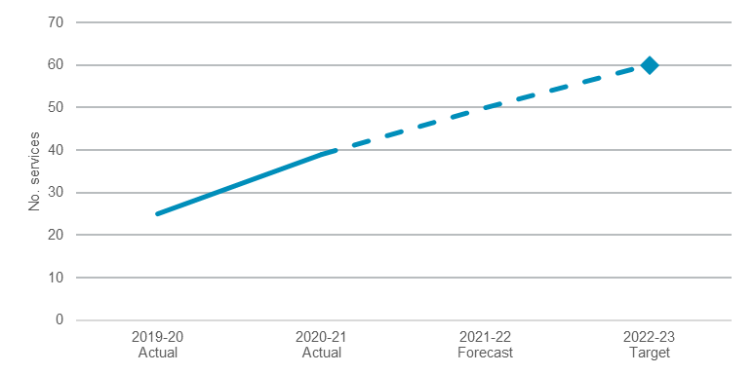

Percentage of transactions available digitally through Service NSW
Service NSW is committed to excellence in customer service and provides access to NSW Government services in person, online and over the phone. One way we are improving customer access to government services is by delivering more services online.
Performance against this indicator continues to improve as a result of ongoing investments in digital platforms and products and is expected to achieve the target of delivering 80 per cent of services digitally before 2023-24.
- Percentage of transactions available digitally through Service NSW
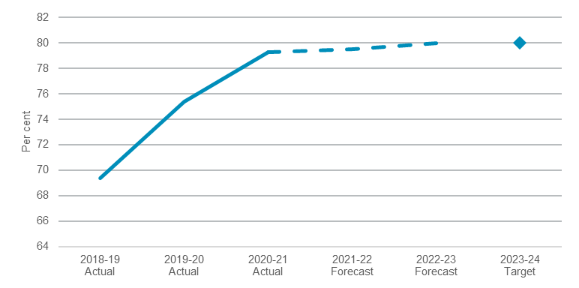
Note: 2021-22 actual as at 31 March 2021.

Performance indicators for this Outcome
Outcome Indicators | Units | 2020-21 | 2021-22
 |  | Actual | Forecast
Increase the number of government services where customers only have to  "Tell Us Once" | no. | 39.0 | 50.0
Percentage of transactions available digitally through Service NSW | % | 79.3^{(a)} | 79.5

Notes
- 2021-22 actual as at 31 March 2021.

Outcome 2: Digital leadership and innovation in government services
 | $514.9 million | Recurrent  Expenses  2021-22
 | $510.2 million | Capital  Expenditure  2021-22

State Outcome overview and 2021-22 investment
Investment in this State Outcome focuses on innovation and technology to increase improvements in digital availability, reliability and the security of NSW Government platforms, information and services. These investments in the Cluster also facilitates its role to prevent and mitigate cyber security threats and to ensure ICT expenditure realises value for money.
This Outcome measures digital government readiness, and the public safety coverage and operation of the Critical Communications Enhancement Program (CCEP).

2021-22 State Outcome Budget highlights
In 2021-22, the Customer Service Cluster will invest $1.0 billion ($514.9 million in recurrent expenses and $510.2 million in capital expenditure) in this Outcome, including:
- $500.0 million over three years to increase the Digital Restart Fund (DRF) increasing the total funding to $2.1 billion. The purpose of the DRF is to support digital ICT initiatives to foster customer-driven transformation, collaboration and enhance cyber security across the NSW Government sector
- $221.9 million ($660.2 million capital expenditure and $286.6 million recurrent expenses over five years) for the final phase of the Critical Communications Enhancement Program (CCEP). This will create a single, interoperable Public Safety Network for all Emergency Service Organisations. The final 318 (of 675) radio sites will be constructed and brought online delivering full state coverage. Network land coverage will increase from 47 per cent to 85 per cent of New South Wales and an increase in coverage of the State’s population from 96.0 per cent to 99.7 per cent
- $2.5 million ($4.9 million over two years) for a Digital Procurement Transformation Program to simplify transacting with the NSW Government. It connects buyers and suppliers and supports social procurement policies and diversity of spend with subject matter experts, Aboriginal-owned, regional and start-up enterprises.

Key performance insights
This section provides analysis and insights on key Outcome Indicators for this State Outcome.

Public safety coverage and operations of the Critical Communications Enhancement Program (CCEP)
The Public Safety Network (PSN) is one of the world's largest trunked radio networks now serving 60 agencies and almost 60,000 registered radios. Next to Australia’s triple zero emergency hotline, the PSN is the most important critical communications network in New South Wales.
The performance target for operational availability for the network is 99.95 per cent. Performance against this indictor continues to track to target, with an average of 1.47 million radio calls made on the network per month.
The PSN is being expanded through the CCEP. Geographic coverage of the PSN is at 41 per cent providing population coverage of 94 per cent. The continued investment in the CCEP will see the geographic and population coverage continue to expand.
- Public safety coverage and operations of the CCEP
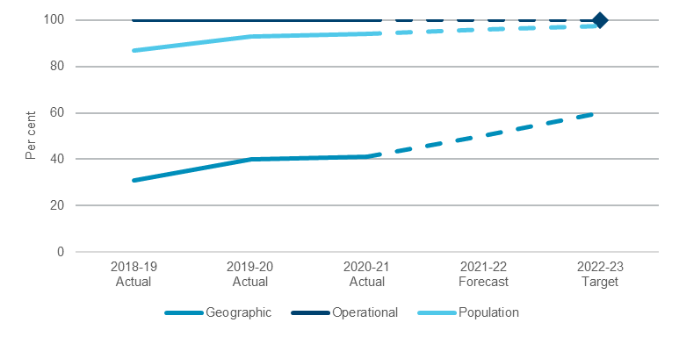
Note: target for geographic and population availability is to maintain current performance.

New South Wales digital government readiness
New South Wales remains the leading Australian jurisdiction for digital readiness, as it has been for the past five years, increasing its digital government readiness score by 0.1 index points to 9.8 out of 10 on the latest Digital Government Readiness report. Digital readiness assesses jurisdictions against various enabling criterion: implementation of an ICT strategy, appropriate ICT policies, having a robust approach to ICT governance, the existence of a whole-of-government service delivery agency, reforming procurement policy to enable digital government and cross-jurisdictional collaboration.
The strong performance against this indicator reflects the New South Wales Government’s holistic commitment to digital government including continued reporting against a comprehensive digital transformation strategy, significant funding through the $2.1 billion Digital Restart Fund, and investments in whole-of-government platforms, security and privacy and emerging technologies such as Artificial Intelligence, Spatial Digital Twins and the Internet-of-Things.

- NSW digital government readiness
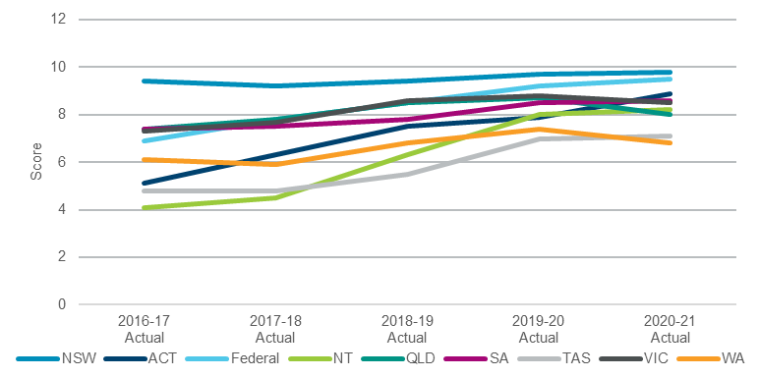

Note: A forecast is not available and there is not a performance target, as the values are sourced from the Digital Government Readiness Report prepared by Intermedium. The next results are expected to be released in early 2022.

Performance indicators for this Outcome
.Outcome Indicators | Units | 2020-21 | 2021-22
 |  | Actual | Forecast
NSW digital government readiness | no.
New South Wales |  | 9.8 | n.a.^{(a)}
Australian Government |  | 9.5 | n.a.^{(a)}
Victoria |  | 8.5 | n.a.^{(a)}
Queensland |  | 8.0 | n.a.^{(a)}
South Australia |  | 8.6 | n.a.^{(a)}
Northern Territory |  | 8.2 | n.a.^{(a)}
Australian Capital Territory |  | 8.9 | n.a.^{(a)}
Western Australia |  | 6.8 | n.a.^{(a)}
Tasmania |  | 7.1 | n.a.^{(a)}
Public safety coverage and operations of the CCEP | %
Geographic |  | 41.0 | 50.3
Operational |  | 99.95 | 99.95
Population |  | 94.0 | 96.1

Note
- A 2021-22 forecast is not available as the values are sourced from the Digital Government Readiness Report prepared by Intermedium. The next results are expected to be released in early 2022.

Outcome 3: Fair, secure and efficient markets
 | $1.5 billion | Recurrent  Expenses  2021-22
 | $77.9 million | Capital  Expenditure  2021-22

State Outcome overview and 2021-22 investment
Investment in this State Outcome enables the Department of Customer Service to deliver an efficient regulatory framework that delivers safety outcomes, consumer and business protections, State insurance schemes and other regulatory requirements whilst meeting the evolving and complex needs of businesses and customers.
This Outcome is measured by the regulatory compliance rates of selected industries, the rate of work-related traumatic injury fatalities and the affordability of the Compulsory Third Party Insurance scheme.

2021-22 State Outcome Budget highlights
In 2021-22, the Customer Service Cluster will invest $1.6 billion ($1.5 billion recurrent expenses and $77.9 million in capital expenditure) in this Outcome, including:
- $41.9 million ($59.9 million over three years) for 12 infrastructure projects at country race clubs across New South Wales to improve racetracks, amenities and animal welfare
- $17.0 million in recurrent expenses ($122.0 million over three years for operating and capital costs) to digitise government licensing applications for the Real Estate, Tattoo and Security Licensing industries and digital licences for Home Building and High-Risk Work
- $11.4 million ($23.0 million over three years) for the eConstruction initiative to develop digital platforms for certification registries aimed at delivering end-to-end quality assurance for builders, customers and suppliers to improve the transparency, accountability and quality of work within the building sector
- $6.4 million ($12.9 million recurrent expenses over two years) to increase the number of inspectors and associated support staff in SafeWork NSW to meet the International Labour Organisation benchmark of one inspector for every 10,000 workers
- $6.0 million in additional funding as part of a broader ongoing funding package to ensure that the Greyhound Welfare and Integrity Commission is sustainably funded, addressing the issues raised by the recent statutory review of the Greyhound Racing Act 2017
- $4.9 million ($11.1 million over four years) for the Building Commissioner to boost regulatory enforcement and continue the transformation of the building sector into a customer‑centric industry focused on the quality of construction
- $1.0 million ($1.3 million recurrent expenses over two years) for the Rehoming Infrastructure Program as part of the $59.9 million commitment above to country racing to provide support to Harness Racing NSW’s initiative to rehome and retrain horses retired from the industry.

Key performance insights
This section provides analysis and insights on key Outcome Indicators for this State Outcome.

Reduced rate of work-related traumatic injury fatalities (worker fatalities per 100,000 employees)
The Work Health and Safety Roadmap for NSW 2022 outlines a strategic approach to reducing workplace fatalities, and injuries by focusing on priority high risk sectors, workplaces and workers.
SafeWork NSW responds proactively and quickly to support worker safety, particularly when a fatality or serious injury occurs. In 2016, SafeWork NSW adopted the national target of a 20 per cent reduction in workplace fatalities and a 30 per cent reduction in workplace injuries and illnesses by 2022.
Through a continually refined compliance program, performance against this indicator continues to improve and is on track to meet the national target of 1.34 fatalities per 100,000 employees by 2022.
- Worker fatalities per 100,000 employees
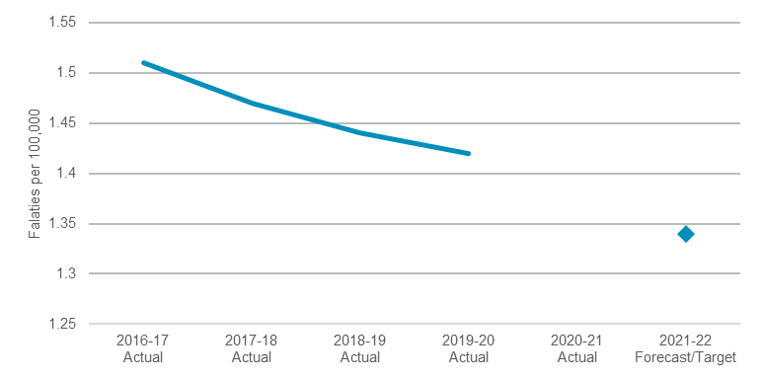
Note: 2020-21 actual data for this indicator is reliant on data provided by SafeWork Australia which is delayed and expected to be available in late 2021.

Compliance rate of selected regulatory activities
The Cluster protects the New South Wales community through innovative regulatory services that also ensure fair, secure and efficient markets. Our compliance efforts include a commitment to working with businesses and educating industry groups and other government agencies to promote compliance and secure standards.
Significant compliance and enforcement outcomes have been achieved by educating and enabling businesses to comply and taking proportional enforcement actions against those who do not meet their regulatory obligations. Enforcement actions are intelligence-based and evidence-led, including legal proceedings where appropriate.
Performance against this indicator is currently exceeding the target of 90 per cent. For the 12 months to March 2021, 95 per cent of selected regulated entities were found compliant with the laws and regulations which govern their operations.

- Compliance rate of selected regulatory activities
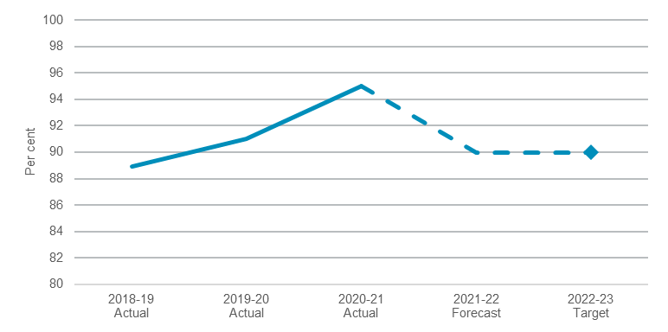

Note: 2020-21 actual is higher than the usual compliance rate as COVID-19 has impacted industry activity. The target for this indicator exists in both 2021-22 and 2022-23, however, has only been included in 2022-23 for presentational purposes.

Performance indicators for this Outcome
Outcome Indicators | Units | 2020-21 | 2021-22
 |  | Actual | Forecast
Affordability of the Compulsory Third Party Insurance scheme (motor vehicles) | % | 24.0 | n.a.^{(a)}
Compliance rate of selected regulatory activities | % | 95.0^{(b)} | 90.0
Reduced rate of work-related traumatic injury fatalities (worker fatalities per 100,000 employees) | no. | n.a^{(c)} | 1.34

Note
- Compulsory ThirdParty insurance scheme affordability is measured as a percentage of the average NSW weekly wage. Forecast for the 2021-22 NSW average weekly wages are expected in the second half of 2021.
- 2020-21 actual is higher than the usual compliance rate as COVID-19 has impacted industry activity.
- 2020-21 actual data for this indicator is reliant on data provided by SafeWork Australia which is delayed and is expected to be available in late 2021.

