2. EDUCATION CLUSTER

Introduction
 | $20.9 billion | Recurrent  Expenses  2021-22
 | $3.4 billion | Capital  Expenditure  2021-22
The Education Cluster administers and delivers lifelong education and training services for NSW students, workers and industry. This spans the early childhood education and care sector, government and non-government schools, and the vocational education and training sector.

State Outcomes to be delivered by the Education Cluster
State Outcomes  What the Cluster is delivering for people and business |  | Key Programs  underway to support delivery of Outcomes
1. Best start in life for young children  A sustainable, accessible, high-quality early childhood education sector.  2021-22 investment: $725.9 million in recurrent expenses |  | - Start Strong: Supporting universal access to early childhood education  - Regulatory and support services aiming to deliver access to quality early childhood education
2. Educational foundations for success  A high standard of education for all children and young people in public and non-government schools.  2021-22 investment: $17.4 billion in recurrent expenses & $3.2 billion in capital expenditure |  | - Teaching and learning in public schools and programs supporting academic achievement, wellbeing, equity and independence  - Construction of new schools and major upgrades  - Non-government school funding  - Implementation of the School Success Model  - Connected Communities program to support Aboriginal student engagement
3. Skilled and employable workforce  A highly skilled and adaptable workforce that contributes to the State’s prosperity and productivity.  2021-22 investment: $2.6 billion in recurrent expenses & $268.6 million in capital expenditure |  | - Smart and Skilled: Government-funded vocational education and training  - Skilling for Recovery fee-free training  - Funding TAFE as a comprehensive public provider  - Regulatory and support services aiming to deliver a viable and high-quality vocational education and training sector
4. High-quality standards for schooling  High-quality standards for schooling in New South Wales through the regulation of schooling, accreditation of early childhood, primary and secondary teachers, and provision of quality curriculum, assessment and certification by the NSW Education Standards Authority (NESA).  2021-22 investment: $212.3 million in recurrent expenses & $1.4 million in capital expenditure |  | - Curriculum Reform  - Implementing NESA-accredited teacher professional development across identified priority areas

Overview of Cluster expenses by State Outcome
A summary of expenses by State Outcome is provided in the charts below.
- Recurrent expenses by Outcome 2021-22 (dollars and %)

Note: The sum of percentages does not equal one hundred due to rounding.
Grouped for presentation purposes, “Other State Outcomes” comprises:
- Best start in life for young children
- High-quality standards for schooling in NSW.
- Capital expenditure by Outcome 2021-22 (dollars and %)

Note: Grouped for presentation purposes, “Other State Outcomes” comprises:
- Skilled and employable workforce
- High-quality standards for schooling in NSW.

Outcome 1: Best start in life for young children
 | $725.9 million | Recurrent  Expenses  2021-22

State Outcome overview and 2021-22 investment
Investments under this State Outcome support a sustainable, accessible, high-quality early childhood education sector.
Children who participate in a quality early childhood education program are more likely to arrive at school equipped with the social, cognitive and emotional skills they need to engage in learning. The NSW Department of Education monitors, supports and regulates early childhood education services in New South Wales, and works to ensure the delivery of quality early childhood education services for children in the years before school.

2021-22 State Outcome Budget highlights
In 2021-22, the Education Cluster will invest $725.9 million in this Outcome, including:
- continued delivery of the NSW Start Strong Preschool Program in both community preschools and long day care centres. Funding support is delivered for children aged three and above in community preschools to support universal access to two years of early childhood education in the years before school, continuing the NSW Government’s commitment made in the 2018-19 budget
- $150.0 million to community preschools to deliver Free Preschool for school year 2022, ensuring continued cost of living support for parents when the current COVID-19 Free Preschool Funding program concludes at the end of 2021. This new program and investment also supports the workforce participation of parents, and gives preschools additional funding support. Preschools opting into the program will be required to provide at least 600 hours of free preschool per year (which is approximately 15 hours or two days per week) to all eligible preschool children
- continuation of capital works grant funding to support the creation of additional community preschool places.

Key performance insights
This section provides analysis and insights on key Outcome Indicators for this State Outcome.

Children enrolled in an early childhood education program in the year before school
This indicator is consistent with benchmarks under the National Partnership Agreement on Universal Access to Early Childhood Education, with an enrolment target of 95 per cent by 2022.
Performance against this indicator continues to improve with participation in early childhood education for 600 hours in the year before school increasing to 95.3 per cent in 2020. This is the State’s highest-ever result against this indicator and performance against this indicator is exceeding the Cluster’s target for 2022.
The Start Strong program is a needs-based funding investment aimed at making 600 hours of preschool participation more affordable in the year before full-time school. Support is also available for three-year-olds, with a focus on children from Aboriginal and low-income families and children with a disability.

- Proportion of children who are enrolled in an early childhood education program for at least 600 hours in the year before school
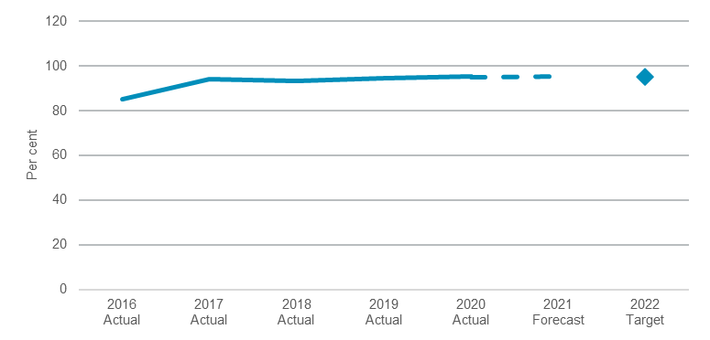

Note: Data sourced from Australian Bureau of Statistics (ABS), Preschool Education, Australia.

Early childhood education services rated as meeting or exceeding the National Quality Standard
The NSW Department of Education monitors compliance with legislative requirements, investigates complaints and responds to incidents.
Performance against this indicator is on track to exceed the target, with 82 per cent of services rated as meeting or exceeding the National Quality Standard as at December 2020.
To support ongoing service quality improvement, the Department is continuing to deliver the Working Towards Quality Support Program and has introduced self-assessment into the assessment and rating process. Service providers have been able to access direct support to assist them in undertaking self-assessment from the Department since early 2020. The Department is also working to increase the understanding of the importance of service quality through the Quality Ratings Initiative and the public facing “Grow to Learn, Learn to Grow” campaign.
- Proportion of early childhood education services rated as meeting or exceeding the National Quality Standard
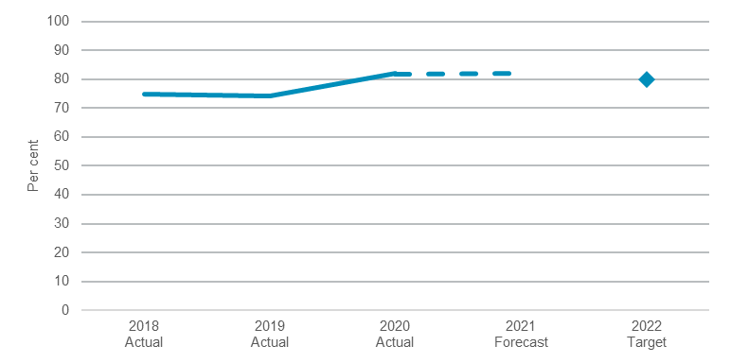
Note: Data sourced from the Australian Children’s Education and Care Quality Authority (ACECQA).

Performance indicators for this Outcome
Outcome Indicators | Units | 2020-21  Actual | 2021-22  Forecast
Proportion of children who are enrolled in an early childhood education program for at least 600 hours in the year before school^{(a)} | % | 95.3 | 95.4
Proportion of enrolled Aboriginal children who are enrolled in an early childhood education program for at least 600 hours in the year before school^{(a)} | % | 93.9 | 94.4
Proportion of enrolled vulnerable and disadvantaged children who are enrolled in an early childhood education program for at least 600 hours in the year before school^{(a)} | % | 93.0 | 93.8
Proportion of early childhood education services rated as meeting or exceeding the National Quality Standard^{(b)} | % | 82.0 | 82.1

Notes
- 2020-21 actuals and 2021-22 forecasts refer to the 2020 and 2021 school years, respectively. Data sourced from Australian Bureau of Statistics (ABS), Preschool Education, Australia.
- Data sourced from the Australian Children’s Education and Care Quality Authority (ACECQA). 2020-21 actual is as at December 2020.

Outcome 2: Educational foundations for success
 | $17.4 billion | Recurrent  Expenses  2021-22
 | $3.2 billion | Capital  Expenditure  2021-22

State Outcome overview and 2021-22 investment
Investments under this State Outcome support a high standard of education for all children and young people in public and non-government schools.
The NSW Department of Education is the largest provider of education in Australia. It delivers high-quality public education through its network of 2,215 public schools and ensures that school infrastructure continues to meet the needs of the State’s growing population. The Department also works closely with the non-government school sector to ensure the delivery of a high-quality and equitable education for all students.

2021-22 State Outcome Budget highlights
In 2021-22, the Education Cluster will invest $20.5 billion ($17.4 billion recurrent expenses and $3.2 billion capital expenditure) in this Outcome, including:
- $15.9 billion recurrent funding to support the delivery of primary and secondary education in government schools in 2021-22, in line with the State’s commitment under the National School Reform Agreement (NSRA)
- $2.1 billion in new capital expenditure over four years to deliver 44 new and upgraded schools, including significant funding to construct 30 schools which are progressing through the planning phase, taking the State’s total investment in school infrastructure to $7.9 billion over four years to deliver major projects at over 210 schools
- $1.5 billion funding to support non-government schools in 2021-22, including funding for non-government school essential capital works under the Building Grants Assistance Scheme
- $124.8 million recurrent funding over four years to implement the Teacher Supply Strategy which aims to attract and retain high performing teachers for NSW schools. The strategy will deliver a sustainable pipeline of teachers with the right subject qualifications and in the right locations
- commencement of a four-year program to provide teaching and learning resources and professional development required to successfully implement the curriculum reforms recommended through the NSW Curriculum Review
- an ongoing commitment under the NSRA for 2019 to 2023 to deliver needs-based funding to government and non-government schools. Under the NSRA, New South Wales has committed to implement national policy initiatives, and a series of state-based reforms to improve student learning, teaching and school improvement across government and non-government schools.

Key performance insights
This section provides analysis and insights on key Outcome Indicators for this State Outcome.

Public school students in the top two NAPLAN bands for reading and numeracy
This Premier’s Priority is to increase the proportion of public school students in the top two NAPLAN bands for literacy and numeracy by 15 per cent by 2023.
NAPLAN did not proceed in 2020 due to COVID-19. The Reading and Numeracy Program and the COVID Intensive Learning Support Program are supporting schools to address learning lost due to COVID-19 through targeted tutoring and student support.
Under the School Success Model, all public schools have set targets in line with this Premier’s Priority and have prepared a Strategic Improvement Plan which outlines the steps they will take to improve learning outcomes. The Department is providing differentiated support to schools, including in-school support from specialist teams and improved access to evidence-based teaching resources.
The Department’s literacy and numeracy programs are focused on lifting student NAPLAN results. Schools have access to evidence-based resources for explicit teaching of reading and numeracy and regular ‘check-in’ assessment to monitor the progress of their students.
- Proportion of public school students in the top two NAPLAN bands for reading and numeracy
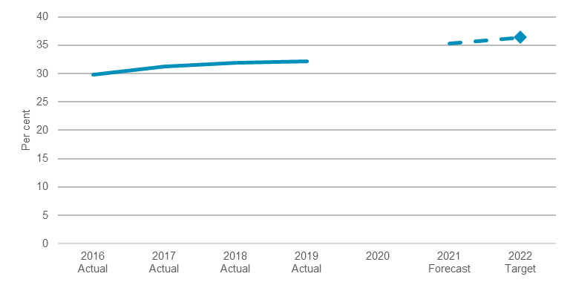
Note: Data sourced from NSW Department of Education, annual NAPLAN results. 2020 data is not available as NAPLAN did not proceed due to COVID-19.

Aboriginal students attaining Year 12
This Premier’s Priority is to increase the proportion of Aboriginal students attaining Year 12 by 50 per cent by 2023, while maintaining their cultural identity. This will be equivalent to increasing the proportion of Aboriginal students attaining the Higher School Certificate (HSC) to 69 per cent.
Interim results for 2020 indicate that 45 per cent of Aboriginal students attained their HSC.
Under the School Success Model, Strategic Improvement Plans set targets and outline the steps secondary schools will take to improve learning outcomes for their Aboriginal students.

The Department has co-designed a suite of initiatives in collaboration with the NSW Coalition of Aboriginal Peak Organisations to support Aboriginal students to engage with education and attain a HSC while also delivering a system wide uplift in cultural awareness through professional learning.
- Proportion of Aboriginal students attaining Year 12
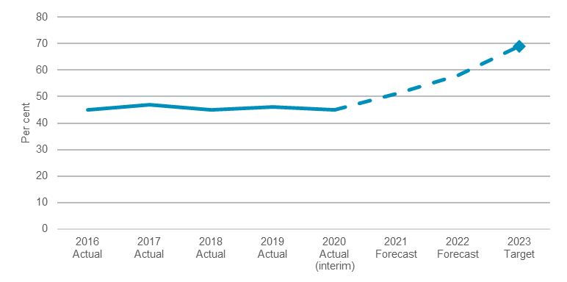
Note: Data sourced from NESA and NSW Department of Education. This Indicator refers to all Aboriginal students in NSW (i.e. both government and non-government schools). See footnote in Outcome Indicator table for further information about
the calculation of attainment rates. 2020 data is interim results.

Performance indicators for this Outcome
Outcome Indicators | Units | 2020-21^{(a)} | 2021-22^{(a)}
 |  | Actual | Forecast
Academic Achievement
Proportion of public school students in the top two NAPLAN bands for reading and numeracy ^{(b)} | % | n.a | 35.2
Proportion of public school students above the national minimum standard for reading and numeracy | % | n.a | 85.7
Proportion of NSW public school students achieving expected growth in reading and numeracy^{(b)} | %
% in reading |  | n.a | 64.8
% in numeracy |  | n.a | 65.9
Student Wellbeing
Proportion of public school students reporting a sense of belonging, expectations for success and advocacy at school^{(c)} | %
% of public school primary students |  | 85.0 | 89.8
% of public school secondary students |  | 67.3 | 68.6
Proportion of public school students attending school at least 90% of the time^{(d)} | %
% of public school primary students |  | n.a | 81.4
% of public school secondary students |  | n.a | 68.6
Student Equity (Aboriginal Students)
Proportion of Aboriginal students attaining Year 12, while maintaining their cultural identity^{(e)} | % | 45.0 | 51.0
Proportion of Aboriginal students in public schools in the top two NAPLAN bands for reading and numeracy^{(b)} | % | n.a | 13.7
Reduce the gap between Aboriginal and non-Aboriginal students in public schools reporting a sense of belonging, expectations for success and advocacy at school | %
Gap between Aboriginal and non-Aboriginal public primary school  students |  | 3.1 | 1.9
Gap between Aboriginal and non-Aboriginal public secondary school  students |  | 13.7 | 9.6
Student Equity (Disadvantaged Students)
Reduce the gap between the highest and lowest socio-economic status students in public schools in the top two NAPLAN bands for reading and numeracy^{(b)(f)} | % | n.a | 36.3
Reduce the gap between the highest and lowest socio-economic status students in public schools above the national minimum standard for reading and numeracy^{(f)} | % | n.a | 28.0
Reduce the gap between the highest and lowest socio-economic status students in public schools reporting a sense of belonging, expectations for success and advocacy at school^{(f)} | %
Gap between low-SES and high-SES public primary school students |  | 9.9 | 6.4
Gap between low-SES and high-SES public secondary school students |  | 22.7 | 17.6
Independence
Proportion of public school students continuing to Year 12 and the proportion of public school students' HSC results in the top two achievement bands^{(g)} | %
% of public school HSC results in top two bands |  | 34.0 | 35.5
Apparent retention rate |  | 73.0 | 76.0
Proportion of all recent school leavers (who left school the previous year) participating in higher education, training or work^{(h)} | % | 86.0 | 91.1

Notes:
Education Ministers made the decision to cancel NAPLAN in 2020 due to the impact of the COVID-19 pandemic. This means that comparative data is not available for 2020.
- 2020-21 actuals and 2021-22 forecasts refer to the 2020 and 2021 school years, respectively.
- Data sourced from NSW Department of Education, annual NAPLAN results. The baseline is the average of 2017 and 2018 results. "Expected growth" is based on the growth achieved by students in reading and numeracy from one NAPLAN assessment to the next (two years later).
- Sourced from the NSW Department of Education's Tell Them From Me student survey. These measures are the average of three survey metrics. The primary school measure is sourced from surveys of students in Years 4 to 6. Measures for
secondary school students are for Years 7 to 12.
- Sourced from NSW Department of Education's mid-year census. Comparative 2020 data is not available due to the effects of the COVID-19 pandemic on student attendance and data collection during the learning from home period.
- Data sourced from NESA and NSW Department of Education. This target refers to all Aboriginal students in NSW (i.e. both government and non-government schools). Attainment rates are estimated by calculating the number of students awarded their HSC expressed as a percentage of the potential Year 12 population. The potential Year 12 population is an estimate of a single-year age group that could have attended Year 12 that year and is derived from administrative records for Year 9 and Year 10 enrolments in earlier years. The results for Year 12 in 2020 are interim. A number of these students will complete their HSC over three years, which will be captured as revisions.
- High socio-economic status students are those whose parents have a bachelor’s degree or above. Low socio-economic
status students are those whose parents achieved a Year 11 or below school education level and do not have any non-school education. This information is self-reported and results should be interpreted with caution.
- Sourced from the NSW Department of Education's mid-year census and from NESA. The apparent retention rate is defined as the number of full time equivalent (FTE) students in Year 12 as a proportion of the cohort enrolment two years prior (when in Year 10). Retention rates are “apparent” as they do not track individual students through to their final years of secondary schooling. Care should be taken in the interpretation of apparent retention rates because the method of
calculation does not take into account a range of factors including migration, interstate movement of students, transfers to
and from non-government schools, part-time schooling, students repeating a year of schooling, and students pursuing other education and training pathways.
- Data sourced from the NSW Department of Education's NSW Post-School Destinations and Expectations Survey.

Outcome 3: Skilled and employable workforce
 | $2.6 billion | Recurrent  Expenses  2021-22
 | $268.6 million | Capital  Expenditure  2021-22

State Outcome overview and 2021-22 investment
Investments under this State Outcome support a highly skilled and adaptable workforce that contributes to the prosperity and productivity of New South Wales.
The NSW Department of Education drives participation and retention in quality Vocational Education and Training (VET) by managing the Smart and Skilled contestable training market, including the apprenticeship and traineeship system in New South Wales. The Department also provides direct funding to TAFE NSW, the State’s comprehensive public provider of VET.

2021-22 State Outcome Budget highlights
In 2021-22, the Education Cluster will invest $2.9 billion ($2.6 billion recurrent expenses and $268.6 million capital expenditure) in this Outcome, including:
- continued investment of $318.6 million recurrent expenses over two years for Skilling for Recovery, an ongoing, key component of the State’s COVID-19 Recovery Plan to help job seekers retrain or upskill, and support school leavers to enter the workforce for the first time. The NSW Government has committed almost $160.0 million to match Commonwealth JobTrainer funding and offer more than 100,000 fee-free training places, with 70,305 enrolments as at 31 May 2021
- $24.6 million in 2021-22, including $13.2 million capital expenditure, to support implementation of recommendations in the Gonski Shergold Review of the NSW VET sector. This funding supports establishing pilot sites for the Institute of Applied Technology at Meadowbank and Kingswood and a pilot for Careers NSW, with a full rollout expected in mid-2022. The NSW Government accepted all five recommendations from the Review - establishing Careers NSW, establishing the NSW Institute of Applied Technology, advocating for expanded access to VET student loans, improving vocational education available in high schools and consulting with industry experts on VET course curriculums
- $5.2 million in 2021-22 to continue the Education Pathways Pilot Program (EPPP) to enhance uptake of vocational career options and improve job-readiness of secondary school students
- $19.0 million investment in 2021-22 into information and communication technology programs across the state in line with TAFE’s ongoing modernisation program to support improved teaching delivery and student experience
- $5.9 million in 2021-22 for TAFE to develop undercover learning areas to support training delivered externally or at height, such as carpentry.

Key performance insights
This section provides analysis and insights on key Outcome Indicators for this State Outcome.

NSW Government funded VET graduates who are employed after training
The NSW Government is committed to ensuring that government-funded training delivers the skills and capabilities needed to gain employment.
With many factors contributing to the likelihood of gaining employment after training, including the broader economic landscape, performance against this indicator has recently experienced a decline. Whilst the proportion of graduates employed after training decreased by 5.6 percentage points in 2020 due to the impacts of COVID-19, the New South Wales decline was significantly less than the national average (8 percentage points). Improved economic conditions in New South Wales are expected to result in improved outcomes in 2021.
The NSW Government’s Skilling for Recovery program aims to deliver 100,000 fee-free training places across the state, supported by regional skills brokers, bespoke skilling solutions for employers and a dedicated Skills Hub to improve employment outcomes. The Department is also optimising the NSW Skills List, engaging with industry on skill needs, and implementing the recommendations of the Review of the NSW VET sector. This includes the establishment of Careers NSW to support improved workforce participation outcomes.
- Proportion of NSW government funded VET graduates who are employed after training
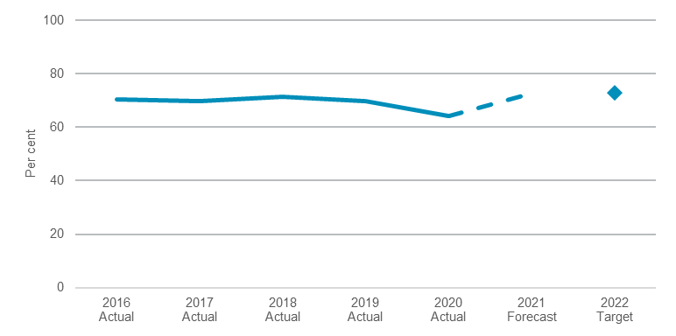
Note: Data sourced from the National Centre for Vocational Education Research (NCVER) Government-funded student outcomes. See footnote (d) in Outcome Indicator table for further information.

Young people in education, training and employment
Engagement in education, training or employment is essential for young people to fully realise social and professional opportunities and avoid dependence on welfare.
While performance against this indicator has been relatively stable since 2010, there was a decline of around 2 percentage points in 2020 due to the impacts of COVID-19 on the state’s labour market. Despite the challenging environment, New South Wales has outperformed the majority of other states and territories where nationally there was a larger negative trend of 3.1 per cent.
The NSW Government’s Skilling for Recovery program is mitigating the employment impacts on young people by offering more than 100,000 fee-free places, with 70,305 enrolments as at May 2021. Skilling for Recovery is also funding an extension of the Regional VET Pathways program which supports at-risk youth re-engage in education, training or transition to employment. The Department also continues to partner with industry to support apprenticeship and traineeship pathways.
- Proportion of young people in NSW who are in education, training and employment
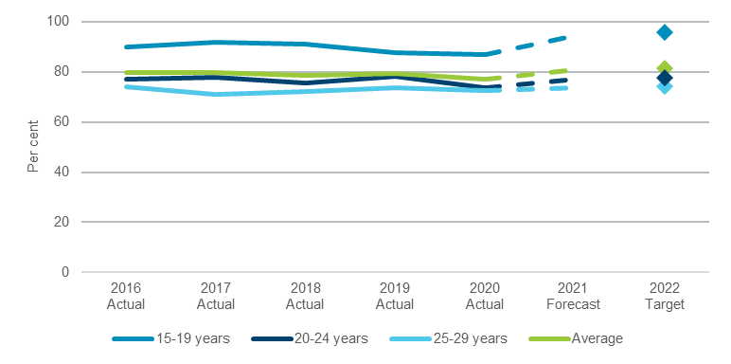
Note: Data sourced from the Australian Bureau of Statistics, Education and Work, Australia. See footnote (b) in Outcome Indicator table for further information.

Employer satisfaction with VET training
In order to grow a highly skilled and adaptable workforce, it is essential that the training delivered in New South Wales meets the needs of local industries.
Performance against this indicator has declined in recent years, consistent with national trends. In 2019, an average of 77.4 per cent of employers reported that VET training met their skills needs.
The Department is undertaking further work to understand how views differ by type of employer and training provider, among other factors. The Department is continuing to work with other jurisdictions on improving the quality of the national training system, strengthening assurance and monitoring of Smart and Skilled providers. The Department works to align VET delivery with industry and employer needs through funding Industry Trade Advisory Bodies (ITABs), and delivering skills brokers and workforce development programs.
- Proportion of NSW employers satisfied with VET training meeting their skill needs
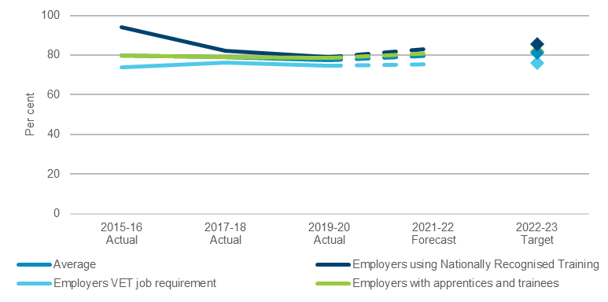
Note: Data sourced from the National Centre for Vocational Education Research (NCVER) Survey of Employer Use and Views of the VET System. This survey is conducted every two years, and the next update will be available in 2021-22. See footnote (a) in Outcome Indicator table for further information.

Performance indicators for this Outcome
Outcome Indicators |  | Units |  | 2020-21 | 2021-22
 |  |  |  | Actual | Forecast
Proportion of NSW employers satisfied with VET training meeting their skill needs^{(a)} | %
Average |  |  | n.a |  |  | 79.9
Employers using Nationally Recognised Training (NRT) |  |  | n.a |  |  | 83.4
Employers VET job requirement |  |  | n.a |  |  | 75.5
Employers with apprentices and trainees |  |  | n.a |  |  | 80.9
Proportion of NSW government funded VET graduates who are employed after training^{(b)} | % |  | 64.3 |  |  | 72.7
Proportion of NSW working age population with qualifications at or above Cert III^{(c)} | % |  | 64.8 |  |  | 68.4
Proportion of young people in NSW who are in education, training and employment | %
15-19 years |  |  | 86.9 |  |  | 94.6
20-24 years |  |  | 73.8 |  |  | 77.2
25-29 years |  |  | 72.6 |  |  | 73.7
Average |  |  | 77.1 |  |  | 80.9

Notes:
- Sourced from the National Centre for Vocational Education Research (NCVER) Survey of Employer Use and Views of the VET System. This survey is conducted every two years, and the next update will be available in 2021-22. The average is derived from the average of the three categories, not raw numbers.
- Sourced from the National Centre for Vocational Education Research (NCVER) Government-funded student outcomes. 2020-21 actuals are based on results published in December 2020. "Fully engaged" covers persons who are engaged in full-time work (at or above 35 hours per week) or study, or who combine any hours of work with any hours of study. The average is derived from the raw numbers for the three cohorts.
- Sourced from the Australian Bureau of Statistics, Education and Work, Australia. 2020-21 actuals are based on data for May 2020.

Outcome 4: High Quality standards for schooling in NSW

State Outcome overview and 2021-22 investment
 | $212.3 million | Recurrent  Expenses  2021-22
 | $1.4 million | Capital  Expenditure  2021-22
Investments under this State Outcome support high quality standards for schooling in New South Wales through the regulation of schooling, accreditation of early childhood, primary and secondary teachers, and provision of quality curriculum, assessment and certification by the NSW Education Standards Authority (NESA).

2021-22 State Outcome Budget highlights
In 2021-22, the Education Cluster will invest $213.7 million ($212.3 million recurrent expenses and $1.4 million capital expenditure) in this Outcome, including:
- $57.7 million ($196.6 million recurrent over four years) to implement the NSW Curriculum Reforms by 2024, to support students in developing strong foundations of knowledge, capabilities and values to be lifelong learners, active citizens and to equip schools for a complex and fast-changing world
- $26.5 million ($74.1 million over four years) to develop curriculum for early and middle years of schooling
- $24.6 million ($95.7 million over four years) to provide stronger pathways and develop curriculum for senior secondary years of schooling
- $3.3 million ($13.6 million over four years) to develop digital curriculum solutions
- $3.3 million ($13.2 million over four years) to support teacher engagement in curriculum development
- $3.2 million to implement the accreditation of teacher professional development across identified priority areas.

Key performance insights
This section provides analysis and insights on key Outcome Indicators for this State Outcome.

Proportion of teachers with a clear understanding of curriculum requirements
In 2021-22, the NSW Government is leading a major program of curriculum reform. This involves the redevelopment of nearly 200 syllabuses by 2024.
NESA is working with schools across all sectors to understand curriculum requirements to teach syllabus content effectively.
Understanding the degree to which teachers are clear about NSW curriculum requirements is an important measure that will guide NESA in how it goes about developing syllabus content, communicating syllabus requirements to teachers, and developing curriculum support resources. This will be included as an outcome indicator in NESA’s 2021-22 Outcome Business Plan.

Proportion of teachers and schools with a clear understanding of school regulation and teacher accreditation requirements
NESA is also developing an Outcome Indicator related to stakeholder understanding of NESA processes and requirements. An increasing proportion of teachers reporting a clear understanding of school regulation and teacher accreditation requirements will reflect that NESA is continuously streamlining regulatory requirements and communicating clearly to teachers and school leaders about what teachers need to do to meet the requirements.

NESA’s work to reduce the administrative burden on teachers and school leaders
NESA is also committed to supporting the NSW Government’s priority for ‘government made easy’. NESA’s 2021-22 Outcome Business Plan will incorporate an Outcome Indicator that demonstrates NESA is working to reduce the administrative burden on teachers and school leaders through simpler and clearer processes and reducing the time required for teachers and school leaders to engage with NESA change initiatives.
NESA is developing surveys to establish baseline performance and targets for each indicator as part of the implementation of NSW curriculum reform, school regulation and teacher accreditation programs. Preliminary data will be available in late 2021, from which baseline and target performance will be set.

