3. HEALTH CLUSTER

Introduction
 | $27.1  billion | Recurrent  Expenses  2021-22
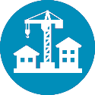 | $3.1  billion | Capital  Expenditure 2021-22
The Health Cluster works to protect, maintain and improve the health and wellbeing of residents in New South Wales.
Since March 2020, the NSW Government has committed more than $4.0 billion to help our healthcare system to increase its capacity and ensure it is well placed to manage the ongoing impacts of COVID-19.
Delivering COVID-19 vaccine rollout:
- Working with General Practitioners to safely deliver COVID-19 vaccinations to the New South Wales community as quickly as possible
- Increasing NSW Health’s vaccination capacity and expanding the vaccination clinic footprint across New South Wales to ensure vaccines are accessible to eligible people across the state, including providing outreach to locations in rural and regional New South Wales
- Establishing a mass vaccination centre at Sydney Olympic Park and planning a new centre at Newcastle to open in July, to complement the existing network of clinics across New South Wales
- Supporting, monitoring and reporting for COVID-19 vaccination adverse events across New South Wales.
Keeping our citizens safe:
- World-leading pathology testing, genome sequencing and contact tracing, including establishing pop-up testing sites across the state
- Screening on entry to health sites across the state to rapidly identify symptomatic visitors, protecting our communities and staff
- Supporting hotel quarantine including health managed hotels for symptomatic travellers and a dedicated presence at Sydney Airport
- Funding to fast-track state-wide research and clinical trials to tackle the global COVID-19 pandemic and reduce its impact on the community
- Promoting COVID-Safe behaviours through clear public communications and advice to government.
Ensuring capacity in our hospitals:
- Quadrupling Intensive Care Unit (ICU) capacity and purchasing additional ventilators
- Significant investment and rapid expansion of telehealth
- Continuing additional elective surgery.

Supporting and protecting our frontline workers:
- Substantial investment in personal protective equipment (PPE)
- Expanding our healthcare and hospital security workforce
- Providing ICU training to upskill healthcare staff to support increased ICU capacity.
Boosting mental health support:
- Funding for specialist mental health support to communities affected by natural disasters in regional and rural New South Wales
- Enhancements to community child and youth mental health services
- Expansion of community-based mental health clinical support and emergency nurse consultants
- Increased availability of virtual mental health services
- Funding to Lifeline and the Mental Health Line to support those in need.

State Outcomes to be delivered by the Health Cluster
State Outcomes  What the Cluster is delivering for people and business |  |  | Key Programs  underway to support delivery of Outcomes
- People receive high-quality, safe care in our hospitals  When people are admitted to a hospital in New South Wales they can expect world-class medical and surgical care within clinically recommended timeframes, with NSW Health operating the largest public hospital system in Australia.  2021-22 investment: $14.0 billion in recurrent expenses & $1.7 billion in capital expenditure |  |  | - Acute Services  - Sub-Acute Services  - Mental Health Services  - Aged Care Services
- People can access care in out of hospital settings to manage their health and wellbeing  Healthcare extends beyond the hospital and connects across settings to reduce the burden of chronic disease, assist people with conditions to live well and avoid complications, support people to recover from illness and injury, and prevent avoidable hospitalisations. NSW Health services include non-admitted and community-based services, sub-acute services, hospital in the home, and dental services.  2021-22 investment: $7.1 billion in recurrent expenses & $566.7 million in capital expenditure |  |  | - Community Based Services  - Mental Health Community Based Services  - Aged Care Community Services  - Drug & Alcohol Services  - Non-Admitted Services
- People receive timely emergency care  NSW Health is responsible for managing and operating ambulance and emergency services, which are often the first point of contact for people needing emergency healthcare.  2021-22 investment: $3.5 billion in recurrent expenses & $813.9 million in capital expenditure |  |  | - Emergency Departments  - Ambulance Emergency Services
- Keeping people healthy through prevention and health promotion  Preventive and population health measures are critical to keeping people healthier. It covers a range of functions including to promote public health, control infectious diseases, reduce preventive diseases and death, help people manage their own health including mental health, and promote equitable health outcomes in the community.  2021-22 investment: $1.5 billion in recurrent expenses & $11.5 million in capital expenditure |  |  | - Dental Services  - Health Protection Services  - Health Prevention Services  - Specific Health Screening Services
- Our people and systems are continuously improving to deliver the best health outcomes and experiences  A skilled workforce with access to world-leading education and training, and a system that harnesses research and digital innovation is essential to continuously improve outcomes and experiences of care across the system.  2021-22 investment: $1.1 billion in recurrent expenses & $12.5 million in capital expenditure |  |  |  | - Teaching, Training & Research  - Medical Research Support Program  - Research and Commercial Capacity Building Initiatives  - Health Care Complaints Commission  - Mental Health Commission of New South Wales

Overview of Cluster expenses by State Outcome
A summary of expenses by State Outcome is provided in the charts below.
- Recurrent expenses by Outcome 2021-22 (dollars and %)

Note: Grouped for presentation purposes, “Other State Outcomes” comprises:
- Keeping people healthy through prevention and health promotion
- Our people and systems are continuously improving to deliver the best health outcomes and experiences.

- Capital expenditure by Outcome 2021-22 (dollars and %)

Note: Grouped for presentation purposes, “Other State Outcomes” comprises:
- Keeping people healthy through prevention and health promotion
- Our people and systems are continuously improving to deliver the best health outcomes and experiences.

Outcome 1: People receive high-quality, safe care in our hospitals
 | $14.0 billion | Recurrent  Expenses  2021-22
 | $1.7 billion | Capital  Expenditure  2021-22

State Outcome overview and 2021-22 investment
When people are admitted to a hospital in New South Wales, they can expect world-class medical and surgical care within clinically recommended timeframes, with NSW Health operating the largest public hospital system in Australia.

2021-22 State Outcome Budget highlights
In 2021-22, the Health Cluster will invest $15.7 billion ($14.0 billion in recurrent expenses and $1.7 billion in capital expenditure) in this Outcome, including:
- $159.3 million to fund services in new hospitals scheduled to open in 2021-22
- $141.0 million in capital expenditure in 2021-22 to unify the electronic medical records solutions currently in use to enhance care coordination, further digitisation, improve patient experience, and increase service sustainability
- $80.0 million to continue additional elective surgery
- $21.6 million over four years to provide a state-wide Transcatheter Aortic Valve Implantation (TAVI) service for high risk patients, including those in rural and remote areas of New South Wales.

Key performance insights
This section provides analysis and insights on key Outcome Indicators for this State Outcome.

Elective surgery patients treated on time
Elective surgery activity was significantly impacted by the COVID-19 pandemic, with non-urgent and most semi-urgent surgery paused Australia-wide from late March to mid May 2020. This response was a necessary step to ensure capacity in our hospitals, preserve personal protective equipment, keep staff and patients safe, and ensure workforce capacity.
Emergency surgery and urgent elective surgery continued to be delivered throughout this period.
By pausing some surgeries, there has been an increase in the number of overdue elective surgery cases. This has affected the proportion of elective surgery patients treated on time. Surgical teams across the state are working to address these overdue procedures.
As the overdue elective surgery list is addressed, on time elective surgery performance will return to previous levels and stabilise. Under usual circumstances NSW Health delivers around 325,000 surgeries a year, with elective surgeries accounting for 70 per cent of activity, and emergency surgery the remainder.

- Proportion of elective surgery patients treated on time
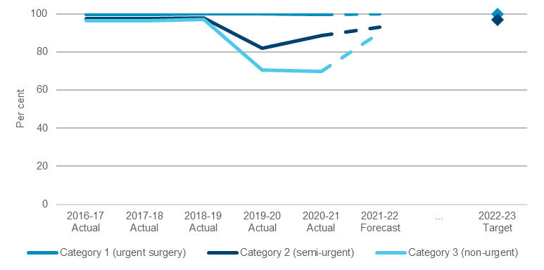

Overall patient experience index – adult admitted patient
Overall, patients in NSW public hospitals are continuing to receive excellent care and treatment according to the Bureau of Health Information Adult Admitted Patient Survey 2019.
Performance for this indicator remains stable. Patients are reporting a better than target level of experience with an overall score of 8.86, above the NSW target of 8.5 out of 10. This is an improvement from 8.6 in the previous year. NSW Health has an increased focus on improving patient, carer, family and staff experiences, with the launch of Elevating the Human Experience – Our Guide to Action, the NSW Health plan and associated program for improving experience across the NSW public health system.
- Overall patient experience index - adult admitted patients
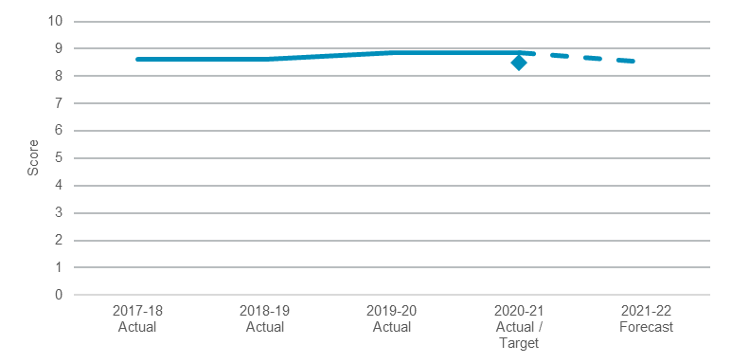
Note: 2020-21 actual as at July-September 2020 quarter.

Performance indicators for this Outcome
Outcome Indicators | Units | 2020-21 | 2021-22
 |  | Actual | Forecast
Elective surgery patients treated on time | %
Elective surgery patients treated on time Category 1 |  | 99.8 | 100
(urgent surgery)
Elective surgery patients treated on time Category 2 |  | 88.7 | 93.0
(semi-urgent)
Elective surgery patients treated on time Category 3 |  | 69.6 | 90.0
(non-urgent)
Fall-related injuries in hospital | no. | 5.1 | <5.1
Overall patient experience index - adult admitted patients | no. | 8.9 | 8.5
Unplanned hospital readmissions within 28 days of separation for all admissions | % | 5.7 | 5.6

Outcome 2: People can access care in out of hospital settings to manage their health and wellbeing
 | $7.1 billion | Recurrent  Expenses  2021-22
 | $566.7 million | Capital  Expenditure  2021-22

State Outcome overview and 2021-22 investment
Healthcare extends beyond the hospital and connects across settings to reduce the burden of chronic disease, assist people with conditions to live well and avoid complications, support people to recover from illness and injury, and prevent avoidable hospitalisations. NSW Health services include non-admitted and community-based services, sub-acute services, hospital in the home, and dental services.

2021-22 State Outcome Budget highlights
In 2021-22, the Health Cluster will invest $7.6 billion ($7.1 billion in recurrent expenses and $566.7 million in capital expenditure) in this Outcome, including:
- $109.5 million over four years to develop 25 ‘Safeguards’ Youth Mental Health Crisis Teams across New South Wales to provide services to children and adolescents with moderate to severe mental health issues and their families/carers
- $82.8 million over four years to continue to strengthen specialist palliative care services, including:
- improving community-based care for people with late stage chronic and degenerative diseases, and people with a disability
- to enhance inpatient palliative care services in Western Sydney
- enhancements to the specialist palliative care workforce in regional and rural New South Wales
- enhanced palliative care consumer support
- operational funding for the Manly Adolescent and Young Adult Hospice
- funding to support palliative care services, including dedicated inpatient beds at Chris O’Brien Life House
- enhance capability including State supported scholarships in palliative care medicine
- $36.4 million over four years for 57 mental health Response and Recovery Specialists across regional and rural New South Wales to provide assertive outreach support for communities, and coordination with local services at the time of a disaster or crisis, and during the ongoing recovery phase
- $8.6 million over four years to support community care for people with movement disorders, such as Parkinson’s Disease, by recruiting specialist nurses and allied health staff in 15 Local Health Districts. This package also includes funding for Parkinson’s NSW to support its InfoLine service as well as additional teaching, training and capacity building
- $7.7 million over four years to pilot a new model of care for children and young people with behavioural disorders including Attention Deficit Hyperactivity Disorder (ADHD) in two regional Local Health Districts
- $3.0 million towards the establishment of ACON’s LGBTQ+ health centre to improve access to primary and community-based healthcare.

Key performance insights
This section provides analysis and insights on key Outcome Indicators for this State Outcome.

Reduce preventable visits to hospital by caring for people in the community
This is a Premier’s Priority focused on improving outpatient and community care.

Performance against this indicator continues to exceed the performance target as the NSW Health system returns to pre-COVID-19 pandemic hospital activity levels.

Delivering healthcare in the community keeps people healthy at home for as long as possible, while ensuring the hospital system operates efficiently for those who need it. NSW Health continues to implement strategies to address preventable hospital visits.
- Proportion of total days spent in hospital by people with conditions where hospitalisation is potentially preventable
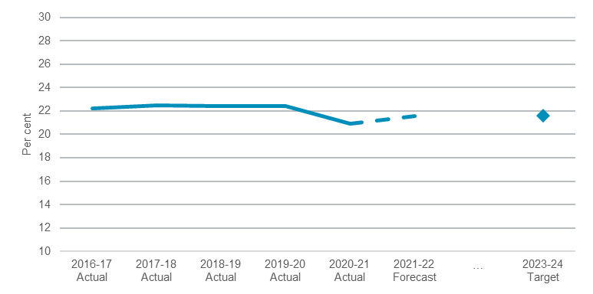

Performance indicators for this Outcome
Outcome Indicators | Units | 2020-21 | 2021-22
 |  | Actual | Forecast
Mental Health acute post discharge follow-up within 7 days | % | 79.0 | 83.7
Reduce preventable visits to hospital by caring for people in the community | % | 20.9 | 21.6

Outcome 3: People receive timely emergency care
 | $3.5 billion | Recurrent  Expenses  2021-22
 | $813.9 million | Capital  Expenditure  2021-22

State Outcome overview and 2021-22 investment
NSW Health is responsible for managing and operating ambulance and emergency services, which are often the first point of contact for people needing emergency healthcare.

2021-22 State Outcome Budget highlights
In 2021-22, the Health Cluster will invest $4.3 billion ($3.5 billion in recurrent expenses and $813.9 million capital expenditure) in this Outcome, including:
- $126.0 million over four years ($58.0 million recurrent expenses and $68.0 million capital expenditure) to improve NSW Ambulance operations through a modern, integrated facility at Sydney Olympic Park
- $69.7 million over four years to improve patient experience in NSW hospital emergency departments, recruit health and security assistants to rural health facilities, and support the Police Ambulance and Clinical Early Response (PACER) program which embeds mental health clinicians with first responders at the scene to provide specialist advice and appropriate care to people experiencing mental health episodes
- $54.3 million over four years to enable NSW Ambulance to secure an improved mix of aircraft, including jet aircraft, to improve patient safety and access to emergency care
- $34.0 million over four years ($31.2 million expenses and $2.9 million capital expenditure) for NSW Ambulance to convert 246 paramedics to intensive care paramedics, of which 203 will be in regional New South Wales
- upgrade in 2021-22 of in-ambulance defibrillators that improve electronic medical record integration capabilities between NSW Ambulance and hospital emergency departments across the state and especially in regional areas.

Key performance insights
This section provides analysis and insights on key Outcome Indicators for this State Outcome.

Triage category 1, 2 and 3 patients commence treatment on time in the emergency department
This is a Premier’s Priority and NSW Health continues to be strongly focused on ensuring people receive timely emergency care.
Performance against this indicator remains stable. NSW Health improvement strategies include streaming patients safely and effectively and implementing evidence-based clinical pathways that support timely assessment and treatment of patients. The new Good to Great program commenced in May 2021 to improve emergency access performance. It is a co-created program which will develop leadership capability, build positive workplace culture and nurture collaborative partnerships in our public hospital emergency departments.

- Percentage of triage category 1, 2 and 3 patients who commence treatment on time in the emergency department
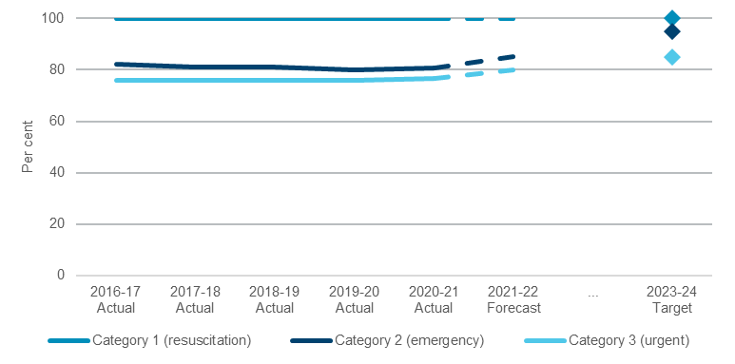

Performance indicators for this Outcome
Outcome Indicators | Units | 2020-21 | 2021-22
 |  | Actual^{(a)} | Forecast
Overall patient experience index - emergency department patients^{(b)} | no. | 8.7 | 8.5^{(c)}
Transfer of care from ambulance to emergency department staff within 30 minutes | % | 87.5 | 90.0
Triage category 1, 2 and 3 patients commence treatment on time in the emergency department ^{(d)} | %
Proportion of emergency department patients in NSW seen on time |  | 100 | 100
Category 1 (resuscitation)
Proportion of emergency department patients in NSW seen on time |  | 80.5 | 85.0
Category 2 (emergency)
Proportion of emergency department patients in NSW seen on time |  | 76.7 | 80.0
Category 3 (urgent)

Notes:
- Score out of 10.
- 2020-21 Actuals provided are a year to date as at March 2021.
- Forecast reflects current target.
- NSW exceeds national targets (Category 2 – 80%, Category 3 – 75%).

Outcome 4: Keeping people healthy through prevention and health promotion

State Outcome overview and 2021-22 investment
 | $1.5 billion | Recurrent  Expenses  2021-22
 | $11.5 million | Capital  Expenditure  2021-22
Preventive and population health measures are critical to keeping people healthier. It covers a range of functions including to promote public health, control infectious diseases, reduce preventive diseases and death, help people manage their own health including mental health, and promote equitable health outcomes in the community.

2021-22 State Outcome Budget highlights
In 2021-22, the Health Cluster will invest $1.5 billion ($1.5 billion in expenses and $11.5 million capital expenditure) in this Outcome, including:
- $977.4 million in additional expenditure for the NSW Health system to manage the impacts of the COVID-19 pandemic, including:
- $340.0 million to fund personal protective equipment procurement and associated warehousing costs to keep our frontline health workers safe
- $261.3 million for COVID-19 vaccine distribution
- $200.0 million for pop-up clinics, testing and contact tracing
- $145.4 million for returning travellers in quarantine requiring medical assistance
- $30.0 million for the ongoing enhanced level of cleaning within health facilities
- $12.2 million over two years to fund Tresillian for six Regional Family Care Centres to provide services to families experiencing difficulties in the critical first years of their child’s life, as well as five ‘Tresillian 2U’ vans, to provide mobile community support to families with infants and children, and staffing for the Macksville residential unit, which provides inpatient services for families experiencing significant parenting challenges requiring intensive intervention.

Key performance insights
This section provides analysis and insights on key Outcome Indicators for this State Outcome.

Towards zero suicides
This is a Premier’s Priority to reduce the rate of suicide deaths in New South Wales by 20 per cent by 2023.
Performance against this indicator has remained stable and data from the NSW Suicide Monitoring System indicates the number of suicides in 2020 in New South Wales has decreased by almost five per cent compared to 2019.
Reducing the rate of suicide requires a collaborative approach across the health system and governments. The NSW Suicide Data Monitoring System has been established in collaboration between the NSW Ministry of Health, Department of Communities and Justice, the State Coroner and NSW Police to enable the collection and reporting of information on recent suspected and confirmed suicides in New South Wales. NSW Health is continuing to work with these agencies to provide monthly public NSW Suicide Monitoring System Reports.
- Number of suicides per 100,000 people
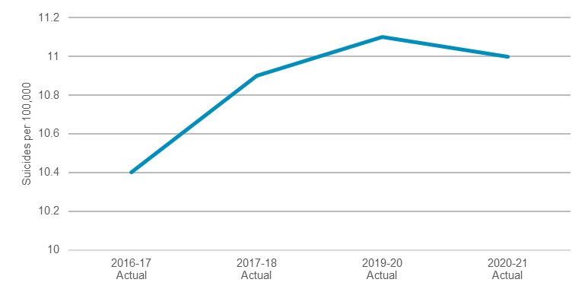

Pregnant women quitting smoking by the second half of their pregnancy
This indicator is aligned with NSW Health’s priority to minimise the harm associated with tobacco use in pregnancy. NSW Health is continuing work to ensure cessation support is offered as part of routine pregnancy care in public hospitals to all pregnant women who smoke.
Performance against this indicator has recently improved. NSW Health has been working on promising long-term measures to improve clinical practice to reduce the harms of tobacco on mothers and babies. NSW Health strategies also include targeted action for priority populations, including to improve outcomes for Aboriginal women. Work undertaken includes improving data systems and electronic referrals to Quitline in maternity and other health services. NSW Health is disseminating over 300 carbon monoxide monitors through the Safer Baby Bundle program to maternity services to support conversations with expecting parents about smoking harms. Development and implementation of some measures has been delayed due to COVID-19.
- Proportion of women quitting smoking by the second half of their pregnancy
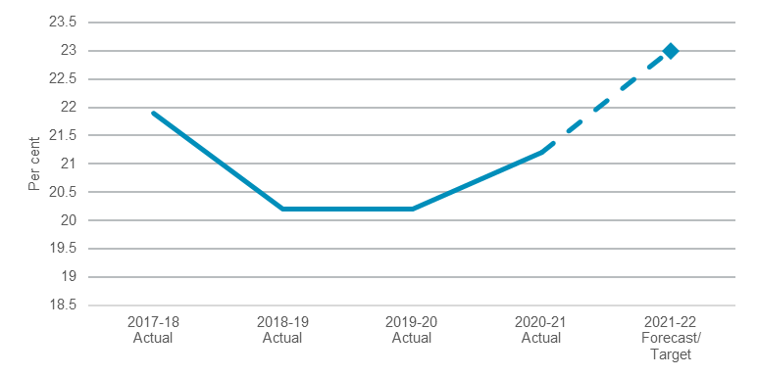

Performance indicators for this Outcome
Outcome Indicators | Units | 2020-21 | 2021-22
 |  | Actual | Forecast
Breast Screen participation rates (Women Aged 50-74) | %
Breast Screen participation rates (Women Aged 50-69) |  | n.a.^{(a)} | ≥55
Breast Screen participation rates (Women Aged 70-74) |  | n.a.^{(a)} | ≥55
Children fully immunised at one year of age | %
Aboriginal children |  | 94.9^{(b)} | 95.0
Non-Aboriginal children |  | 94.8^{(b)} | 95.0
Get Healthy Information and Coaching Service - Get Healthy in Pregnancy Referrals | no. | 10,503^{(c)} | ≥12,000
Pregnant women quitting smoking by the second half of their pregnancy | % | 21.2 | 23.0
Towards zero suicides (per 100,000 people) | no. | 11.0 | n.a.

Note:
- Breast Screen participation rates for 2020-21 is not available until June 2021.
- Complete data from January to December 2020.
- 2020-21 actual is for three quarters as at end of Quarter 3 2020-21.

Outcome 5: Our people and systems are continuously improving to deliver the best health outcomes and experiences
 | $1.1 billion | Recurrent  Expenses  2021-22
 | $12.5 million | Capital  Expenditure  2021-22

State Outcome overview and 2021-22 investment
A skilled workforce with access to world leading education and training, and a system that harnesses research and digital innovation is essential to continuously improving outcomes and experiences of care across the system. This expertise is delivered by a range of statutory bodies and system managers.

2021-22 State Outcome Budget highlights
In 2021-22, the Health Cluster will invest $1.1 billion ($1.1 billion in recurrent expenses and $12.5 million in capital expenditure) in this Outcome, including:
- $4.6 million over four years to boost resources for the Health Care Complaints Commission, enabling it to process complaints in a more timely way.

Key performance insights
This section provides analysis and insights on key Outcome Indicators for this State Outcome.

Increasing the volume of discharge summaries delivered electronically to General Practitioners (GPs)
Electronic discharge summaries enable well-coordinated and effective sharing of health information between care settings and clinicians. They support patients as they return to the community and may reduce unnecessary hospital visits. A number of planned projects will focus on increasing the percentage of discharge summaries delivered electronically to GPs.
Performance against this indicator continues to exceed the previous target and as at the end of December 2020 has increased 1.2 percentage points from 2019-20. There has been a continued increase on the delivery of electronic discharge summaries to GPs.

- Increase in the percentage of discharge summaries delivered electronically to GPs
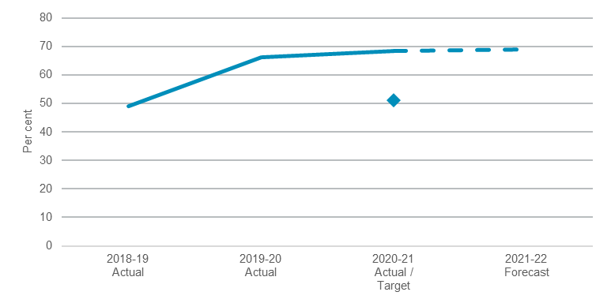

Performance indicators for this Outcome
Outcome Indicators | Units | 2020-21 | 2021-22
 |  | Actual | Forecast
Ethics Application Approvals - By the Human Research Ethics Committee within 45 calendar days | % | 81.0 | 80.0
Increase the percentage of discharge summaries delivered electronically to GPs | % | 68.3 | 69.0

The total amount of capital investment in 2021-22 will be $3.2 billion. This includes $138.7 million of capital expensing from the Ministry of Health’s expense budget.
The total expenditure on COVID-19 is $1.1 billion in 2021-22. This includes $80.0 million of additional elective surgery listed under Outcome 1.

