4. PLANNING, INDUSTRY AND ENVIRONMENT CLUSTER

Introduction
 | $6.1 billion | Recurrent  Expenses  2021-22
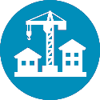 | $995.0 million | Capital  Expenditure  2021-22
The Planning, Industry and Environment Cluster is responsible for the stewardship of the NSW Government’s natural and built assets. The Cluster’s key areas of focus include: planning and enabling development and the delivery of infrastructure to drive economic activity, protecting our native flora and fauna, setting the future direction of waste, sustainable materials and the circular economy, and ensuring an affordable, reliable and sustainable energy future. The Cluster is also responsible for creating better public and open spaces, improving the use and management of government-owned land and property, securing and improving the State’s water supply, increasing housing affordability and supply, and improving outcomes for Aboriginal people across the State, with a focus on land and housing.

State Outcomes to be delivered by the Planning, Industry and Environment Cluster
State Outcomes  What the Cluster is delivering for people and business |  | Key Programs  underway to support delivery of Outcomes
- Connecting communities to resilient and sustainable energy and local environments  Protecting and preserving the quality of our environment via active stewardship to support a healthy New South Wales while securing an affordable, reliable and sustainable energy future.  2021-22 investment: $2.4 billion in recurrent expenses & $351.2 million in capital expenditure |  | - Conservation, preservation and improved community enjoyment of national parks  - Ensuring a secure and sustainable energy future  - Reducing carbon emissions while supporting a sustainable, climate-resilient New South Wales  - Encouraging a circular economy to turn waste into a resource
- Create a strong and liveable NSW  Planning for great places that create the conditions for prosperity, economic development, innovation and jobs. The delivery of infrastructure and a diverse housing mix that responds to the needs of communities, and securing environmental sustainability, good design, greener places and safe and inclusive public spaces that bring communities together.  2021-22 investment: $1.1 billion in recurrent expenses & $33.4 million in capital expenditure |  | - Coordinating and enabling the place and infrastructure outcomes of regional plans  - Delivering better outcomes for place, design, public spaces and green infrastructure  - Make strong, fair and quick planning assessments driving balanced outcomes
- Maximise community benefit from government land and property  Delivering a coordinated, strategic approach to the use of government-owned property to maximise community benefits by delivering quality public spaces and diverse housing outcomes.  2021-22 investment: $1.7 billion in recurrent expenses & $564.2 million in capital expenditure |  | - Better use of government-owned land and property  - Empowering Aboriginal communities for independent social and economic futures  - Better place creation  - Optimise benefits of Crown land
- Sustainable, secure and healthy water resources and services  Providing confidence to communities and stakeholders through the transparent stewardship of water resources, provision of services and reforms that support sustainable and healthy environments, economies and societies across New South Wales.  2021-22 investment: $815.9 million in recurrent expenses & $46.2 million in capital expenditure |  | - Improved water sustainability, water access and water health  - Improved water regulation

Overview of Cluster expenses by State Outcome
A summary of expenses by State Outcome is provided in the charts below.
- Recurrent expenses by Outcome 2021-22 (dollars and %)

Note: The sum of percentages does not equal one hundred due to rounding.
- Capital expenditure by Outcome 2021-22 (dollars and %)

Note: Grouped for presentation purposes, “Other State Outcomes” comprises:
- Create a strong and liveable NSW
- Sustainable, secure and healthy water resources and services.

Outcome 1: Connecting communities to resilient and sustainable energy and local environments
 | $2.4 billion | Recurrent  Expenses  2021-22
 | $351.2 million | Capital  Expenditure  2021-22

State Outcome overview and 2021-22 investment
Protecting and preserving the quality of our environment through active stewardship to support a healthy New South Wales and securing an affordable, reliable and sustainable energy future.
This State Outcome comprises activity across energy, climate change and resource use and sustainability; biodiversity protection including habitat conservation, threatened species and aquatic habitats; nature-based experiences in national parks and zoos; and human and environmental health through regulation.
Delivery is shared by the Department of Planning, Industry and Environment (the Department), the NSW Environment Protection Authority (EPA), Natural Resources Commission, the Biodiversity Conservation Trust, Zoological Parks Board, and the Environmental Trust.

2021-22 State Outcome Budget highlights
In 2021-22, the Planning, Industry and Environment Cluster will invest $2.8 billion ($2.4 billion recurrent expenses and $351.2 million capital expenditure) in this Outcome, including:
- $785.4 million ($1.9 billion recurrent expenses and $495.8 million capital expenditure over four years) for national parks. This includes:
- $21.7 million ($15.7 million recurrent expenses and $49.6 million capital expenditure over four years) for grants from the Environmental Trust to the National Parks and Wildlife Services to support the acquisition of high value conservation land for protection in the NSW national parks estate, support the rewilding of threatened fauna, and implement ecological health monitoring and reporting projects to deliver improved conservation outcomes through evidence-based park management
- $10.3 million ($5.4 million recurrent expenses and $80.4 million capital expenditure over four years) for new signature walking experiences, including the Great Southern Walk in the Illawarra. The walks will include a range of dedicated accommodation options, making our natural and cultural heritage assets in our NSW national parks a must-see destination for local, national and international visitors
- $333.2 million ($1.3 billion recurrent expenses over four years) to enable the provision of energy rebates and emergency vouchers to help reduce energy bills and provide the community with more affordable energy
- $257.3 million ($959.1 million recurrent expenses and $75.3 million capital expenditure over four years) to protect New South Wales’ invaluable biodiversity, including:
- $46.3 million ($125.0 million recurrent expenses and $68.3 million capital expenditure over five years) to deliver on the NSW Government’s goal to double the number of koalas in New South Wales by 2050
- $15.0 million ($75.0 million recurrent expenses over five years) to continue the Saving our Species program, New South Wales’ flagship threatened species conservation program, to maximise the number of ecological communities and threatened species that are secure in the wild in New South Wales

- $13.5 million ($25.7 million recurrent expenses and $3.8 million capital expenditure over two years) to continue the delivery of the Land Management and Biodiversity Conservation Framework, including regulatory activities, implementation of the Biodiversity Offsets Scheme, and biodiversity mapping, assessment and evaluation
- $149.7 million ($698.8 million recurrent expenses and $5.0 million capital expenditure over four years) to protect the community and environment from waste pollution and support the transition to a circular economy where we use materials more sustainably and reduce our carbon emissions. Activities include:
- implementing the NSW Waste and Sustainable Materials Strategy 2041 and NSW Plastics Action Plan
- continuing to keep our community safe and environment clean by targeting illegal dumping, littering and hazardous wastes
- $147.6 million ($248.5 million recurrent expenses and $164.4 million capital expenditure over four years) to implement the Electricity Infrastructure Roadmap, the Government’s plan to attract $32.0 billion in private investment in new generation, storage, firming and network infrastructure by 2030, including:
- $35.1 million ($121.6 million recurrent expenses over two years) to establish the administrative entities including the Consumer Trustee, Financial Trustee and the Regulator
- $15.2 million ($72.4 million recurrent expenses and $2.4 million capital expenditure over four years) for the Energy Corporation of NSW to enable the coordinated delivery of Renewable Energy Zones across New South Wales
- $140.9 million recurrent expenses to manage waste and clean-up relating to bushfires and floods
- $49.0 million ($253.1 million recurrent expenses over four years) to transition New South Wales to net zero emissions by 2050, create more sustainable businesses and support job creation for the future economy. A key element is the Net Zero Industry and Innovation Program, launched in March 2021 with three focus areas:
- supporting existing industry to transition to low emission alternatives and future proof their businesses
- creating the jobs of the future by setting up low carbon industries such as green hydrogen
- bolstering research and development in clean technology to support decarbonising in ways that grow the economy.

Key performance insights
This section provides analysis and insights on key Outcome Indicators for this State Outcome.

Energy as a proportion of the average household cost of living
This indicator measures low and average-income household electricity bills as a proportion of the household’s disposable income. The NSW Government’s energy efficiency programs, energy rebates and the Electricity Infrastructure Roadmap seek to reduce energy costs for consumers.
Performance against this indicator has improved in the last three years, which means households have more money to spend on other costs of living. This is due to a mix of market and regulatory changes, especially a reduction in the wholesale electricity cost component of retail electricity prices.

Under the NSW Government’s Electricity Infrastructure Roadmap to modernise the electricity sector, households are expected to save an average of $130 annually on electricity bills between 2023 to 2040. Energy as a proportion of the average household cost of living is expected to remain stable in 2020-21 and 2021-22.
- Energy as a proportion of the average household cost of living
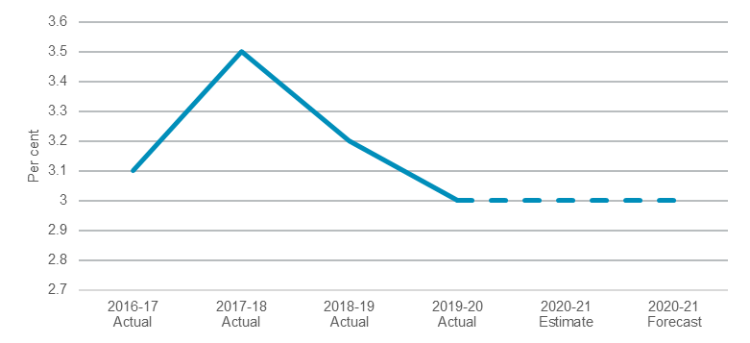
Note: 2020-21 actual data is not yet available, and an estimate for 2020-21 has been provided.

Millions of tonnes of CO₂ equivalent emissions (MtCO₂-e) emitted annually in New South Wales
The NSW Government’s commitment to achieve net zero emissions by 2050 is set out in the NSW Climate Change Policy Framework released in 2016.
This indicator reports greenhouse gas emissions from all sectors of the economy and all other emitting and greenhouse gas sequestering activities occurring in New South Wales.
Performance against this indicator continues to remain stable with 2019 emissions, 17 per cent lower than 2005 levels. The Net Zero Plan Stage 1: 2020-2030 sets out the NSW Government’s plan to reduce emissions by 35 per cent by 2030 compared to 2005 levels, and ultimately aims to achieve net zero emissions in ways that grow the economy and reduce the cost of living and doing business.
The NSW Government has committed $1.2 billion from 2020-21 to 2029-30 to support programs under the Net Zero Plan Stage 1: 2020-2030. Further detailed plans will be developed over the next two decades to ensure net zero emissions are achieved by 2050.
- Millions of tonnes of CO₂ equivalent emissions (MtCO₂-e) emitted annually in NSW
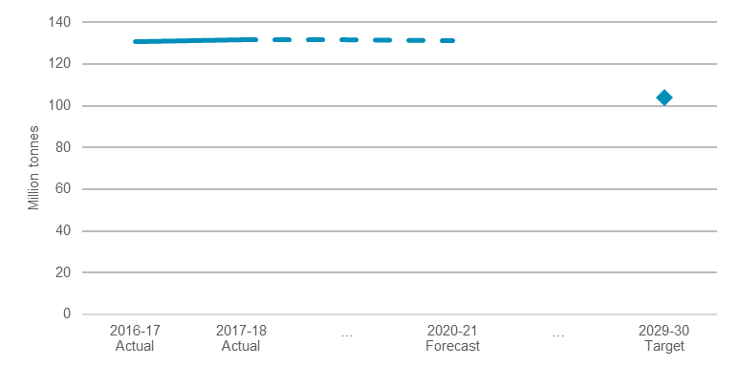
Note: 2020-21 actual data is not yet available, and an estimate for 2020-21 has been provided.

Number of threatened species and ecological communities on track to be secure in the wild
Saving our Species is the NSW Government’s flagship program for threatened species conservation which aims to secure threatened species in the wild and control key threats facing threatened plants and animals.
Through investment of $100.0 million from 2016-17 to 2020-21, the number of threatened species and threatened ecological communities under active management has risen from 94, to over 400 species at 1,050 sites, a 400 per cent increase since the 2015-16 baseline. The program now has over 220 partners working with the NSW Government to co-invest time and resources into species conservation. There has been a decrease in threatened species and ecological communities security as a result of the drought and 2019-20 bushfires as reflected in the graph below.
There are roughly 270 species on track to be secure in the long term and this will increase as program outcomes continue to turn around the decline of threatened species and communities over time.
- Number of threatened species and ecological communities on track to be secure in the wild
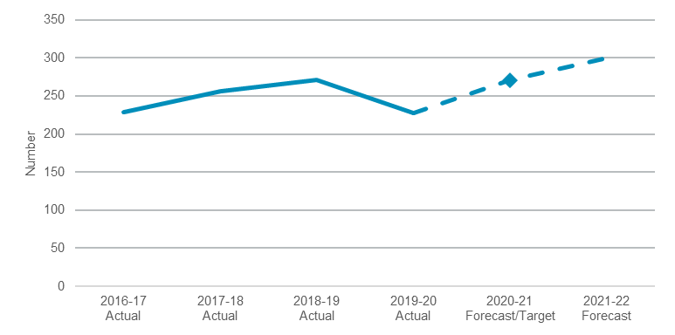

Note: 2020-21 actual data is not yet available, and an estimate for 2020-21 has been provided.

Performance indicators for this Outcome
Outcome Indicators | Units | 2020-21 | 2021-22
 |  | Actual | Forecast
Proportion of prioritised aquatic habitats receiving environmental water in NSW | % | 35.0 ^{(a,b)} | 30.0
Energy as a proportion of the average household cost of living | % | 3.0 ^{(a)} | 3.0
Number of environmental incidents impacting human health and the environment | no. | 8,933 ^{(a)} | 8,900 ^{(c)}
Millions of tonnes of CO₂ equivalent emissions (MtCO₂-e) emitted annually in NSW | no. | 131.3 ^{(a)} | n.a^{. (d)}
NSW Energy Security Target met
Demand | MW | 15,633 ^{(a)} | 16,063
Supply | MW | 16,256 ^{(a)} | 16,458
Number of hectares managed for conservation, including national parks and reserves, and private land
Private land | million Ha | n.a.^{(e)} | n.a. ^{(e)}
Public land | million Ha | 7.456 ^{(a, f)} | 7.556 ^{(f)}
Number of visitors each year to national parks and zoos
Number of visitors to parks | million | 60.2 ^{(g)} | n.a. ^{(g)}
Number of visitors to zoos | million | 1.14 ^{(a,h)} | 1.10
Number of threatened, or previously locally extinct, species and ecological communities on track to be secure in the wild | no. | 271 ^{(a)} | 300

Notes:
- 2020-21 data is not yet available, and an estimate for 2020-21 has been provided.
- High rainfall events over the State and wetter conditions in third quarter of 2020-21 have positively influenced the year end estimate for 2020-21.
- While the aspiration is to have fewer environmental incidents overall, reports of incidents have been steady at around 8,900 per year. Reporting of incidents is encouraged through increased public awareness, education campaigns, and during extreme events (such as high rainfall events). EPA regularly seeks to improve access for citizens to report incidents through the EPA Environment Line and to improve reporting and management of incidents across local and state government and emergency services. These measures may lead to increases in the number of reported incidents.
- 2021-22 forecast data available August 2021.
- Performance will depend on individual outcomes of tenders and fixed price offers, as well as available budget.
- These figures are reported to threedecimal places, due to the magnitude of the numbers.
- 2017-18 data has been provided, as 2019-20 data will not be available due to impacts of bushfires and COVID-19.
New data will be available for 2021-22 (reported every two years).
- The Dine & Discover NSW program has contributed to strong performance in the last half of 2020-21. COVID-19 related restrictions (i.e. overseas tourist limits) will continue to impact visitation in 2021-22 (and beyond).

Outcome 2: Create a strong and liveable NSW

State Outcome overview and 2021-22 investment
 | $1.1 billion | Recurrent  Expenses  2021-22
 | $33.4 million | Capital  Expenditure  2021-22
Planning for great places that create the conditions for prosperity, economic development, innovation and jobs, delivering infrastructure and a diverse housing mix that responds to the needs of communities, and securing environmental sustainability, good design, greener places and safe and inclusive public spaces that bring communities together.
This State Outcome comprises initiatives aimed at improving liveability across New South Wales with enhanced open, green and public spaces, delivering planning efficiencies to drive productivity, increasing housing supply and enabling infrastructure delivery in growth areas to create healthy, connected and prosperous places.
Delivery of this Outcome is shared between Place Design and Public Spaces, Planning and Assessment and Housing and Property.

2021-22 State Outcome Budget highlights
In 2021-22, the Planning, Industry and Environment Cluster will invest $1.2 billion ($1.1 billion recurrent expenses and $33.4 million capital expenditure) in this Outcome, including:
- $179.9 million ($328.3 million recurrent expenses and $36.3 million capital expenditure over four years) to deliver the NSW Planning Reform Action Plan to improve the timeliness, transparency and certainty of the State’s planning system. This includes $86.9 million ($173.8 million recurrent expenses over two years) for the NSW Public Spaces Legacy Program, which will continue to accelerate planning assessments and fund 60 councils to provide new and improved public and open spaces across the State. Other planning reforms include consolidating employment zones and optimising the use of industrial land to generate jobs and support economic growth
- $139.3 million recurrent expenses to deliver the Accelerated Infrastructure Fund 2, which will provide funding to councils in high growth areas to support construction activity and the release of new homes and employment areas in key greenfield sites. This follows on from $70.0 million invested in the Accelerated Infrastructure Fund in 2020-21, which co-funded councils in north-west Sydney to deliver 14 projects worth $143 million, unlocking the development of up to 40,000 new homes, 115 hectares of employment land and up to 1,000 jobs
- $78.5 million ($314.0 million recurrent expenses over four years) for existing pensioner council rate concessions to assist councils in easing the cost of living
- $69.3 million ($123.1 million capital expenditure over three years) to continue the Strategic Open Spaces Program across Greater Sydney, including new and upgraded parks at Penrith, Ermington, Appin, Leppington, Frenchs Forest, Belrose, Carramar, Beaumont Hills, Hurstville; and funding for Callan Park
- $22.6 million ($15.4 million recurrent expenses and $30.0 million capital expenditure over two years) for the Cumberland Plain Conservation Plan to acquire the first stage of the Georges River Koala Reserve, restore native plants for koala habitat, deliver koala exclusion fencing to protect koalas from urban interfaces and establish biodiversity stewardship agreements for up to 540 hectares of conservation lands in the Greater Macarthur Growth Area

- $4.9 million ($20.0 million recurrent expenses over four years) to continue to deliver strategic plans to shape land use rezoning outcomes; deliver the committed 12 State-led rezoning precincts by the end of 2022 and then ongoing additional precincts, support councils through collaboration on council-led precincts and deliver ongoing State-led rezonings
- $1.5 million ($34.1 million recurrent expenses over three years) to expand the Roads to Home Program, which will provide planning and infrastructure upgrades to up to 10 additional Aboriginal communities. This brings the Government’s commitment to the Roads to Home Program to $108.9 million since 2019-20 for up to 31 Aboriginal communities.

Key performance insights
This section provides analysis and insights on key Outcome Indicators for this State Outcome.

Ensure a 17 per cent reduction in State significant development assessment times from 120 to 100 days by June 2023
During 2021, the Department focused resources on closing long standing legacy applications, which initially increased timeframes. Following these focused efforts, the overall assessment timeframes are now trending down towards the 30 June 2021 target of 116 days. Forecasting shows performance improving steadily to reduce assessment timeframes towards the 2021-22 and 2022-23 targets.
In 2021, the Department introduced several measures to assist with reducing assessment timeframes. This included introducing more effective case management, utilising resources to streamline inter-agency and stakeholder issues across portfolios of projects, and improving delegations.
The Department has also introduced several key reforms including the rapid assessment framework (effective from July 2021), which will help further drive timeframes down towards 100 days. Other initiatives include the standardisation of the Secretary’s Environment Assessment Requirements and improving the quality of assessment and supporting reports.
- Number of days to complete state significant development assessments
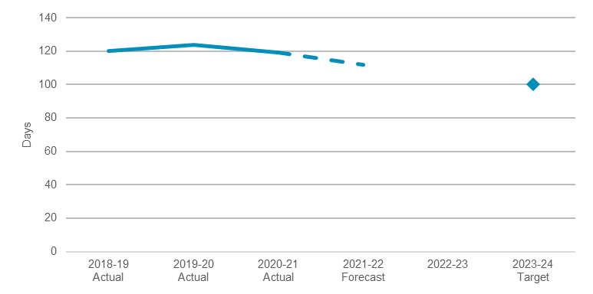

Increase the proportion of homes in urban areas within 10 minutes’ walk of quality green, open and public space by 10 per cent by 2023
This indicator is on track to achieve its target by June 2023. At 30 April 2021, new or improved public space projects had increased walkable 10 minute access to quality green, open and public spaces for 118,160 homes within urban areas of New South Wales. This will be extended to an additional 111,840 homes by 30 June 2023.
The key programs contributing to this achievement include the Everyone Can Play grants, a program to support the delivery of inclusive play spaces and ensure people of all ages, abilities, and cultural backgrounds can play; the Parramatta Road Urban Amenity Improvement Program, the Precinct Support Scheme, the Metropolitan Green Space Program, the NSW Public Spaces Legacy Program, and the Your High Street and Streets as Shared Spaces grant funding programs. The Department is also partnering with local communities to design and deliver eight new, high quality public spaces through the Parks for People Strategic Open Space Program.
The Department is driving reform to enable more activated public space over the long term including by developing the State’s first NSW Public Spaces Charter, and Public Open Space Strategy, working with New South Wales councils to implement Sydney’s Green Grid and empowering councils to secure new parks through their local planning strategies.
- Percentage increase of homes in urban areas within 10 minutes’ walk of new or improved public space
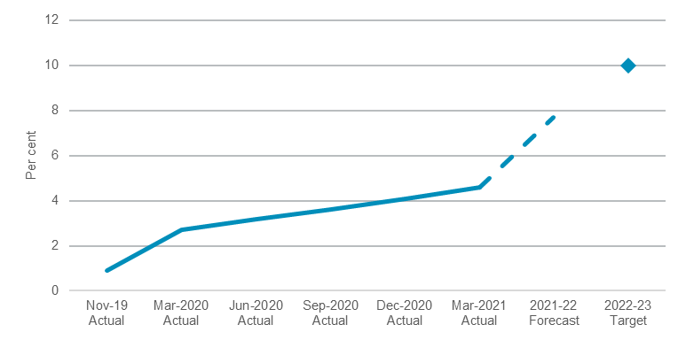

Plant one million trees across Greater Sydney by 2022
Performance against this Premier’s Priority is on track to meet its target, with more than 500,000 trees planted and a further 250,000 trees procured to be planted by 2022. This represents more than double the number of trees planted in the 12 months to March 2021.
To help engage all sectors of the community in this priority, the Department is also pursuing several flagship programs, including:
- partnerships with peak organisations such as Landcare NSW, Greening Australia and Planet Ark to increase engagement and tree planting on public and private land
- working with NSW Government agencies such as NSW Health and the Department of Education to deliver greening demonstration projects at Fairfield and Westmead Hospitals and a cooling the schools tree canopy program at some of Greater Sydney’s hottest schools

- delivering innovation projects with councils and corporate partners, such as Skyparks at Bondi Junction Westfield, University of NSW and the Entertainment Quarter through the installation of light-weight modular green roof units.
- Number of trees planted across Greater Sydney
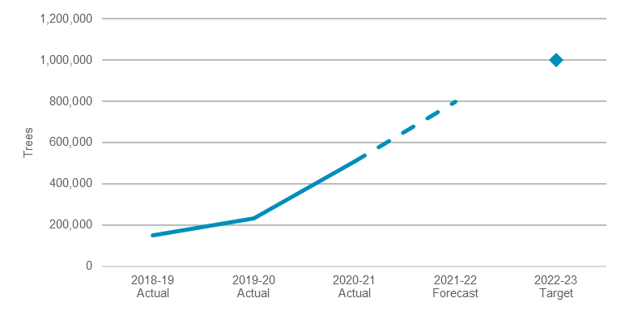

Performance indicators for this Outcome
Outcome Indicators | Units | 2020-21 | 2021-22
 |  | Actual | Forecast
Ensure a 17 per cent reduction in state significant development assessment times from 120 to 100 days by June 2023 (except projects subject to an Independent Planning Commission hearing) | days | 119.0 | 112.0
Increase the proportion of homes in urban areas within 10 minutes’ walk of quality green, open and public space by 10 per cent by 2023 | % | 4.6 | 7.7
Plant one million trees across Greater Sydney by December 2022 | no. | 505,939 | 800,000^{(a)}
100 per cent of precincts delivered within publicly stated timeframes | % | 33 | 100

Note:
(a) Figure is the cumulative number of trees forecast to be planted by June 2022.

Outcome 3: Maximise community benefit from government land and property

State Outcome overview and 2021-22 investment
 | $1.7 billion | Recurrent  Expenses  2021-22
 | $564.2 million | Capital  Expenditure  2021-22
Delivering a coordinated, strategic approach to the use of government-owned property to maximise community benefits by delivering quality public spaces and diverse housing outcomes.
This State Outcome comprises activities aimed at improving asset management; the development and maintenance of social housing; the management of Crown land and key precincts; increasing the supply of housing for Aboriginal communities; and improving public spaces and parklands.
Delivery is shared by the Department of Planning, Industry and Environment, Land and Housing Corporation, Aboriginal Housing Office, Property & Development NSW, Greater Sydney Parklands, Royal Botanic Gardens and Domain Trust, Place Management NSW, Sydney Olympic Park Authority and the Hunter and Central Coast Development Corporation.

2021-22 State Outcome Budget highlights
In 2021-22, the Planning, Industry and Environment Cluster will invest $2.3 billion ($1.7 billion recurrent expenses and $564.2 million capital expenditure) in this Outcome, including:
- $337.9 million ($307.1 million recurrent expenses and $204.2 million capital expenditure over four years) for the construction and acceleration of new social housing properties, as well as upgrades and maintenance, by the Land and Housing Corporation and the Aboriginal Housing Office. Activity will support job creation, improve the quality, comfort and safety of housing for tenants, provide roof restorations and replacements, recladding, solar power installations, drought relief hydro panels, climate resilient housing works and air conditioning
- $79.6 million ($48.5 million recurrent expenses and $31.2 million capital expenditure) to create better public and open spaces and improve government infrastructure including upgrades to showgrounds, public reserves, national parks, gardens and parklands, and accommodation for frontline workers in rural and remote communities
- $73.4 million ($191.8 million recurrent expenses and $63.1 million capital expenditure over four years) for improvements to the Greater Sydney Parklands including: developing the Western Sydney parklands into a multi-use urban parkland that provides a diverse range of recreational, entertainment and tourist facilities; and improving Centennial Park and Moore Park Trust lands to increase public use and enhance recreational, cultural and environmental value
- $54.8 million ($106.0 million recurrent expenses and $50.9 million capital expenditure over four years) for improvements to the Royal Botanic Gardens and Domain Trust including improvements to the Australian Institute of Botanical Science facilities, and delivering a new botanical facility in Western Sydney to ensure the security of plant specimens essential for conservation, bushfire regeneration and ongoing management of the natural environment
- $20.0 million ($60.0 million recurrent expenses over three years) for 300 new housing sector pre-apprenticeships, apprenticeships and cadetships to provide career pathways for young people and social housing tenants

- $18.9 million ($7.4 million recurrent expenses and $103.2 million capital expenditure over four years) for new office hubs in Dubbo and Coffs Harbour to consolidate existing tenancies and provide modern, efficient office spaces to attract and retain regional government staff
- $10.0 million ($5.2 million recurrent expenses and $119.3 million capital expenditure over four years) to support the adaptive re-use of the Registrar General’s Building as a cultural venue and public open space consistent with the Macquarie Street East Precinct Review
- $6.7 million for further infrastructure upgrades at racecourses across regional New South Wales, generating jobs and supporting economic growth in the regions
- $5.8 million ($11.6 million recurrent expenses over two years) for the extension of the Services Our Way program, providing a critical connection between government and non-government services and on the ground, practical support and skill development for Aboriginal people and families with complex needs.

Key performance insights
This section provides analysis and insights on key Outcome Indicators for this State Outcome.

Number of additional and upgraded homes that have commenced construction in priority communities
The NSW Government is investing in social and affordable housing for Indigenous priority communities in New South Wales to deliver diverse housing options where it is needed most leveraging government land and property.
Performance against this indicator is currently on track to meet the 2020-21 target. In 2019-20, 714 additional and upgraded homes commenced construction in priority communities. In 2020-21, 580 have currently commenced against a target of 682 for the year. The number decreased from 2019-20 due to the National Partnership Agreement on Remote Indigenous Housing (NPARIH) ending in 2020-21. The 2020-21 target remains on track due to the uplift of the Aboriginal Housing Office’s Capital Works program provided as part of NSW economic stimulus measures.
- Number of additional/upgraded homes that have commenced construction in priority communities
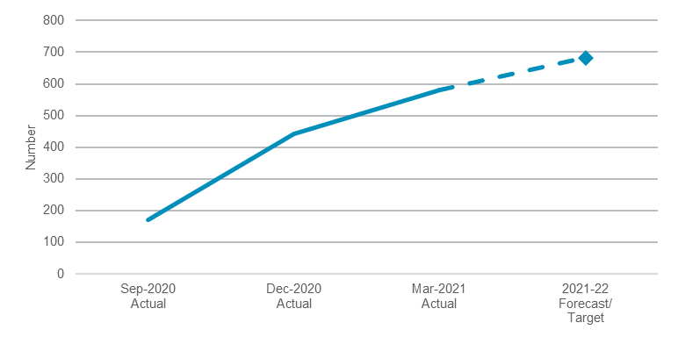
Note: This indicator measures the number of homes each financial year and only the current financial year performance is shown for presentational purposes and the indicator restarts at zero at the beginning of each financial year.

Percentage of entities in the DPIE Housing and Property group that are compliant with TPP19-07 NSW Asset Management Policy by 2024
The indicator demonstrates to the people of New South Wales that Housing and Property is continuously monitoring the performance and condition of its assets, increasing public accountability, and seeking to obtain better value from public funds. The objective of the Asset Management Policy for the NSW Public Sector is to achieve a consistent and improved approach to asset planning and delivery.
The policy requires that Housing and Property entities have a fit-for-purpose asset register, an asset management policy, a strategic asset management plan, and an asset management plan. All of Housing and Property’s entities were granted transitional status during 2020-21 and have successfully completed strategic asset management and asset management plans.

Performance indicators for this Outcome
Outcome Indicators | Units | 2020-21 | 2021-22
 |  | Actual | Forecast
Number of additional/upgraded homes that have commenced construction in priority communities | no. | 580 | 630
Number of reviews completed on NSW Government land and property in strategic  precincts and/or portfolios | no. | 3 | 4

Outcome 4: Sustainable, secure and healthy water resources and services

State Outcome overview and 2021-22 investment
 | $815.9 million | Recurrent  Expenses  2021-22
 | $46.2 million | Capital  Expenditure  2021-22
Providing confidence to communities and stakeholders through the transparent stewardship of water resources, and provision of services and reforms that support sustainable and healthy environments, economies and societies across New South Wales.
The State Outcome comprises activities aimed at improving water sustainability, access to and the health of water, improving water regulation, and increasing the safety of New South Wales dams.
Responsibility for delivery of this State Outcome is shared by the Department of Planning, Industry and Environment (Water Group) and the Natural Resources Access Regulator (NRAR).

2021-22 State Outcome Budget highlights
In 2021-22, the Planning, Industry and Environment Cluster will invest $862.1 million ($815.9 million recurrent expenses and $46.2 million capital expenditure) in this Outcome, including:
- $152.1 million ($635.0 million recurrent expenses over four years) for water rebates to low-income households to assist with cost of living
- $131.9 million ($100.5 million recurrent expenses and $31.4 million capital expenditure) made up of combined Commonwealth and State government funding to continue the development of business cases and early planning for water security measures, as part of the $245.0 million commitment to address water security issues in the Lachlan Valley, Peel Valley and Border Rivers Regions
- $75.8 million ($306.9 million recurrent expenses over four years) committed as part of the Independent Pricing and Regulatory Tribunal draft price determinations which will deliver:
- $46.6 million ($176.6 million recurrent expenses over four years) for Water Administration Ministerial Corporation water management services
- $29.3 million ($130.6 million recurrent expenses over four years) for Water NSW rural bulk water services for the State’s Community Service Obligation
- $68.6 million ($280.2 million recurrent expenses over four years) under the Safe and Secure Water Program for critical local water infrastructure to maintain and improve town water supply
- $49.5 million ($84.0 million recurrent expenses over two years) to continue commitments for drought-related water infrastructure being delivered by local councils and other drought proofing and support measures for regional communities
- $47.3 million for the Regional Water Stimulus program to deliver urgent water infrastructure to protect and optimise the use and reuse of the State’s precious water resources

- $32.2 million ($130.7 million recurrent expenses over four years) to investigate suspicious activities and alleged breaches to water regulation in New South Wales and manage dam safety
- $19.9 million ($37.0 million recurrent expenses over four years) to support the delivery of water strategies:
- $13.1 million to deliver regional and Greater Sydney water strategies and set medium to long term strategic directions for water resource management across the State
- $6.8 million ($23.8 million recurrent expenses over four years) to deliver the NSW Water Strategy and the Aboriginal and ground water strategies to set the direction for water policy, planning and infrastructure decisions for the next 20 years and beyond, based on enhanced modelling capabilities to underpin sophisticated climate analysis
- $8.3 million ($13.6 million recurrent expenses over four years) to deliver detailed business cases, detailed site assessments and community engagement for the Lostock Dam to Glennies Creek Dam two-way pipeline to significantly improve water security in the Hunter and to address economic risks facing the region
- $4.8 million ($12.5 million recurrent expenses for three years) to reduce water losses and improve water security needs while delaying or avoiding more costly water supply augmentation and optimising future capital investment.

Key performance insights
This section provides analysis and insights on key Outcome Indicators for this State Outcome.

Proportion of water strategy actions implemented across New South Wales
This indicator monitors the number of actions implemented for completed water strategies across New South Wales, delivering greater sustainability, security and health of water resources.
Performance against this indicator is currently on track to meet its 2023 target of 60 per cent of water strategy actions implemented, with 20 per cent of actions forecast to be implemented by the end of 2020-21. This measure is tied to the number of water strategies completed and is expected to lift markedly as more water strategies are finalised. Whilst only one water strategy will be completed by June 2021, current forecasts predict more than half will be completed by June 2022, with all 12 complete by December 2022.
Actions currently being implemented relate to the Greater Hunter Regional Water Strategy. Events such as the COVID-19 pandemic, 2019-20 bushfires, and the 2021 flooding emergency, impacted the delivery of strategies and the total number of actions that were available for completion over the last 12 months.

- Proportion of water strategy actions implemented across New South Wales
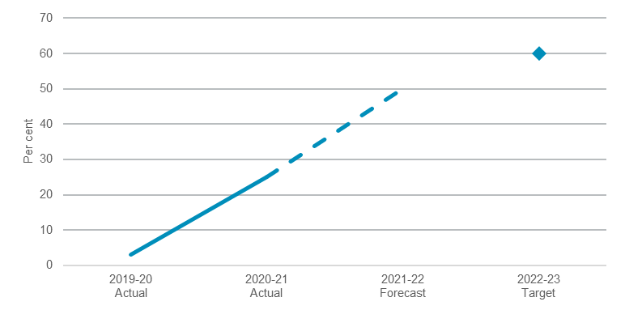

Proportion of reports of alleged breaches of water law assigned a risk rating and allocated for action on time
This indicator drives confidence in the water management framework through improved compliance and enforcement, and aims to demonstrate improvements in the efficiency, effectiveness and prudency of NRAR’s activities.
Performance against this indicator is exceeding its 2023 target of more than 90 per cent of cases triaged within five days, from a baseline of 71 per cent in 2019-20. The continued improvement of this metric is primarily due to a dedicated NRAR team focused on embedding further efficiencies in their procedures and retaining skilled operators with water regulation expertise.
- Proportion of reports of alleged breaches of water law assigned a risk rating and allocated for action on time
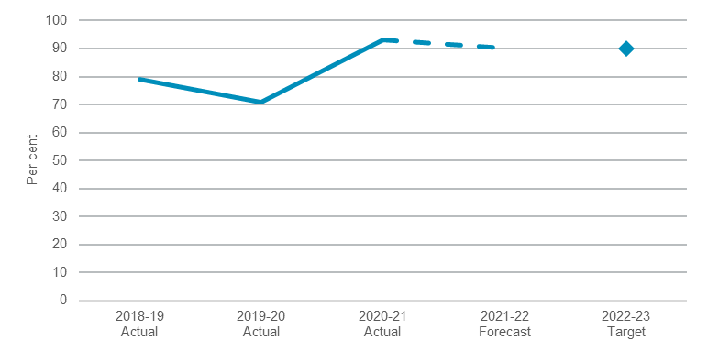

Performance indicators for this Outcome
Outcome Indicators | Units | 2020-21 | 2021-22
 |  | Actual | Forecast
Gigalitres saved, offset or brought into an improved framework as a result of investment in water efficiency projects | GL | 0 | n.a.^{(a)}
Proportion of 92 water utilities across NSW assessed as improved on environmental, water quality, and affordability metrics on an annual basis | % | 55.0 | 55.0
Proportion of reports of alleged breaches of water law assigned a risk rating and allocated for action on time | % | 93.0 | 90.0
Proportion of water strategy actions implemented across NSW^{(b)} | % | 25.0 | 50.0
Water resources are demonstrated to be well managed, as measured by proportion of water sharing plans implemented as demonstrated through audit and evaluation | % | 100.0 | 100.0

Notes:
- This indicator is currently under review for appropriateness and is unlikely to be reported in future, therefore the 2021-22 Forecast not available at time of print. A replacement indicator is currently under development.
- Reported as proportion of actions implemented of completed Water Strategies (currently one strategy completed).

The Independent Pricing and Regulatory Tribunal (IPART) regulates prices for government monopoly services. Figures in this paper were based on the draft determination made in March 2021. Prices remain subject to change until such time as the determination is final.
Note $16.3 million ($64.2 million over four years) of Natural Resources Access Regulator (NRAR)’s funding is included in the Water Administration Ministerial Corporation IPART determination.

