5. pREMIER AND cABINET CLUSTER

Introduction
 | $3.6  billion | Recurrent  Expenses  2021-22
 | $1.3  billion | Capital  Expenditure 2021-22
The Premier and Cabinet Cluster works for the people of New South Wales by supporting the Premier and the Cabinet to deliver the Government’s objectives. It also delivers a diverse range of outcomes including infrastructure, long-term planning, commercial deals for major developments and precincts, preparedness for disaster and incident recovery, brings the voices of Aboriginal people into policy making, supports arts and culture, protects and preserves the State’s heritage, delivers policy and services, facilitates stewardship of the public service and attracts new and expanding businesses to create jobs for the people of New South Wales, along with growing the visitor economy.

State Outcomes to be delivered by the Premier and Cabinet Cluster
State Outcomes  What the Cluster is delivering for people and business |  |  | Key Programs  underway to support delivery of Outcomes
- Effective and coordinated government  Supporting the Cluster’s strategic direction, coordination, assurance and delivery role across government, supporting and attracting new and expanding businesses to create jobs for the people of New South Wales, and growing the visitor economy.  2021-22 investment: $2.3 billion in recurrent expenses & $697.5 million in capital expenditure |  |  |  | - Infrastructure coordination, prioritisation and development  - Disaster recovery and building future community resilience  - Growing the New South Wales visitor economy  - Delivering the Global NSW strategy
2. Excellence in arts, culture and heritage  Maximising ‘excellence in arts, culture and heritage’ leverages New South Wales’ capabilities, positioning the State as a world-class centre for performances, events, exhibitions and cultural visitation, and developing State cultural assets for future generations. Acknowledging that arts, screen, heritage and culture play a critical role in the State’s economy, from skills development and job creation to attracting tourists.  2021-22 investment: $778.5 million in recurrent expenses & $533.9 million in capital expenditure |  |  |  | - Maintain World Heritage and other heritage listed sites  - Collect, conserve and maintain cultural assets  - Engage and exhibit  - Support the arts and culture industry sector  - Educate, research and inspire
3. Empowering Aboriginal communities  Empowering Aboriginal communities leads to a transformed relationship between Aboriginal peoples and government, as well as supporting the delivery of policies and practices that support Aboriginal peoples’ right to self-determination.  2021-22 investment: $106.2 million in recurrent expenses & $0.1 million in capital expenditure |  |  |  | - Closing the Gap Jurisdictional plan for New South Wales  - Stolen Generations Reparations Scheme  - Aboriginal Economic Prosperity Framework  - Aboriginal cultural heritage reform
4. Accountable and responsible government  Supporting good government decision-making and upholding government integrity.  2021-22 investment: $370.3 million in recurrent expenses & $22.8 million in capital expenditure |  |  |  | - Statutory compliance of integrity agencies and independent entities  - Oversight and monitoring  - Training and prevention  - Conduct, regulate and report on elections

Overview of Cluster expenses by State Outcome
A summary of expenses by State Outcome is provided in the charts below.
- Recurrent expenses by Outcome 2021-22 (dollars and %)

- Capital expenditure by Outcome 2021-22 (dollars and %)

Note: The sum of percentages does not equal one hundred due to rounding.
Grouped for presentation purposes, “Other State Outcomes” comprises:
- Accountable and responsible government
- Empowering Aboriginal communities.

Outcome 1: Effective and coordinated government
 | $2.3  billion | Recurrent  Expenses  2021-22
 | $697.5  million | Capital  Expenditure 2021-22

State Outcome overview and 2021-22 investment
This Outcome accounts for the Cluster’s strategic direction, coordination, assurance, investment, industry support and project delivery role across government.

2021-22 State Outcome Budget highlights
In 2021-22, the Premier and Cabinet Cluster will invest $3.0 billion ($2.3 billion in recurrent expenses and $697.5 million in capital expenditure) in this Outcome, including:
- $1.1 billion ($1.4 billion recurrent expenses and $1.2 billion capital expenditure over four years) for Infrastructure NSW to support major infrastructure. Infrastructure NSW is currently responsible for delivering a number of major infrastructure projects for New South Wales with total expenditure of $2.5 billion including:
- $828.0 million for the Sydney Football Stadium Redevelopment
- $750.0 million for the new Sydney Fish Markets
- $355.2 million total remaining cost in developing the Barangaroo precinct
- $789.1 million ($1.6 billion recurrent expenses and $107.2 million capital expenditure over four years) for Resilience NSW to coordinate and oversee disaster management, disaster recovery and build community resilience to future disasters across New South Wales. It is responsible for the State’s recovery from natural disasters and the development of the State’s Resilience Strategy, including:
- $370.2 million ($563.0 million recurrent expenses and $100.0 million in capital expenditure over four years) in disaster relief through the 2021 NSW Storm and Flood Recovery package
- $16.5 million ($41.8 million recurrent expenses over four years), as part of a $268.2 million Stage 2 response to the NSW Bushfire Inquiry, for the establishment of a Bushfire and Natural Hazards Research and Technology Program
- $416.1 million ($1.0 billion recurrent expenses and $14.8 million capital expenditure over four years) for Investment NSW, created on 29 March 2021, to drive local and international investment and create jobs for New South Wales including:
- $35.0 million to implement initiatives under the Entrepreneurship and Innovation Ecosystem government action plan to foster originality, design and investment while creating sustainable jobs in targeted sectors, precincts and regional New South Wales
- $11.0 million ($36.0 million recurrent expenses over four years) for two research initiatives aligned with the State’s 2021 Accelerating Research and Development Action Plan:
    - Emerging Industry Infrastructure Fund to encourage co-investment in targeted industries to develop capability and attract global skills
    - Bushfire Response Research and Development Mission to assist in research and development of technologies to plan, prepare for and respond to bushfires in New South Wales

- $373.4 million ($992.8 million recurrent expenses and $11.6 million capital expenditure over four years) for Destination NSW to promote the State’s tourism and major events sector, including:
- $53.0 million for a COVID-19 response package for eligible disrupted major events, a support package to help the business events industry across New South Wales and a funding boost for tourism marketing
- $50.0 million ($200.0 million recurrent expenses over four years) to rejuvenate the State’s visitor economy by securing future significant events that signal New South Wales as the premier state to visit and do business
- $149.5 million ($201.8 million recurrent expenses and $685.7 million capital expenditure over four years) for the Western Parkland City Authority to deliver on the Government’s promise of a thriving Parkland City for Western Sydney, including:
- $47.3 million ($870.0 million estimated total capital expenditure) for enabling works to prepare the site and build a solid foundation for the new Bradfield City Centre to align with the development of the Western Sydney International (Nancy-Bird Walton) Airport and the Sydney Metro – Western Sydney Airport
- $5.0 million ($21.0 million recurrent expenses and $47.8 million capital expenditure over two years) for the construction of Bradfield City Centre’s First Building, an initial step to develop Bradfield into a thriving city and home to advanced manufacturing, research, science and education.

Key performance insights
This section provides analysis and insights on key Outcome Indicators for this State Outcome.

Improving governance, design and delivery of project infrastructure to make a significant difference for the people of New South Wales
The Cluster, through Infrastructure NSW, supports Government by overseeing project assurance through the Investor Assurance (Gateway) process, including regular reporting on major projects. It also directly delivers infrastructure projects either for other Clusters or as the responsible agency for project delivery. To maintain independence, NSW Treasury carries out Gateway assurance processes for major projects delivered by Infrastructure NSW.
This indicator tracks compliance with Gateway processes and delivery of infrastructure projects. Performance against this indicator is stable and is expected to meet the performance target.
- Percentage of major projects compliant with Gateway processes
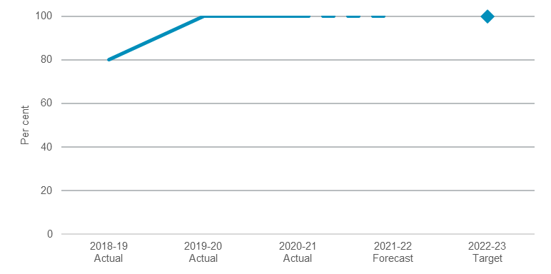

Drive the Premier’s Priorities to make a significant difference for the people of New South Wales
The Premier’s Priorities focus on some of the most complex challenges our community faces. The Premier’s Implementation Unit tracks progress of delivery on an annual basis. Meeting these ambitious targets requires cooperation across NSW Government and innovative approaches.
Performance against this indicator remains stable and is expected to meet performance target.
- Percentage of the 14 Premier’s Priorities assessed as ‘likely to be delivered’
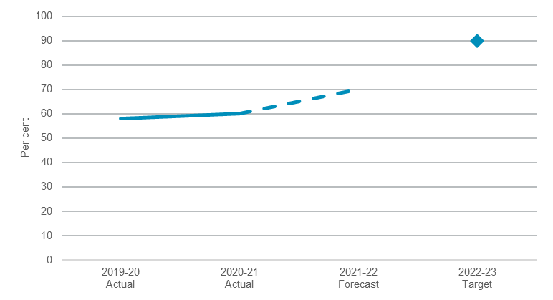

Increases in employment in New South Wales since April 2019 (seasonally adjusted)
Performance against this indicator continues to be challenging due to the impact of COVID-19 on the labour market. Around 270,000 workers in New South Wales lost their jobs between March and May 2020 as restrictions to halt the spread of COVID-19 forced many businesses to close or curtail operations. Twelve months later as restrictions eased, New South Wales regained almost all the lost employment by March 2021.
Despite the labour market rebounding as the economy reopened, the impact of COVID-19 on the population and certain segments of the economy means that the number of people employed is still significantly below where it would have been if not for the pandemic. Under current Commonwealth policy settings, the loss to working age population in New South Wales is expected to be permanent, weighing down employment.

- Jobs created in New South Wales since April 2019

Performance indicators for this Outcome
Outcome Indicators | Units | 2020-21 | 2021-22
 |  | Actual | Forecast
Delivery of the 14 Premier’s Priorities as indicated by their "likelihood of delivery" assessment | % | 60.0^{(a)} | 70.0
Effective delivery of infrastructure projects | % | 100.0 | 100.0
Compliance with Gateway processes for major projects | % | 100.0^{(a)} | 100.0
Jobs created in New South Wales since April 2019 (seasonally adjusted) | no. | 11,090 | 44,020

Notes
- Data is a forecast as financial year is not complete.

Outcome 2: Excellence in arts, culture and heritage
 | $778.5  million | Recurrent  Expenses  2021-22
 | $533.9  million | Capital  Expenditure 2021-22

State Outcome overview and 2021-22 investment
Arts, screen, heritage and culture play a critical role in the State’s economy, from skills development and job creation to attracting cultural tourists. Maximising ‘excellence in arts, culture and heritage’ will leverage New South Wales’ current capabilities, further position the State as a world-class centre for performances, events, exhibitions and cultural visitation, as well as the development of new state cultural assets for future generations.

2021-22 State Outcome Budget highlights
In 2021-22, the Premier and Cabinet Cluster will invest $1.3 billion ($778.5 million in recurrent expenses and $533.9 million in capital expenditure) in this Outcome, including:
- $844.8 million ($1.4 billion recurrent expenses and $1.0 billion capital expenditure over four years) for the Community Engagement division of the Department of Premier and Cabinet. Through Create NSW and Heritage NSW, the Division is responsible for driving and supporting the State’s arts, culture and heritage sectors, including:
- $840.0 million total government contribution for the new flag-ship Powerhouse Parramatta with expanded storage at the Museum Discovery Centre, Castle Hill and the assessment and digitisation of 338,000 items from the Powerhouse Collection
- $30.0 million ($60.0 million recurrent expenses over two years) for the Creative Capital program to deliver new cultural infrastructure projects in Greater Sydney and regional New South Wales to boost community participation in the arts, along with cultural tourism
- $15.0 million for a Cahill High Line, inspired by the Manhattan High Line, temporarily transforming the Cahill Expressway into a contemporary landscape which will host a series of events and provide a viewing deck for New Year’s Eve fireworks and Sydney Harbour until the opening of the 2022 Sydney Festival
- $10.0 million ($40.0 million recurrent expenses over four years) to attract major blockbuster art and museum exhibitions to New South Wales, showcasing the world’s finest treasures in our world-renowned cultural institutions
- $6.0 million ($24.0 million recurrent expenses over four years) to expand the State’s Arts and Cultural Funding Program to incentivise innovation, vibrancy and creativity within the cultural sector. The uplift will focus on funding to small and medium arts companies, along with funding to enable additional regional touring
- $5.0 million to establish the Heritage Blue Plaques Program that will identify heritage sites for communities to appreciate and connect with their historic surrounds
- $4.8 million ($2.6 million recurrent expenses and $165.6 million capital expenditure over four years) for the transformation of the Ultimo Powerhouse Museum, including Australia’s first dedicated design and fashion museum and an academy supporting 60 regional students to experience immersive education and exhibition programs
- $222.2 million ($297.0 million recurrent expenses and $182.0 million capital expenditure over four years) for the Art Gallery of New South Wales to operate one of Australia’s flagship art museums, including $152.7 million for the completion and opening of the new Sydney Modern facility

- $127.1 million ($426.8 million recurrent expenses and $58.0 million capital expenditure over four years) for the State Library of New South Wales to continue collecting and preserving materials, encourage research and learning, and provide support to local libraries across the State
- $82.1 million ($243.2 million recurrent expenses and $49.6 million capital expenditure over four years) for the Australian Museum to operate expanded public spaces and improved amenities within the recently re-opened historic complex
- $73.6 million ($340.4 million recurrent expenses and $11.9 million capital expenditure over four years) for the Museum of Applied Arts and Sciences to operate the Ultimo Powerhouse Museum, the Sydney Observatory, Museums Discovery Centre, Castle Hill and, on opening, Powerhouse Parramatta
- $43.8 million ($143.2 million recurrent expenses and $14.0 million capital expenditure over four years) for the State Archives and Records Authority to continue the development, preservation and access to historical and Government records
- $33.5 million ($116.7 million recurrent expenses and $17.9 million capital expenditure over four years) for the Historic Houses Trust of New South Wales to continue to manage, maintain and interpret some of the most historically important houses, gardens and museums in New South Wales
- $5.2 million for the Sydney Opera House to upgrade recording and broadcast studio equipment, supporting the expansion of national and international audience participation and underpinning the Opera House’s digital education program.

Key performance insights
This section provides analysis and insights on key Outcome Indicators for this State Outcome.

Sydney and New South Wales are world-class centres for performances, events, exhibitions and cultural visitation, telling stories that reflect our diverse histories and contemporary life
New South Wales is the home of the nation’s largest and most diverse arts, cultural and heritage sectors, as well as the engine room of Australia’s creative industries. New South Wales’ arts, screen, heritage and culture sectors play a critical role in the State’s economy, supporting skills development and job creation along with actively promoting tourism. This indicator tracks Sydney’s Liveability rating and the increase in the number of annual visits to the Cluster’s arts, cultural and heritage venues.
Maintaining performance levels against this indicator continues to be challenging due to COVID-19 restrictions and its impact on the public’s appreciation of the State’s cultural institutions along with the delay of the assessment of the Liveable City Rating (Culture and Environment) due to the COVID-19 pandemic.
Through the Government’s COVID-19 Response and Recovery package, $3.5 million has been invested in driving attendance to Sydney’s cultural institutions, and in turn activating the CBD, through the Culture Up Late program. This program has opened up Sydney’s major cultural institutions to visitors at night, with special programming and exhibitions, including concerts and subsidised tickets at cultural institutions.
- Liveable City Rating (Culture and Environment)
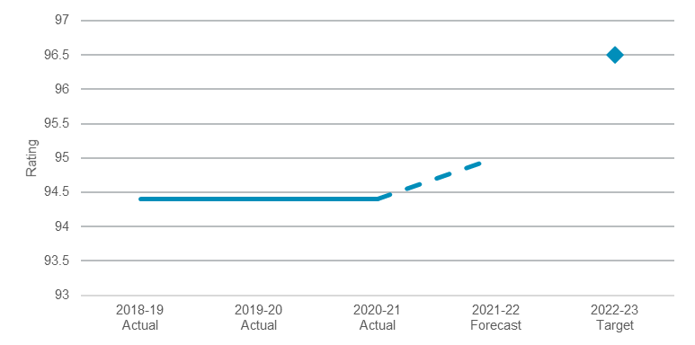
Note: The Liveable City Rating is provided by the Economist’s Global Liveability Report and represents a “Culture and Environment” rating with scores across nine components as to whether they are available in the city.

Collect, research, conserve and exhibit NSW cultural and heritage assets
New South Wales cultural infrastructure, inclusive of the facility itself and the collections maintained within the facility, create jobs, attracts visitors to New South Wales and preserves cultural assets for future generations.
Delivery of key cultural infrastructure projects remains on schedule. This, along with upgrades and maintenance announced in the prior budget, has ensured the underlying quality of the assets and performance against this indicator remains stable and on track to meet the target.
- Value of cultural and heritage assets being maintained and protected for current and future generations
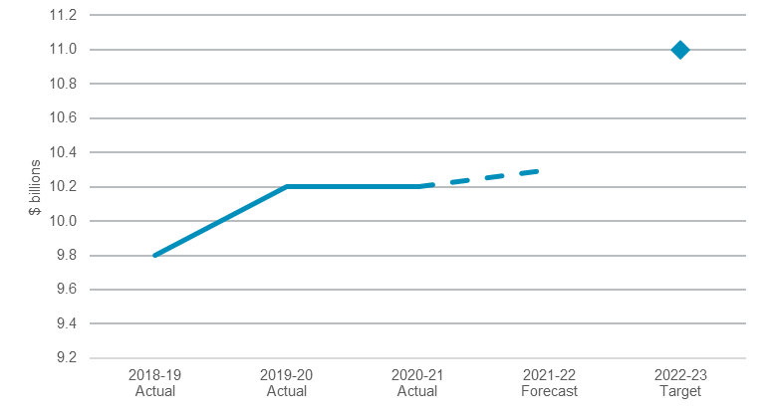

Performance indicators for this Outcome
Outcome Indicators | Units | 2020-21 | 2021-22
 |  | Actual | Forecast
Cultural and heritage assets being maintained and protected for current and future generations | $b | 10.2 ^{(a)} | 10.3
Increase annual visits to Premier and Cabinet arts, cultural and heritage venues | million | 5.4 ^{(a)} | 4.8 ^{(b)}
Increase in the number of customers who have their Heritage Act applications determined within statutory timeframes | % | 40.0 ^{(a)} | 75.0
Liveable City Rating (Culture and Environment) | no. | 94.4 ^{(a} | 95.0

Notes
- Data is a forecast as financial year is not complete.
- 2021-22 forecast originally based on assumption some cultural institutions being closed.

Outcome 3: Empowering Aboriginal communities
 | $106.2  million | Recurrent  Expenses  2021-22
 | $0.1  million | Capital  Expenditure 2021-22

State Outcome overview and 2021-22 investment
Empowering Aboriginal communities leads to a transformed relationship between Aboriginal peoples and government, as well as supporting the delivery of policies and practices that support Aboriginal peoples’ right to self-determination.

2021-22 State Outcome Budget highlights
In 2021-22, the Premier and Cabinet Cluster will invest $106.2 million ($106.2 million recurrent expenses and $0.1 million capital expenditure) in this Outcome, including:
- $41.0 million ($44.9 million recurrent expenses over four years) in additional funding for the Stolen Generations Reparation Scheme to ensure all living Stolen Generation survivors receive their ex-gratia payments
- $20.0 million total Government contribution for Closing the Gap initiatives in accordance with the National Agreement, and support for the equal participation of Aboriginal communities in priority reforms.

Key performance insights
This section provides analysis and insights on key Outcome Indicators for this State Outcome.

Drive transformation in Aboriginal communities – government relationships
Unfinished Business, the NSW Parliament General Purpose Standing Committee’s report on its inquiry into Stolen Generations reparations, was tabled in Parliament on 23 June 2016. The report made 35 recommendations relating to reparations. This indicator remains a key area of focus as it tracks Government’s compliance with the Stolen Generations Reparations Scheme guidelines.
Performance against this indicator remains stable and in line with the target at 100 per cent compliance with the Stolen Generations Reparations Scheme guidelines.

Drive sustainable economic prosperity
The Aboriginal Procurement Policy guides the NSW Government procurement activity with the objective to support the opportunity to increase Aboriginal skills, economic participation and grow the Indigenous business sector. The Government’s procurement capacity will be leveraged to support Aboriginal employment opportunities and participation along with growth of Aboriginal-owned businesses in order to drive prosperity across Aboriginal communities.
This indicator tracks the increase in Premier and Cabinet Cluster contracts awarded to Aboriginal businesses in line with the Aboriginal Procurement Policy target of seven per cent in 2022-23.
The policy has been recently strengthened with the Aboriginal Procurement Policy and the Aboriginal Participation in Construction Policy combined from 1 January 2021. This concentrates the Government’s procurement activities through a single policy framework in order to improve outcomes.
Performance against this indicator has improved since 2019-20, with four per cent of Premier and Cabinet Cluster contracts awarded to Aboriginal businesses in 2020-21.
- Percentage of Premier and Cabinet Cluster contracts awarded to Aboriginal business in line with Aboriginal procurement target
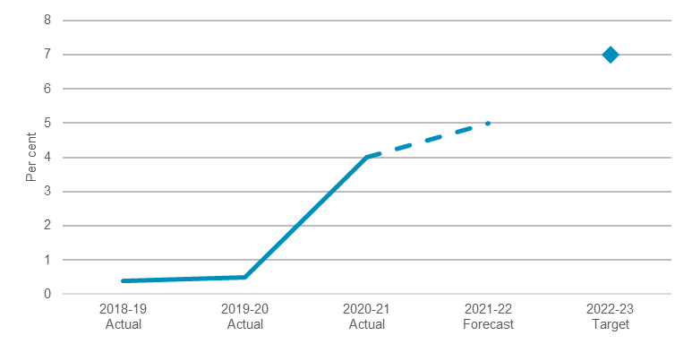

Performance indicators for this Outcome
Outcome Indicators | Units | 2020-21 | 2021-22
 |  | Actual | Forecast
Compliance with the Stolen Generations Reparations Scheme guidelines | % | 100 | 100
Increase in Premier and Cabinet cluster contracts awarded to Aboriginal business in line with the Aboriginal procurement target | % | 4.0^{(a)} | 5.0

Notes
- Data is a forecast as financial year is not complete.

Outcome 4: Accountable and responsible government

State Outcome overview and 2021-22 investment
 | $370.3  million | Recurrent  Expenses  2021-22
 | $22.8  million | Capital  Expenditure 2021-22
This Outcome accounts for the Cluster’s role in supporting good government decision-making and upholding government integrity.

2021-22 State Outcome Budget highlights
In 2021-22, the Premier and Cabinet Cluster will invest $393.1 million ($370.3 million in recurrent expenses and $22.8 million in capital expenditure) in this Outcome to enhance these independent agencies’ abilities to fulfil their statutory obligations, including:
- $201.5 million ($526.1 million recurrent expenses and $17.2 million capital expenditure over four years) for the New South Wales Electoral Commission including:
- $97.6 million for the conduct of the 2021 Local Government elections
- $18.4 million ($97.7 million recurrent expenses and $7.8 million capital expenditure over four years) for the 2023 State elections
- $9.6 million ($8.1 million recurrent expenses and $7.1 million capital expenditure over four years) to modernise voting centre devices that support the delivery of independent and fair New South Wales elections
- $37.8 million ($123.3 million recurrent expenses and $7.9 million capital expenditure over four years) for the Public Service Commission
- $32.2 million ($123.8 million recurrent expenses and $3.8 million capital expenditure over four years) for the Independent Commission Against Corruption
- $29.3 million ($115.6 million recurrent expenses and $1.7 million capital expenditure over four years) for the New South Wales Ombudsman
- $24.4 million ($95.1 million recurrent expenses and $18.9 million capital expenditure over four years) for the Law Enforcement Conduct Commission.

Key performance insights
This section provides analysis and insights on key Outcome Indicators for this State Outcome.

Upholding government integrity through responsive, risk-based and efficient oversight
Individual integrity agencies are integral to instilling public trust and confidence in government. This indicator tracks whether integrity agencies and independent entities are meeting their statutory requirements.
Performance against this indicator remains stable at the 2022-23 target level, with ongoing full compliance recorded by integrity agencies and independent agencies.
- Percentage of statutory requirements met by integrity agencies and independent entities
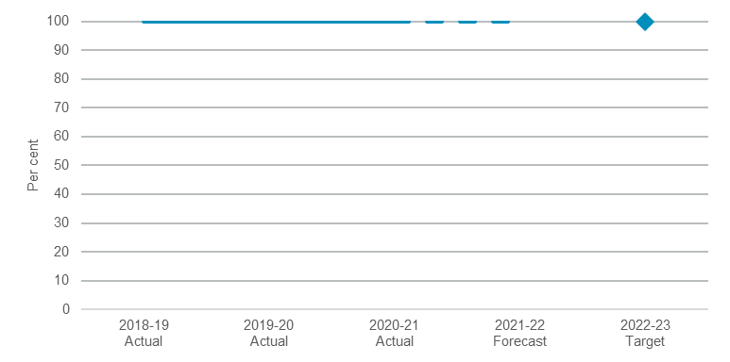

Increasing the percentage of female leaders in the NSW public service
Both employee engagement and a diversified workforce are key indicators of workforce innovation, productivity and performance. Improvement in these indicators will underpin the achievement of Premier’s Priority 14 – World Class Public Service. These indicators track public sector engagement as well as key metrics including: the number of female leaders, Aboriginal leaders and roles held by people with a disability.
- Percentage of female leaders in NSW Public Service
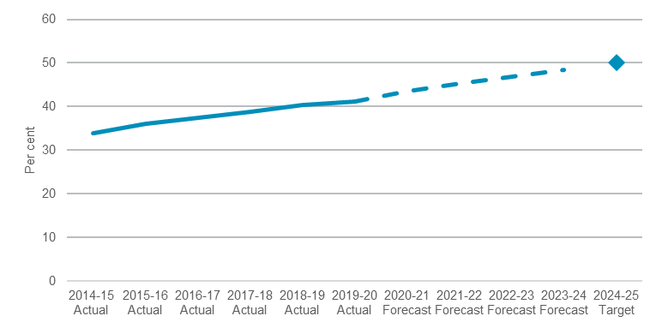

Performance indicators for this Outcome
Outcome Indicators | Units | 2020-21 | 2021-22
 |  | Actual | Forecast
Increase annual engagement of public sector employees | % | 67.2 ^{(a)} | 67.5
Increase in percentage of public sector roles held by people with a disability | % | 2.4^{(b)} | 4.0
114 Aboriginal leaders by 2025 | no. | 105^{(b)} | 115
Increase percentage of female leaders in the public sector | % | 41.1 ^{(c)} | 45.2
Increase workforce satisfaction in relation to effective utilisations of technology in order to improve outcomes | % | n.a. ^{(d)} | n.a.^{(d)}
NSW attracts the best employees ensuring delivery of a World Class Public Service for the people of NSW | % | 74.0 | 76.0
Percentage of State General Election (SGE) staff trained | %
% of SGE staff satisfied with training |  | n.a.^{(e)} | 94.0
% of SGE Staff trained |  | n.a.^{(e)} | 100.0
Website user satisfaction rates |  | n.a.^{(e)} | 80.0
Meeting statutory requirements for integrity agencies and independent entities | % | 100.0 | 100.0
No successful challenges to elections | % | 0.0 | 0.0
Overall core voter satisfaction rates | % | 84.0 | 86.0
Participation rates State/local elections | %
Participation rates for NSW - local elections |  | n.a.^{(f)} | n.a.^{(f)}
Participation rates for NSW - State elections |  | n.a.^{(f)} | 90.5
Voter enrolment rate | % | n.a.^{(f)} | 98.3

Notes:
- Data sourced from 2020 People Matter Employee Survey that occurred in October / November 2020.
- Data is a forecast as financial year is not complete.
- Data sourced from 2020 Workforce Profile Collection census data from June 2020 census date and available from November 2020.
- This is a new metric. 2020-21 as the first year will determine baseline for 2021-22.
- Metric is in progress.
- Local and State elections are yet to be held.

