6. REGIONAL NSW CLUSTER

Introduction
 | $2.5¹  billion | Recurrent  Expenses  2021-22
 | $334.2  million | Capital  Expenditure 2021-22
¹ Excludes other funds and trusts
The Regional NSW Cluster works to maximise the long-term wellbeing of regional New South Wales and is committed to making these regions a great place to live, work, visit and do business.
As the agency for regional issues, Regional NSW seeks to help build strong, cohesive communities and economies, grow primary industries and ensure sustainable land use practices, create regional employment opportunities, and steward the use of our natural endowments including advancing sustainable mining and resource development.

State Outcomes to be delivered by the Regional NSW Cluster
State Outcomes  What the Cluster is delivering for people and business |  | Key Programs  underway to support delivery of Outcomes
1. Productive and sustainable land use  Enhancing the use of the State’s public and private lands, by supporting their sustainability, use and productivity. This is achieved by providing on-ground and frontline support to land managers to better manage natural resources, respond to biosecurity risks and improve primary production, productivity and output in the State.  2021-22 investment: $261.6 million in recurrent expenses & $26.1 million in capital expenditure |  | - Protect the economy, environment and community, including from biosecurity risks  - Enabling land managers to better manage our natural resources
2. Stronger primary industries  Focusing on primary industries’ productivity, growth and ensuring the sector’s sustainability for the benefit of all citizens. Our commitment to research and innovation, safe and secure food supply and industry support and development programs, delivered via an on-ground presence across the State, ensures biosecurity food security and economic growth for the State.  2021-22 investment: $681.3 million in recurrent expenses & $77.7 million in capital expenditure |  | - Protect and promote biosecurity, food safety, animal welfare & market access  - Enhance productivity of plant, livestock and the sustainable use of agricultural resources  - Sustainable growth of fishing and aquaculture and protecting aquatic resources  - Manage the sustainability of forestry  - New South Wales Rural Assistance Authority  - New South Wales Food Authority
3. Mineral and petroleum industries generating prosperity, safely  Supporting and growing responsible mining and exploration across regional New South Wales. This is critical for regional employment, export earnings and royalties. Our mission is to make the State the number one destination for mining investment, whilst ensuring safety and environmental outcomes.  2021-22 investment: $124.2 million in recurrent expenses & $2.9 million in capital expenditure |  | - Make regional NSW a preferred investment destination for exploration and mining  - Regulating safe and environmentally sustainable mining
4. Stronger and cohesive regional communities and economies  Focusing on community wellbeing and economic growth in regional New South Wales. Regions have endured unprecedented destruction and disruption through the compounding impacts of drought, bushfires, floods and COVID-19. We continue to refocus efforts on the changed economic conditions and delivering the 20-Year Economic Vision for Regional NSW.  2021-22 investment: $1.4 billion in recurrent expenses & $227.5 million in capital expenditure |  | - Growth, development and wellbeing in regional NSW  - Regional Growth NSW Development Corporation

Overview of Cluster expenses by State Outcome
A summary of expenses by State Outcome is provided in the charts below.
- Recurrent expenses by Outcome 2021-22 (dollars and %)

Note: The sum of percentages does not equal one hundred due to rounding.
- Capital expenditure by Outcome 2021-22 (dollars and %)

Note: Grouped for presentation purposes, “Other State Outcomes” comprises:
- Mineral and petroleum industries generating prosperity, safely
- Productive and sustainable land use.

Outcome 1: Productive and sustainable land use
 | $261.6  million | Recurrent  Expenses  2021-22
 | $26.1  million | Capital  Expenditure 2021-22

State Outcome overview and 2021-22 investment
Led by Local Land Services (LLS), this Outcome realises improved sustainability and productivity of public and private land through delivery of LLS’ legislated services, including travelling stock reserves, natural resource management, agricultural advice, animal and plant biosecurity and emergency management. This is achieved by providing on-ground and frontline support to land managers. Everyone in New South Wales will benefit from well managed access to, and use of, natural resources that maximise economic opportunities in a safe and sustainable way.

2021-22 State Outcome Budget highlights
In 2021-22, the Regional NSW Cluster will invest $287.7 million ($261.6 million recurrent expenses and $26.1 million capital expenditure) in this Outcome, including:
- $113.6 million ($334.0 million recurrent expenses and $16.2 million capital expenditure over four years) for the conservation and restoration of natural and cultural resources, through conservation earthworks, river and coastal restoration and rehabilitation, emergency response, native vegetation management, pest and weed control in alignment with the Local Land Services Act 2013
- $85.1 million ($265.0 million recurrent expenses and $12.7 million capital expenditure over four years) to protect the economy, environment and community from invasive species, and plant and animal biosecurity risks including $19.6 million ($32.7 million recurrent expenditure over two years) to extend the NSW Border Wild Dog Exclusion Fence by 742 kilometres
- $39.8 million ($63.3 million recurrent expenses over two years) to deliver the National Land Care Program and to partner with Landcare communities in New South Wales to conserve and fund our natural resource priorities arising from vegetation loss, soil degradation and pests, weeds and animals
- $27.2 million ($78.4 million in recurrent expenses and $5.0 million capital expenditure over four years) to provide a range of initiatives to support productive and sustainable land use. These include climate and market change response initiatives, incentive programs and access to best practice information and technology to improve farm system resilience, productivity and sustainability into the future. Further, the investment also enables delivery of legislative responsibilities to provide Travelling Stock Route (TSR) permits and fees, pest control, weed control, biodiversity conservation and cultural management, stock management, TSR planning and customer service (capacity building)
- $20.9 million ($42.3 million recurrent expense and $4.2 million capital expenditure over four years) to deliver private native forestry reforms that enable new private native forestry extension and approval arrangements. These reforms will allow landholders to discuss native forestry issues in the context of overall farm business planning and deliver sustainable management, regulate native vegetation clearing and promote biodiversity conservation consistent with the biodiversity conservation legislation.

Key performance insights
This section provides analysis and insights on key Outcome Indicators for this State Outcome.

Increased land manager recommendation of LLS for services relating to agricultural productivity and natural resource management
This indicator demonstrates engagement and satisfaction with LLS' services and provides valuable insight into which services are working well and which need improvement. It is measured through ongoing monitoring of stakeholder net promoter scores (NPS) and is reviewed against an annual target of greater than 82 per cent.
Generally, the NPS for LLS trends in the range of 70 to 90 per cent. For the 2020 calendar year, the NPS was 86 per cent, above the target of 82 per cent. This high performance was due to increased positive response to LLS support throughout the tough times of drought and bushfire recovery. Performance is expected to continue to meet the target of 82 per cent going forward. LLS actively manages this performance by tailoring its services to the needs of land managers, providing timely advice and tailoring service delivery approaches and programs as required to prevent the spread of pests and diseases, and enhance management of soils, water, plants, animals and their products.
- Increased land manager recommendation of LLS for services relating to agricultural productivity and natural resource management
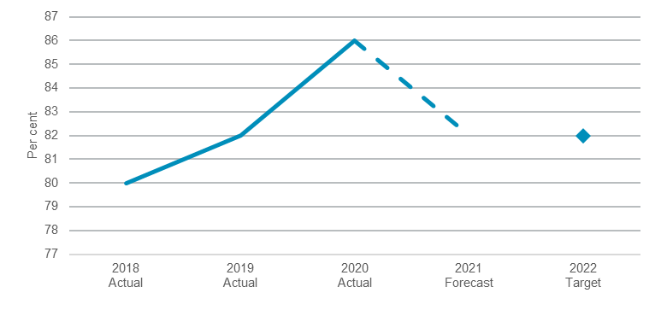
Note: The 2020 figure provided is an estimate as it is a quarterly measure.

Increased engagement of land managers in LLS programs relating to agricultural productivity and natural resource management
Engagement in LLS activities supports land managers to better manage the State’s natural resources, respond to biosecurity risks, and improve primary production in New South Wales. Since 2014, LLS has undertaken more than 17,000 awareness raising and training events, engaging with more than 400,000 participants.
LLS has successfully shifted service delivery models in response to the COVID-19 pandemic including holding virtual events. Broader customer reach has also been achieved as a result of additional economic stimulus through targeted drought investment, bushfire recovery programs and COVID-19 stimulus measures in 2020. Performance against this indicator is now on track to meet its target, with a large increase in engagement with more than 120,000 landholders engaged in 2020.

- Number of land managers engaged in LLS programs relating to agricultural productivity and natural resource management
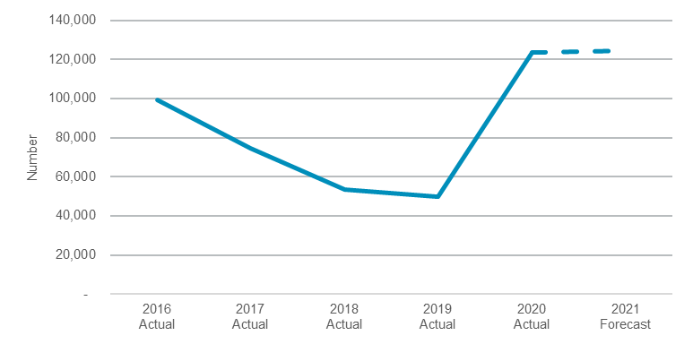
Note: Indicator methodology has been revised in 2020 resulting in a break in time series and therefore actuals prior to 2020 are not comparable to 2020 and the previously published target is no longer applicable. A new performance target is under development.

Increased area of improved land manager practices relating to agricultural productivity and natural resource management over four years
Equipping land managers with awareness and knowledge of better land management practices enables them to better manage the State’s public and private lands. LLS delivers awareness raising and training events along with other engagement processes and incentives to support this. Since 2014, these activities have resulted in land managers applying more than 190 million hectares of improved agriculture and natural resource management practices.
In addition, recent efforts to support drought and bushfire recovery have enabled other opportunities to address farm management issues, most notably management of vertebrate pests. Performance against this indicator has improved with a significant increase in area of improved land manager practices and is now exceeding the target, with more than 32 million hectares improved in 2020.
- Increased area of improved land manager practices relating to agricultural and natural resource management over four years
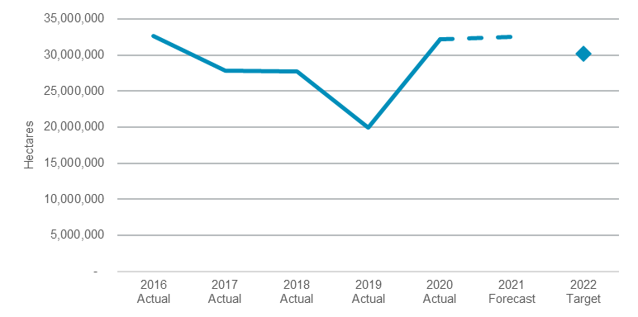

Performance indicators for this Outcome
Outcome Indicators | Units | 2020-21 | 2021-22
 |  | Actual | Forecast
Increased area of improved land manager practices relating to agriculture and natural resource management over four years^{(a)} | Ha. | 32,201,334 | 32,523,347
Increased land manager recommendation of LLS to their friends for services relating to agricultural productivity and natural resource management^{(a)} | % | 86.0 | 82.0
Increased engagement of land managers in LLS programs relating to agricultural productivity and natural resource management^{(a)} | no. | 123,359 | 124,593

Note
- As these indicators are measured on a calendar year basis, 2020-21 actual data and 2021-22 forecast data in this table relates to the 2020 and 2021 calendar years respectively.

Outcome 2: Stronger primary industries
 | $681.3  million | Recurrent  Expenses  2021-22
 | $77.7  million | Capital  Expenditure 2021-22

State Outcome overview and 2021-22 investment
Led by the Department of Primary Industries (DPI), this Outcome’s focus is on the state’s primary industries’ productivity, growth and ensuring the sector’s sustainability for the benefit of all citizens. DPI plays a central role in the government’s commitment to regional New South Wales by driving a strong primary industries sector. Our commitment to research and innovation, safe and secure food supply and industry support and development programs, delivered via an on-ground presence across the State, ensures biosecurity, food security and economic growth for the State.

2021-22 State Outcome Budget highlights
In 2021-22, the Regional NSW Cluster will invest $759.0 million ($681.3 million recurrent expenses and $77.7 million capital expenditure) in this Outcome, including:
- $187.8 million ($232.6 million recurrent expenses over four years) for on-farm assistance, productivity improvements, innovation and climate resilience in the primary production sector through well-managed loans, rebate and grant programs; in order to become the single gateway for assistance for NSW primary producers, including $95.0 million to combat the current mouse plague in regional New South Wales in 2021-22
- $182.4 million ($608.3 million recurrent expenses and $43.3 million capital expenditure over four years) to enhance productivity of plant and livestock farming systems, improving the productivity and sustainability from climate adaptation on agricultural resources, including $47.9 million over four years for the ‘Farms of the Future’ pilot as part of the $63.4 million Future Ready Regions initiative. This also includes capital investment of $51.7 million ($56.6 million over two years) in the State’s primary industries research and development infrastructure portfolio
- $176.9 million ($478.0 million recurrent expenses and $25.3 million capital expenditure over four years) to protect New South Wales from increasing high priority biosecurity risks, promote compliance with the Commonwealth Biosecurity Act 2015 (including invasive plants and animals), undertake biosecurity diagnosis, deliver legislative food safety requirements, safeguard animal welfare and ensure market access by undertaking biosecurity preparedness exercises, disaster response impact assessments and recovery advisory services, including $5.0 million in 2021-22 to ensure appropriate supply of zinc phosphate for NSW farmers to manage the long-term threats posed by the current mouse plague
- $164.9 million ($526.2 million recurrent expenses and $6.9 million capital expenditure over four years) to enable the sustainable growth of fishing, aquaculture and hunting, through investment in research, management of Aboriginal fishing, marine and coastal environment, safeguarding inland freshwater threatened fish species and freshwater fisheries, protecting aquatic resources. This is achieved through licencing and other compliance activities, and ensuring safe and responsible hunting under the Game and Feral Animal Control Act 2002
- $38.2 million recurrent expenses to deliver round two of the Emergency Water Infrastructure Rebate program to support innovative on-farm infrastructure investment and drought preparedness
- $13.4 million ($51.2 million recurrent expenses over four years) to lead policy and industry development, research and regulatory oversight for the State’s $2.4 billion wood and product manufacturing industry as set out in Plantations and Reafforestation Act 1999.

Key performance insights
This section provides analysis and insights on key Outcome Indicators for this State Outcome.

Growth in total primary industries output over 12 months
Drought, bushfires, floods and the outbreak of COVID-19 have had a significant impact on primary industry output over recent years. However, primary industries have demonstrated their ability to rebound quickly with 2020-21 forecast to record strong year on year growth. The New South Wales winter crop (grains, oilseeds and pulses) is estimated to have broken all-time production records.
This demonstrates the increased resilience of the sector, supported by DPI activities throughout these events, and the ability to capitalise on DPI research and development programs which have supported biosecurity responses and record yields in the 2020-21 cropping year. Despite this, the performance against this indicator remains challenging. The sector continues to face significant challenges including the rebuilding of a substantially depleted livestock herd, accessing sufficient labour to maintain productivity and advancing the State’s infrastructure and capability to address biosecurity risks that are continuing to rise in volume and complexity.
- Total primary industries output over 12 months
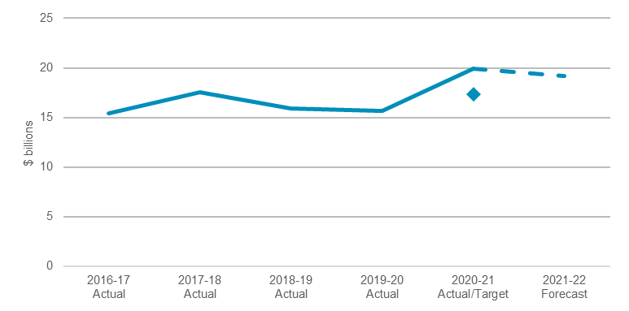

Increase in stakeholder satisfaction
Maintaining strong stakeholder relationships is central to DPI’s role in supporting stronger primary industries. The challenging conditions affecting primary industries across New South Wales over recent years has impacted stakeholders experience and satisfaction with DPI.
DPI has worked closely with a wide range of stakeholders through the recent challenges of drought, floods, the COVID-19 pandemic and increasing biosecurity threats however these challenges have impacted stakeholder engagement. Additional focus on improving stakeholder collaboration and recovery from recent disasters is expected to result in improvements in satisfaction, enabling the 2022-23 performance target to be met.
- Rating of industry stakeholders based on engagement with DPI
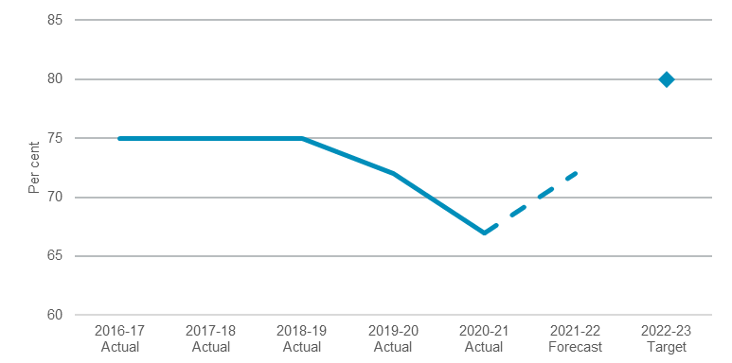

Maintain top one per cent of International Research Ranking in Agricultural Science, Plant and Animal Sciences
Publication of research in high impact scientific journals demonstrates the quantity, quality and robustness of DPI’s science functions. DPI benchmarks against similar organisations using widely recognised metrics such as the number of scientific publications, citation and science impact. The citation ranking is based on how many other scientists refer to DPI’s research in their scientific papers. As such, it is a measure of the impact or the ‘usefulness’ of DPI’s research work, which can improve performance of the State’s primary industries.
Performance against this indicator continues to remain stable, with DPI consistently maintaining its place in the top one per cent of research organisations globally for over a decade and on track to maintain this place in 2021-22.

- Maintain top one per cent of international research ranking in agricultural science, plant and animal sciences
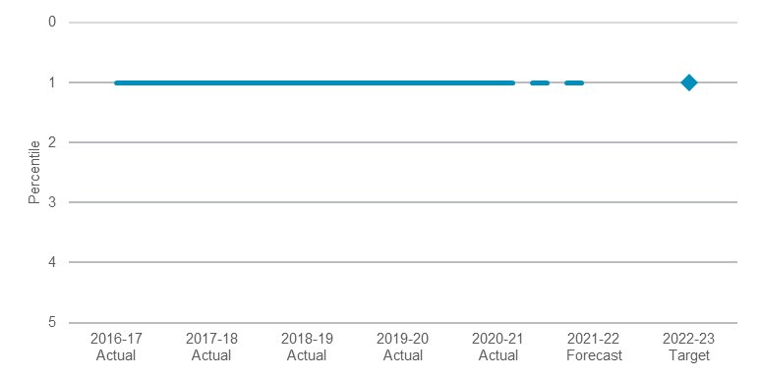

Performance indicators for this Outcome
Outcome Indicators | Units | 2020-21 | 2021-22
 |  | Actual | Forecast
Growth in total primary industries output over 12 months | $ billions | 19.9 | 19.2
Maintain top one per cent of International Research Ranking in Agricultural Science, Plant and Animal Sciences | % | 1.0 | 1.0
Increase in stakeholder satisfaction | % | 67.0 | 72.0

Outcome 3: Mineral and petroleum industries generating prosperity, safely
 | $124.2  million | Recurrent  Expenses  2021-22
 | $2.9  million | Capital  Expenditure 2021-22

State Outcome overview and 2021-22 investment
Led by the Mining, Exploration & Geoscience division and the NSW Resources Regulator, this Outcome’s focus is to support and grow responsible mining and exploration across regional New South Wales. Our mission is to make New South Wales a preferred investment destination for exploration and mining through leading practice policy and legislation, excellence in geoscience, efficient titles assessment and proactive regulation. The sustainable growth of the minerals industry creates opportunity for economic growth and employment opportunities for the people of New South Wales.

2021-22 State Outcome Budget highlights
In 2021-22, the Regional NSW Cluster will invest $127.1 million ($124.2 million recurrent expenses and $2.9 million capital expenditure) in this Outcome, including:
- $34.5 million ($103.1 million recurrent expenses over four years) to grow investment in mining and exploration by acquiring, synthesising and delivering data, promoting the State’s resources, undertaking economic and resource analysis and providing geoscientific and market information to inform decision making and land use planning to support mineral and petroleum exploration and mining. This includes $39.7 million over four years from the Coal Innovation Fund for research and investment in carbon capture, use and storage and low emissions coal technology projects, from a mixture of legislated funding sources, industry levies and NSW Government investment
- $33.6 million ($140.0 million recurrent expenses and $1.0 million capital expenditure over four years) to regulate mine and petroleum site safety in relation to Work Health and Safety compliance and enforcement
- $26.1 million ($75.6 million recurrent expenses over four years) to address remediation of high-risk legacy mine sites, including site assessment, contamination safety and risk reduction to manage physical risks to the public from legacy mines, including an additional $47.7 million over four years to address 20 high and extreme risk legacy mines
- $15.7 million ($42.3 million recurrent expenses and $4.0 million capital expenditure over four years) to deliver robust assessment of exploration and mining titles applications, rollout and enhancement of the Titles Management System and calculation of quarterly royalty returns for collection by Revenue NSW
- $9.2 million ($38.3 million recurrent expenses over four years) to undertake regulatory compliance inspections and investigate instances of non-compliance of the Mining Act 1992. This investment also provides support for regulatory operations and programs focused on industry engagement, compliance and intelligence through development and maintenance of online systems.

Key performance insights
This section provides analysis and insights on key Outcome Indicators for this State Outcome.

Efficient and effective mining titles assessment performance as measured against industry agreed KPIs for titles assessment activity over 12 months
The sustainable growth of the minerals industry helps to ensure New South Wales is well placed to benefit from global demand for metals, create jobs and capitalise on the opportunity for economic growth. This indicator tracks the output of programs aimed at enhancing access to the State’s mineral and petroleum resources.
Performance against this indicator remains high, due in part to the increases in resources and the focus on ageing titles that have driven improvements to processes. In 2019-20, New South Wales achieved an average of 94.3 per cent, well above the industry agreed key performance indicator target of 85 per cent for 2020-21.
- Mining titles assessment performance
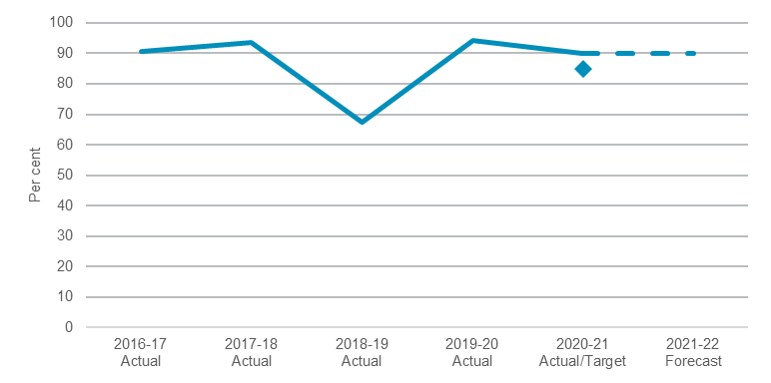

New South Wales to average over 10 per cent share of Australian mineral exploration expenditure in Australia over five years to 2025
The State’s share of exploration expenditure is positively correlated to mineral and petroleum discovery and mining investment.
Performance remains above the target at 10.3 per cent in the 2020 calendar year, with 11.8 per cent for new deposits. This is mainly driven by the Mining, Exploration & Geoscience division facilitating measures to improve industry confidence, including supporting positive policy settings, greater geoscientific data acquisition, dissemination and release as well as more consistent approval pathways and timeframes.

- Proportion of NSW’s share of Australian mineral exploration expenditure in Australia
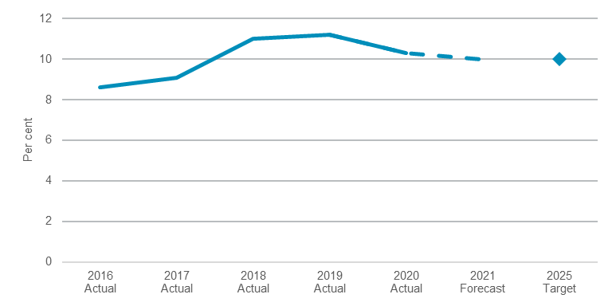

Proportion of high risk and priority mine sites proactively inspected for compliance with work health and safety (WHS) and the Mining Act 1992 requirements
Proactive, consistent regulation of high-risk sites contributes to improved industry performance and ultimately better health, safety and environmental outcomes in New South Wales mines.
Regulatory oversight is a key aspect of ensuring compliance with the legislative requirements and providing certainty in the regulatory process and framework. WHS site inspections focus on critical controls that when implemented correctly prevent the occurrence of significant mining accidents or disasters. Site inspections authorised under the Mining Act 1992 are typically associated with rehabilitation obligations. The Resources Regulator is currently ramping up inspections as well as implementation of a significant body of work introducing regulatory reforms in this space.
Performance against this indicator for both WHS and the Mining Act 1992 is stable.
- Proportion of high risk and priority mine sites proactively inspected for compliance with WHS and the Mining Act 1992
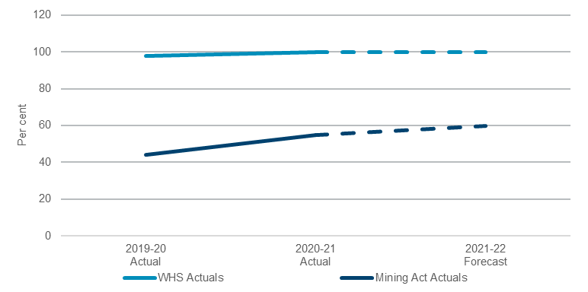

Performance indicators for this Outcome
Outcome Indicators | Units | 2020-21 | 2021-22
 |  | Actual | Forecast
Improved pre-competitive mineral and petroleum resource data and analysis to support exploration as measured by the Fraser Institute over 12 months^{(a)} | % | 97.0 | 95.0
Efficient and effective titles assessment performance as measured against industry agreed KPIs for titles assessment activity over 12 months | % | 90.0 | 90.0
NSW to average over 10 per cent share of Australian mineral exploration expenditure in Australia over five years to 2025^{(a)} | % | 10.3 | 10.0
Proportion of total Australian private mining capital spent in NSW^{(a)} | % | 8.2 | 8.4
Proportion of high risk and priority mine sites proactively inspected for compliance with WHS & Mining Act requirement | %
WHS |  | 100.0 | 100.0
Mining Act |  | >55.0 | >60.0

Note
- As this indicator is measured on a calendar year basis, 2020-21 actual data and 2021-22 forecast relates to 2020 and 2021 respectively.

Outcome 4: Stronger and cohesive regional communities and economies

State Outcome overview and 2021-22 investment
 | $1.4  billion | Recurrent  Expenses  2021-22
 | $227.5  million | Capital  Expenditure 2021-22
Led by Public Works Advisory & Regional Development, Regional Precincts and Office of the Cross Border Commissioner divisions, this Outcome’s focus is community wellbeing and economic growth in regional New South Wales. The regions have endured unprecedented destruction and disruption through the compounding impacts of droughts, bushfires, floods and the COVID-19 pandemic. The implementation of a refreshed 20-Year Economic Vision for Regional NSW will support industries and communities to recover and build resilience.

2021-22 State Outcome Budget Highlights
In 2021-22, the Regional NSW Cluster will invest $1.7 billion ($1.4 billion recurrent expenses and $227.5 million capital expenditure) in this Outcome, including:
- $514.0 million ($897.1 million recurrent expenses over three years) to deliver the following targeted recovery programs that provide economic stimulus and support recovery from natural disasters such as COVID-19, bushfire, drought, mouse plague and flood, targeting regional councils, businesses in driver industries and community organisations:
- Bushfire Local Economic Recovery Package ($177.6 million)
- Infrastructure and Jobs Acceleration Fund ($99.5 million)
- Drought Stimulus Package ($76.1 million)
- NSW Storm and Flood Clean up ($64.8 million)
- Bushfire Local Industry Recovery Package ($55.9 million)
- Mouse Plague Response ($40.0 million)
- $398.4 million ($571.0 million recurrent expenses over four years) to deliver programs that will enable economic growth, social development, wellbeing and community amenity across regional NSW and support the ongoing prosperity of mining communities, allowing regional councils and community groups to deliver locally based infrastructure projects, investing in vital job creating projects for families and businesses across regional NSW, including:
- Regional Growth Fund ($210.6 million)
- Stronger Country Communities Fund ($69.6 million)
- Resources for Regions ($20.7 million)
- $318.2 million ($334.8 million recurrent expenses and $543.1 million capital expenditure over four years) for Snowy Hydro Legacy Fund projects including Special Activation Precincts to deliver place-based solutions to foster economic development, and to bring a faster, more reliable digital network to regional New South Wales through the Regional Digital Connectivity Program

- $83.3 million ($302.2 million recurrent expenses over four years) for Public Works Advisory to provide strategic advice on whole-of-government construction procurement and assurance policy, support government response to natural disasters, accidents or engineering emergencies, asset and facilities management, expert advice, design and planning work for more than 400 towns and regional water supply and wastewater management schemes, and to manage the delivery of $3.5 billion of regional infrastructure projects and programs of work
- $79.5 million ($93.0 million recurrent expenses over two years) from the Regional Job Creation Fund to incentivise the attraction and expansion of businesses and jobs retention and creation in Regional NSW by offering between $100,000 and up to $10.0 million in co-funding to activate or bring forward regional projects in engine, enabling or emerging engine industries. The projects are expected to create 5,000 full time equivalent ongoing jobs over three years
- $8.5 million ($14.0 million in recurrent expenses over three years) to support the Office for Regional Youth, the Regional Youth Taskforce, new Regional Youth Community Coordinators and a Regional Youth Wellbeing Program to support recovery and resilience of children and young people in flood impacted communities.

Key performance insights
This section provides analysis and insights on key Outcome Indicators for this State Outcome.

Percentage growth in employment in regional NSW over four years
This indicator tracks the economic change and growth in the regional New South Wales economy and its subsequent impact on employment. The target of 1.1 per cent growth each year equates to 50,000 jobs in regional New South Wales over the next four years.
Performance against this indicator remains challenging as COVID-19 restrictions have had a major impact on labour market conditions across Australia since March 2020. Regional NSW continues to drive regional growth strategies to stimulate economies and increase employment opportunities across the regions.
- Percentage growth in employment in regional New South Wales over four years
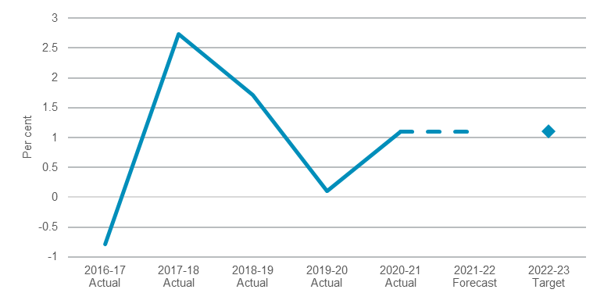

Performance indicators for this Outcome
Outcome Indicators | Units | 2020-21 | 2021-22
 |  | Actual | Forecast
Percentage growth in employment in regional NSW over four years | % | 1.1 | 1.1

