7. STRONGER COMMUNITIES CLUSTER

Introduction
 | $18.3  billion | Recurrent  Expenses  2021-22
 | $1.5  billion | Capital  Expenditure 2021-22
The Stronger Communities Cluster delivers community services that support a safe and just New South Wales. It supports safer, stronger communities through: operating an effective legal system; the protection of children and families; building resilience to natural disasters and emergencies; promoting public safety; reducing reoffending; supporting community harmony and social cohesion; and promoting physical activity and participation in organised sport, active recreation and sporting events.
The Stronger Communities Cluster has responsibility for delivering key policies for the Government, including seven State Outcomes and five Premier’s Priorities. The Stronger Communities Cluster also includes the Office of the Children’s Guardian; the Ageing and Disability Commissioner; Women NSW; the Advocate for Children and Young People; Multicultural NSW; the Office for Veterans Affairs; and the Office of Sport.

State Outcomes to be delivered by the Stronger Communities Cluster
State Outcomes  What the Cluster is delivering for people and business |  | Key Programs  underway to support delivery of Outcomes
1. Active and inclusive communities  Delivering programs and support services that aim to improve wellbeing, increase physical activity and community participation, and promote community harmony and social cohesion, particularly for participants in the National Disability Insurance Scheme (NDIS).  2021-22 investment: $4.2 billion in recurrent expenses & $21.8 million in capital expenditure |  | - Supporting the NDIS  - Office of Sport Programs  - Community Support and Development  - Multicultural NSW
2. Children and families thrive  Ensuring the safety and wellbeing of vulnerable children, young people and families, and protecting them from the risk of harm, abuse and neglect.  2021-22 investment: $2.7 billion in recurrent expenses & $139.7 million in capital expenditure |  | - Out of Home Care and Permanency Support  - Child Protection  - Targeted Early Intervention  - Domestic and Family Violence
3. Efficient and effective legal system  Resolving matters through legal services, the administration of courts and tribunals, and client-facing justice services to victims and vulnerable people.  2021-22 investment: $1.8 billion in recurrent expenses & $256.4 million in capital expenditure |  | - Courts and Tribunals  - Legal Aid and Justice Services  - Victims Services  - Office of the Director of Public Prosecutions
4. People have a safe and affordable place to live  Assisting people who are unable to access or maintain appropriate housing, including homelessness services.  2021-22 investment: $1.1 billion in recurrent expenses & $51.2 million in capital expenditure |  | - Social Housing  - Homelessness Services
5. Prepared for disasters and emergencies  Delivering emergency management to enhance response and recovery efforts and build community resilience.  2021-22 investment: $1.7 billion in recurrent expenses & $159.6 million in capital expenditure |  | - Fire and Rescue NSW  - NSW State Emergency Service  - NSW Rural Fire Service
6. Reduce reoffending  Operating the State’s corrections system, including support for, and management of, adult and youth offenders in correctional centres and the community.  2021-22 investment: $2.4 billion in recurrent expenses & $494.6 million in capital expenditure |  | - Adult and Youth Custodial Offender Management - Public  - Community Offender Management  - Offender Management Services
7. Safer communities  Preventing, detecting and investigating crime, maintaining social order and community safety, promoting road safety, and supporting emergency management.  2021-22 investment: $4.3 billion in recurrent expenses & $390.9 million in capital expenditure |  | - 24-hour policing Metropolitan  - 24-hour policing Regional NSW  - Investigation and Counter-Terrorism  - NSW Crime Commission

Overview of Cluster expenses by State Outcome
A summary of expenses by State Outcome is provided in the charts below.
- Recurrent expenses by Outcome 2021-22 (dollars and %)

Note: The sum of percentages does not equal one hundred due to rounding.
- Capital expenditure by Outcome 2021-22 (dollars and %)

Outcome 1: Active and inclusive communities

State Outcome overview and 2021-22 investment
 | $4.2 billion | Recurrent  Expenses  2021-22
 | $21.8 million | Capital  Expenditure  2021-22
This Outcome captures the range of programs and support services that aim to improve wellbeing, increase physical activity and community participation in sport and active recreation, and promote community harmony, social inclusion and cohesion, particularly for participants in the National Disability Insurance Scheme (NDIS).
Services are delivered under this Outcome by the Department of Communities and Justice (including Women NSW and Office of Veterans Affairs), Multicultural NSW, Office of the Ageing and Disability Commissioner, and the Office of Sport.

2021-22 State Outcome Budget highlights
In 2021-22, the Stronger Communities Cluster will invest $4.2 billion ($4.2 billion in recurrent expenses and $21.8 million in capital expenditure) in this Outcome, including:
- $3.6 billion in cash and in-kind contributions for individual packages and other flexible supports under the NDIS so that people with disability, their families and carers can achieve their goals and participate fully in the community
- $735.1 million for the Office of Sport to deliver programs and infrastructure, which enable communities to maximise the social, health and economic benefits realised through sport and active recreation. This includes:
- $102.5 million ($205.1 million over two years) for the Multisport Community Infrastructure Fund to support the development of local sporting facilities across New South Wales. A focus of this Fund will be to increase participation and maximise accessibility through development of universally designed facilities, which can be utilised by multiple sporting codes
- $75.0 million ($150.0 million over two years) for the Centres of Excellence Grant Program. Funding will be made available to various sporting codes to improve talent pathways and community engagement
- $22.2 million ($43.9 million over two years) for the Learn to Swim Active Pre-Schooler Voucher program to give children aged 3-6 years and not yet enrolled in school the opportunity to develop critical swimming and water safety skills by providing one $100 voucher per year for eligible swimming programs
- $8.0 million to develop a final business case for the Suburban Stadia Strategy to enable the Government to commence the development of one stadium by 2023
- $6.7 million to develop a final business case for the Hunter Sport and Entertainment precinct
- $5.2 million ($21.4 million over four years) to support the ongoing operations of the NSW Institute of Sport
- $4.0 million ($16.0 million over four years) for the expansion of the Surf Club Facility Program, which enables the construction of new and upgraded safe and inclusive Surf Club facilities in New South Wales

- $49.1 million for Multicultural NSW to promote social cohesion through delivery of community programs, multicultural events, and language services. This includes:
- $2.8 million ($8.5 million over three years) to support new and emerging communities through the continuation of key Multicultural NSW programs and the Settlement Services Unit
- $1.0 million capital expenditure for the digitisation of Multicultural NSW language interpreting services to improve accessibility in remote areas, and in the field for emergency personnel
- $18.6 million over two years for the Community Building Partnerships Program to stimulate further investment in local communities, increasing total funding for the Program to $37.2 million in 2021-22. This additional funding is equivalent to an additional $100,000 for every electorate.

Key performance insights
This section provides analysis and insights on key Outcome Indicators for this State Outcome.

Percentage of children (aged 5-14) participating in organised physical activity outside of school hours for at least 3.2 hours per week on average
The COVID-19 pandemic has affected performance against this indicator. Due to health and social distancing restrictions placed on operating sporting facilities, community sports and competitions, performance against this indicator for the 2020 calendar year (25.0 per cent) dropped almost six percentage points compared with the 2019 year (30.7 per cent).
Performance is expected to return to pre-COVID levels in 2021, provided there are no significant restrictions placed on community sports. Continued investment in sport and recreation centres and in providing accessible and affordable participation opportunities, including through the Active Kids Voucher Program, will support all New South Wales children to increase their regular participation in organised physical activities. New facilities investment through the Multisport Community Infrastructure Fund will support local community-based organisations to develop multisport facilities across New South Wales, which will also support achievement of the 35 per cent target by 2023.
- Percentage of children regularly participating in organised physical activities outside school hours for at least 3.2 hours per week on average
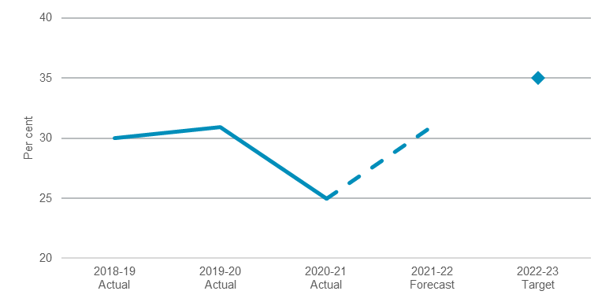
Note: 2020-21 actual reflects latest available information as at 30 April 2021.

Number of veterans gaining employment in the NSW public sector
The Veterans Employment Program (VEP) continues to be a national leader in veterans’ employment initiatives.
The target set by the Premier in November 2018 to employ 1,000 veterans into the NSW public sector has been achieved earlier than anticipated. 1,094 veterans have been employed into New South Wales public sector roles in the period from October 2018 to March 2021.
The VEP continues to develop new initiatives including delivery of a workshop four times per year to assist veterans to find roles in the New South Wales public sector.
- Number of veterans gaining employment in the NSW public sector
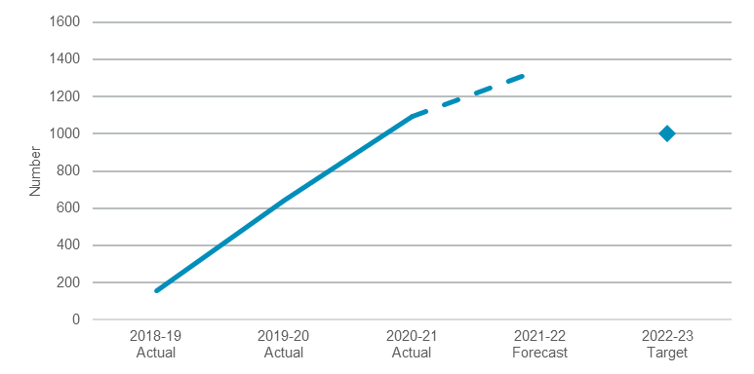
Note: 2020-21 actual reflects latest available information as at 30 April 2021.

Performance indicators for this Outcome
Outcome Indicators | Units | 2020-21 | 2021-22
 |  | Actual^{(a)} | Forecast
Number of veterans gaining employment in the NSW public sector | no. | 1,094 | 1,344
Percentage of children regularly participating in organised physical activities outside school hours for at least 3.2 hours per week on average | % | 25 | 31

Note
- Latest information available as at 30 April 2021.

Outcome 2: Children and families thrive
 | $2.7 billion | Recurrent  Expenses  2021-22
 | $139.7 million | Capital  Expenditure  2021-22

State Outcome overview and 2021-22 investment
This Outcome focuses on ensuring the safety and wellbeing of vulnerable children, young people and families, protecting them from the risk of harm, abuse and neglect. Services supporting this Outcome are delivered by the Department of Communities and Justice and the Office of the Children’s Guardian.
This work also supports the Premier’s Priorities to protect our most vulnerable children, increase permanency for children in out-of-home care, and reduce domestic violence reoffending.

2021-22 State Outcome Budget highlights
In 2021-22, the Stronger Communities Cluster will invest $2.9 billion ($2.7 billion in recurrent expenses and $139.7 million in capital expenditure) in this Outcome, including:
- $1.4 billion to support the safety, welfare and wellbeing of vulnerable children in out-of-home care and supporting permanency outcomes. This includes $5.7 million ($12.0 million over four years) to increase guardianship and adoptions for children in out-of-home care. Funding will support a targeted promotion and awareness campaign, establish a dedicated guardianship and adoption taskforce, and improve support for prospective guardians and adoptive parents
- $756.5 million to support a robust child protection system to assess reports of child abuse and neglect, and provide support to keep children safely at home and prevent entries to care
- $204.9 million to prevent family, domestic and sexual violence, reduce reoffending and support victim safety through the continuation of evidence-based early intervention, victim support and perpetrator interventions. This includes:
- Approximately $70.0 million ($140.0 million over two years) to invest in frontline family, domestic and sexual violence services across New South Wales, jointly funded with the Commonwealth Government under the new National Partnership on family, domestic and sexual violence
- $7.2 million ($33.9 million over four years) to support the safety of domestic and family violence victim survivors with specialist case-management through the expansion of the Staying Home Leaving Violence program, and continuation of the Domestic Violence Pro-Active Support Service.

Key performance insights
This section provides analysis and insights on key Outcome Indicators for this State Outcome.

Number of people charged with a domestic violence assault who had an earlier domestic assault charge in the last 12 months
Performance against this indicator continues to be challenging. In the 12 months to February 2021, there was a 1.3 per cent increase in the number of domestic violence assault reoffenders from the 2015 baseline.

In recognition of the complex nature of domestic violence and reoffending behaviours, the NSW Government continues to develop, evaluate and deliver evidence-based programs to reduce reoffending in the short and long-term. This includes ongoing investment in effective community-based Men’s Behaviour Change Programs, including EQUIPS (Explore, Question, Understand, Investigate and Practise, Plan and Succeed). Ongoing investment is also supporting continuation of the Practice Guide for Intervention, to enable Community Corrections officers to proactively assist offenders to address factors contributing to their offending behaviour.
Over the past year, frontline domestic violence services have reported increased demand, all whilst having to quickly adapt service delivery to COVID-19 conditions. In response to this, the New South Wales and Commonwealth Governments provided an additional $33.0 million in 2020-21 to support the safety of victim-survivors during the pandemic. This support will be extended under the new National Partnership on family, domestic and sexual violence, which will provide approximately $140.0 million over two years in additional New South Wales and Commonwealth funding.
- Number of people charged with a domestic violence assault who had an earlier domestic assault charge in the last 12 months
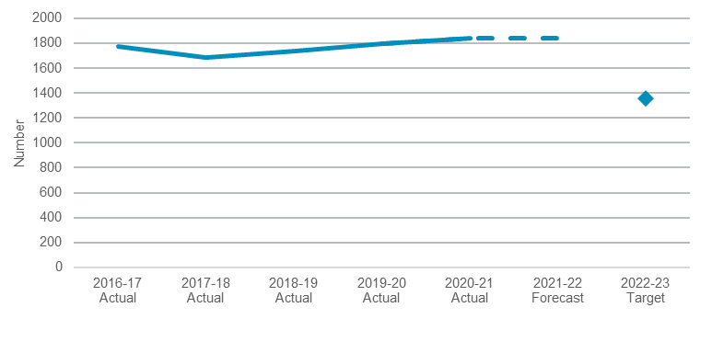
Note: 2020-21 actual reflects latest available information as at 30 April 2021.

Proportion of children and young people re-reported at risk of significant harm (ROSH) within 12 months
Performance against this indicator continues to be challenging. The proportion of children and young people re-reported at ROSH within 12 months continued to increase in 2020-21, with significant growth in ROSH reports placing upward pressure on ROSH re-report rates.
Analysis of barriers to lowering the re-report rate have informed new strategies being employed, including:
- continuing to improve casework practice, ensuring timely and appropriate referrals to service providers, and ensuring cases are closed with appropriate responses in place, including alternative support pathways
- enhancing the e-reporting tool and verifying risk information through advanced screening to improve the quality of information in reports and supporting more accurate assessments of children at ROSH.
Initiatives will be monitored and formally evaluated to measure their impact and ensure continual practice improvement.

- Proportion of children and young people re-reported at risk of significant harm (ROSH) within 12 months
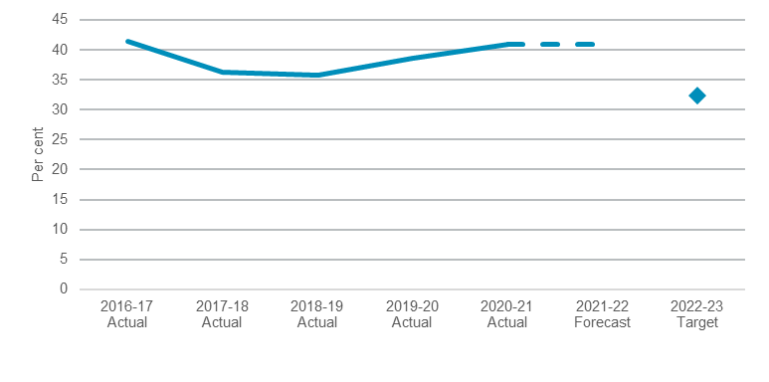
Note: 2020-21 actual reflects latest available information as at 30 April 2021.

Number of children and young people exiting out-of-home care (OOHC) to restoration, guardianship or adoption
Adoptions from OOHC in New South Wales to permanent, safe, loving homes remain the highest in Australia. The number of children exiting OOHC to permanent, legal guardianship have increased year on year since 2016. However, achievement of the target for this indicator remains challenging.
In 2021-22 the NSW Government is investing $12.0 million over four years to boost achievement of adoption and guardianship, including through targeted promotion and awareness campaigns to increase the number of prospective guardians and adoptive parents, as well as establishing a dedicated guardianship and adoptions taskforce. Part of this investment is also aimed at increasing efficiency in preparing and completing court processes for adoption and guardianship, so more children can move from OOHC to a permanent, safe, and loving home sooner.
Key areas identified to help drive positive outcomes and reach the performance target for this indicator include strengthening monitoring and performance mechanisms, undertaking permanency reviews for children in long term stable placements, and implementation of the Aboriginal Case Management Policy.
- Number of children and young people exiting Out-of-Home Care to restoration, guardianship or adoption
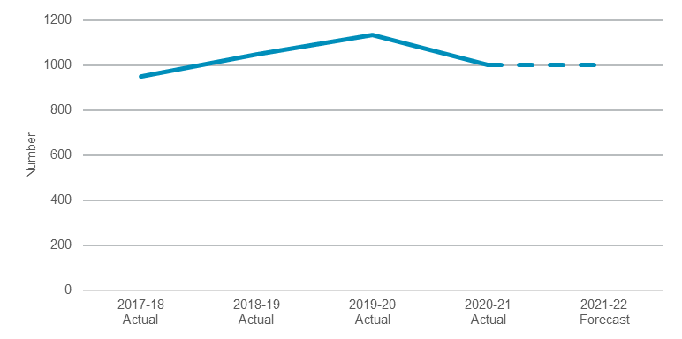
Note: 2020-21 reflects annual rounded forecast to 30 June 2021. The target is for 5,250 (cumulative) permanent outcomes or 1,313 (average) per year over four years to 2022-23, and is not displayed for presentation purposes

Performance indicators for this Outcome
Outcome Indicators | Units | 2020-21 | 2021-22
 |  | Actual ^{(a)} | Forecast
Number of children and young people exiting out-of-home care to restoration, guardianship or adoption^{(b)} | no. | 1,000 | 1,000
Number of entries to out-of-home care^{(b)} | no. | 2,400 | 2,500
Number of people charged with a domestic violence assault who had an earlier domestic assault charge in the last 12 months | no. | 1,838 | 1,838
Proportion of children and young people re-reported at risk of significant harm (ROSH) within 12 months (as at 30 June) ^{(b)} | % | 41 | 41

Notes
- Latest information available as at 30 April 2021
- Annual rounded forecast to 30 June

Outcome 3: Efficient and effective legal system
 | $1.8 billion | Recurrent  Expenses  2021-22
 | $256.4 million | Capital  Expenditure  2021-22

State Outcome overview and 2021-22 investment
This Outcome focuses on the resolution of criminal and civil matters by funding legal services, the administration of courts and tribunals, and targeted services for victims and vulnerable people.
This Outcome captures services provided across the Department of Communities and Justice, Legal Aid NSW, the Office of the Director of Public Prosecutions, the Crown Solicitor’s Office, the Judicial Commission of NSW and NSW Trustee and Guardian.
The long-term increase in the number and complexity of criminal lodgements is the primary challenge facing this Outcome.

2021-22 State Outcome Budget highlights
In 2021-22, the Stronger Communities Cluster will invest $2.0 billion ($1.8 billion in recurrent expenses and $256.4 million in capital expenditure) in this Outcome, including:
- $755.1 million to support courts and tribunals in New South Wales including new ongoing funding for additional Local Court magistrates and associated additional resources for Legal Aid and the Office of the Director of Public Prosecution reflected below
- $404.8 million to support Legal Aid NSW in providing legal services to disadvantaged clients in most areas of criminal, civil and family law
- $184.0 million to the Office of the Director of Public Prosecutions NSW supporting the operations of the State’s independent prosecutor in the NSW Children’s, Local, District and Supreme courts
- $130.5 million to support Victim Services which includes $41.7 million ($84.4 million over two years) to meet increased demand for payments to victims of crime
- $101.0 million to support NSW Trustee and Guardian, which includes $10.1 million ($41.5 million over four years) to support the delivery of critical services
- $5.5 million in capital expenditure for domestic violence saferooms in up to 44 courts in priority locations and to enhance JUSTConnect enabling domestic violence complainants to give evidence from their own device.

Key performance insights
This section provides analysis and insights on key Outcome Indicators for this State Outcome.

Percentage of Local Court criminal cases finalised within six months
Performance against this indicator remains challenging exacerbated by the COVID-19 environment. Approximately 25,000 cases were deferred in the early stages of the pandemic which has increased the number of outstanding cases before the Local Court.
New investment in additional magistrates funded in the 2021-22 Budget is expected to improve performance against this indicator along with additional resources for Legal Aid and the Office of the Director of Public Prosecutions.
Further ongoing investment in court digitisation ($54.5 million over three years) is expected to deliver productivity gains that will assist in offsetting growing caseloads, improving performance against this indicator. This includes moving more than 200,000 short procedural court appearances online by 2023. The 2021-22 Budget provides additional funding in Audio-Visual Link (AVL) facilities as part of the Sustaining Critical Infrastructure Program supporting more efficient processes for court users.
- Percentage of Local Court criminal cases finalised within 6 months
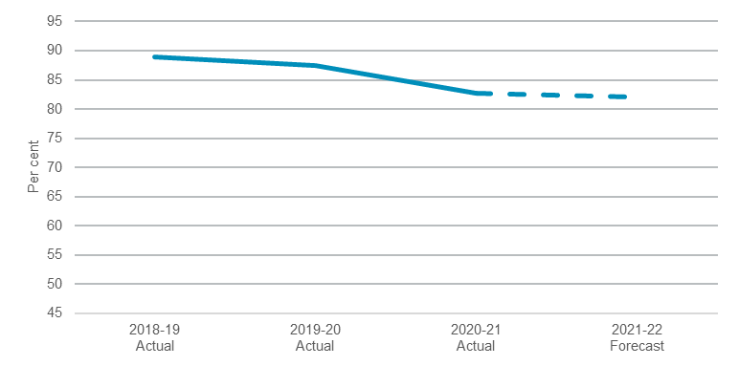
Note: 2020-21 actual reflects latest available information as at 30 April 2021. Target has been excluded as it is in the process of being reviewed.

Percentage of District Court criminal cases finalised within 12 months
Performance against this indicator is improving. The District Court is meeting its performance target and is expected to continue to do so for 2021-22. The District Court has significantly benefited from recent Government investment in additional judges as well as from legislative changes. These have contributed to a reduction in demand and capacity to better manage workload.
This investment allowed the District Court to recover from disruptions caused by COVID-19, in terms of matters finalised more quickly.
The District Court reduced short term backlogs caused by the need to defer jury trials in the early stage of the COVID-19 pandemic. Modelling indicates that with current capacity, the District Court will reduce its pending caseload by the end of 2021-22.

- Percentage of District Court criminal cases finalised within 12 months
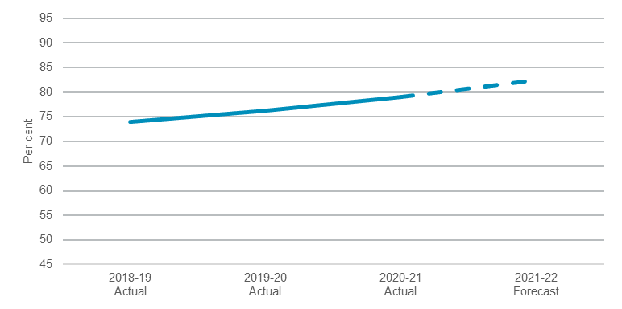
Note: 2020-21 actual reflects latest available information as at 30 April 2021. Target has been excluded as it is in the process of being reviewed.

Percentage of domestic and family violence related offences resolved in the Local Court within three months
Performance against this indicator is currently challenging. Performance has been impacted by the deferral of cases during COVID-19. In the 12 months to March 2021, 50.6 per cent of matters were resolved within three months. This level of performance is expected to be maintained.
The Local Court continues to invest significant effort into managing domestic violence matters, including a practice direction requiring that matters involving a domestic violence offence be listed on the first available date, as well as capital investment for domestic violence saferooms. New processes put in place during COVID-19 to improve court efficiency and user experiences are being sustained, including greater use of AVL.
- Percentage of domestic violence related criminal offences finalised in the Local Court within 3 months of the first court appearance
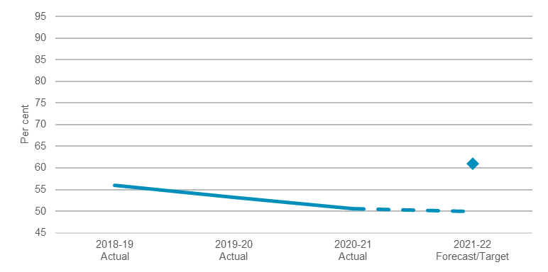
Note: 2020-21 actual reflects latest available information as at 30 April 2021.

Performance indicators for this Outcome
Outcome Indicators | Units | 2020-21  Actual^{(a)} | 2021-22  Forecast
Percentage of District Court criminal cases finalised within 12 months | % | 79.0 | 82.5
Percentage of District Court criminal cases finalised within 24 months | % | 95.7 | 95.0
Percentage of domestic violence related criminal offences finalised in the Local Court within 3 months of the first court appearance | % | 50.6 | 50.0
Percentage of Local Court criminal cases finalised within 12 months | % | 95.7 | 95.0
Percentage of Local Court criminal cases finalised within 6 months | % | 82.7 | 82.0
Percentage of NSW Civil and Administrative Tribunal (NCAT) cases finalised within 6 months | % | 95.2 | 95.0

Note
- Latest information available as at 30 April 2021, reflecting 12 months to March 2021.

Outcome 4: People have a safe and affordable place to live
 | $1.1 billion | Recurrent  Expenses  2021-22
 | $51.2 million | Capital  Expenditure  2021-22

State Outcome overview and 2021-22 investment
This Outcome captures the assistance provided to people who are unable to access or maintain appropriate housing. This assistance allows those in need of assistance to live independently within society.
The services supporting this Outcome are delivered by the Department of Communities and Justice, and include:
- homelessness services
- social housing and support.

2021-22 State Outcome Budget highlights
In 2021-22, the Stronger Communities Cluster will invest $1.2 billion ($1.1 billion in recurrent expenses and $51.2 million in capital expenditure) in this Outcome, including:
- $730.5 million for social housing, supporting secure and affordable housing for people on low incomes which includes $52.4 million towards the Aboriginal Community Housing Investment Fund and associated Roads to Home housing assistance (part of the $66.8 million program announced in the 2020-21 Budget)
- $295.9 million to deliver a range of specialist homelessness services across New South Wales
- $20.7 million ($57.0 million over two years) to expand the Together Home Program for those experiencing homelessness, providing an additional 250 households with leasing and wrap around support services for two years, and funding towards the construction of 100 new dwellings for people who require long term housing support at the end of the program.

Key performance insights
This section provides analysis and insights on key Outcome Indicators for this State Outcome.

Number of homeless persons in New South Wales living in improvised dwellings, tents, or sleeping out
Performance against this indicator is on track to meet the target. The New South Wales-wide street count in February 2021 identified 1,141 people experiencing street homelessness in New South Wales, a 13 per cent reduction compared to the 2020 street count. This included a 19 per cent reduction in street homelessness in the City of Sydney Local Government Area (LGA) compared to 2020.
The NSW Government invested significant funding in 2019-20 and the 2020-21 Budget to protect those at risk during the COVID-19 pandemic. Between April 2020 and April 2021, 38,761 people were assisted with temporary accommodation across New South Wales, including 5,001 people who identified as rough sleepers.
Reductions in street homelessness are being driven in part by the effective implementation of the Together Home program and investments in prevention and early intervention.

The Together Home program, which provides housing and essential support services to people experiencing homelessness in New South Wales, has been expanded in this budget to bring total expenditure for the program to $122.1 million. The additional investment of $20.7 million in 2021-22 ($57.0 million over two years) will go towards leasing accommodation, wrap around support services and providing 100 new dwellings for people who exit the program and require long term social housing support.
The NSW Government also continues to invest over $20 million per year in the NSW Homelessness Strategy for prevention and early intervention programs to support people to establish and sustain long-term housing, screen young people at risk of homelessness, and to expand Assertive Outreach services.

Proportion of tenants successfully transitioning out of social housing annually
Performance against this indicator remains challenging. Housing affordability remains a significant issue in New South Wales with limited supply of private rentals at the low end of the market. The move of people out of major metropolitan areas during the COVID-19 pandemic has also affected affordability in regional areas of the State.
Housing 2041 sets a 20-year vision for housing in New South Wales and considers housing needs from homelessness to home ownership, including social and affordable housing. This is expected to improve housing access across the spectrum, supporting transitions out of social housing.
- Proportion of tenants successfully transitioning out of social housing annually
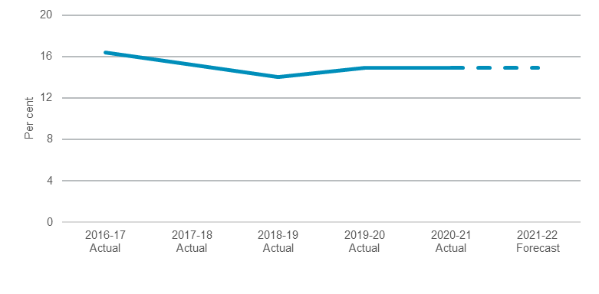
Note: 2020-21 actual reflects latest available information as at 30 April 2021.The target for this indicator is to maintain performance and has not been included in the chart for presentational purposes.

Proportion of social housing applicants each year who are diverted from social housing to the private rental market, not returning for further assistance 12 months later
Performance against this indicator continues to exceed the performance target. Since Future Directions was released, around 80 per cent of people receiving support under diversion programs do not need further assistance 12 months after receiving the subsidy or payment. These programs include one-off support (such as no-interest bond loans) and medium-term rent subsidies in the private rental market (Rent Choice/Start Safely).
The effectiveness of the Rent Choice programs ($20.0 million in additional funding provided in 2019-20 and 2020-21) at diverting people from social housing is driven by the identification of suitable applicants at the outset. The Rent Choice programs' efficiency will be assessed in 2021-22.
- Proportion of social housing applicants each year who are diverted from social housing to the private rental market not returning for further assistance 12 months later
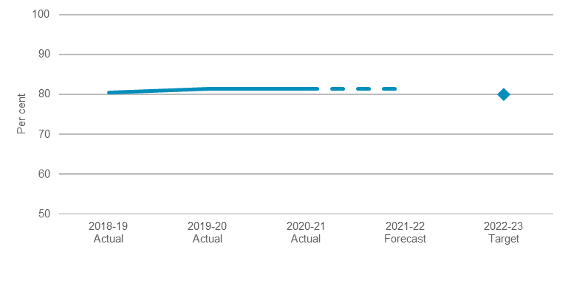
Note: 2020-21 actual reflects latest available information as at 30 April 2021.

Performance indicators for this Outcome
Outcome Indicators | Units | 2020-21 | 2021-22
 |  | Actual ^{(a)} | Forecast
Number of homeless persons in New South Wales living in improvised dwellings, tents, or sleeping out | no. | n.a.^{(b)} | n.a.^{(b)}
Proportion of social housing applicants each year who are diverted from social housing to the private rental market not returning for further assistance 12 months later | % | 81.3 | 81.3
Proportion of tenants successfully transitioning out of social housing annually | % | 14.9 | 14.9

Notes
- Latest information available as at 30 April 2021.
- Data is currently not available.

Outcome 5: Prepared for disasters and emergencies
 | $1.7 billion | Recurrent  Expenses  2021-22
 | $159.6 million | Capital  Expenditure  2021-22

State Outcome overview and 2021-22 investment
This Outcome focuses on the duties and responsibilities of the emergency services, including co-ordination of emergency prevention, preparedness, response and recovery operations. It is comprised of the operations under Fire and Rescue NSW (FRNSW), the NSW Rural Fire Service (NSW RFS), and the NSW State Emergency Service (NSW SES).
The emergency services agencies are supported by Resilience NSW, which is responsible for disaster recovery and building community resilience to future disasters and includes the former Office of Emergency Management functions. Resilience NSW is in the Premier and Cabinet Cluster.

2021-22 State Outcome Budget highlights
In 2021-22, the Stronger Communities Cluster will invest $1.9 billion ($1.7 billion in recurrent expenses and $159.6 million in capital expenditure) in this Outcome, including:
- $847.1 million in recurrent expenses and $82.6 million in capital expenditure for FRNSW to respond to hazards and emergency incidents quickly and effectively across metropolitan New South Wales to minimise the impact of these events on people, property and the environment
- $655.3 million in recurrent expenses and $29.7 million in capital expenditure for the NSW RFS to combat bushfires across New South Wales through reduction of bushfire hazards, reduction of fire ignition sources and monitoring of bushfire prone areas
- $193.1 million in recurrent expenses and $47.3 million in capital expenditure for the NSW SES to respond to flood and storm emergencies, as well as road accident rescue, bush search and rescue, and evidence searches in rural parts of New South Wales
- $192.9 million ($161.9 million in recurrent expenses and $31.0 million in capital expenditure) over four years as part of the Stage 2 response to the NSW Bushfire Inquiry, including:
- $48.2 million over two years to extend fleet replacement and vehicle safety retrofits
- $34.4 million over four years to expand NSW RFS’ delivery of a Strategic Fire Trail Network, and ongoing funding for critical Private Land Fire Trail staff in regional areas
- $22.7 million over four years for additional Personal Protective Clothing for FRNSW firefighters
- $20.0 million over two years for NSW RFS to upgrade Fire Control Centres and Emergency Operations Centres and Station/Neighbourhood Safe Places
- $18.4 million over two years for FRNSW to enhance Integrated Call and Dispatch capability
- $17.2 million over two years for NSW RFS to purchase three emergency helicopters
- $16.1 million in 2022-23 for a further extension of funding for NSW RFS mitigation crews to maintain current levels of hazard reduction works
- $5.2 million over four years to invest in drone technology through enhancements to FRNSW’s Remote Piloted Aircraft Systems capability

- $50.5 million recurrent expenses and $25.0 million capital expenditure over four years for the Stay Safe and Keep Operational program, which will support the communication requirements of the emergency services agencies in areas not currently serviced by the Government Radio Network across New South Wales
- $35.3 million to support the Emergency and Rescue Workers Compensation Fund
- $4.8 million over four years for NSW SES to gather flood intelligence and analysis with the aim of minimising the impacts of flooding on the community, including updating local flood plans as part of the Hawkesbury-Nepean Valley Flood Risk Management Strategy.

Key performance insights
This section provides analysis and insights on key Outcome Indicators for this State Outcome.

Number of dwellings that have sustained damage or were destroyed by fire
Performance against this indicator is improving, and data has been consistent across recent years. The reduced incidence of bushfires in 2020-21 reduced the number of residential structure fires.
A key driver of performance for this indicator is the delivery of a wide range of fire safety education, prevention and preparedness programs to create a safer environment and build resilience, particularly through targeting programs and services to identified at-risk community groups. FRNSW continues to focus effort on the Safety Visits program for at-risk groups, as well as delivering educational presentations to pre-school and primary school children, educational programs to older adults, and community safety activities across New South Wales to Indigenous Australians. The NSW RFS continues to deliver the Home Fire Safety program to local communities including schools, encouraging homeowners in rural areas to be home fire safe.
- Number of dwellings that have sustained damage or were destroyed by fire

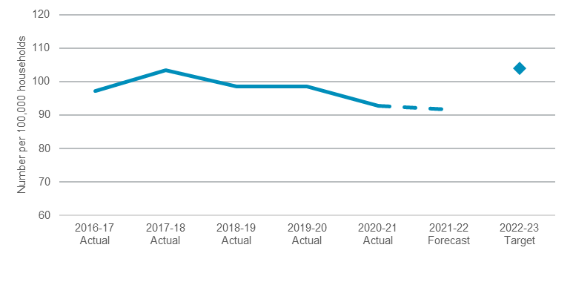
Note: 2020-21 actual reflects latest available information as at 30 April 2021. The 2022-23 target is calculated on a 10-year average, the Cluster has been outperforming this average in recent years.

Average response time to emergency incidents
The NSW Government continues to invest significantly in FRNSW and the NSWRFS to ensure these agencies have sufficient resources to respond to hazard and emergency incidents quickly and effectively. However, performance against this indicator is challenging. Factors influencing response times include land area, population size and density, population dispersion, road and transport infrastructure, crew configurations, response systems and processes, and travel distances.
Increased rainfall in New South Wales for the summer of 2020-21 had a significant impact on the number of structure fires in regional areas of the State. In 2020-21, the average response time to emergency incidents was 12.7 minutes, outperforming the rolling 10-year average of 14.3 minutes. This recent performance is considered an anomaly due to increased rainfall, which resulted in a significant decline in bushfire activity and subsequently fewer structure fires.
- Average response time to emergency incidents
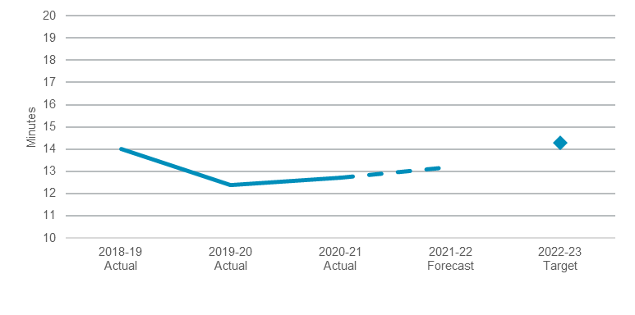
Note: 2020-21 actual reflects latest available information as at 30 April 2021. The 2022-23 target is calculated on a 10-year average, the Cluster has been outperforming this average in recent years.

Performance indicators for this Outcome
Outcome Indicators | Units | 2020-21 | 2021-22
 |  | Actual^{(a)} | Forecast
Number of dwellings that have sustained damage or were destroyed by fire as a result of an emergency or disaster event | no. | 92.8 | 91.7
Average response time to emergency incidents^{(b)} | min | 12.7 | 13.2

Note:
- Latest information available as at 30 April 2021.
- Supporting information and data for this indicator refers to: the time taken for 90 per cent of all responses to arrive at a structure fire, according to the Report on Government Services.

Outcome 6: Reduce reoffending
 | $2.4 billion | Recurrent  Expenses  2021-22
 | $494.6 million | Capital  Expenditure  2021-22

State Outcome overview and 2021-22 investment
This Outcome relates to the State’s corrections system, including support for, and management of, adult and youth offenders in correctional centres and the community.
The Cluster works to achieve this Outcome through focusing on the following strategic priorities:
- reducing adult and youth reoffending
- reducing domestic violence reoffending in both adults and youths
- addressing Aboriginal over-representation in both adult and youth justice systems
- addressing the needs of women and young female offenders
- countering terrorism and violent extremism.

2021-22 State Outcome Budget highlights
In 2021-22, the Stronger Communities cluster will invest $2.9 billion ($2.4 billion in recurrent expenses and $494.6 million in capital expenditure) in this Outcome, including:
- $2.2 billion for the management of adult offenders in custody and in the community, which includes the delivery of programs to reduce reoffending and to support reintegration
- $494.6 million in capital expenditure to support the management of youth and adult offenders in New South Wales including new funding for:
- $30.0 million ($120.0 million over four years) for the Sustaining Critical Infrastructure Program, delivering infrastructure upgrades across the Department of Communities and Justice critical asset base which includes investment in Audio Visual Link facilities and other upgrades for correctional centres
- $30.0 million ($85.0 million over four years) to protect highly sensitive data and ICT infrastructure through investments in cyber security
- $256.2 million for the supervision and care of youth offenders, which includes individualised case management and specialised skills training.

Key performance insights
This section provides analysis and insights on key Outcome Indicators for this State Outcome.

Number of young people each year who reoffend within 12 months of participation in a Youth Justice Conference or completion of a custodial order or sentence to a supervision order
Performance against this indicator continues to be on track to meet the target with the number of young people reoffending trending downwards over the past 10 years. The number of young people in custody in New South Wales has fallen in both sentenced and unsentenced detention, including the rate of young Aboriginal Australians.
The trends indicate that the suite of diversionary reforms and work focused on addressing Aboriginal over-representation is delivering its intended outcomes. Enhancements will continue to be implemented to maximise the opportunity for therapeutic interventions for young people in custody and address the number of young people entering custody on remand.
The Youth Justice system continues to perform at a high standard. Investment from the 2020-21 Budget will allow the Youth Justice system to continue as one of the best performing Youth Justice systems in Australia. This investment will also allow the custodial and community offender populations to be safely detained in Youth Justice centres and receive community-based interventions that are proven to reduce reoffending.
- Number of young people each year who reoffend within 12 months of participation in a Youth Justice Conference or completion of a custodial order or sentence to a supervision order
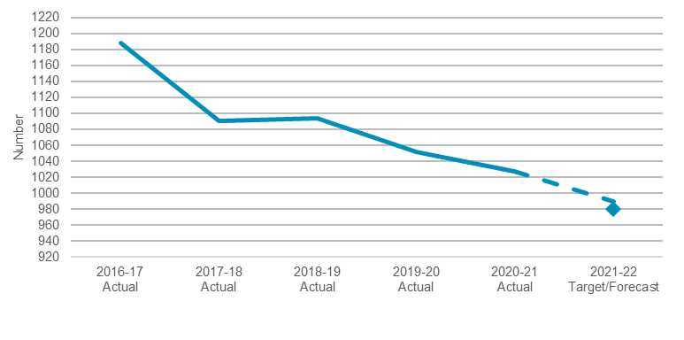
Note: 2020-21 is reoffending in the 12 months to December 2019 cohort. Previous years based on reoffending in the 12 months to June. Each of these data points reflects a 12 month delay due to the inherent lag in measuring this indicator.

Proportion of adult offenders receiving a supervised community sentence who have a new proven personal, property or serious drug offence within 12 months of sentence
People on supervised or community-based orders represent the largest cohort of offenders managed by Corrective Services NSW, at approximately 35,000 people. The delivery of rehabilitation services and support for this cohort reduces the likelihood of reoffending. Community Corrections is vital in improving community safety and ensuring people do not become further entrenched in the criminal justice system.
Performance against this indicator remains challenging, however the annual rate of reoffending appears to be stabilising compared to the upward trend observed from 2016 to 2019. While the annual rate of reoffending has not decreased, the most recent rate of reoffending amongst the quarterly cohort (those who were sentenced to a community based order in the last quarter of 2019) is observed to be decreasing. Investment in Community Corrections capacity in the 2020-21 Budget and new investment in 2021-22 will enable Community Corrections to increase supervision and interventions that are commensurate with risk, which is expected to improve performance against this indicator.
- Proportion of adult offenders receiving a supervised community sentence who have a new proven personal, property or serious drug offence within 12 months of sentence
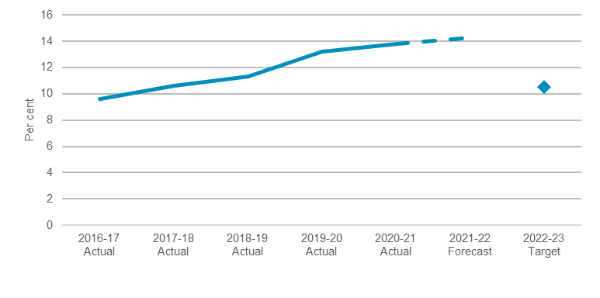
Note: 2020-21 based on annual average reoffending to December 2020. Previous years based on annual average reoffending to June. Each of these data points reflects a 12 month delay due to the inherent lag in measuring this indicator.

Proportion of adult offenders released from custody who have a new proven personal, property or serious drug offence in the 12 months following release
Performance against this indicator remains challenging. People released from prison are the offender group most at risk of reoffending. Of the persons that were released from prison in 2017, 26.8 per cent reoffended within 12 months, representing a 16.5 per cent increase since 2011. The increase was at least in part due to the impact of police targeting repeat offenders and the subsequent reconviction of these offenders. This occurs as a result of the NSW Police Force targeting of repeat offenders using the Suspect Targeting Management Plan (STMP) which operates by identifying individuals at risk of offending. A recent Bureau of Crime Statistics & Research (BOCSAR) study has shown that targeting repeat offenders using the STMP can be associated with a reduction in crime in certain cases.
Since then there has been improvements with reductions in reoffending recorded. Over the past 12 months the annual average reoffending rate reduced from 29.9 per cent in the first quarter of 2019 to 29.1 per cent in the last quarter of 2019. There is an 18-month reporting time lag as the performance measure captures serious offences committed in a fixed period after the prisoner is released. These results are within the forecasted range of reduction in reoffending due to the cumulative impact of strategies rolled out in 2017 and ramped up in 2018 and 2019.
Investment in supervision capacity in correctional centres provided in the 2020-21 Budget is expected to improve performance against this indicator.

- Proportion of adult offenders released from custody who have a new proven personal, property or serious drug offence in the 12 months following release
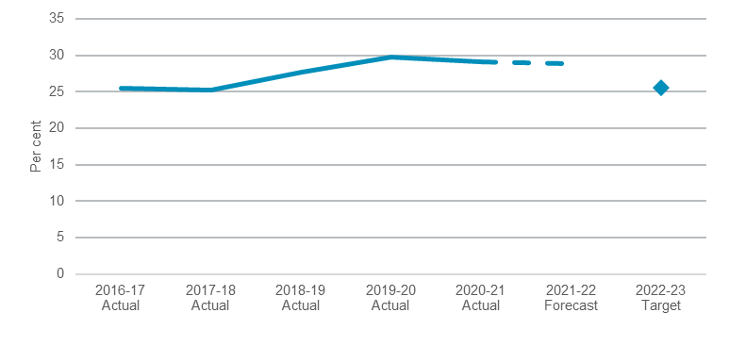
Note: 2020-21 based on annual average reoffending to December 2020. Previous years based on annual average reoffending to June. Each of these data points reflects a 12 month delay due to the inherent lag in measuring this indicator.

Performance indicators for this Outcome
Outcome Indicators^{(a)} | Units | 2020-21 | 2021-22
 |  | Actual^{(b)} | Forecast^{(c)}
Number of young people each year who reoffend within 12 months of participation in a Youth Justice Conference or completion of a custodial order or sentence to a supervision order | no. | 1,027 | 990
Proportion of adult offenders receiving a supervised community sentence who have a new proven personal, property or serious drug offence within 12 months of sentence | % | 13.8 | 14.3
Proportion of adult offenders released from custody who have a new proven personal, property or serious drug offence in the 12 months following release | % | 29.1 | 28.8

Notes
- Each of these data points reflects a 12 month delay due to the inherent lag in measuring these indicators.
- Reoffending to 31 December 2020.
- Forecast based on 12 months following the 2020-21 data.

Outcome 7: Safer communities
 | $4.3 billion | Recurrent  Expenses  2021-22
 | $390.9 million | Capital  Expenditure  2021-22

State Outcome overview and 2021-22 investment
This Outcome captures activities relating to preventing, detecting and investigating crime, maintaining social order and community safety, promoting road safety, and supporting emergency management.
This Outcome is delivered by the NSW Police Force and the NSW Crime Commission, who focus on:
- preventing, disrupting and responding to crime, including serious and organised criminal activities
- monitoring and promoting road safety
- maintaining social order
- performing and coordinating emergency and rescue operations
- confiscating the proceeds of crime.

2021-22 State Outcome Budget highlights
In 2021-22, the Stronger Communities Cluster will invest $4.7 billion ($4.3 billion in recurrent expenses and $390.9 million in capital expenditure) in this Outcome, including:
- $4.3 billion for the NSW Police Force which includes:
- $41.5 million for 250 additional police. These will join the 700 police recruited in 2019-20 and 2020-21, as part of the State’s commitment to deliver 1,500 new police over four years to enhance the State’s crime fighting capability and keep the community safe
- $47.9 million to commence a three-year pilot of an optional disengagement scheme supporting officers to exit the NSW Police Force.
- $389.4 million in capital expenditure for NSW Police Force infrastructure which includes $1.6 million ($18.9 million over five years) to commence phase 2 of the Marine Vessel Replacement Program providing a new police vessel fleet and ensuring that the NSW Police Force continues to have the capability and capacity to deliver crucial services
- $31.3 million to support the NSW Crime Commission in reducing the incidence of organised and other serious crime across the State including $3.9 million ($16.3 million over four years) to enhance the financial investigations capability.

Key performance insights
This section provides analysis and insights on key Outcome Indicators for this State Outcome.

Rate of violent crime in New South Wales per 100,000 population
Performance against this indicator has remained stable for the 24 months to December 2020 with 10 out of 17 crime categories showing downward trends, six stable and one with an upward trend (up 10.1 per cent).
Robbery without a weapon and robbery with a firearm have been trending down. Many violent crimes fell sharply in April 2020 because of measures to reduce the spread of the COVID-19 pandemic. Recent data indicates that violent offending has returned to pre-pandemic levels.

- Rate of violent crime in NSW per 100,000 population
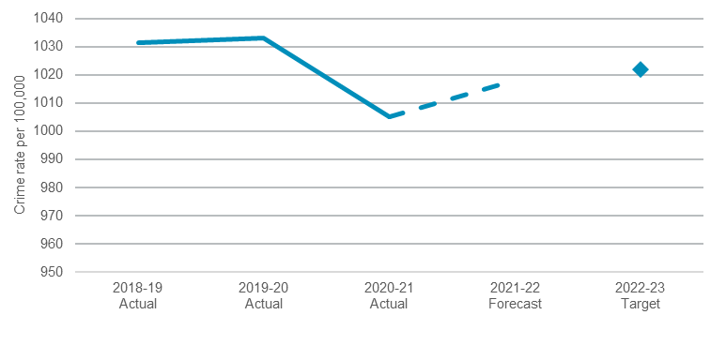
Note: 2020-21 actual reflects latest available information as at 30 April 2021.

Rate of property crime in New South Wales per 100,000 population
Performance against this indicator is stable and remains below target. For the 24 months to December 2020, property crimes have been trending down. Break-ins and theft from vehicles, retail stores and persons were considerably lower than the same period to December 2019. All high-volume property crimes fell sharply in April 2020 because of measures to reduce the spread of the COVID-19 pandemic. Recent data shows that many property offences remain below pre-pandemic levels.
- Rate of property crime in NSW per 100,000 population
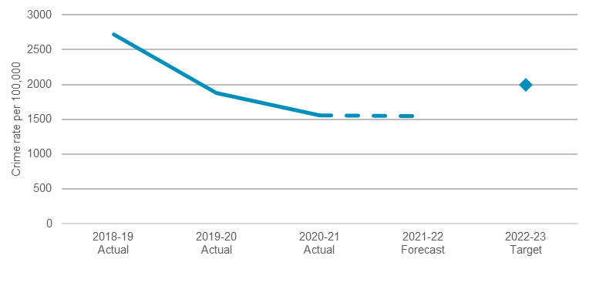
Note: 2020-21 actual reflects latest available information as at 30 April 2021.

Percentage of people who feel safe walking alone in their neighbourhood at night
Performance against this indicator has remained relatively stable over the last five years, with results above target for the period to December 2020.

- Percentage of people who feel safe walking alone in their neighbourhood at night
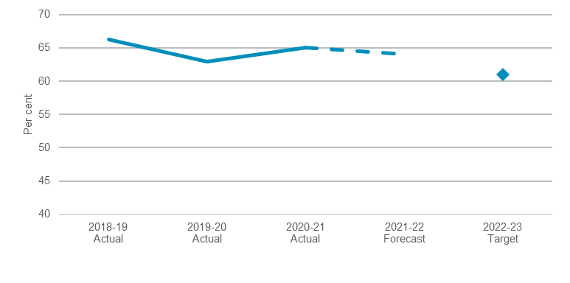
Note: 2020-21 actual reflects latest available information as at 30 April 2021.

Performance indicators for this Outcome
Outcome Indicators | Units | 2020-21 | 2021-22
 |  | Actual^{(a)} | Forecast
Percentage of people who feel safe walking alone in their neighbourhood at night | % | 65.1 | 64.1
Rate of domestic violence related assault incidents recorded by police involving grievous bodily harm | no. | 4.9 | 4.7
Rate of property crime in NSW per 100,000 population | no. | 1,558 | 1,555
Rate of recorded incidents of fraud in NSW per 100,000 population | no. | 548 | 569
Rate of violent crime in NSW per 100,000 population | no. | 1,005 | 1,018

Note:
- Latest information available as at 30 April 2021.

