8. TRANSPORT CLUSTER

Introduction
 | $16.8  billion | Recurrent  Expenses  2021-22
 | $18.7  billion | Capital  Expenditure 2021-22
The Transport Cluster plans, delivers and operates integrated services and infrastructure across all modes of transport, including road, train, metro, bus, ferry, light rail, cycling and walking.
The Cluster contributes to economic growth and wellbeing in New South Wales by managing and improving the transport system to enable the safe, efficient and reliable movement of people and goods. It connects us to each other and to the great social, cultural and leisure activities that the State has to offer.

State Outcomes to be delivered by the Transport Cluster
State Outcomes  What the Cluster is delivering for people and business |  | Key Programs  underway to support delivery of Outcomes
- Connecting our customers’ whole lives  Transport plays a vital role in the lives of its customers, delivering transport solutions catering for the range of journey types needed by people and freight. Transport provides safe and seamless journeys, and new mobility options and experiences by delivering, operating and maintaining services and infrastructure, focused on reliability, availability and customer experience.  2021-22 investment: $15.9 billion in recurrent expenses & $3.3 billion capital expenditure |  | - Greater Sydney mobility, including delivering public transport services, the More Trains, More Services, Active Transport and congestion management  - Regional and outer metropolitan mobility, including delivering public transport services, town bypasses, road improvements and bridge upgrades  - Asset management, including road, bridge, tunnel, fleet and infrastructure maintenance to ensure that travel is safe and reliable, and assets are sustainably managed  - State-wide customer services and technology, including digital services, registration and ticketing  - Transport safety, including road and public transport safety strategies and campaigns and blackspot treatments
2. Successful places for communities  Transport helps create places that integrate the right mix of infrastructure, services, access and experiences for communities, supporting them to achieve their desired social, cultural and economic outcomes. Transport works in close partnership with communities to ensure the places created reflect their people and culture, protecting and enhancing communities and their environments.  2021-22 investment: $822.1 million recurrent expenses & $703.0 million capital expenditure |  | - Access upgrades and schemes, including Transport Access Program, commuter carparks, and subsidies and schemes to enhance access to travel for vulnerable and disadvantaged communities  - Renewal and development of key precincts, including Circular Quay renewal  - Community amenity, including boating programs, policies and regulation that enhance amenities for the community
3. Sustainable Transport systems and solutions that enable economic activity  The transport system powers and connects a globally competitive, inclusive and sustainable New South Wales. Transport plays a critical role in driving economic growth and improving quality of life for the people of New South Wales. Transport invests in network enhancements, efficient networks and manages and maintains quality assets.  2021-22 investment: $153.7 million recurrent expenses & $14.7 billion capital expenditure |  | - Greater Sydney capacity enhancements, including building Metro, Parramatta Light Rail, motorways and major road upgrades  - Regional and outer metropolitan capacity enhancements, including Coffs Harbour Bypass, Princes Highway and Great Western Highway Upgrade  - Productivity through partnerships, including road, waterway and rail projects to provide productive freight movements

Overview of Cluster expenses by State Outcome
A summary of expenses by State Outcome is provided in the charts below.
- Recurrent expenses by Outcome 2021-22 (dollars and %)

Note: Grouped for presentation purposes, “Other State Outcomes” comprises:
- Successful Places for Communities
- Sustainable Transport systems and solutions that enable economic activity.
- Capital expenditure by Outcome 2021-22 (dollars and %)

Note: The sum of percentages does not equal to one hundred due to rounding.

Outcome 1: Connecting our customers’ whole lives
 | $15.9 billion | Recurrent  Expenses  2021-22
 | $3.3 billion | Capital  Expenditure  2021-22

State Outcome overview and 2021-22 investment
Transport plays a vital role in customers’ lives, delivering and enabling transport solutions that cater for the wide range of journey types needed by people and for freight. Transport works to meet customers’ expectations of effortless, accessible, and personalised journeys, regardless of mode, which are safe, reliable, and sustainable. This includes creating complete journey solutions - blending public, private, car share, on-demand, active and personal mobility.

2021-22 State Outcome Budget highlights
In 2021-22, the Transport Cluster will invest $19.2 billion ($15.9 billion recurrent expenses and $3.3 billion capital expenditure) in this Outcome, including:
- $1.6 billion in recurrent expenses for bus services in 2021-22 throughout New South Wales, including regional and metropolitan bus services and school services
- $645.7 million ($1.3 billion recurrent expenses and $0.7 billion capital expenditure over four years) to continue NSW and Commonwealth Government investment to improve road safety, including a significant increase in investment through the NSW Road Safety Plan 2021 targeting high risk areas with a regional focus
- $549.5 million in recurrent expenses in 2021-22, as part of the $600.0 million Regional Stimulus Program to accelerate a range of regional Transport programs and projects, including Fixing Country Bridges, rollout of real-time tracking on regional bus services, Transport Connected Buses Program, Bus Growth Program and regional road projects, aimed at supporting jobs and stimulating the economy in regional New South Wales
- $320.0 million in capital expenditure ($1.3 billion over four years) to deliver a modern new Regional Rail Fleet to replace the ageing XPT, XPLORER and Endeavour trains and construct a new purpose-built maintenance facility in Dubbo
- $297.3 million ($1.3 billion recurrent expenses and $56.6 million capital expenditure over four years) to continue implementation of the More Trains, More Services program for increased rail services, including more frequent and additional services on the Illawarra, Airport and South Coast lines
- $281.4 million in capital expenditure ($992.0 million over four years) to continue delivery of the Mariyung Fleet (New Intercity Fleet), a new, state-of-the-art fleet, that will provide a new level of comfort and convenience, improved accessibility, enhanced safety for customers who travel between Sydney, the Central Coast and Newcastle, the Blue Mountains, and the South Coast
- $101.4 million in capital expenditure ($187.7 million over four years) for wharf upgrades and maritime infrastructure investment across New South Wales, including upgrades to ferry wharves at Darling Point, Double Bay and Greenwich Point, as well as ongoing maintenance and upgrades to various regional maritime assets, such as the Coffs Harbour boat ramp
- $99.4 million in capital expenditure ($327.0 million over four years) for NSW and Commonwealth Government funded works on the Newell Highway, including continued delivery of 40 new overtaking lanes, flood mitigation, and Parkes Bypass

- $63.8 million in capital expenditure ($103.8 million over three years) for the Fixing Country Rail program to provide improved capacity, access, efficiency, and reliability of the regional rail network, as well as delivering a highly functional transport network for moving freight in and out of regional areas
- $29.0 million in capital expenditure ($339.9 million over four years) to continue NSW and Commonwealth Government funding for the Newcastle Inner City Bypass from Rankin Park to Jesmond
- $27.4 million in capital expenditure to continue sealing the Silver City and Cobb Highways, expected to be completed by late 2022
- $28.1 million in capital expenditure ($438.0 million over four years) to continue planning and design for the Muswellbrook Bypass and Singleton Bypass to improve travel times for long haul freight movements, and safety for all road users on the New England Highway.

Key performance insights
This section provides analysis and insights on key Outcome Indicators for this State Outcome.

Customer satisfaction
This indicator measures overall satisfaction with public transport services across nine key satisfaction drivers including: timeliness, safety and security, ticketing, convenience, accessibility, comfort, cleanliness, information and customer service. Maintaining or improving satisfaction shows how well the public transport system is meeting customer expectations and needs.
Performance against this indicator has improved over the past year, with the latest results being the highest recorded. Timeliness, comfort and cleanliness were key drivers of improved customer satisfaction, despite the challenges posed by COVID-19. The COVID-safe Transport Plan provided 100,000 extra spaces on the network each week, and the NSW Government’s $250.0 million for additional cleaning packages supporting the safe movement of our customers. Delivering new infrastructure and services will be a continuing commitment to respond to customers’ needs.
- Customer satisfaction
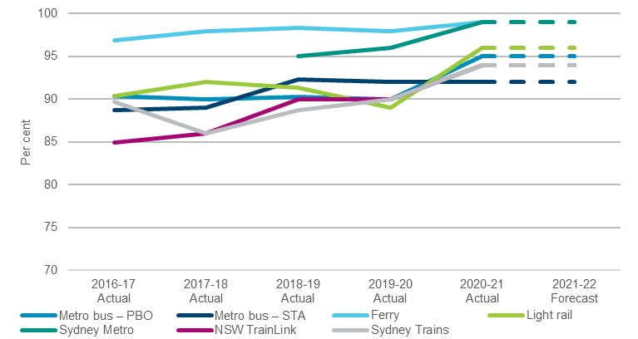

Reliability
Improved reliability means people can expect consistent travel time, and spend less time waiting. Performance against this indicator for public transport and road modes are relatively stable with an overall improvement since last year.
Transport has been working to introduce more comfortable and reliable fleet onto the network, including additional Waratah Series 2 trains, Mariyung Fleet (New Intercity Fleet) and the new Regional Rail Fleet. In addition, Transport continues to deliver More Trains, More Services for increased rail services on the Illawarra, Airport and South Coast lines.
Reliability on the Sydney road network is relatively stable with performance largely driven by traffic levels. On the road network pinch point projects, customer information, road safety and mobility enhancements will improve journey times and reliability.
- Reliability
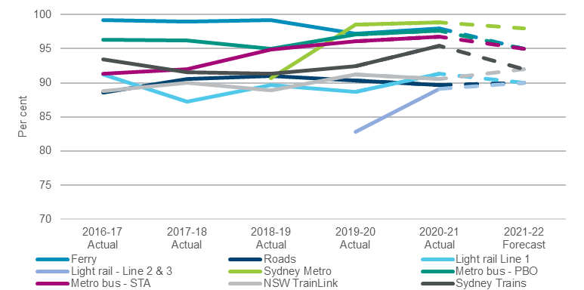

Safety
Road safety reflects lives lost on New South Wales roads. The NSW Road Safety Plan 2021 sets a target to reduce road fatalities by 30.0 per cent from 2008-2010 levels by the end of 2021.
Performance against this indicator continues to improve. The New South Wales Safer Roads Program prioritises funding to deliver road safety infrastructure projects across NSW. Over five years to 2022-23, $822.0 million will be invested in the Safer Roads Program, which supports the delivery of life saving road safety treatments through two initiatives, Saving Lives on Country Roads and Liveable and Safe Urban Communities.

- Total NSW road fatalities per 100,000 population
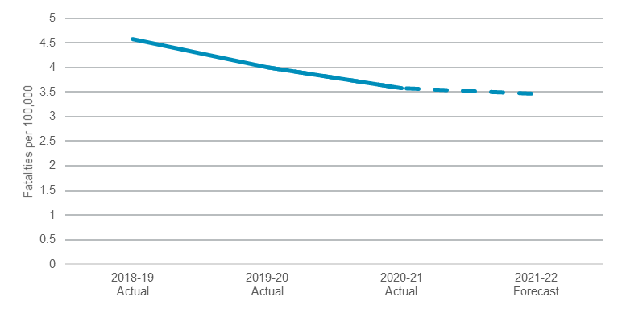

Performance indicators for this Outcome
Outcome Indicators^{(a)} | Units | 2020-21 | 2021-22
 |  | Actual | Forecast
Customer satisfaction | %
Sydney Metro bus – PBO^{(b)} |  | 95.0 | ≥95
Sydney Metro bus – STA |  | 92.0 | ≥92
Ferry |  | 99.0 | ≥99
Light rail |  | 96.0 | ≥96
Sydney Metro |  | 99.0 | ≥99
NSW TrainLink |  | 94.0 | ≥94
Sydney Trains |  | 94.0 | ≥94
Day-return regional - per cent of regional population with access to public transport day-return to nearest city or major centre | % | 91.3 | ≥91.3
Reliability^{(f)} | %
on-time running (Ferry) |  | 98.0 | 95.0
road journey time reliability |  | 89.7 | 90.0
headway (Light rail line 1)^{(c)} |  | 91.3 | 90.0
headway (Light rail line 2 and line 3)^{(d)} |  | 89.1 | 90.0
headway (Sydney Metro) |  | 98.9 | 98.0
on-time running (Metro bus – PBO)^{(b)} |  | 97.6 | 95.0
on-time running (Metro bus – STA) |  | 96.8 | 95.0
on-time running (NSW TrainLink) |  | 90.6 | 92.0
punctuality (Sydney Trains) |  | 95.4 | 92.0
Safety - Total NSW Road fatalities per 100,000 population^{(e)} | no. | 3.58 | ≤3.5

Notes
- All customer satisfaction indicators are based on November 2020 results for 2020-21. A customer satisfaction survey for road users was not undertaken in 2020-21 due to COVID-19.
- PBO: Private Bus Operator.
- Light rail line 1, is the route from Central Station to Dulwich Hill.
- Light rail line 2 and line 3, is the route that links the Sydney CBD to Randwick and Kingsford.
(f) Reliability indicators are based on March 2021 results for 2020-21. Reliability targets have been used for the 2021-22 forecast figures.
(e) Road fatalities rate per 100,000 population is the 2020-21 preliminary 12 months result to March 2021.

Outcome 2: Successful places for communities
 | $822.1 million | Recurrent  Expenses  2021-22
 | $703.0 million | Capital  Expenditure  2021-22

State Outcome overview and 2021-22 investment
Transport helps create places that integrate the right mix of infrastructure, services, access and experiences for communities, supporting them to achieve their desired social, cultural, and economic outcomes.
At the heart of communities are places where people come together to interact, transact and travel to other communities. Transport works in close partnership with communities to ensure the places created reflect their people and culture and protect and enhance communities and their environments.

2021-22 State Outcome Budget highlights
In 2021-22, the Transport Cluster will invest $1.5 billion ($822.1 million recurrent expenses and $703.0 million capital expenditure) in this Outcome, including:
- $365.0 million in capital expenditure ($717.9 million over four years) to continue the upgrade of train stations under the Transport Access Program to make them more accessible, including new lifts, ramps and footbridges
- $232.0 million in capital expenditure ($480.9 million over four years) in NSW and Commonwealth Government funding to provide additional car spaces through the Commuter Car Parking Program
- $83.9 million in recurrent expenses for the Commonwealth Home Support Program to provide entry-level support to older individuals to stay independent and in their own home longer by providing transportation for medical and recreational reasons
- $42.9 million in recurrent expenses ($176.9 million over four years) for transport disability subsidies, including the Taxi Transport Subsidy Scheme and the Wheelchair Accessible Taxi Driver Incentive Scheme.

Key performance insights
This section provides analysis and insights on key Outcome Indicators for this State Outcome.

Customer Satisfaction for people with a disability
This indicator demonstrates the level of satisfaction for people with disability or other mobility limitations to have the same access to services as the rest of the community, resulting in improved social and economic inclusion and wellbeing. It also indicates whether people with a disability have the same experience of transport modes as the general population.
Performance against this indicator has generally improved. The Transport Access Program invests in accessibility upgrades to train stations and ferry wharves. This continues to improve access to public transport for people with limited mobility. Transport is also investing in new train fleet which will provide improved accessibility for commuters using wheelchairs, prams or other mobility constraints.

- Customer satisfaction for people with disability
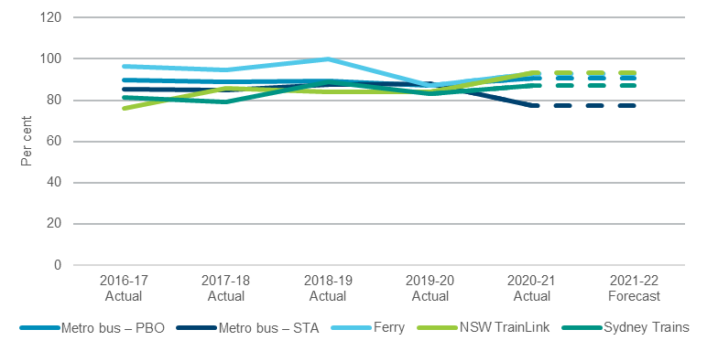
Note: PBO: Private Bus Operator.

Performance indicators for this Outcome
Outcome Indicators^{(a)} | Units | 2020-21 | 2021-22
 |  | Actual | Forecast
Customer satisfaction for people with disability | %
Metro bus – PBO ^{(b)} |  | 90.6 | ≥90
Metro bus – STA |  | 77.2 | ≥77
Ferry |  | 93.1 | ≥93
NSW TrainLink |  | 93.2 | ≥93
Sydney Trains |  | 87.2 | ≥87

Notes
- All customer satisfaction for people with disability indicators for 2020-21 are based on November 2020 results.
- PBO: Private Bus Operator.

Outcome 3: Sustainable Transport systems and solutions that enable economic activity

State Outcome overview and 2021-22 investment
 | $153.7 million | Recurrent  Expenses  2021-22
 | $14.7 billion | Capital  Expenditure  2021-22
The transport system powers and connects a globally competitive, inclusive and sustainable New South Wales. Transport plays a critical role in driving economic growth and improving quality of life for the people of New South Wales, with a new focus on place and mobility. Transport will support the transformation of regional centres into hubs for investment, employment, tourism and essential services. Transport invests in network enhancements and manages and maintains quality assets and efficient networks.

2021-22 State Outcome Budget highlights
In 2021-22, the Transport Cluster will invest $14.9 billion ($153.7 million recurrent expenses and $14.7 billion capital expenditure) in this Outcome, including:
- $3.1 billion in capital expenditure ($6.1 billion over four years) to continue construction of the Sydney Metro City and Southwest linking Chatswood and Bankstown
- $2.9 billion in capital expenditure ($12.0 billion over four years) to progress construction of Sydney Metro West, which will provide a faster, easier and more reliable journey between Westmead and the Sydney CBD
- $1.2 billion in capital expenditure ($1.9 billion over four years) to continue construction of the WestConnex Motorway including delivery of the final stages of the project, the M4-M5 link tunnels and the Rozelle Interchange by 2023
- $1.1 billion in capital expenditure ($4.8 billion over four years) to commence construction on the Sydney Gateway project and the M6 Stage 1 Extension
- $1.1 billion in capital expenditure ($3.0 billion over four years) to continue implementation of the More Trains, More Services program for increased rail services including more frequent and additional services on the Illawarra, Airport and South Coast lines
- $943.0 million in capital expenditure ($8.0 billion over four years) for the planning and construction for the NSW and Commonwealth Government funded Sydney Metro - Western Sydney Airport to be completed in time for the opening of the airport
- $899.7 million in capital expenditure over the next four years, including $201.4 million in 2021-22, for the Western Sydney Growth Roads program to accommodate population and employment growth in Western Sydney. Key projects include:
- Mulgoa Road upgrades (State and Federal funded)
- The Horsley Drive, M7 motorway to Cowpasture Road
- Memorial Avenue, Old Windsor Road to Windsor Road
- Appin Road Improvements (Federal funded)
- Spring Farm Parkway Stage 1
- Mamre Road, M4 Motorway to Erskine Park Road
- $657.0 million in capital expenditure to continue construction of Parramatta Light Rail (Stage 1 and 2) to support growth in Western Sydney by growing communities and places and to continue development of Stage 2 which will connect to Stage 1 and run north of the Parramatta River through the rapidly developing suburbs of Ermington, Melrose Park and Wentworth Point to Sydney Olympic Park
- $454.0 million in capital expenditure ($6.3 billion over four years) for the planning and preconstruction of a new crossing of Sydney Harbour and a western bypass of the Sydney CBD, including the upgrade of four kilometres of one of Australia’s busiest roads, the Warringah Freeway as part of the Western Harbour Tunnel and Beaches Link Program
- $317.9 million in capital expenditure ($2.0 billion over four years) to continue the transformation of the Princes Highway with NSW and Commonwealth Government funding for priority projects including Mount Ousley Interchange, Jervis Bay Road Intersection, Jervis Bay to Sussex Inlet Upgrade, Milton Ulladulla Bypass, and Moruya Bypass and continue construction of Nowra and Batemans Bay bridges, as well as completing construction of the Berry to Bomaderry Upgrade and Albion Park Rail Bypass to improve safety, journey times and freight efficiency
- $269.4 million in capital expenditure ($1.3 billion over four years) for NSW and Commonwealth Government funded road upgrades to support the new Western Sydney Airport at Badgerys Creek, including The Northern Road between Narellan and Penrith and the M12 Motorway
- $221.1 million in capital expenditure ($1.8 billion over four years) to continue the NSW and Commonwealth Government funded Pacific Highway upgrade program, including commencing construction of the Coffs Harbour Bypass to improve connectivity, road transport efficiency and safety for local and interstate motorists
- $207.8 million in capital expenditure ($514.3 million over the next four years) for Pinch Points to alleviate congestion, including programs such as the Gateway to the South, Hunter Pinch Points, and the recently announced State and Commonwealth Government Pinch Point stimulus program
- $131.5 million in capital expenditure ($2.0 billion over four years) for NSW and Commonwealth Government funded Great Western Highway Upgrade program between Katoomba-Lithgow and Kelso to Raglan to reduce congestion and deliver safer, more efficient and reliable journeys through the Blue Mountains and better connect communities in the Central West
- $117.2 million in recurrent expenses ($344.8 million over four years) for the Regional Seniors Travel Card program, providing $250 per year towards fuel, taxi travel or NSW TrainLink tickets for eligible seniors living in regional New South Wales. This includes an additional $246.3 million to extend the program for a further two years
- $52.6 million in capital expenditure ($147.1 million over four years) for continuing Barton Highway improvements, including continuing construction of the NSW and Commonwealth Government funded Barton Highway duplication
- $45.0 million in capital expenditure ($298.0 million over four years) to continue planning and deliver early works for the Fast Rail program to deliver faster connections between Sydney, Canberra, Bomaderry, Newcastle, the Central Coast, and the Central West and initial works including duplication of the line between Berry and Gerringong
- $37.0 million in capital expenditure ($242.4 million over the next four years) to continue planning the duplication of Heathcote Road between The Avenue and Princes Highway, start construction between Infantry Parade and The Avenue, and start early works for Woronora River Bridge
- $14.0 million ($115.6 million over four years) for the construction of the Henry Lawson Drive widening between Tower Road, Georges Hall and Auld Avenue, Milperra (Stage 1) to double capacity and reduce congestion and to continue the development of Stage 2 between Keys Parade and the M5 Motorway
- $14.0 million in capital expenditure ($44.0 million over the next fouryears), to continue to plan the duplication of Picton Road to improve safety and connectivity along a key link for the Illawarra Region, South Coast, Sydney, Canberra and Melbourne
- $9.5 million ($11.7 million in recurrent expenses and $2.6 million capital over two years) for the Skill and Employment Generation program to significantly increase the apprenticeship intake for trade skills across road and rail industry sectors, enhancing the graduate entry program and expansion of the Rail Skills Centre.

Key performance insights
This section provides analysis and insights on key Outcome Indicators for this State Outcome.

30-minute city
This indicator reflects the capability of the transport network to provide 30-minute peak-hour access (the 30-minute city) to metropolitan centres for people living in Greater Sydney. Access to employment, services and education drives economic growth and quality of life.
Performance against this indicator remains stable. Small improvements in timetables and interchanging has improved accessibility for existing dwellings. Investments in major road infrastructure projects like Sydney Gateway, WestConnex, NorthConnex and Western Harbour Tunnel will deliver a more connected and efficient network. The delivery of new rail infrastructure and mass rapid transit such as Sydney Metro and Parramatta Light Rail will improve the movement of people across the network.
- Proportion of dwellings able to reach their nearest metropolitan centre using public transport and/or walking within 30 minutes
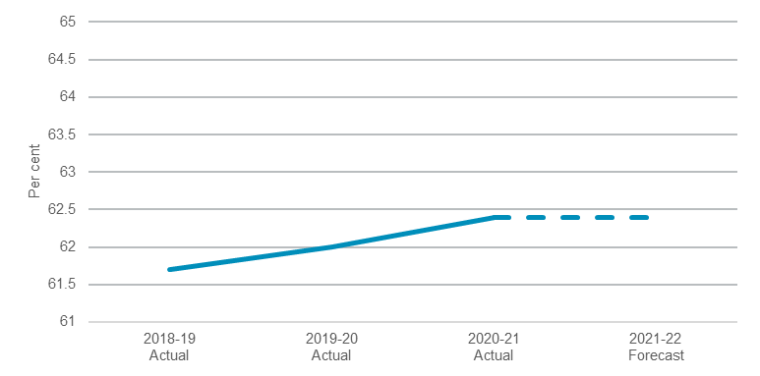

Performance indicators for this Outcome
Outcome Indicators | Units | 2020-21 | 2021-22
 |  | Actual | Forecast
30-minute city - Proportion of dwellings able to reach their nearest metropolitan centre using public transport and/or walking within 30 minutes | % | 62.4 | ≥62.4

