9. TREASURY CLUSTER

Introduction
 | $12.5  billion | Recurrent  Expenses  2021-22
 | $18.5  million | Capital  Expenditure 2021-22
The Treasury Cluster, as the Government’s principal financial and economic adviser, helps the people of New South Wales have access to services and infrastructure that deliver social and economic benefits, underpinned by a strong and sustainable economic and financial position.
Treasury manages the State’s finances and assets, monitors the performance of its commercial agencies, and develops its performance and financial management policies. Treasury is known for the provision of quality advice, stewardship and influence (particularly economic and fiscal), excellence in delivery, and strong and transparent risk management.

State Outcomes to be delivered by the Treasury Cluster
State Outcomes  What the Cluster is delivering for people and business |  | Key Programs  underway to support delivery of Outcomes
1. A strong resilient and diverse economy  Driving whole-of-state economic strategy, that supports a competitive business environment, drives productivity, increases real incomes, fosters employment opportunities and makes it easy to do business in New South Wales.  2021-22 investment: $483.2 million in recurrent expenses & $5.1 million in capital expenditure |  | - Building a Strong and Productive Economy  - Improving Economic Wellbeing
2. A sustainable fiscal environment enabling delivery of outcomes  Managing whole-of-state financial asset and liability activities, as measured by investment and debt performance, and maintenance of the State’s triple-A credit rating. Working towards the State’s objective of full funding of the Defined Benefits Superannuation liability by 2040. Providing informed, evidence-based fiscal, commercial and financial analysis and advice.  2021-22 investment: $12.0 billion in recurrent expenses & $9.3 million in capital expenditure |  | - Fiscal Planning and Management  - Sector Support and Resource Allocation  - Commercial and Balance Sheet Management  - Sector, Procurement Services, Analytics and Systems  - Evidence Informed Investment and Policy  - Financial Reporting and Systems Management
3. Stewardship of the public sector performance and financial system  Steward and support sector performance to deliver outcomes for citizens, ensure transparency and accountability, and the effective use of public funds.  2021-22 investment: $46.3 million in recurrent expenses & $4.2 million in capital expenditure |  | - Performance and Financial Systems Stewardship  - Digitally Focussed Treasury  - Highly Capable, Collaborative and Diverse Team

Overview of Cluster expenses by State Outcome
A summary of expenses by State Outcome is provided in the charts below.
- Recurrent expenses by Outcome 2021-22 (dollars and %)

Note: Grouped for presentation purposes, “Other State Outcomes” comprises:
- A strong, resilient and diverse economy
- Stewardship of the public sector performance and financial system.
- Capital expenditure by Outcome 2021-22 (dollars and %)

Note: The sum of percentages does not equal one hundred due to rounding.

Outcome 1: A strong, resilient and diverse economy
 | $483.2  million | Recurrent  Expenses  2021-22
 | $5.1  million | Capital  Expenditure 2021-22

State Outcome overview and 2021-22 investment
New South Wales is Australia’s largest state economy, accounting for around a third of the nation’s economic output and home to nearly a third of Australians.
Treasury is the Government’s chief economic advisor, leading advice on economic policy, productivity, economic analysis, tax policy and better regulation. Treasury contributes to a strong, resilient and diverse economy through economic and productivity reform.

2021-22 State Outcome Budget highlights
In 2021-22, the Treasury Cluster will invest $488.2 million ($483.2 million recurrent expenses and $5.1 million capital expenditure) in this Outcome, including:
- $9.8 million ($39.3 million recurrent expenses over four years) for the Business Connect Program which provides professional business advice for small businesses across New South Wales to support them to start, run, adapt and grow
- $8.9 million ($13.7 million in recurrent expenses and $1.0 million in capital over four years) for a number of productivity initiatives to support economic recovery post COVID-19
- $4.3 million for Small Business COVID Stimulus for the NSW Small Business Commission to deliver increased mediation and advisory services to commercial parties following the measures announced by the Government to provide relief to tenants in financial duress due to COVID-19
- $3.0 million ($30.0 million recurrent expenses over four years) for social impact investments with a focus on women facing disadvantage and Indigenous youth
- $2.5 million to support Automatic Mutual Recognition (AMR) of occupational licensing. AMR will deliver economic benefits to occupational licence holders through lower costs as they move across borders or operate in multiple jurisdictions, and to businesses and consumers who gain access to a more diverse supply of labour
- $2.0 million ($5.0 million over four years) for the Small Business Tendering Support program which will deliver training via a partnership with TAFE and guidance material for small businesses to increase capability and better enable them to tender for NSW Government opportunities
- a refreshed Small and Medium Enterprises (SME) and Regional Procurement Policy to increase opportunities for SMEs and regional businesses to supply goods and services to the NSW Government, with a focus on local participation
- a new Small Business Shorter Payment Terms Policy, commencing 1 July 2021, requiring large businesses who contract to supply goods and services to the NSW Government to pay their small business subcontractors within 20 business days.

Key performance insights
This section provides analysis and insights on the key Outcome Indicator to this State Outcome.

Growth in real GSP per capita (four year moving average)
Performance against this indicator continues to be challenging due to the impact of COVID-19. The NSW economy contracted sharply over the first half of 2020, with most of the contraction occurring in the June quarter as containment measures were put in place in response to COVID-19. Border restrictions have also dramatically slowed the rate of population growth. Consequently, Gross State Product (GSP) per capita contracted sharply in 2019-20, showing only modest growth in four-year annual average terms.
The Government’s response, through economic support measures and successful containment of the virus, has seen the economy reopen (excluding international borders) and recover more quickly than expected supported by stimulus measures. Despite that, the rebound is still insufficient to offset the decline in 2019-20, which will continue to weigh on the four-year annual average growth rate and keep the indicator below target until after 2022-23.
- Annual real GSP per capita growth (4 year moving average)
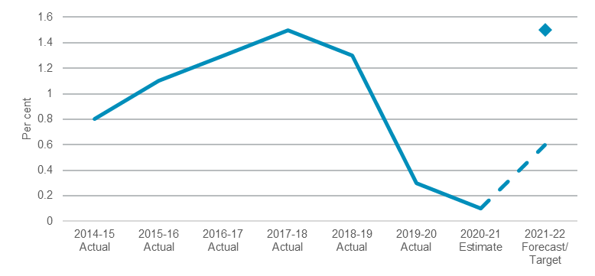
Note: The 2020-21 actual will be available in late November 2021 and an estimate has been provided for 2020-21.

Performance indicators for this Outcome
Outcome Indicator^{(a)} | Units | 2020-21 | 2021-22
 |  | Actual | Forecast
Growth in real GSP per capita (4 year moving average)^{(b)} | % | 0.1 | 0.6

Notes
- Indicator “Jobs created in New South Wales since April 2019” has been removed from the Treasury Cluster due to Machinery of Government changes.
- The 2020-21 actual will be available in late November 2021 and the 2020-21 figure included is an estimate.

Outcome 2: A sustainable fiscal environment enabling delivery of outcomes
 | $12.0  billion | Recurrent  Expenses  2021-22
 | $9.3  million | Capital  Expenditure 2021-22

State Outcome overview and 2021-22 investment
NSW Treasury’s management of the State’s fiscal environment aims to ensure that the people of New South Wales have access to services and infrastructure that deliver social and economic benefits, contributing to an enduring economic recovery and a sustainable financial position over the medium-term.

2021-22 State Outcome Budget highlights
In 2021-22, the Treasury Cluster will invest $12.0 billion ($12.0 billion recurrent expenses and $9.3 million capital expenditure) in this Outcome, including:
- continuing to support the embedding and maturity of outcomes and performance informed budgeting and resource allocation
- management of the Treasury Banking System post the completion of the banking tender to drive efficiencies through new banking arrangements and maximise returns on the State’s centrally managed cash holdings
- managing the State’s core debt portfolio to minimise the market value and cost of debt within specified risk parameters and manage any significant financial risks for the State
- administering Restart NSW, the Social and Affordable Housing Fund, and the NSW Generations Fund, to maximise returns on investment in productive infrastructure, and boost delivery of social and affordable housing across New South Wales
- overseeing the State’s investments, including the retained interests in Ausgrid and Endeavour Energy, as well as administering the residual assets and liabilities of major State asset recycling and long-term lease transactions
- managing the NSW public sector Defined Benefit Superannuation Scheme.

Key performance insights
This section provides analysis and insights on key Outcome Indicators to this State Outcome.

Fully fund the State’s unfunded defined benefit superannuation liabilities by 2040
Performance against this indicator is on track to meet the target. The State has embarked on a two-year superannuation contribution holiday (2020-21 and 2021-22) and re-anchored the commitment to fully fund the State's defined benefit superannuation liability by 2040 instead of 2030.

- NSW Unfunded defined benefit superannuation liabilities
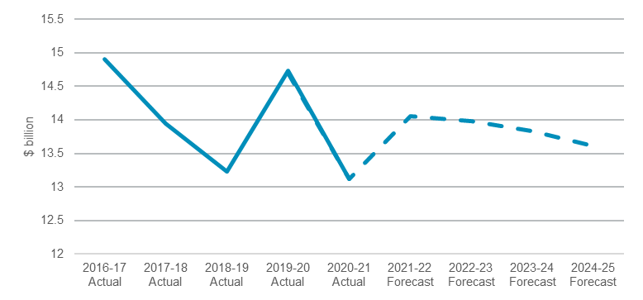
Note: The target for this indicator is for 2040 and has not been included given the chart scale for presentational purposes. The 2020-21 actual is not yet available, and an estimate has been provided.

Maintaining the triple-A credit rating
Performance against this indicator is stable for the Moody’s rating. On 1 December 2020, Moody’s reaffirmed NSW’s triple-A credit rating despite the severe economic and revenue disruptions caused by COVID-19 and the lingering economic impacts of recent drought and bushfires. In reaffirming the State’s triple-A credit rating, Moody’s cited the State’s fiscal strength, flexibility, large and diverse economic base, and its proven history of strong fiscal resolve.
On 7 December 2020, S&P Global downgraded NSW’s credit rating by one notch to double-A plus due to the State’s operating deficits and increase in debt resulting from the economic shock caused by COVID-19. S&P has noted the NSW Government’s excellent financial management, and that they expect a quick return to an operating surplus.
- Annual expense growth below long-term revenue growth
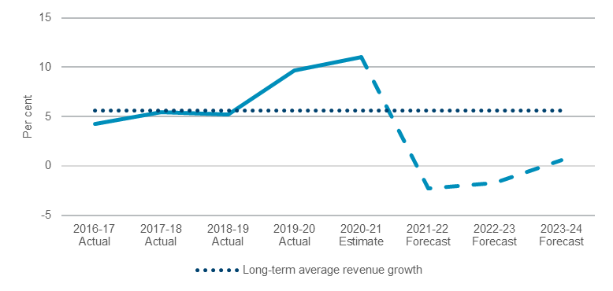
Note: The 2020-21 actual is the calculated result based on General Government results and will be available with the published Total State Sector Accounts 2020-21 after the Budget and an estimate has been provided for 2020-21.

Performance indicators for this Outcome
Outcome Indicators | Units | 2020-21 | 2021-22
 |  | Actual | Forecast
Annual expense growth below long-term revenue growth | % | 11.0^{(a)} | -2.3
Full funding of the State’s superannuation liability by June 2040 ^{(b)} | $billion | 13.1 | 14.1
Maintaining the Triple-A Credit Rating (Moody’s) | no. | Yes | n.a^{.(c)}
Maintaining the Triple-A Credit Rating (Standard & Poor’s) | no. | No^{(d)} | n.a^{.(c)}
Reducing the long-term fiscal gap | % | n.a | 2.6^{(e)}

Notes
- 2020-21 actual is the calculated result based on General Government results and will be available with the published Total State Sector Accounts 2020-21 after the Budget and an estimate has been provided.
- The State is on track to meet its 2040 superannuation target. The State has embarked on a 2-year superannuation contribution holiday (2020-21 and 2021-22) and re-anchored the commitment to fully fund the State's defined benefit superannuation liability by 2040 instead of 2030. The $13.1 billion for 2020-21 and $14.1 billion for 2021-22 are estimates for the respective annual liability balances.
- The credit rating agencies’ reviews will commence immediately after the 2021-22 Budget which will advise the NSW credit rating for 2021-22. No forecast is available.
- 2020-21 credit rating from Standard & Poor’s is double-A plus.
- 2021-22 Forecast refers to the projected fiscal gap of 2.6 per cent of GSP in 2060-61 as reported in the 2021-22 NSW Intergenerational Report. The fiscal gap is the projected change in revenues less expenditures (including recurrent and net capital expenditures but excluding interest) as a percentage of Gross State Product (GSP) between 2018-19 and 2060-61.

Outcome 3: Stewardship of the public sector performance and financial system

State Outcome overview and 2021-22 investment
 | $46.3  million | Recurrent  Expenses  2021-22
 | $4.2  million | Capital  Expenditure 2021-22
Treasury plays a critical role as the performance and financial steward for the NSW Government Sector. This role is endorsed by the Government Sector Finance Act 2018 which clarifies that agencies are required to report and demonstrate performance outcomes and not just financial results. This moves Treasury’s role beyond the traditional financial and regulatory function, towards supporting sector performance to deliver outcomes for people, ensure transparency, accountability and the effective use of public funds. Under this Outcome, Treasury aims to build sector capability and assist agencies to achieve their own performance goals while also meeting all compliance and reporting obligations.

2021-22 State Outcome Budget highlights
In 2021-22, the Treasury Cluster will invest $50.5 million ($46.3 million recurrent expenses and $4.2 million capital expenditure) in this Outcome, including
- $30.0 million to deliver a comprehensive suite of activities including; embedding evidence based decision making and Outcome Budgeting, digitising procurement guidelines and tools, ongoing training and guidance on budgeting and financial reporting systems, social impact investment policy guidance, banking best practice support and tools, investment and debt advice, and stewardship
- $10.2 million to promote a Digitally Focused Treasury, continuing with the replacement of several legacy component products with flexible modern tools to enhance digital design and responsiveness.

Key performance insights
This section provides analysis and insights on key Outcome Indicators to this State Outcome.

No material adverse findings in Audit Office Reports to Parliament
The Audit Office of NSW performs independent reviews of the sector, including financial audits, performance audits and internal controls reviews. The results are reported to Parliament to ensure accountability to the people of New South Wales.
Performance against this indicator remains stable. There have been no qualified financial audit opinions in any of the recent year-ends. There were no material systemic issues identified. Treasury is continuing to support the sector through a range of activities including developing and maintaining appropriate performance and financial management policy instruments and building sector capability to adhere to them.

- No material adverse findings in Audit Office Reports to Parliament
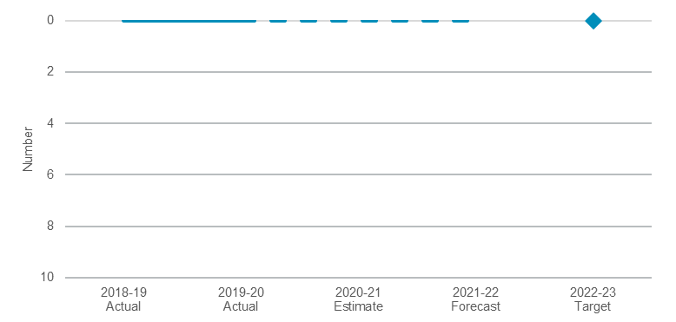

Support provided by Treasury and the effectiveness of Treasury performance and financial management stewardship
In 2021, Treasury conducted its first annual Treasury Stewardship Survey, which sought to understand Treasury’s General Government customers’ views on the stewardship support provided by Treasury to drive effective performance and financial management.
The performance against this indicator was 3.9 out of 5.0 in 2021. The baseline performance for this indicator is 3.9 out of 5.0. The target is to improve against the baseline each year. Treasury will continue to refine its Customer Relationship Model to provide stronger and improved support to the sector.

Provision of effective tools and frameworks (including technology) to enable the General Government sector to strengthen their performance and financial management, and promote efficient, effective and economical use of government resources
The Treasury Stewardship Survey conducted for the first time in 2021 also sought to understand Treasury’s General Government customers’ views on the effectiveness of Treasury-led policies, tools, and services to drive effective performance and financial management.
The performance against this indicator was 3.3 out of 5.0 in 2021. The baseline performance for this indicator is 3.3 out of 5.0. The target is to improve against the baseline each year. Treasury will continue to undertake improvements to financial information systems, frameworks and guidelines.

Performance indicators for this Outcome
Outcome Indicators | Units | 2020-21 | 2021-22
 |  | Actual | Forecast
No material adverse findings in Audit Office Reports to Parliament | no. | 0^{(a)} | 0
A voice of the customer survey of the support provided by Treasury and the effectiveness of Treasury performance and financial management stewardship | no.^{(b)} | 3.9 | 3.9+ ^{(c)}
Provision of effective tools and frameworks (including technology) to enable the sector to strengthen their performance and financial management, and promote efficient, effective and economical use of government resource | no.^{(b)} | 3.3 | 3.3+^{(c)}

Notes
(a) An estimate has been provided as 2020-21 actual data is not yet available and will be known with the publication of the Total State Sector Accounts 2020-21 after the Budget.
(b) Score out of 5.0.
(c) 2021-22 forecast is for improvements in these indicators.

