STATEMENT OF THE SECRETARY
The 2025-26 Budget Papers incorporate the requirements of the Government Sector Finance Act 2018 and the Fiscal Responsibility Act 2012.

Best available information
The Estimated Financial Statements have been prepared to reflect economic and financial data and estimates of Government policy decisions up to 11 June 2025, including information provided in the 2025-26 Australian Government Budget released on 25 March 2025.
Any estimates or assumptions made in calculating revenues, expenses, other economic flows, assets or liabilities are based on the latest information available at the time.

Professional judgement
The Estimated Financial Statements contain projections for the Budget year (2025-26) and the three following years (2026-27 to 2028-29).
The forward-looking nature of these projections means it is necessary to apply professional judgement in their preparation. That judgement includes an informed assessment of the most likely economic and financial outcomes including spending and revenue profiles. Differences between underlying assumptions and eventual outcomes can reflect the reality of an uncertain operating environment and the impact of many variables over which the Government has little or no control.
Treasury has exercised its best professional judgement in preparing the Estimated Financial Statements. These Statements have been prepared in accordance with the Statement of Significant Accounting Policies and Forecast Assumptions.
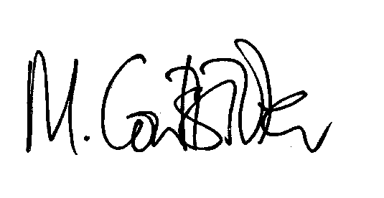
Michael Coutts-Trotter
Secretary, NSW Treasury
24 June 2025

