# 2. HEALTHy

1. Introduction

The NSW Government is making strategic investments to ensure families and households have accessible, affordable, timely and high-quality healthcare.

The health system in New South Wales is the largest in Australia. It delivers services through public hospitals and provides community health and other public health and population health services.

New South Wales spending on health allows for the delivery of these important services and is reflected in the following NSW Outcomes:

* People receive timely, quality care in hospitals and the community
* People are supported to make the best decisions for their health
* People are enabled to lead active lifestyles.

These outcomes help build a better New South Wales.

1. Health in New South Wales

Good health supports people to lead fulfilling lives, engage in their community, build skills and participate in employment. Longevity is an important factor to understanding the health of the people of New South Wales.

### Life expectancy

In the period 2021-2023, a person born in New South Wales is expected to live to 83.1 years (Chart 2.1). This is broadly in line with the national average of 83.0 years and 1.1 years more than in 2010-2012. There was a decline in life expectancy in New South Wales from 2018-2020 to 2021-2023 of 0.2 years. The high number of deaths during the COVID-19 pandemic likely contributed to the decline (Australian Bureau of Statistics (ABS), 2024).

The life expectancy of females is higher than males over the reported period. In 2021-2023, females have a life expectancy of 85.2 years, compared with males at 81.2 years. Life expectancy for Aboriginal and Torres Strait Islander people was 75.8 years in 2020-2022. This was 2.1 years higher than the 2020-2022 estimate for Aboriginal and Torres Strait Islander people across Australia, however, it was less than the NSW average.

1. Life expectancy at birth, NSW

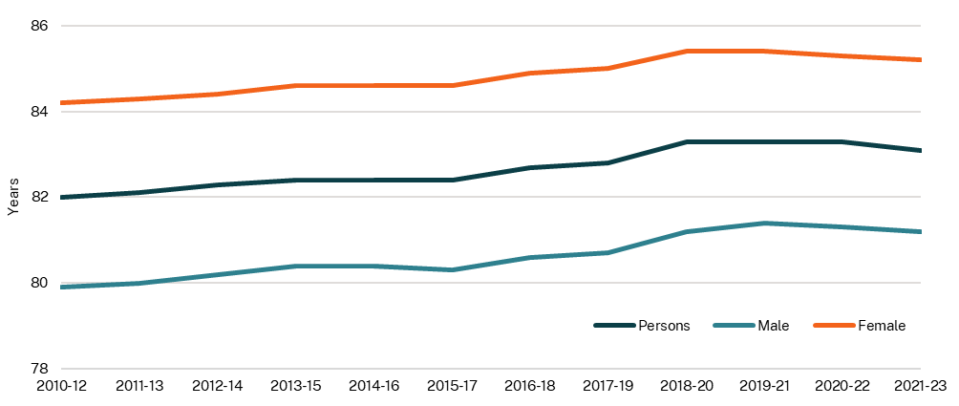

Source: ABS, 2024

1. NSW health system performance

The NSW Government is committed to delivering healthcare that is kind, compassionate, and respectful. Care that recognises and responds to the diverse needs and experiences of our communities.

A key goal of our health system is to ensure that every person can access timely, high-quality, and well-coordinated care, no matter who they are or where they live. The performance of our health services across New South Wales is essential in supporting the physical and mental wellbeing of our people.

The Essential Health Services package invests $836.4 million in 2025-26 for essential health services and to reduce overdue surgeries. It also funds the opening of new and upgraded hospitals including the Sydney Children’s Hospitals at Randwick and Westmead, Gunnedah Hospital and the Statewide Mental Health Infrastructure Program.

Other significant measures include:

* $158.8 million on top of $126.6 million already invested to deliver three new regional helicopter bases to improve ambulance and paramedic response times
* $83.8 million for a Maternity Care and First 2,000 Days package that includes measures to grow and upskill the maternity workforce, and increase midwifery continuity of care and parenting support in regional areas
* $23.1 million over three years to expand community-led suicide prevention and wellbeing support programs that are culturally responsive to the needs of First Nations cohorts
* $15.4 million in 2025-26 to boost the community mental health workforce, enhance mental health support for young people with severe and complex mental illness, and provide regional communities with mental health support.

The NSW Government will deliver $12.4 billion of capital investment to build and upgrade health infrastructure over the next four years, with $3.3 billion in 2025-26.

The 2024-25 Budget’s $189 million Bulk-Billing Support Initiative continues to provide important relief to GP clinics, reducing pressures on emergency departments and ensuring accessible and affordable primary healthcare for families and households.

### Improving Emergency Department treatment commencement times

The proportion of patients commencing treatment on time in the Emergency Department (ED) has been trending downwards since the COVID-19 pandemic. This indicator is driven by demand for urgent emergency hospital services, especially increases in the three most urgent triage categories. From 2018-19 to 2023-24, the number of presentations to ED in New South Wales increased by 6.8 per cent (Australian Institute of Health and Welfare (AIHW), 2025).

Despite increasing demand, the proportion of patients commencing treatment on time across all triage categories in the December 2024 and March 2025 quarters rose (Chart 2.2). This comes after a $480.7 million Emergency Department Relief package in the 2024-25 Budget.

New South Wales has been the highest-performing jurisdiction for patients seen on time in Australia from 2020-21 to 2023-24, with the total across all triage categories of 74 per cent compared to a national average of 67 per cent in 2023-24 (Report on Government Services (RoGS), 2025).

NSW Health is implementing a number of programs to alleviate the pressure on emergency departments, such as discharge patient flow concierge services and providing alternative care pathways where needed.

1. Proportion of patients commencing emergency treatment on time, NSW, quarterly

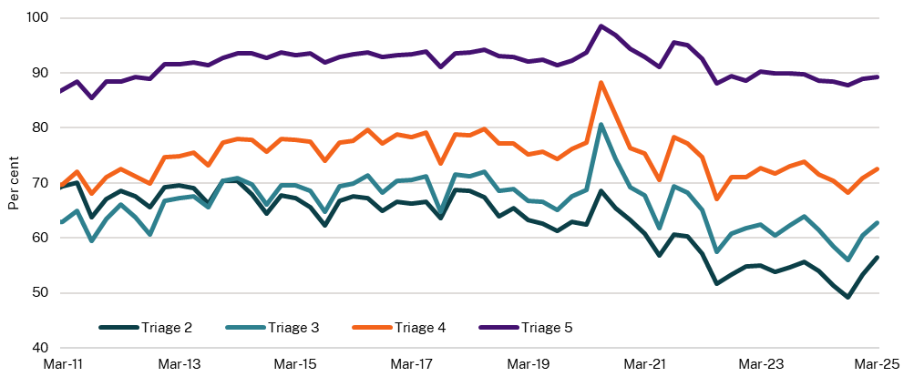

Source: Bureau of Health Information (BHI), 2025

Note: Triage 2 (emergency) requires treatment within 10 minutes; Triage 3 (urgent) within 30 minutes; Triage 4 (Semi‑urgent) within 60 minutes; Triage 5 (Non-urgent) within 120 minutes. Triage 1 (immediate treatment within 2 minutes) results are not reported by the Bureau of Health Information.

### Average length of hospital stays

In the March quarter 2025, the average length of hospital stay for all overnight episodes (including acute, non-acute and mental health episodes) was 6.0 days (BHI, 2025). For acute overnight episodes only, the average length of hospital stay was 4.7 days in the March quarter 2025 (Chart 2.3).

In the two years prior to the COVID-19 pandemic (December quarter 2017 to December quarter 2019), the average length of hospital stay ranged between 5.4 and 5.7 days for all episodes. In more recent times (March quarter 2021 to March quarter 2025), this range has increased to between 5.7 and 6.5 days for all episodes (BHI, 2025).

The presence of complex or chronic health conditions can lead to longer hospitalisations for patients. Improved discharge planning, as well as coordinated care planning and navigation services may help to prevent or shorten some hospital admissions (NSW Health, 2025).

1. Average length of hospital stay, NSW, quarterly

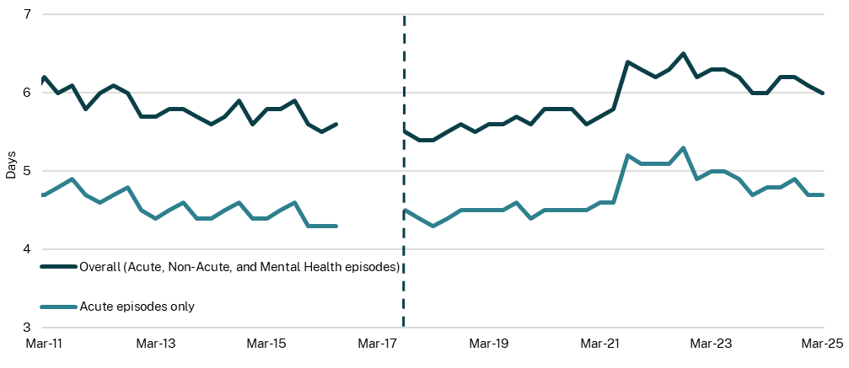

Source: BHI, 2025

Note: Dashed line reflects a methodological break in the series. Between 1 July 2016 and 30 June 2017, all NSW Local Health Districts and networks introduced a mental health care type when classifying newly admitted or long-standing patients. Data is missing during this period. Comparisons before and after this period should be made with caution.

### Proportion of non-admitted service provided through virtual care

Virtual care services are held over the phone or by video call. During the COVID-19 pandemic, virtual care, especially in providing non-admitted patient services, significantly increased as a way to maintain healthcare access while minimising physical contact (NSW Health, 2025).

Prior to the COVID-19 pandemic, the use of virtual care services was relatively low at around 11.1 per cent of non-admitted services in 2019. There are clear spikes in demand, coinciding with pandemic restrictions in the June quarter 2020 (26.1 per cent) and the September quarter 2021 (19.3 per cent) (Chart 2.4).

In the following years, virtual care has stabilised as reform initiatives supported the continued and sustainable use of virtual care. From the December quarter 2023 to the December quarter 2024, the proportion of non-admitted virtual care services increased from 16.4 to 18.1 per cent. This is above the level seen prior to the COVID-19 pandemic, indicating a more permanent shift in service delivery.

1. Proportion of non-admitted service provided through virtual care, NSW, quarterly

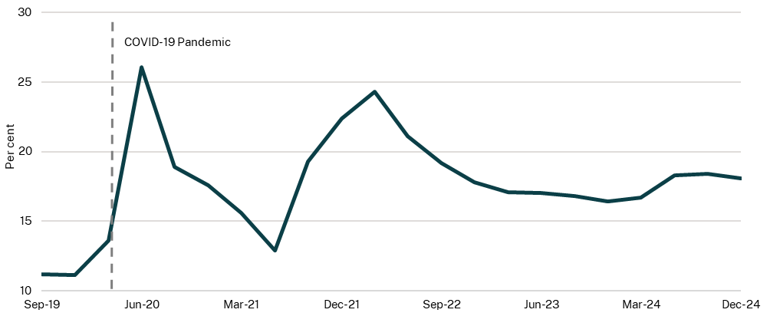

Source: NSW Health, 2025

### Mental healthcare satisfaction

Experiences of mental health care are captured through the Your Experience of Service survey. Combined survey responses of very good and excellent are improving towards NSW Health’s target of 80 per cent, with 75.9 per cent of people in 2024 rating their care as very good or excellent (Chart 2.5). Currently three jurisdictions including New South Wales report mental health experience data. Recent comparisons show that people receiving care in New South Wales report more positive experiences than those in Victoria and Queensland.[1]

Your Experience of Service survey results are monitored as part of a suite of eleven Key Performance Indicators in relation to the performance of mental health services, monitored by NSW Health and embedded in the annual Service Agreements with Local Health Districts and Specialty Health Networks.

1. Mental healthcare services satisfaction, NSW, annual

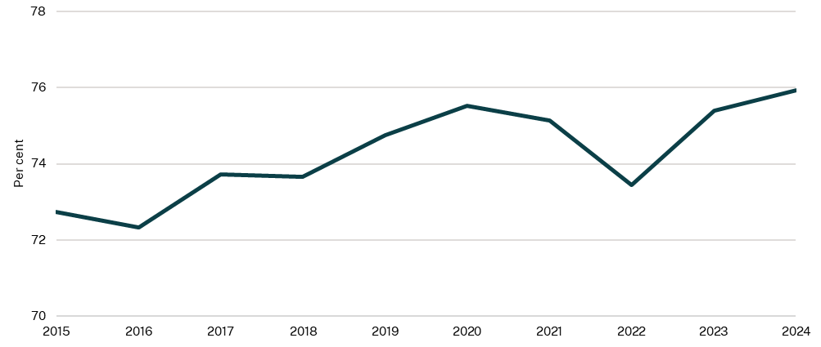

Source: BHI, NSW Health, 2025

Note: Combined survey responses of very good and excellent.

1. Leading indicators of community health

Community health includes out of hospital approaches to improving health and preventing diseases in NSW residents by addressing social, environmental and behavioural determinants of health. Monitoring early health indicators such as birth weight and behavioural trends such as smoking and physical activity can reveal future health impacts on individuals and potential constraints on the NSW health system.

### Children born with a healthy birth weight

A healthy birth weight, between 2,500 grams and 4,499 grams, is a leading indicator of an infant's future health (AIHW, 2022). Good maternal health both before and during pregnancy increases the likelihood of having a healthy baby. Comprehensive care for women before and during pregnancy, with a focus on screening for and addressing known risk factors such as smoking in pregnancy, is crucial for achieving healthy birthweights across the population.

The proportion of babies in New South Wales born with a healthy weight has been stable since 2012, sitting at around 94 per cent (Chart 2.6). The proportion of Aboriginal babies born in New South Wales with a healthy weight has been consistently lower than the proportion for all babies since 2012, at around 90 per cent on average.

In this Budget, the NSW Government is investing $21.9 million over three years for the Aboriginal Families First 2,000 Days measure to provide culturally responsive care during pregnancy and the first five years of life.

1. Children born with a healthy birthweight, NSW, annual

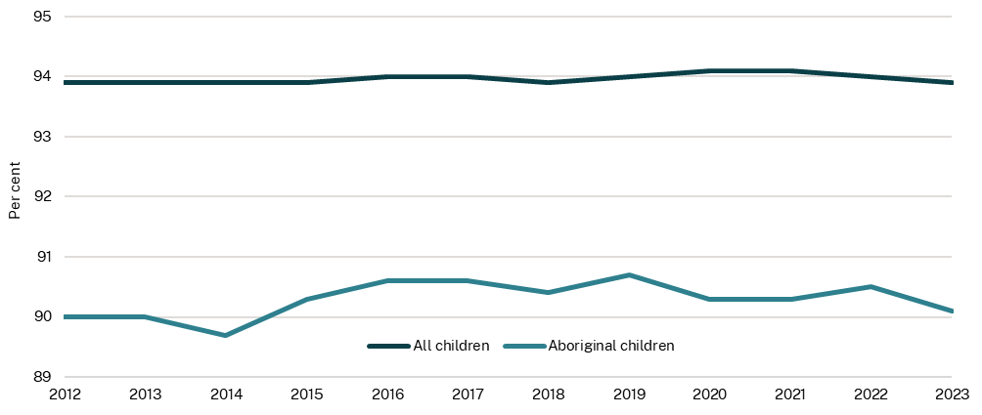

Source: NSW Health, 2025

### Prevalence of smoking and e-cigarette use (vaping)

There has been a long-term reduction in smoking rates in New South Wales (Chart 2.7), however the proportion of people using e-cigarettes daily in New South Wales has increased.

In 2024, the smoking rate (daily or occasionally) among people aged 16 years and over in New South Wales was 10.5 per cent. This figure has declined from 18.5 per cent in 2006. The rate of vaping (daily or occasionally) among people aged 16 years and over in 2024 was 6.7 per cent. While this decreased from 8.5 per cent in 2023, e-cigarette use has trended upwards since data collection began in 2014 when 1.3 per cent of people aged 16 and over vaped daily or occasionally.

1. People over 16 who smoke or vape daily or occasionally, NSW, annual

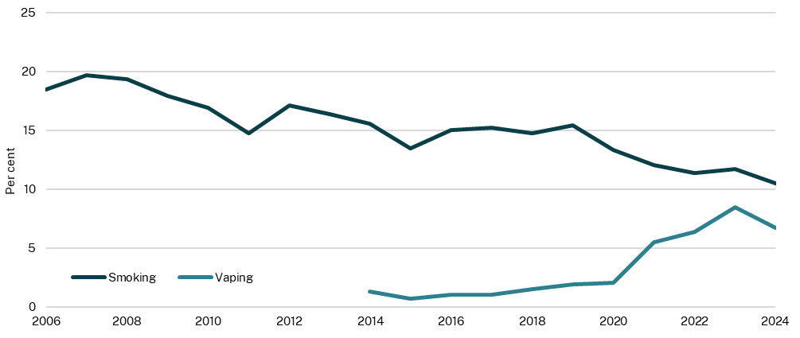

Source: NSW Health, 2025

Note: Survey results are subject to a margin of error. Apparent differences may not be statistically significant.

### Proportion of adults meeting the guideline for sufficient physical activity

The Australian Government has developed evidence-based guidelines that establish physical activity, sedentary behaviour and sleep recommendations for specific age groups. This measure relates to the proportion of adults who meet this guideline for sufficient physical activity.

The guideline for adults (aged under 65 years) is between 2.5 and 5 hours of moderate physical activity or between 1.25 and 2.5 hours of vigorous physical activity in a week, or an equivalent combination of moderate and vigorous activities. Muscle strengthening activities should be included on at least two days in the week. Physical activity includes sport, incidental activity such as walking or cycling (active transport) and muscle strengthening activities like Pilates.

The proportion of adults in New South Wales meeting the guidelines for sufficient physical activity has increased from 55.2 per cent in 2006 to 64.8 per cent in 2024 (Chart 2.8) (NSW Health, 2025).

1. Proportion of adults meeting physical activity guidelines, NSW, annual

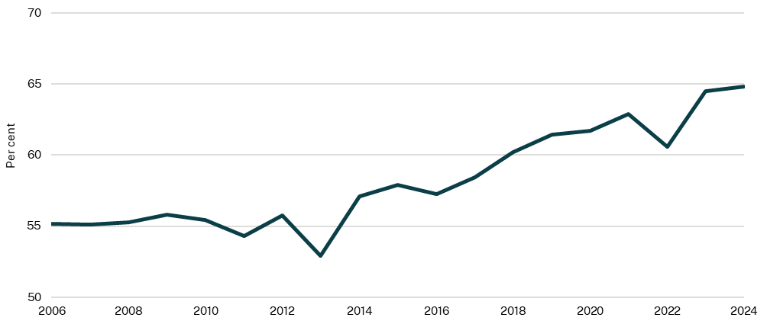

Source: NSW Health, 2025

Note: Survey results are subject to a margin of error. Apparent differences may not be statistically significant.

1. Chronic disease detection and prevention

The prevalence of chronic conditions is increasing in Australia. In 2022, 49.9 per cent of adults had one or more chronic conditions, a 7.7 percentage point increase since 2007-08 (ABS, 2022). For many people, chronic conditions impact their health, wellbeing and income.

### Number and rate of potentially preventable hospitalisations for chronic conditions

This indicator measures potentially preventable hospitalisations (PPH) relating to a wide range of chronic conditions, including asthma, heart diseases, diabetes, anaemia and nutritional deficiencies (AIHW, 2025). Measuring potentially preventable hospitalisations for selected chronic conditions can highlight the effectiveness of healthcare in the community for these conditions.

The latest provisional data from AIHW shows that in 2023-24 in New South Wales, there were 8.5 potentially preventable hospitalisations per 1,000 of the population for chronic conditions or 87,660 potentially preventable hospitalisations. This rate has improved over the past five years (Chart 2.9). In 2017-18, there were 10.7 potentially preventable hospitalisations per 1,000 of the population. Compared with other states in Australia, New South Wales has the lowest rate of potentially preventable hospitalisations for chronic conditions (AIHW, 2025).

1. Potentially preventable hospitalisations due to chronic conditions, NSW, annual

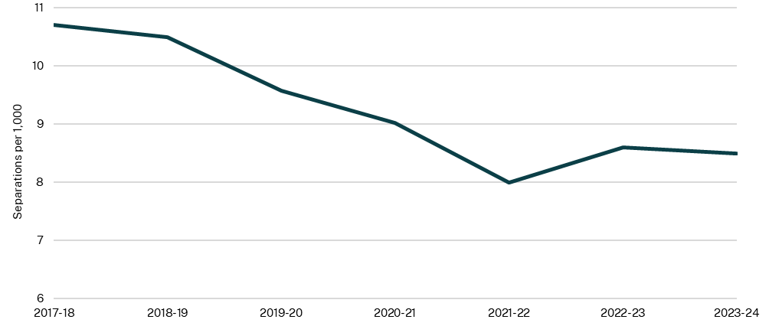

Source: AIHW, 2025

### Breast screen participation rates

In New South Wales, breast cancer is the second most common cancer overall after prostate cancer and is the most common cancer in women (Cancer Statistics, Cancer Institute NSW, 2025). For women 50 years of age and over, a screening mammogram is the most effective method of finding breast cancer early and increases the chance of survival. BreastScreen NSW recommends women aged 50–74 have a mammogram every two years. Breast cancer mortality has decreased in Australia since BreastScreen Australia began, from 74 deaths per 100,000 women aged 50–74 in 1991, to 37 deaths per 100,000 women in 2022 (AIHW, 2024).

Despite a small drop in screening participation from 51.9 per cent in December 2023 to 51.6 per cent in December 2024, rates have recovered to pre-pandemic levels (Chart 2.10). However, rates are still below the national target of 65 per cent. Screening rates fell sharply during the pandemic, dropping to 49.9 per cent in 2020 and 43.4 per cent in 2021, due to the temporary suspension of BreastScreen NSW services (NSW Health, 2025).

Aboriginal women’s participation in breast cancer screening in New South Wales has never been higher, with almost half of all Aboriginal women aged 50-74 (45.1 per cent as of May 2025) having had a screen with BreastScreen NSW in the last 2 years. Participation rates for Aboriginal women aged 40–49 in New South Wales have more than doubled since BreastScreen NSW lowered the recommended breast screening commencement age from 50 to 40 years to address the disparity in breast cancer outcomes experienced by these women (Cancer Statistics, Cancer Institute NSW, 2025).

1. Biennial breast screen participation rates for women aged 50-74, NSW, annual

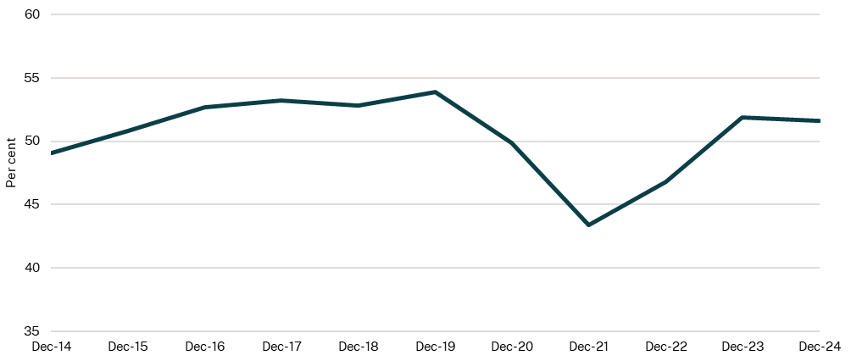

Source: Cancer Statistics, Cancer Institute NSW, 2025

Note: Breast screen participation rates are calculated as the number of individual women in the 50-74 age group who were screened by BreastScreen NSW in the 24 months up to the reporting date, divided by the estimated number of women in the 50-74 age range in New South Wales.

1. AIHW, https://www.aihw.gov.au/mental-health/topic-areas/consumer-rated-experience