# 3. SKILLED

1. Introduction

Building a better New South Wales means a skilled society that enables everyone to realise their potential through training and education. This means children get the best start in life, and people have the education and training to thrive.

Early Childhood Education and Care (ECEC), government and non-government schools and Vocational Education and Training (VET) support the development, learning and wellbeing of children and students.

Outcomes associated with the Skilled theme are:

* All children benefit from quality early childhood education and care
* All school students are supported to reach their full potential
* Vocational education delivers the skills that people and businesses need.

1. Education and skills in New South Wales

Educational attainment is important for building a skilled and productive workforce. A highly skilled workforce drives economic growth and increases living standards. School and non‑school qualifications are important factors which influence the ability of a person to enter the workforce and participate at their full potential.

After successful collaboration, New South Wales signed a 10-year agreement with the Australian Government in March 2025 to fully fund NSW Government schools. This will see a $10.4 billion in additional funding to New South Wales public schools over the 10-year period, $4.8 billion from the Australian Government and $5.6 billion from the NSW Government. The funding is tied to reforms that lift education standards including more individualised support for students while continuing evidence-based teaching practices.

### Attainment of Year 12 or equivalent, or Certificate level III or above

In New South Wales, 81.2 per cent of people aged 15 to 64 year olds have attained a Year 12, or Certificate level III or above qualification in 2024, an increase of 8.0 percentage points from 73.2 per cent in 2014 (Chart 3.1). The upward trend is in line with the national results.

1. People aged 15-64 who completed Year 12 or Certificate III or above, NSW

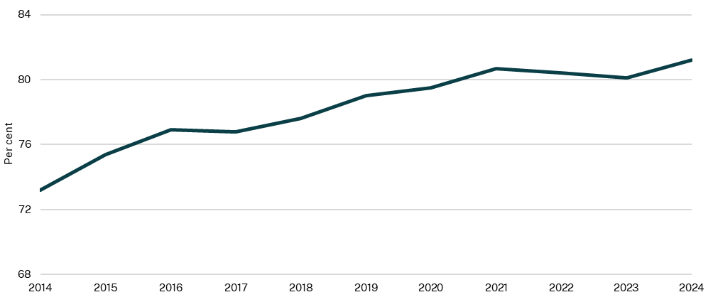

Source: Australian Bureau of Statistics (ABS), 2024

1. Early childhood education and care

Quality ECEC positively impacts children’s learning, development and wellbeing outcomes and supports the transition into school. The NSW Government is committed to delivering ECEC across New South Wales that is affordable, accessible, safe and inclusive for all children.

On average, over the past nine years, 85.1 per cent of children in New South Wales have been enrolled in a preschool program in the year before school. This proportion has been relatively stable over this period, with the exception of 2020 where enrolments dipped to 83.8 per cent (Chart 3.2).

The proportion of Aboriginal and Torres Strait Islander children enrolled in preschool in the year before school has steadily increased from 48.8 per cent in 2017 to 85.2 per cent in 2024. Target 3 of Closing the Gap aims to increase the proportion of Aboriginal and Torres Strait Islander children enrolled in the year before full-time schooling in early childhood education to 95 per cent by 2025.

The 2025-26 Budget includes $200.9 million to increase First Nations access, enrolment and attendance in early childhood education.

1. Children enrolled in preschool in the year before full-time school, NSW

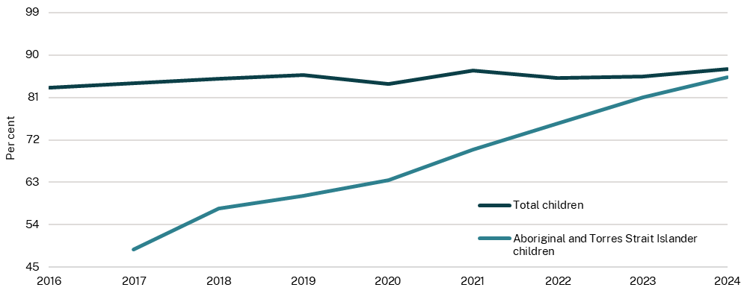

Source: Report on Government Services (RoGS), 2025

1. Primary and secondary school

**School attendance**

Beyond teaching life-long necessary skills such as literacy and numeracy, schools help children and young adults develop social-emotional skills, provide safe and inclusive environments and a sense of community and support for both students, parents and families. Education is a crucial factor that drives innovation, access to jobs and future prosperity.

The NSW Government supports both government and non-government schooling in primary and secondary education. In 2024, primary and secondary school attendance was 90.0 per cent and 83.2 per cent, respectively (Chart 3.3).

NSW student attendance rate for government schools for grades 1 to 10 of 87.5 per cent was slightly higher than the national average of 87.1 per cent in 2024 (RoGS, 2025). The NSW Government is working to improve attendance rates under its ‘Our Plan for NSW Public Education’, targeting an attendance rate of 88.8 per cent in 2027 (NSW Department of Education, 2025).

1. Attendance rate at government schools, NSW

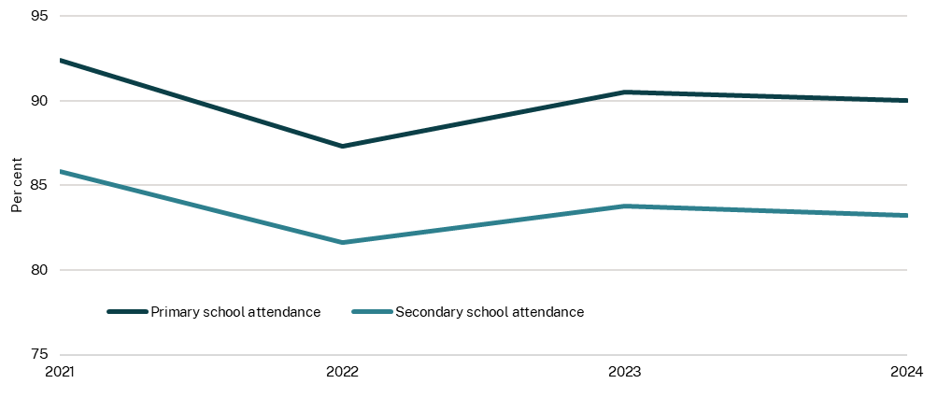

Source: NSW Department of Education, 2025

### Teacher vacancies and cancelled classes

The number of vacant teacher positions measures the number of positions permanently vacant and being recruited for at the beginning of each school year (Day 1, Term 1). In many cases, these vacant positions will be temporarily filled by a casual or temporary teacher while permanent recruitment is underway.

As at Day 1, Term 1 2025 there were 1,294 vacant permanent teacher positions (Chart 3.4). There has been an improvement in recruitment as the number of vacancies has trended downwards from a high of 2,252 at the start of the school term in 2022.

1. Teacher vacant positions and cancelled classes, NSW

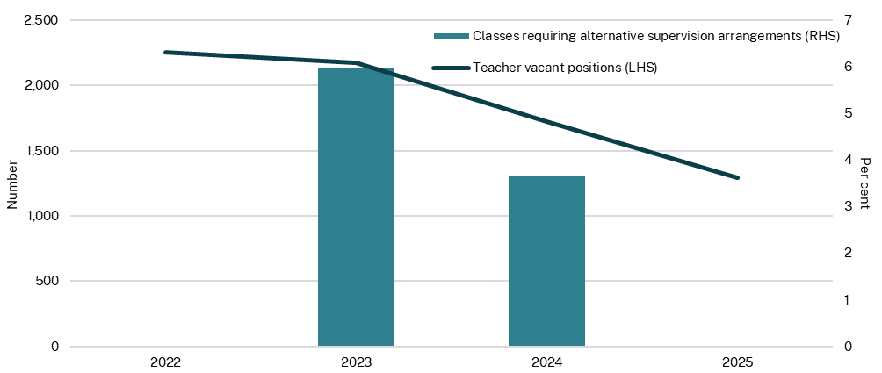

Source: NSW Department of Education, 2024 and 2025

Note: Data for classes requiring alternative supervision arragements is collected during Term 3 Weeks 5 to 7. Data for 2025 is not yet avaliable.

The Alternative Supervision Arrangements Survey started in 2023, measure over three weeks per year, the number of casual teachers they required for each day. Where there was a shortfall of casual teachers, schools were asked to record alternate supervision strategies used to ensure duty of care.

As a result of the casual shortfall, in 2024 out of 155,753 total lessons, approximately 3.6 per cent of scheduled lessons (5,669 lessons) in NSW public schools required alternative supervision arrangements per day. This is a decrease from 2023, where out of 164,017 total lessons, approximately 6.0 per cent of lessons (9,822 lessons) required alternate arrangements per day.

1. Vocational Education and Training qualifications

Vocational Education and Training (VET) provides opportunities for people to improve or gain skills to enter the workforce or advance their careers. This can drive economic growth and enhance individual and community wellbeing. Many occupations experience skills shortages and rely on TAFE and other VET trained workers. Building new homes and the energy transition, as well as supporting the growing care economy is undermined by historic decline in VET training over the last 10 years.

As the largest public provider of VET in the State, TAFE NSW empowers students to achieve their educational and employment goals, supporting industry needs and strengthening communities. The 2025-26 Budget includes a record $2.8 billion for TAFE, which includes $121 million for essential capital and $100 million to relocate Bankstown TAFE. It also funds $215.9 million for 1,300 apprentices in local government.

The 2025-26 Budget includes $803.4 million further investment in reforming the TAFE system, repairing and maintaining facilities and converting casual TAFE employees to permanent roles. This Budget supports 4,800 existing workers to join the construction workforce to deal with skills shortage, build homes New South Wales needs and drive economic growth.

In 2024, 87.0 per cent of NSW VET students were employed or engaged in further study after training. This has increased by 3.7 percentage points since 2020 but has been relatively stable since 2022 (Chart 3.5). Of those 87.0 per cent, the majority (96.3 per cent) were employed after training (some may also engage in further study in addition to employment).

1. VET learners who were employed or in further study after training, NSW

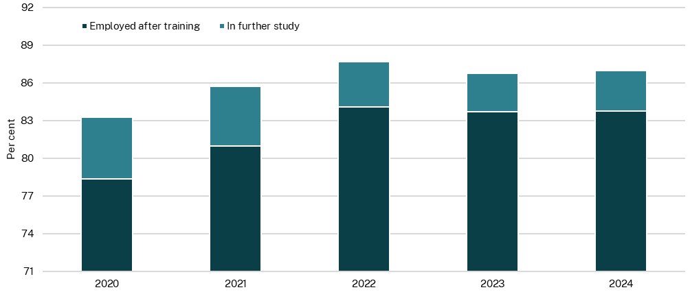

Source: National Centre for Vocational Education Research (NCVER), 2025

### Government-funded VET enrolments in critical skills areas

Critical skills areas are based on training activity funded by the NSW Government’s Smart and Skilled Program which is developed in consultation with relevant policy areas and industry bodies. Mapping of NCVER program enrolment data for government funded students to the critical skills areas shows that the care and support economy, construction (housing and infrastructure) and Net Zero and energy transition areas make up the largest number of VET commencements from 2020 to 2024 (Chart 3.6).

Students may be mapped to multiple skills areas so different cohorts will overlap, for example, if a tertiary student completes their qualification in electrotechnology their completions status could be mapped against three different categories including construction, Net Zero and energy transition and advanced manufacturing.

VET qualification completion rates in New South Wales (across all provider types) was 47.1 per cent and 47.3 per cent for qualifications commencing in 2018 and 2019, respectively (completion rates after four years). This is higher than Victoria, South Australia, the Northern Territory, and the Australian Capital Territory, but lower than Queensland, Western Australia, and Tasmania.[1]

1. VET qualification enrolments in critical skills areas

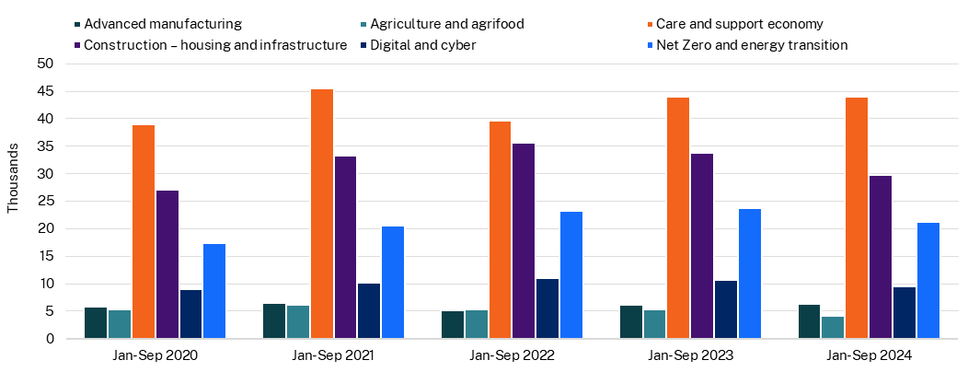

Source: NCVER, 2025 and areas mapped by the Department of Education using occupation groups

Note: The data includes commencements from government-funded providers only. Certain occupation groups may fall under multiple skills areas, so the students cohort overlap.

1. Education and skills for First Nations people

New South Wales has the largest share of Australia’s Aboriginal and Torres Strait Islander population, at 34.2 per cent in 2021 (ABS, 2021). In 2021, 4.2 per cent of the NSW population identified as an Aboriginal and Torres Strait Islander (ABS, 2022).

School attendance rates for Aboriginal and Torres Strait Islander students in New South Wales has trended above the national average (grades 1 to 10) since 2021. In 2024, the attendance rate for NSW Aboriginal and Torres Strait Islander students (grades 1 to 10) was 78.7 per cent compared to the national average of 75.7 per cent (ACARA, National School Attendance Data Collection).

The proportion of Aboriginal and Torres Strait Islander people aged between 20 and 24 years who have obtained a minimum of Year 12 or equivalent qualification has shown a sustained increase from 42.5 per cent in 2001 to 69.3 per cent in 2021. Growth has slowed in the last five years, increasing just 5 percentage points between 2016 and 2021 compared to 10.8 percentage points between 2011 and 2016 (Chart 3.7). While there has been improvement, the national Closing the Gap target of 96 per cent by 2031 is not on track to be met.

A NSW Department of Education (NSW DoE) research paper (2021) found that drivers of the HSC attainment for First Nations students include: having aspirations to finish school and go to university, positive student engagement in school, and teacher and family advocacy/support and encouragement at school and at home. Importantly, a key driver of nurturing First Nations students’ aspirations to complete Year 12 and go to university was the way in which students feel about their culture at school and their teachers’ understanding of culture.[2]

The NSW DoE has a number of strategies and programs in place to support engagement and retain attendance of First Nations students in schools, including:

* Connected Communities Strategy which supports culturally responsive school environments by valuing and recognising students’ identity and culture and by empowering parent and community voice and input.
* Aboriginal Education Guiding Principles (2024), supported by a package of professional learning, strengthening culturally responsive educational leadership and integration of Aboriginal education excellence in school planning, teaching and leadership.
* Aboriginal Language and Cultural Nests that aim to improve engagement, wellbeing and academic outcomes through language revitalization.
* Kimberwalli the Aboriginal Centre for Excellence delivers Aboriginal Education School Excursions and Programs to support Aboriginal students to feel strong in culture, stay engaged in school and pursue post-school pathways to transition to further education and employment.

1. Aboriginal and Torres Strait Islander people aged 20-24 years, Year 12 or equivalent attainment, NSW

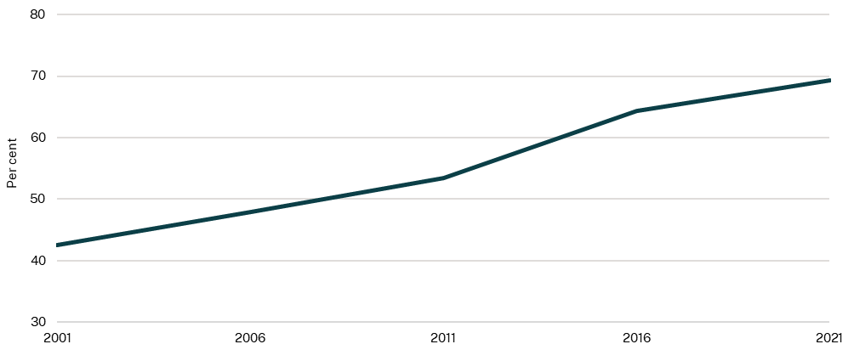

Source: ABS, 2021

### Aboriginal and Torres Strait Islander people enrolled in a VET program

In addition to secondary schooling, post-school education and skills development have also been increased in the last 4 years. The number of Aboriginal and Torres Strait Islander vocational education program enrolments was 36,475 in 2023 (Chart 3.8). While this is lower than a high of 45,550 in 2019, it has improved since the low of 31,000 in 2020.

1. Aboriginal and Torres Strait Islander people VET program enrolments, NSW

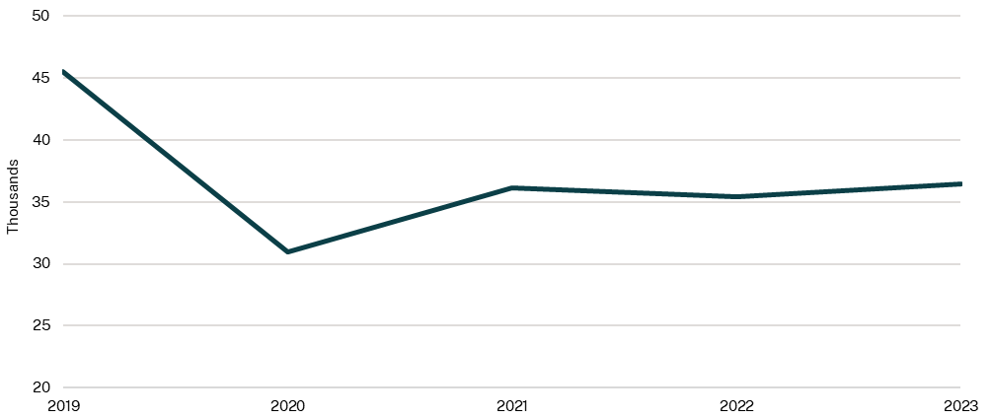

Source: NCVER, 2024

### Aboriginal and Torres Strait Islander youth who are in employment, education, or training

In New South Wales, the proportion of Aboriginal and Torres Strait Islander youth (aged 15 to 24 years) who are in employment, education or training has been increasing since 2001 from 52.6 per cent to 62.0 per cent in 2021 (Chart 3.9). This is above the national Closing the Gap 2021 trajectory of 60.5 per cent required to attain the target of 67 per cent by 2031, however, at a national level the target is not on track to be met. Further, the proportion of NSW Aboriginal and Torres Strait Islander youth aged 15-24 years who are in employment, education or training remains below NSW non-Indigenous youth aged 15-24 years (80.2 per cent in 2021, 79.9 in 2001).[3]

The increase was greatest between 2006 and 2011, with an increase of 5.4 percentage points, accounting for more than half of the increase over 20 years (2001 to 2021). This coincides with the introduction of Closing the Gap in 2008 and the 2005 Social Justice Report, which called for Australian governments to commit to achieving equality for Aboriginal and Torres Strait Islander people.

1. Aboriginal and Torres Strait Islander people aged 15-24 in employment, education or training, NSW

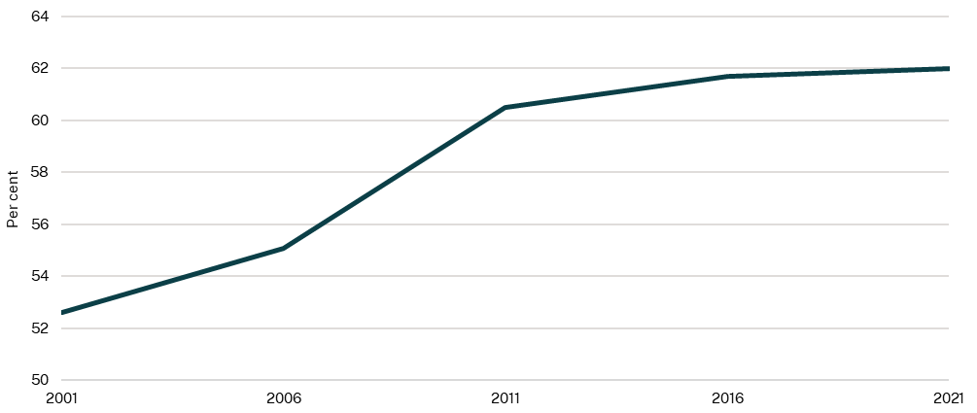

Source: ABS, 2021

1. NCVER, 2023, [VET qualification completion rates 2023: data slicer](https://www.ncver.edu.au/research-and-statistics/data/all-data/vet-qualification-completion-rates-2023-data-slicer)
2. Centre for Education Statistics and Evaluation, 2021, Supporting Aboriginal students to attain the HSC, Department of Education.
3. Productivity Commission, n.d, [Aboriginal and Torres Strait Islander youth are engaged in employment or education - Dashboard | Closing the Gap Information Repository - Productivity Commission](https://www.pc.gov.au/closing-the-gap-data/dashboard/se/outcome-area7)