# 4. PROSPEROUS

1. Introduction

Incentivising innovation and productivity to drive economic growth will help to build a better New South Wales. Households, individuals and businesses across the state will all benefit from a growing, resilient, dynamic and inclusive economy. Inclusive economic growth that supports high living standards can be achieved through robust financial management, sound regulation and open markets.

NSW Government investments in education, innovation, wages, supporting businesses and shared infrastructure are core to the new growth agenda.

Outcomes associated with the Prosperous theme are:

* State finances are robust and sustainable
* Markets are fair and competitive and workplaces are safe
* A vibrant and diverse economy that supports improving living standards
* Everyone has access to productive and rewarding jobs.

1. Prosperity and equality in New South Wales

**Household disposable income**

Real household disposable income per capita is a measure of the income households have available for spending and saving, after tax and interest payments, adjusted for inflation, on a per person basis. It provides insights into people’s economic wellbeing, reflecting people’s real purchasing power.

The level of real household disposable income per capita declined for the second year in a row in 2023-24 by 2.3 per cent to $61,837 (Chart 4.1). A similar trend was seen nationally, where over the same period, real household disposable income per capita in Australia fell by 2.6 per cent to $58,559 in 2023-24.

The fall in real household disposable income per capita in 2022-23 and 2023-24 was partly due to high inflation, as nominal household disposable income per capita actually increased. Contributing to the decline was also both higher interest rate payments and increases in the amount of tax payable as incomes have grown relative to income tax thresholds.

While the household consumption deflator still shows the lingering effects of high inflation on purchasing power, other price measures such as the Sydney consumer price index show inflation fell back to within the Reserve Bank of Australia’s target band in the September quarter 2024 after peaking in the December quarter 2022. With the NSW Government abolishing the public sector wage cap, a tight labour market supporting private sector wages, and inflation falling, real wages are starting to grow again.

Over the longer term, real disposable income per capita in New South Wales has broadly trended upwards, growing by an average annual rate of 1.9 per cent from $37,261 in 1991-92 to $66,477 in 2021-22. This was slightly below the national average annual growth rate of 2.0 per cent over the same period where real disposable income per capita increased from $34,252 to $63,876.

1. Real household disposable income per capita (2023-24 dollars), NSW

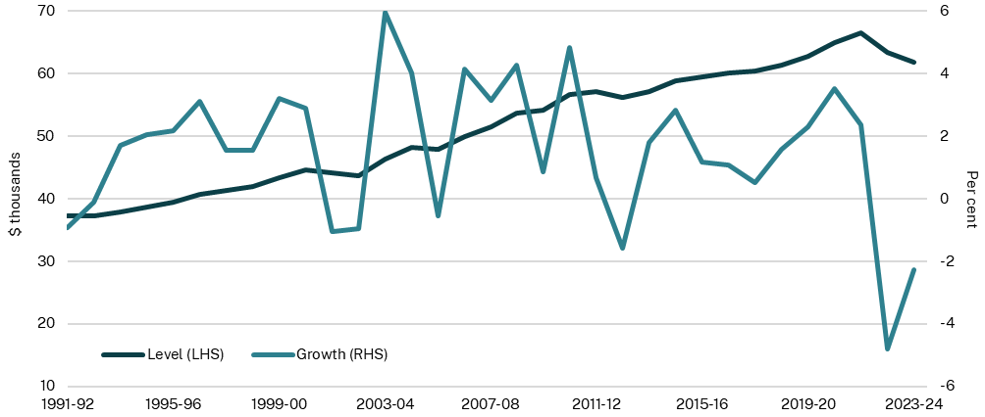

Source: Australian Bureau of Statistics (ABS), 2024

Note: Real household disposable income per capita was deflated using the household consumption deflator.

### Equity in New South Wales

A measure of inequality is the Gini coefficient, it ranges between 0 and 1 (where 0 indicates perfect equality). The Gini coefficient for income in New South Wales increased from 0.335 in 2001 to 0.372 in 2012. It averaged at 0.354 between 2013 and 2020 before increasing to a high of 0.381 in 2021. Since then, the Gini coefficient has declined to 0.369 in 2023 (Chart 4.2).

The NSW Gini coefficient for wealth fell from its high of 0.626 in 2014 to 0.604 in 2022. An analysis of Household, Income and Labour Dynamics in Australia (HILDA) survey data[1] showed that household wealth is highly skewed in New South Wales, with the top 10 per cent of households holding around 42 per cent of total net wealth and the bottom 50 per cent holding about 10 per cent in 2022. Wealth also varies across cohorts, with the average household net wealth of homeowners ($2.1 million) being approximately 11.2 times larger than renters ($184,000) in 2022. This ratio has increased since 2002 as rising house prices led to wealth growth for existing homeowners.

The wealth gaps between people living in Greater Sydney and people living in the rest of New South Wales, and males and females have decreased since 2002. People living in the rest of New South Wales have experienced faster growth in wealth compared to those in Greater Sydney, while females have doubled their wealth from 2002 to 2022, reducing the gap with males.

1. Gini coefficient for income and wealth, NSW

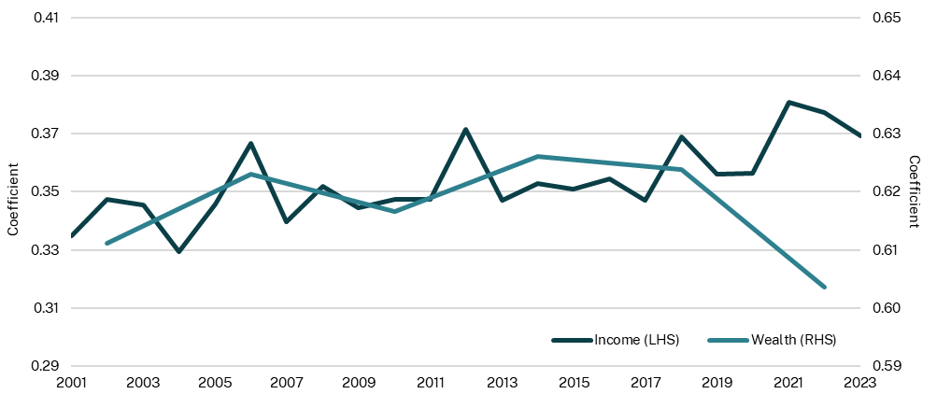

Source: HILDA, 2024

Note: Wealth data is collected every four years starting in 2002 while income is annual starting in 2001. Equivalised household disposable income and equivalised household net wealth are used to calculate Gini coefficients.

### Labour underutilisation

The labour underutilisation rate is a broader measure of the spare capacity in the labour market than the unemployment rate. It is defined as the sum of people who are actively seeking work, but are unemployed, and people who want to work more hours than they currently are, expressed as a percentage of the labour force. The labour underutilisation rate provides insight into the extent that the labour force is being used to its full capacity.

The labour underutilisation rate in New South Wales has fluctuated between 6.9 per cent and 17.9 per cent since the March quarter 1978 (Chart 4.3). Following an average labour underutilisation rate of 12.8 per cent throughout the 2010s, it reached more than 17 per cent in the middle of 2020 due to the COVID-19 pandemic and lockdowns. Noting the differing economic context, the last time it was this high was during the early 1990s recession.

Since the June quarter 2020, labour underutilisation in New South Wales has decreased, following the national trend. In the March quarter 2025, the labour underutilisation rate was 10.0 per cent in New South Wales and 9.9 per cent in Australia. The March quarter 2025 for New South Wales is lower than the average rate in the decade prior to the COVID-19 pandemic of 12.8 per cent.

1. Labour underutilisation rate

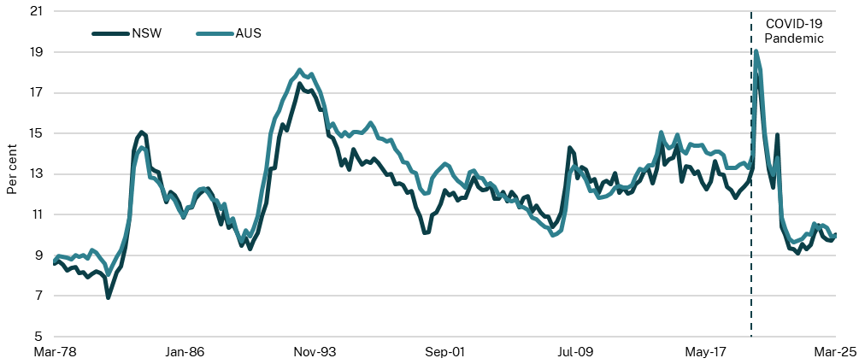

Source: ABS, 2025

Note: The quarterly series is based on the data for the last month of each quarter from the ABS Labour Force, April 2025 released on 15 May 2025.

1. Vibrant and prosperous New South Wales

A rich and vibrant economy enriches people’s lives, supports businesses, tourism and employment. The NSW Government supports initiatives to drive a diverse and prosperous economy that improves living standards. It does so by boosting trade and investment, and delivering regulatory reform and programs that capture the potential of a vibrant 24-hour economy.

The Vibrancy Reforms implemented in 2023-24 included:

* protecting the intent of Special Entertainment Precincts by notifying property buyers moving into an existing entertainment zone
* removing the rule that prevents people living within five kilometres of a registered club from signing in without first becoming a member
* ending restrictions on outdoor dining approvals that prevented patrons from standing while drinking outside a licensed premise.

The NSW Government is committed to making Sydney a global city. The NSW Government is making sure the arts and cultural scenes reflect that with an additional $451.2 million to support local industry and creators in New South Wales. This includes $280 million for the Made in NSW and Post, Digital and Visual Effects Rebate Program, $100 million for new screen infrastructure; $20.6 million for the Office of the 24-Hour Economy Commissioner to support the night-time economy and local councils through regulatory reform, grants programs, precinct-based initiatives, digital tools and other support; and $20 million for Sound NSW to deliver programs that drive audience and international market development, strengthen the live music industry and champion NSW artists. There is also a commitment of $5.0 million for the Vibrant Streets Package, to support the NSW Government’s vibrancy agenda by creating more flexible, safe and welcoming streets, transport hubs and public spaces.

There are economic and lifestyle benefits that support the wellbeing of our diverse population having opportunities to engage in a broad range of activities at any time of the day or night. Night-time in-person spending is a key indicator of the value of the night-time economy as well as an indicator of people’s participation in activities outside their homes at night. Night‑time in-person spending measures a person’s spending between 6pm and 6am. The spending includes card payment transactions but not cash and direct debit transactions, transactions between accounts and online purchases.

Nominal night-time in-person spending increased between 2020 to 2023 (Chart 4.4). This recovery, supported by the Office of the 24-Hour Economy Commissioner, stimulates and builds capacity in the night-time economy following the lifting of COVID-19 pandemic related restrictions and general availability of vaccines and other supporting medical care. The $15.5 billion in night-time in-person spending in 2024 remains higher than pre COVID-19 pandemic levels.

1. Nominal night-time in-person spending, NSW

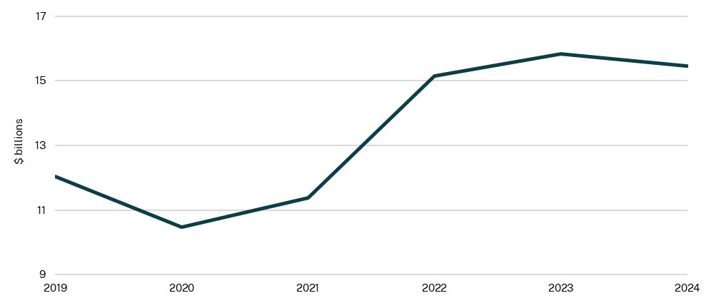

Source: Department of Creative Industries, Tourism, Hospitality and Sport (DCITHS), 2025

Note: Annual calendar year spend reported.

### Visitor expenditure

The 2025-26 Budget includes $135 million for Destination NSW events, promotion and industry support to grow the New South Wales visitor economy.

The NSW Government invests in tourism attraction to support a strong visitor economy, which supports growth, businesses and jobs. In 2023-24, the NSW visitor economy surpassed $50.0 billion in nominal expenditure for the first time in history, making it the number one state for visitor expenditure in Australia (Chart 4.5).

Typically, around 20 to 30 per cent of NSW visitor expenditure is attributed to international visitors. This marks New South Wales as a hotspot for tourists from around the world. This growth in the visitor economy is in line with the Visitor Economy Strategy, a roadmap for growing the NSW visitor economy.

1. Visitor expenditure, NSW

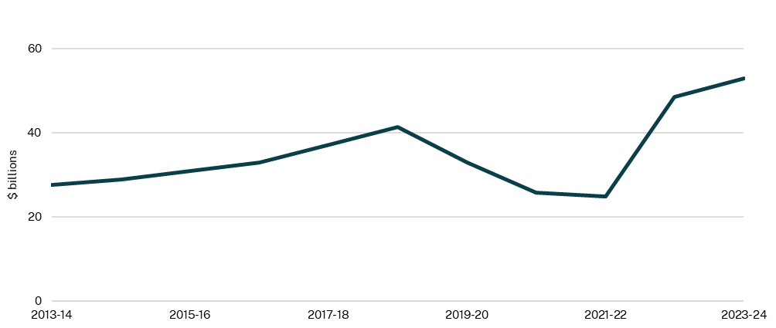

Source: Tourism Research Australia, 2025

#### Supporting trade, investment and employment

International trade is a crucial component of NSW’s economy with exports accounting for 17.4 per cent ($142.5 billion) of the state’s real gross state product in 2023-24 (Investment NSW, 2025).

In 2023-24, New South Wales secured $3.0 billion of capital investment as a result of its investment attraction activities, an increase from $1.4 billion in 2022-23 (Chart 4.6). From July 2024 to April 2025, facilitated investment has reached $1.4 billion and is expected to continue to grow by the end of the financial year.

Export sales facilitated through NSW Government support increased from $126.5 million in 2022-23 to $211.8 million in 2023-24. From July 2024 to April 2025, facilitated export sales was $541.7 million, including significant international education exports. The growth in export sales year-on-year shows greater demand for NSW products and services globally.

1. Value of investment and exports facilitated, NSW

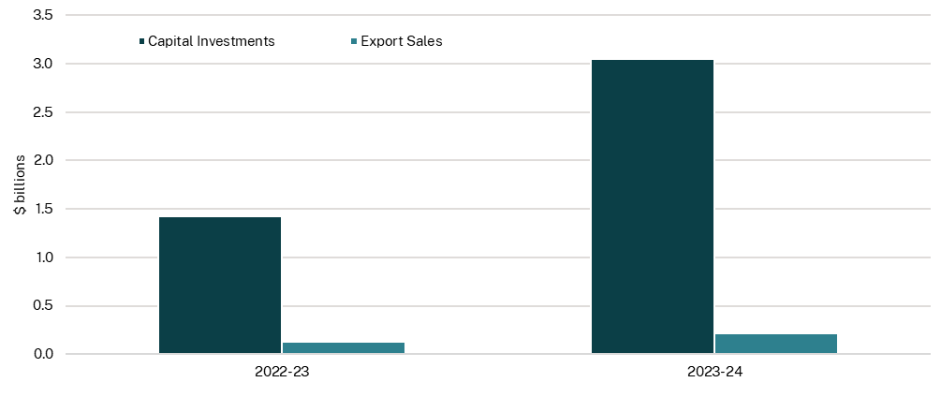

*Source: Premier’s Department, 2025*

### Proportion of alcohol related incidents

To support the longevity and success of tourism and the night-time economy, the NSW Government has a regulatory and compliance role in reducing alcohol-related violence.

The proportion of alcohol-related incidents at licensed premises has decreased from 89.6 per cent in 2014-15 to 82.9 per cent in 2023-24 (Chart 4.7). This reflects the continuous efforts of the NSW Government to reduce the impact of alcohol in the community through education, awareness raising and service controls.

1. Alcohol related incidents, NSW

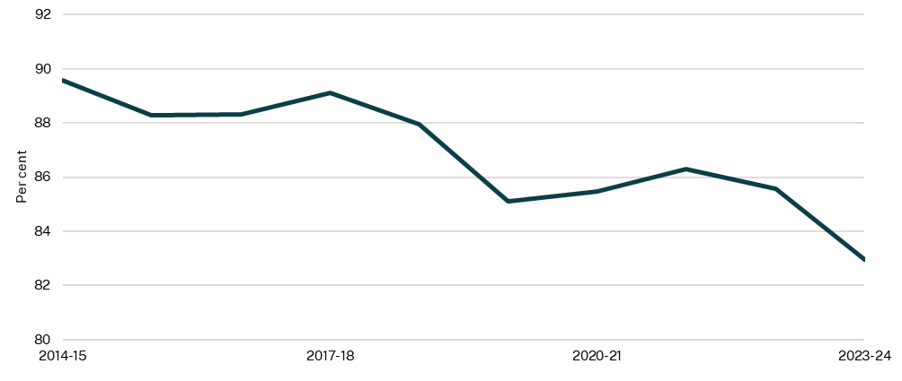

Source: Department of Creative Industries, Tourism, Hospitality and Sport, 2025

1. Release 22 of Household, Income and Labour Dynamics in Australia (HILDA) Survey was released in December 2023 and provides data collected from 2001 (wave 1) to 2022 (wave 22).