# 5. HOUSED

1. Introduction

The NSW Government is committed to building homes to support the increasing demand for housing. The Building Homes for NSW program supports a vision of safe, accessible and affordable housing – for renters and people wanting to enter the housing market. It took decades of underinvestment and poor policymaking to create the housing crisis. Fixing this decline will take significant government investment and consistent focus.

The NSW Government’s planning responsibilities and social housing programs support access to safe and affordable homes, and enhance places to be liveable and attractive for communities. A housed New South Wales means a society where residents and families have stable living conditions and communities are thriving and well-located.

Outcomes associated with the Housed theme are:

* Quality housing solutions are sufficient and affordable
* Places are well-designed and sustainable
* Vulnerable people have access to suitable housing.

1. Housing costs and home ownership in New South Wales

### Housing affordability

Secure and affordable housing is fundamental to the wellbeing of individuals and families. Stable living conditions support people to find jobs, connect with their community and access services.

Housing costs are becoming a larger proportion of household budgets for many individuals and families. From the September quarter 2005 to the December quarter 2019, median new mortgage payments as a share of average household earnings based on the average income of two full-time working adults in New South Wales fluctuated between 16.2 per cent and 24.9 per cent (Chart 5.1). Since the COVID-19 pandemic, higher interest rates, strong growth in dwelling prices and relatively weak growth in household earnings have made housing less affordable. The share of average household earnings spent on median new mortgage payments increased from 17.1 per cent in the December quarter 2020 to 31.0 per cent in the December quarter 2024.

The shortage of housing has made it not only difficult for potential home purchasers but also for renters to find a property to rent. The NSW rental vacancy rate has been broadly falling from 2020 to 2024. NSW median rents for dwellings increased by 40.6 per cent from $480 per week in the December quarter 2020 to $675 per week in the December quarter 2024. As a result, the proportion of average household earnings needed to service median advertised rent has risen from 20.2 per cent to 25.1 per cent over the same period.

The NSW Government has taken several steps to encourage the supply of affordable housing in New South Wales, alongside the delivery of market dwellings. In December 2023, the NSW Government implemented the Infill Affordable Housing Bonus Scheme, which permits additional height and floor space to residential developments that include a required amount of affordable housing. Since being introduced, this scheme has already seen more than 2,800 dwellings approved with more than 500 affordable homes. There are currently another 8,000 dwellings under assessment within this pathway, which include more than 1,700 affordable homes.

In addition, the recently established Housing Delivery Authority (HDA) considers the provision of affordable housing as one of the key criteria in the Expression of Interests that are submitted for major residential projects, driving the supply of more market housing broadly, as well as more affordable housing.

The 2024-25 Budget included $450 million to build new rental housing for essential workers. The first site in Camperdown will include around 500 new homes, including 200 for essential workers such as nurses, teachers, police officers and fire fighters.

1. Housing costs as a share of income, NSW

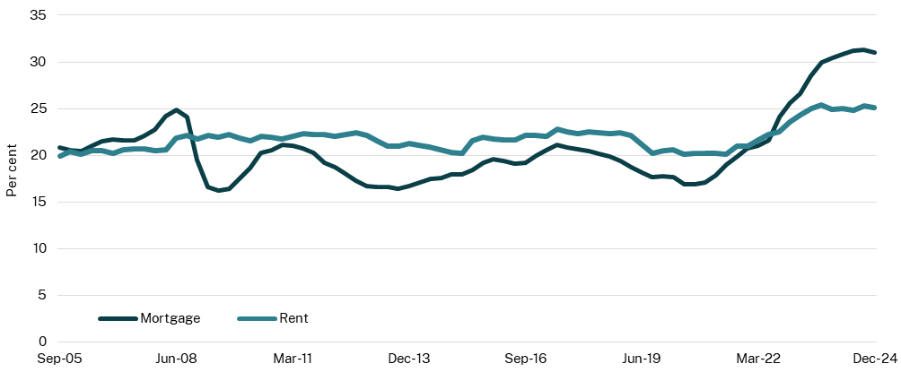

Source: Australian Bureau of Statistics (ABS) 2025; Cotality 2025; Household, Income and Labour Dynamics in Australia survey 2024; NSW Treasury 2025

Note: The mortgage series represents the median new mortgage payment as a share of dual-income owner-occupier household earnings with a 20 per cent average tax rate, 20 per cent deposit and a variable rate 30-year loan. The rent series represents the median advertised rents as a share of average dual-income rental household earnings.

### Home ownership

Home ownership provides individuals with greater housing security and long-term social and economic benefits (Australian Institute of Health and Welfare (AIHW), 2023). As housing costs increase and take up an increasingly large share of the household budget, people are finding it more difficult to buy a home. In the decade from 2010 to 2020, the ratio of median value of NSW dwellings to average household earnings averaged 3.5. This increased to 3.8 in the December quarter 2020 and has since increased to 4.7 in the December quarter 2024.

NSW home ownership rates increased slightly from 67.7 per cent in 1996 to 68.5 per cent in 2006 before declining (Chart 5.2). Home ownership rates fell from 68.1 per cent in 2011 to 64.8 per cent in 2021. This is predominately driven by Greater Sydney, where home ownership rates have fallen from 66.6 per cent to 61.7 per cent over the same period.

Home ownership rates in Greater Sydney have consistently been lower than across the rest of New South Wales. The rapid population growth in metropolitan areas – driven by employment, education and migration – has outpaced the development of new housing, making it increasingly difficult for supply to meet demand.

Policy reforms which increase housing diversity, such as the NSW Government’s recently introduced Low and Mid-Rise Reforms, directly contribute to opportunities for home ownership as the reforms make a broader range of housing options available for people to make first home purchases, or to downsize and create movement in the housing market. This combined with stimulating supply through state-led rezonings, will increase opportunities for people to enter the housing market.

1. Home ownership rates, NSW

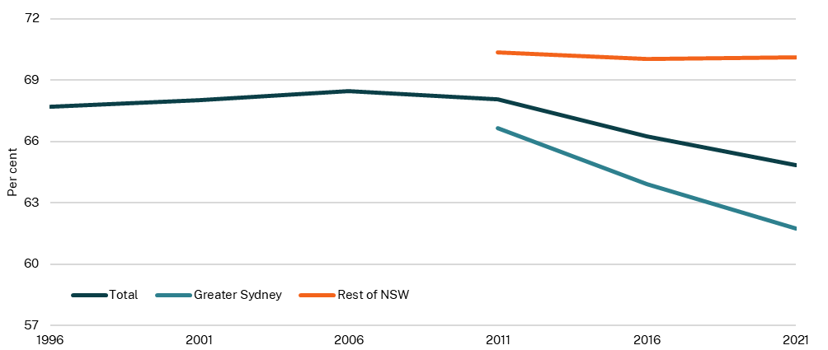

Source: ABS Census

Note: Census provides the most accurate and comprehensive data on home ownership. The latest available data point for Census is 2021. The data for regions is only available from 2011 as this is when the Australian Statistical Geography Standard was adopted which included the Greater Capital City Statistical Area classification. There is intention to explore more timely measures on home ownership in the future.

1. Social housing and homelessness

Social housing provides secure, affordable housing for people who are unable to afford housing in the private market. Housing market conditions, including a tight rental market, present challenges for those transitioning out of social housing.

The NSW Government has a variety of initiatives that assist in reducing homelessness. It partners with specialist homelessness services, including Aboriginal organisations and local community groups, to prevent recurring cycles of homelessness and foster longer-term housing stability.

### Supply of social housing

There are three types of social housing:

* Public housing which is managed by the NSW Government
* Community housing which is managed by not-for-profit organisations
* Aboriginal housing, managed by both the NSW Government and Aboriginal housing providers.

As at 30 June 2024, New South Wales had 155,905 social housing dwellings comprising 94,470 public housing, 49,516 community housing, 6,539 Aboriginal Community Housing and 5,380 Aboriginal Housing Office homes (Chart 5.3). Over the past seven years, there has been a compositional change in social housing, with the growth of community housing.

The $6.1 billion allocated in the 2024-25 Budget was the largest post-war investment in social housing in New South Wales.

1. Number of social housing dwellings, NSW

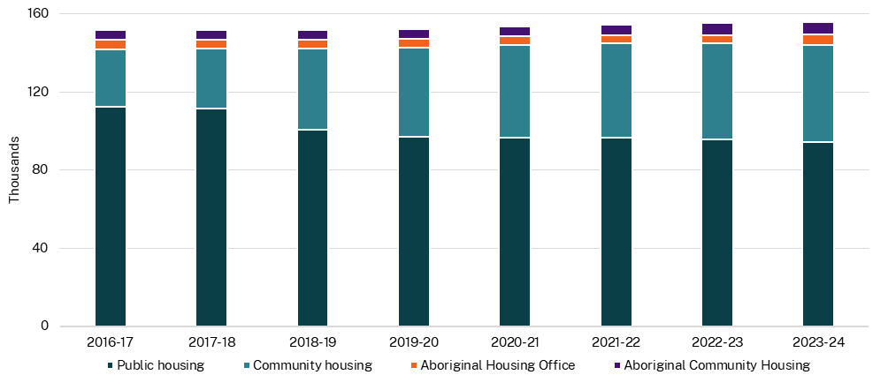

Source: Department of Communities and Justice (DCJ), 2024

### Demand for social housing

Households in urgent housing need on the NSW Housing Register include both priority applicants waiting to be housed and existing tenants in social housing waiting urgently to be rehoused, as their current house does not meet their needs. Priority applicants are those who have an urgent and ongoing housing need and are unable to resolve their need in the private market. For example, this may include a victim-survivor of domestic and family violence, who is unable to access affordable housing in the private market.

As of June 2024, there were 15,152 households in urgent need on the NSW Housing Register. Of these households, 61.2 per cent had a female listed as the head of the household. The number of households in urgent need on the Register has continued to increase since 2020‑21. This increase is largely due to a constrained private rental market with increased rents and low vacancy rates.

The average wait time for households in urgent need, who are on the Register, increased from 26.2 months in 2020-21 to 27.5 months in 2021-22, before decreasing to 26.7 months in 2023‑24 (Chart 5.4).

1. Average wait time for households in urgent need, NSW

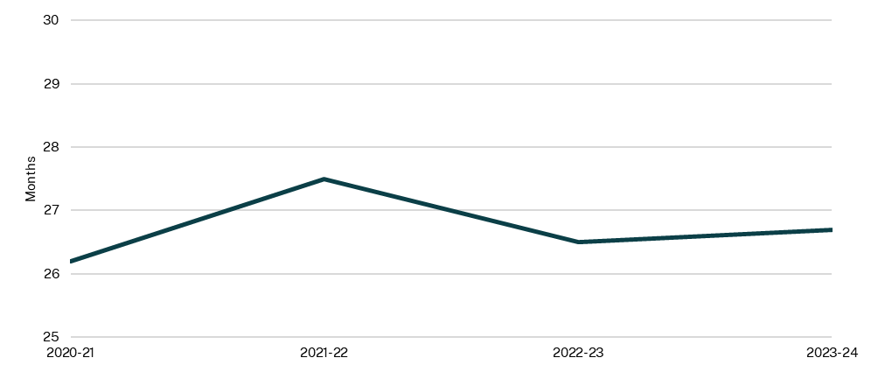

Source: DCJ, 2024

### Homelessness

The NSW Government funds specialist homelessness services (SHS) to support people who are experiencing or are at risk of becoming homeless. The support provided by SHS includes outreach, case management and transitional and crisis accommodation. Many people who have experienced homelessness have complex needs and require support to establish and maintain a tenancy. Without support, they can experience a failed tenancy and return to homelessness.

In the last six years, the number of SHS clients who have returned to homelessness after being housed within a 24-month period increased to 4,366 in 2020-21 from 4,300 in 2018-19, before decreasing to 4,183 in 2023-24 (Chart 5.5). The proportion of SHS clients who are returning to homelessness has fallen from 11.9 per cent in 2018-19 to 10.8 per cent in 2023-24 suggesting more clients have been able to maintain suitable accommodation.

1. Clients who are housed and then return to homelessness, NSW

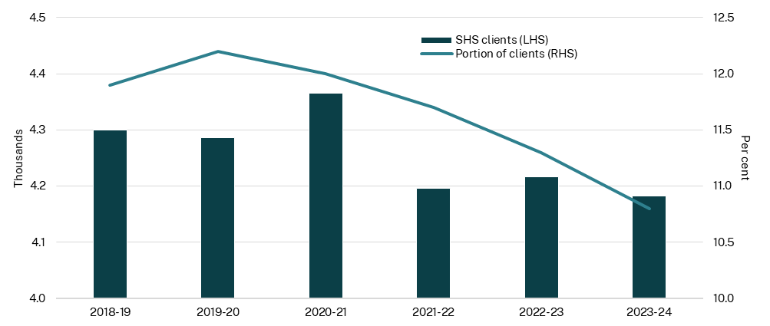

Source: AIHW, 2024

1. Planning and development

The NSW Government, local governments and a range of independent bodies are responsible for decision making within the land use system, including the rezoning of land and the approval of development applications.

The time required to approve development applications affects the speed, and cost, of bringing new housing to market. Timely planning assessments improve housing supply and affordability, while delays in assessment timelines can increase costs and create uncertainty.

The 2025-26 Budget provides $83.4 million additional planning resources to speed up approvals and to expand the new HDA.

### Development applications

The NSW Government is committed to providing homes through reforms designed to streamline planning approvals for major housing developments. The average number of days to determine a development application differs depending on the type of application, reflecting differences in scope and complexity of assessments.

* Regionally Significant Development Applications are large-scale or complex developments, such as residential projects valued at over $30 million.
* State Significant Projects are traditionally focused on large-scale non-residential projects, but recent reforms have broadened scope to increase focus on major residential and mixed-use developments. The biggest change has been the creation of the New South Wales HDA, that is designed to identify and fast-track the delivery of new home projects. By streamlining planning processes and unlocking key sites for development, these initiatives aim to boost much needed housing supply and help New South Wales meet its targets under the National Housing Accord.
* Local Development Applications comprise around 95 per cent of applications and commonly involve building a new house, adding an extension, or making changes to an existing building.

State Significant Projects and Regionally Significant Development Applications assessments comprise only around 5 per cent of the total applications by volume (Department of Planning, Housing and Infrastructure (DPHI), 2025).

The average number of days to determine a State Significant Project has improved from 122 days in the six months to March 2018 to 94 days in the six months to March 2025 (Chart 5.6). New South Wales has also seen average assessment times for councils continue to reduce, with a 14 per cent reduction in the average assessment time, and in May 2025 the average assessment time for councils for housing development applications was less than 100 days for the first time since mid-2022. This trend is consistent with the Statement of Expectations issued by the Minister for Planning and Public Spaces to councils.

In the December quarter 2024, New South Wales continued to have the greatest number of homes under construction nationally, at more than 70,000 dwellings, and New South Wales has the highest number nationally of multi-unit housing. This will increase further as HDA development applications are submitted and assessed. From July 2024 to April 2025, 52.7 per cent of construction approvals in New South Wales were for multi-dwellings, while Queensland was at 35.8 per cent and Victoria at 42.9 per cent. A higher percentage of multi‑dwellings means that construction of these projects will take a longer average time, however, these projects will also deliver more homes over time for New South Wales.

1. Average days to determine a development application, NSW

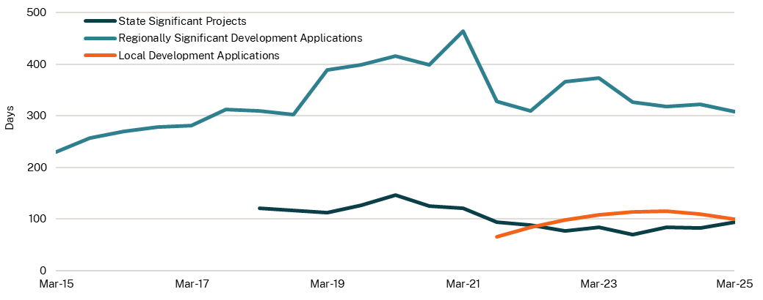

Source: DPHI, 2025

Note: The days to determine a development application is based on six-month rolling average.

### Dwelling completions

Dwelling approvals typically precede completions by around two to three years. High interest rates, reduced dwelling investment, increased raw material costs and labour shortages have contributed to a residential construction slowdown. Chart 5.7 shows the number of dwelling completions per 1,000 people for New South Wales, Victoria and Queensland.

In the Australian Government’s 2025-26 Budget, it was indicated that capacity constraints in the construction sector are gradually easing. Inflation in the price of materials has fallen and financing costs are expected to moderate to allow for more housing investment in the next few years.

While it will take time for these constraints across industry to ease and for this to have a flow‑on effect of more homes being completed within New South Wales, the National Housing Accord is measured over a five-year period to June 2029. With current constraints on the construction industry, the focus for New South Wales in the early years of the Accord Period is to ensure that developable land is appropriately zoned for increased density, and that the planning system supports more development applications being lodged.

In the financial year to date, New South Wales has had more than 85,000 development applications lodged as at 30 May 2025. This is an increase of 28 per cent on the same period for the previous year and exceeds the total number of applications lodged for 2023-24. The Australian Bureau of Statistics (ABS) data for the first six months of the Housing Accord period shows that more than 23,000 new dwellings commenced construction in New South Wales between July and December 2024, which is an 18.7 per cent increase on the six months prior.

Reforms to the planning system, and the NSW Government’s housing policies to date are demonstrating that the approval, construction and completion of new homes in New South Wales are moving in the right direction. Under the TOD Program, there are more than 10,000 dwellings currently under assessment in State Significant Development Applications alone, which does not factor in other dwellings that are under assessment or approved by local councils. The Infill Affordable Housing Bonus Scheme has already seen more than 2,800 dwellings approved including more than 500 new affordable homes, and another 8,000 homes are currently under assessment including 1,700 affordable.

The HDA is streamlining assessment of major residential developments to drive completions, with more than 53,000 potential homes having been declared as state significant developments.

1. Dwelling completions

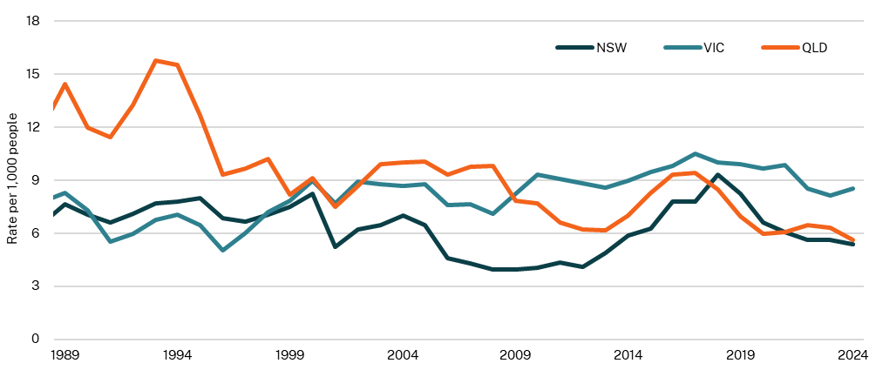

Source: ABS, 2025; NSW Treasury

Note: 2024 is based on projected population figures. This series includes alterations and additions completions.