# 7. COMMUNITY

1. Introduction

Building a better New South Wales also includes building a community-oriented New South Wales – a society that supports connections with family, friends, community and promotes diversity and culture.

A strong and vibrant community is associated with strong social bonds, where people are engaged, culture and diversity are celebrated, people feel heard and where people are free to enjoy their recreation and leisure.

NSW Outcomes associated with the Community wellbeing theme include:

* Government is coordinated, transparent and trusted
* Aboriginal people’s voices are heard at the centre of government
* Creative and cultural sectors are sustainable and growing
* Communities are diverse, engaged and cohesive.

While the Community wellbeing theme includes the NSW Outcome Aboriginal people’s voices are heard at the centre of government, First Nations outcomes and indicators are intended to be used across the entire Performance and Wellbeing Framework. Where possible and appropriate, wellbeing metrics and performance indicators have been disaggregated for First Nations status.

1. Our communities across New South Wales

### Feeling a sense of belonging

A sense of belonging and feeling connected to place and community influences a person’s wellbeing. Being part of a larger group as well as engaging with the broader community can support and contribute to a sense of belonging for people.

The Household, Income and Labour Dynamics in Australia (HILDA) survey captures people’s perception of feeling part of their local community in terms of their social connections and networks among other things. From 2001 to 2023, the overall satisfaction level with feeling part of the local community increased from an average score of 6.7 to 7.1 out of 10 (with 10 being “Totally satisfied”) (Chart 7.1). During this period, people aged 65 and over consistently reported higher satisfaction scores with their local community than other age groups, with an average score of 7.2.

1. Satisfaction with feeling part of your local community, NSW

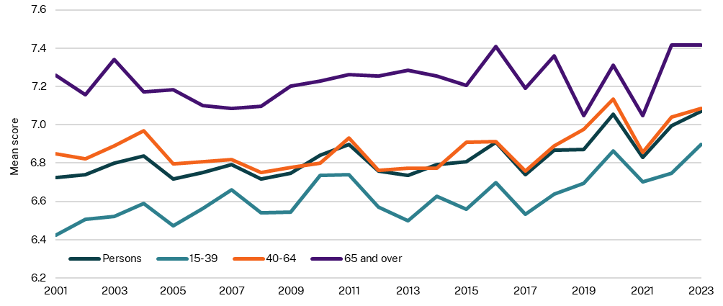

Source: HILDA, 2024

1. Supporting arts, culture and diversity

Supporting the arts, culture and our diversity helps people enjoy their recreational time, feel connected and thrive.

### Annual visitation to selected NSW Government cultural institutions

New South Wales is home to the oldest and most recognised cultural institutions in the country. These institutions are integral for our communities as they preserve, acknowledge and celebrate our history, artefacts, culture and heritage. They also provide valuable education and research services, and host world class exhibitions and events.

Most cultural institutions experienced positive growth in visitation numbers in 2023-24. The Australian Museum had the highest annual growth in 2023-24 at 57.9 per cent, followed by the State Library of NSW at 43.4 per cent. While the Powerhouse Museum in Ultimo closed for heritage revitalisation works in February 2024, outreach and touring exhibitions continue to deliver services to the community (Chart 7.2).

1. In-person visits to cultural institutions, NSW

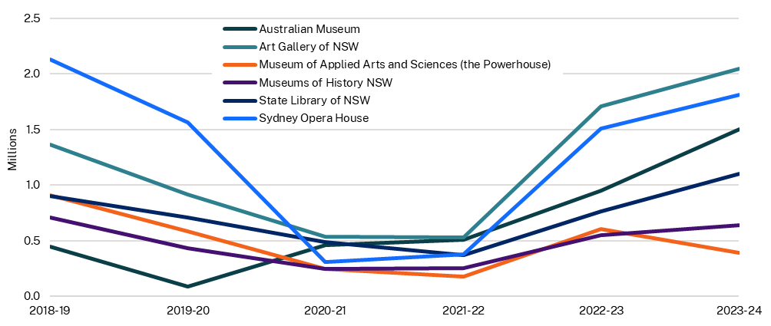

Source: Annual Reports of Cultural Institutions, 2018-19 to 2023-24

Note: In-person visits only. NSW State cultural institutions are based in Greater Sydney. To ensure a consistent approach in determining annual visitation, the common agreed definition was onsite attendance. This excludes attendance at regional tours of exhibitions. Each cultural institution has its own methodology and categorisation of onsite visitation, and attendance rates may not be directly comparable between institutions. Visits relate only to the primary site of visitation. Powerhouse Museum Ultimo closed for heritage revitalisation works on 4 February 2024*.*

### Live performance attendance in New South Wales

A thriving, vibrant live performance scene supports communities by fostering cultural experiences where people can enjoy their recreational time in a way that promotes connectivity, learning and shared experience. The NSW Government invests in live performances, and community and cultural events through initiatives such as the Arts and Cultural Funding Program, Live Performance Venue Program, Stronger Together Festival, Events Grants Program and the Contemporary Music Festival Viability Fund (NSW Government, 2025). The number of people attending live performances increased 26.6 per cent from 2022 to 2023 (Chart 7.3).

The 2025-26 Budget invests $20.0 million for Sound NSW to implement the NSW Contemporary Music Strategy through grants programs, capacity-building initiatives and regulatory reform to strengthen the New South Wales music industry. There is also a commitment of $20.0 million for Create NSW to continue delivering services to support creative industries and the NSW Creative Communities Policy. 

1. Number of attendees to live performances, NSW

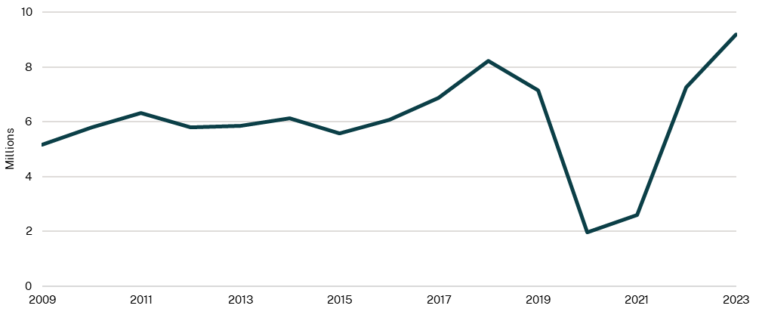

Source: Live Performance Australia Ticket Attendance Report, 2024

1. Supporting strong First Nations communities

For government policies to meaningfully reflect and address the values, priorities and experiences of our First Nations communities, it is essential that First Nations voices are at the centre of government decision-making through formal partnerships and that their connections to culture and Country are maintained. This voice and connection is integral for the strength of the New South Wales community.

The 2025-26 Budget includes a record $731.8 million to support First Nations communities in New South Wales and build upon previous spend to improve outcomes. This includes a significant further investment in Closing the Gap, with $202.4 million of new funding.

### Key agreements and partnerships for meaningful change

The National Agreement on Closing the Gap places First Nations peoples’ leadership and partnership at the heart of meaningful change. The NSW Partnership Agreement on Closing the Gap is a state-level agreement between the NSW Government, NSW Coalition of Aboriginal Peak Organisations, and Local Government NSW to jointly implement the National Agreement on Closing the Gap as equal partners.

Priority Reform 2 of the Closing the Gap Agreement commits to build the Aboriginal Community-Controlled Sector. The NSW Government provides funding to Aboriginal Community-Controlled Organisations (ACCOs) to design and deliver solutions that align with local community aspirations, ensuring that government investment strengthens culturally informed and community driven development (Chart 7.4). Funding enables a range of programs to be delivered that focus on community wellbeing, cultural continuity and locally driven initiatives. According to the 2023-24 NSW Indigenous Expenditure Report, approximately 30.9 per cent of First Nations-specific services and programs were delivered by ACCOs.

1. Funding for First Nations programs and services delivered by ACCOs (2023-24 dollars), NSW

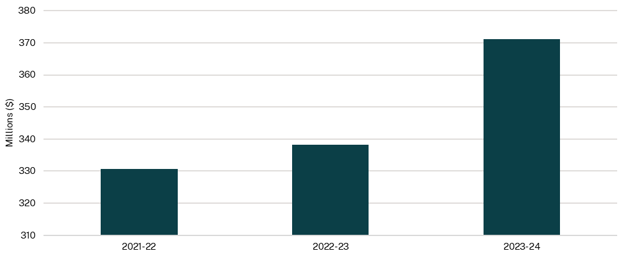

Source: NSW Treasury, 2025

Note: Funding including and prior to 2022-23 is actuals. For 2023-24, funding reflects year end projections as at March 2024. This may not reflect all of the NSW Government expenditure with ACCOs and is based on the data collected for the NSW Indigenous Expenditure Report.

### National parks and Private Land Conservation under Aboriginal management

Caring for Country is an integral component of First Nations cultures. The NSW Government offers two main partnership mechanisms to facilitate shared management of land and waters by First Nations communities: joint management of National Parks and Private Land Conservation agreements. These arrangements support continued cultural practice, conservation of cultural heritage, application of traditional cultural knowledge and deliver flow on benefits for both First Nations people and the broader New South Wales community.

This indicator measures the number of hectares of land reserved under the *National Parks and Wildlife Act 1974* that are under Aboriginal joint management, and land managed under a Private Land Conservation agreement by Aboriginal individuals or community organisations.

The number of hectares of National Parks estate under Aboriginal joint management steadily grew from 1999 to 2016 (Chart 7.5). There was a decrease of 768,000 hectares between 2016 and 2017, because an agreement for Aboriginal joint management of land was not renewed. By 2024, there were 2,335,000 hectares of National Parks under Aboriginal joint management, which comprised approximately 30.5 per cent of the National Parks estate.

On 16 March 2023, the Biodiversity Conservation Trust (BCT) entered into a funded conservation agreement with the Nari Nari Tribal Council supporting cultural land management practices and conservation efforts across the 55,220 hectare Gayini Nimmie Caira Conservation Area. The agreement embeds the role of Traditional Custodians in managing land for current and future generations and is the largest private land holding to be funded, in perpetuity, by the NSW Government.

1. Land under Aboriginal (Joint) Management, NSW

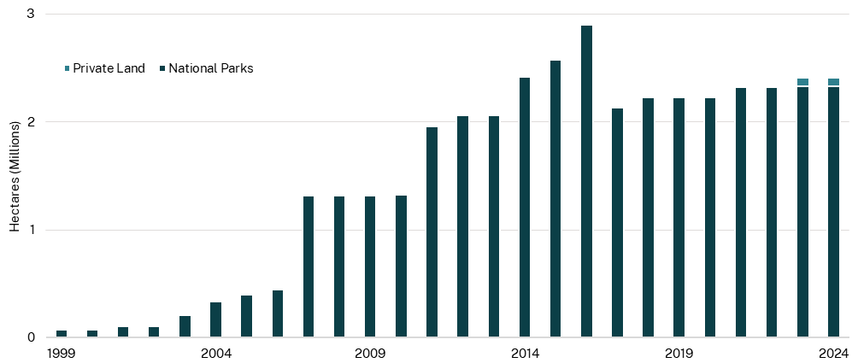

Source: Department of Climate Change, Energy, the Environment and Water, 2025

1. Maintaining trust and integrity in government institutions

Strong government institutions that are responsible and trusted underpin social cohesiveness.

### Trust in NSW Government services

High levels of satisfaction with a government service can increase the perceptions of trust in government services.[1] Government agencies can earn trust by delivering promised services that respect and value community feedback.[2]

The Department of Customer Service (DCS), through its Customer Experience Survey (CXS), asks respondents to rate the extent they trust government services to be working in their best interests.

Trust in NSW Government services is measured based on the proportion of respondents that selected ‘trust a great deal’ or ‘somewhat trust’ that the government services is working in their best interests. Between March quarter 2022 and March quarter 2025, overall trust in NSW Government services has been relatively stable, ranging from 71.0 per cent to 74.2 per cent (Chart 7.6). The results for March quarter 2025 highlight that the level of trust in government services was higher in New South Wales at 74.0 per cent compared to Victoria and Queensland at 67.6 per cent and 72.8 per cent, respectively.

1. Trust in government services, NSW

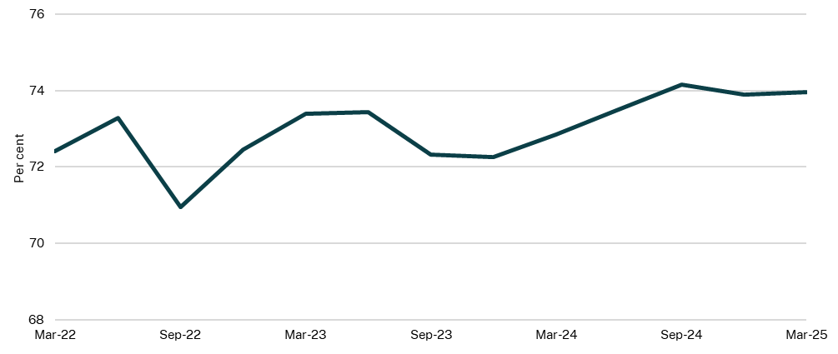

Source: DCS, 2025

1. OECD, 2025, Drivers of Trust in Public Institutions in Australia, Building Trust in Public Institutions, OECD Publishing
2. Evans M, Dare L, Tanton R, Vidyattama Y, Seaborn J, 2019, Trust in Australian Regional Public Services: “Citizens not customers – keep it simple, say what you do and do what you say”, APS Reform