# 8. connected

1. Introduction

The NSW Government is committed to effective and reliable government services and infrastructure for New South Wales. A connected New South Wales is a society where people and businesses are connected, and services are accessible. The NSW Government provides funding for services that enable and promote access to government services, and the provision and maintenance of the public transport network and roads.

Outcomes associated with the Connected theme are:

* Government services are accessible, effective and integrated
* People, businesses and communities are connected through safe and reliable transport
* People and businesses have access to digital services.

1. Satisfaction with government services

### Satisfaction with government services

Satisfaction with government services improves the overall quality of life for individuals and families by ensuring that essential services such as health, transport and public safety are delivered effectively and efficiently.

The proportion of NSW residents satisfied with government services increased from 75.1 per cent in the March quarter 2022 to 76.1 per cent in the March quarter 2025 (Chart 8.1).

1. Customers satisfied with government services, NSW

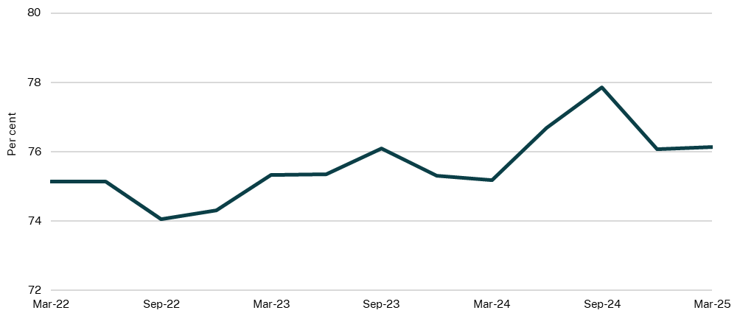

Source: Department of Customer Service (DCS), 2025

1. Access to government services

Easy and adequate access to government services is essential to securing a fair, prosperous and inclusive society. Recognising the importance of public access to government services, the NSW Government tracks the accessibility of government websites, first-time resolution from government interactions and public transport accessibility levels.

### Accessible NSW Government websites

Accessible government websites ensure all people, including people with a disability, have equal opportunities to access digital content published by the NSW Government. Accessibility is scored out of 100 with higher scores reflecting higher accessibility for ‘nsw.gov.au’ and ‘service.nsw.gov.au’ websites. The ‘nsw.gov.au’ website aims to conform to the Website Content Accessibility Guidelines (WCAG) at level AA (DCS, 2025).

The ‘nsw.gov.au’ website’s average score increased from 80.7 in the March quarter 2023 to 83.4 out of 100 in the December quarter 2024 (Chart 8.2). Average scores for the ‘service.nsw.gov.au’ website rose slightly from 88.0 to 88.9 during this period. Both websites experienced a surge in scores in the March quarter 2024, with ‘nsw.gov.au’ reaching a high of 86.5 and ‘service.nsw.gov.au’ reaching a high of 93.6. Significant fluctuations in accessibility scores reflect ongoing content, design and technical changes on the websites which can impact accessibility scores (DCS, 2025).

1. NSW Government websites that conform to accessibility standards

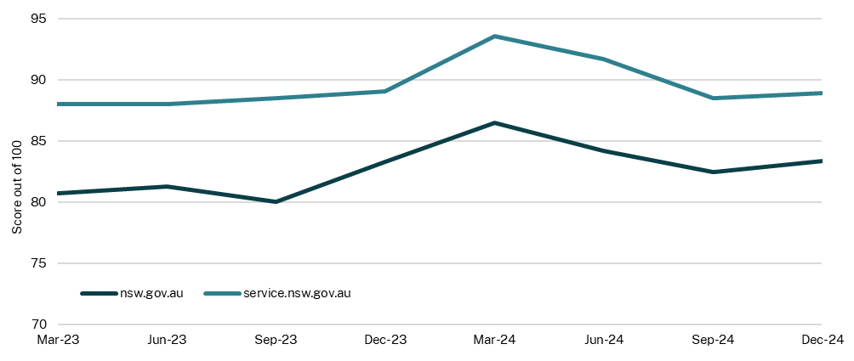

Source: DCS, 2025

### Effective resolution from a government interaction

A measure of the effectiveness of government services is the extent to which customers are able to reach an outcome on their first attempt – this is a measured of a first-time resolution (DCS, 2025). Since data collection began, in the March quarter 2025, 77.2 per cent of customers were able to reach an outcome on their first attempt when interacting with a government service.

### Access to public transport

Easy access to public transport helps to connect people to jobs and other services. Places that are highly connected to public transport can have a positive impact on people’s lives through improved economic opportunities and social connections. The access level of different geographical locations to public transport services is measured using the Public Transport Accessibility Level (PTAL). An area with a high PTAL score means it is highly accessible, with nearby stops and stations, as well as frequent services passing through the closest stations (Transport for NSW (TfNSW), 2025).

The proportion of Greater Sydney that had medium to very high accessibility increased from 67.9 per cent in December 2022 to 68.5 per cent in December 2024 (Chart 8.3). Areas with medium to very high accessibility can access various public transport modes to reach a destination with little or no private vehicle usage. Increased accessibility was largely due to the extension of the Sydney Metro line from Chatswood to Sydenham, which improved people’s access to public transport services around new stations such as Crows Nest and Victoria Cross (TfNSW, 2025).

The proportion of Outer Metropolitan areas with medium to very high accessibility rose from 23.5 per cent in December 2022 to 24.9 per cent in December 2024. This increase was attributed to more frequent bus and/or train timetabled services around Wyoming, Windale, Glenbrook, Katoomba and West Wallsend (TfNSW, 2025).

The NSW Government continues to make significant investments to improve transport connections.

1. Areas with a medium to very high Public Transport Accessibility Level score, NSW

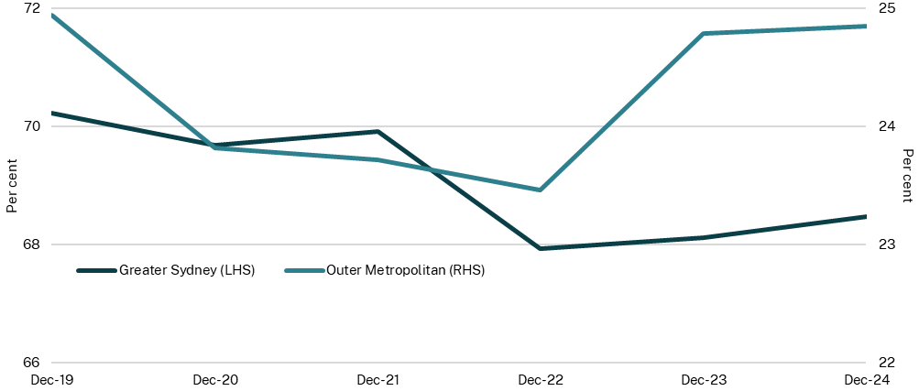

Source: TfNSW, 2025

Note: Outer metropolitan refers to Southern Highlands and Shoalhaven, Illawarra, Newcastle and Lake Macquarie, Lower Hunter, Port Stephens and Maitland, Central Coast, and Blue Mountains (TfNSW, 2025).

1. Public transport and road performance

The NSW Government builds and operates a transport network that connects people and businesses to places, services and opportunities. The NSW Government also manages roads, rail, waterways, and other active transport assets to support a safe and reliable transport network. An effective transport network enables individuals to reliably access essential services, visit friends and family as well as travel to recreational places, employment and education opportunities.

Public transport services include providing trains, metro, buses, ferries, and light rail. Connecting these different transport modes contributes to improved travel experiences.

### Customer satisfaction - roads

A well-maintained road network contributes to economic growth as it facilitates efficient transportation of people and/or goods from one place to another. TfNSW conducts surveys to understand people’s experiences across different transport modes.

Between May 2022 and November 2024, motorcyclists’ satisfaction levels ranged between 84 per cent and 93 per cent (Chart 8.4). Motorcyclists were generally most satisfied with licensing and registration as well as journey times (TfNSW, 2024). Private vehicle users’ satisfaction levels increased from 88 per cent in May 2022 to 91 per cent in November 2024. These road users were also mostly satisfied with licensing and registration (TfNSW, 2024). Active transport users have maintained high levels of satisfaction at 90 per cent or above since November 2023, with cyclists and pedestrians most satisfied with reliable journey times (TfNSW, 2024).

Heavy vehicle road users were less satisfied with roads compared to other road users. These road users were least satisfied with the availability and quality of rest areas and the quality and smoothness of roads (TfNSW, 2024).

The NSW Government is continuing to improve the safety and easing traffic congestion for road users. For example, the 2025-26 Budget delivers $1 billion for the first stage of the Fifteenth Avenue Upgrade between Liverpool and the Western Sydney International Airport.

1. Customer satisfaction by road users, NSW

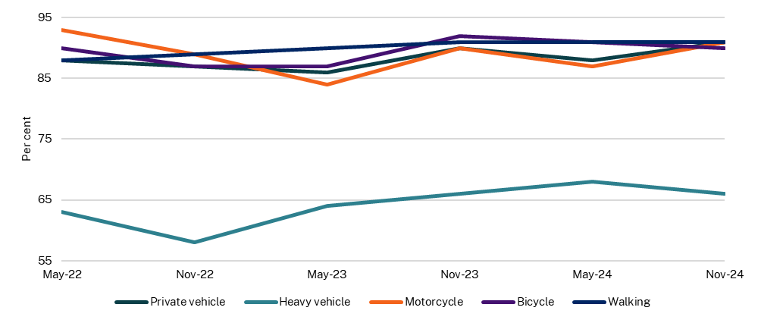

Source: TfNSW, 2025

### Public transport and active transport mode share

Public and active transport modes can reduce economic, social and environmental costs associated with private transport, and improve health outcomes. Data from the Household Travel Survey is used to measure the proportion of travel taken by public transport or active transport (walking and cycling). TfNSW conducts this survey once a year to capture travel habits of people in the Sydney Greater Metropolitan Area.

Walking remains the predominant mode of active transport in the Sydney Greater Capital City Statistical Area (GCCSA). The proportion of trips taken using active transport on an average weekday in the Sydney GCCSA increased from 18.0 per cent in 2016-17 to 19.8 per cent in 2023-24. The proportion of trips taken using public transport was relatively steady from 2016‑17 to 2019-20, averaging 12.2 per cent. There was a considerable decline from 2019-20 to 2020-21 which reflected reduced travel due to the COVID-19 pandemic restrictions. The proportion of public transport trips increased from 7.2 per cent in 2021-22 to 11.0 per cent in 2023-24 which may have been due to changing travel behaviors or increased travel trips for education or work purposes since the easing of pandemic-related restrictions (Chart 8.5).

1. Mode share for trips taken by public and active transport, Greater Sydney

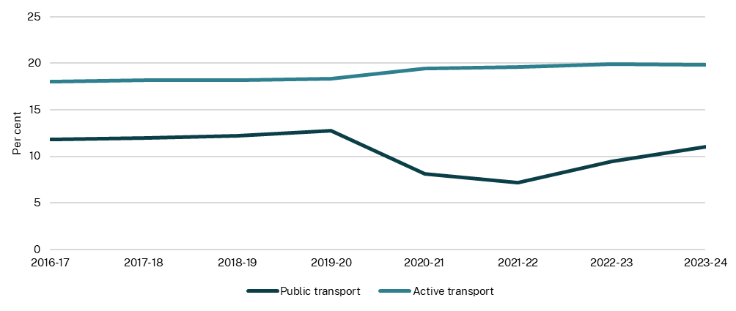

Source: TfNSW, 2025

### Road fatalities

The economic and social costs of road fatalities are significant and can result in reduced productivity from mortalities and costs of suffering and pain.[1] The overall rate of NSW road fatalities dropped considerably by 20.5 per cent from 5.1 per 100,000 people in the 12-month period ending March 2018 to 4.1 per 100,000 people in the 12-month period ending March 2024 (Chart 8.6). Fatalities in Australia also fell over the same period, with the rate falling by 7.8 per cent from 5.1 per 100,000 people to 4.7 per 100,000 people.

Road fatality rates have been lower in New South Wales compared to Australia for the past decade except for the 12-month period ending March 2018. In the 12-month period ending March 2025, the road fatalities rate is estimated to be 4.0 per 100,000 in New South Wales and 4.6 per 100,000 for Australia.

1. Road fatalities per 100,000 people, NSW

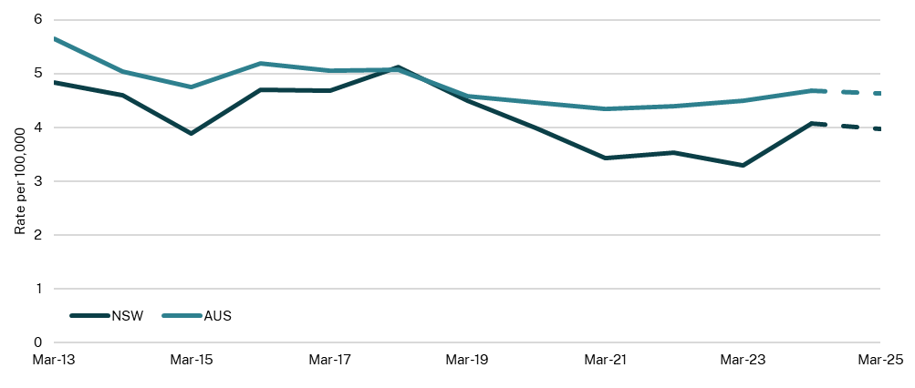

Source: Bureau of Infrastructure and Transport Research Economics, 2025; Australian Bureau of Statistics, 2025; NSW Treasury; data for 2024 and 2025 are preliminary

Speed has been the most significant contributor to fatal crashes (TfNSW, 2025). From 2020 to 2024, 40.7 per cent of total fatal crashes were attributed to excessive speed (TfNSW, 2025). Over the same period, 16.1 per cent of fatal crashes involved illegal alcohol[2], 16.6 per cent involved fatigue and 11.7 per cent of fatal crashes involved an available seatbelt not worn.[3]

1. Steinhauser, R, Lancsar, E, Bourke, S, Munira, L, Breunig, R, Gruen, R, Dobes L, Bulfone, L, Glass, K, Gordon, C and Cox, J 2022, [Social Cost of Road Crashes](https://www.bitre.gov.au/sites/default/files/documents/social-cost-of-road-crashes.pdf), The Australian National University
2. The proportion of crashes involving alcohol is from January 2020 to September 2024. Data for the 2024 year is preliminary and subject to change
3. Contributing factors of fatal crashes are not mutually exclusive (i.e. all contributing factors such as alcohol, fatigue and instances where seatbelts were not worn can be involved in a crash). If alcohol and fatigue contributed to a fatal crash, data would be counted towards both alcohol and fatigue fatal crash data. Data for the 2024 year is preliminary and subject to change