# 9. SUSTAINABLE

1. Introduction

The NSW Government is committed to building a better New South Wales and ensuring that the environment and its natural resources are responsibly and sustainably managed.

A sustainable New South Wales is a community that values its environment and heritage and manages natural resources responsibly. This means the environment and natural resources are managed so the interests of current and future generations are balanced, energy systems are secure, and Aboriginal communities are supported to care for Country.

Outcomes associated with the Sustainable theme are:

* A secure and sustainable transition to a circular economy and Net Zero
* Natural resources are used productively and sustainably
* The environment and our heritage is protected, enhanced and enjoyed
* Communities and businesses reduce emissions and adapt to the impacts of climate change.

1. The NSW environment

The natural environment that people live in is crucial to their wellbeing. It supports clean air and water, and safe food production. A sustainable and healthy environment also helps to protect people from extreme weather events and supports mental and physical health.

### Temperature

Climate change poses a significant threat to the environment and the health and wellbeing of the people of New South Wales. Rising temperatures are a key indicator of the impact of climate change on the environment. Deviations from the average long-run temperature help provide a broad indication of long-term environmental and climate trends. In 2024, New South Wales was on average 1.6 degrees Celsius hotter than the average temperature from 1961 to 1990 (Chart 9.1). It also marks the 28th year in a row with an average annual temperature above the long-run average. Compared to the same 1961 to 1990 climatology, over the last decade, New South Wales has been 1.1 degrees Celsius hotter on average.

1. Temperature deviations from long-run average, NSW

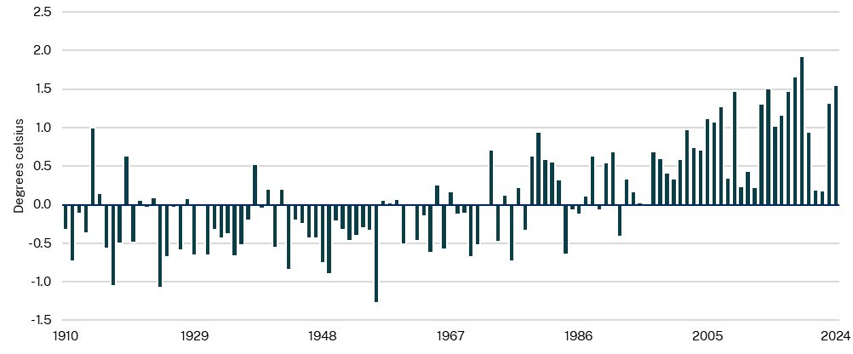

Source: Australian Government Bureau of Meteorology (BoM), 2025

Note: Data is based on the World Meteorological Organisation standard reference period of 1961 to 1990 for calculating anomalies and tracking climate change. Includes NSW/ACT data.

### Air quality

Clean air is crucial for a healthy population. The NSW Clean Air Metric (CAM) assesses air quality in accordance with the National Environmental Protection Measures (NEPM) ambient air quality standard for fine particles or PM2.5. Fine particles are the leading cause of health damage (mainly lung and heart diseases) from air pollution, and are a key indicator of air quality (Department of Climate Change, Energy, the Environment and Water (DCCEEW), 2025).

The NEPM standards for fine particles are set as a benchmark of 100 per cent. A CAM score above 100 per cent indicates NSW residents were exposed to fine particles at levels exceeding the national standard benchmark of 100 per cent.

Air quality improved in New South Wales as the CAM fell from 84 per cent to 82 per cent from 2023 to 2024 (Chart 9.2). New South Wales recorded the best air quality since data collection began in 1998 in 2022 with a 60 per cent CAM result. This was partly due to La Niña bringing record wet conditions. The CAM score reached a high of 132 per cent in 2019 due to smoke from the 2019‑20 bushfire season.

1. Clean air metric, NSW

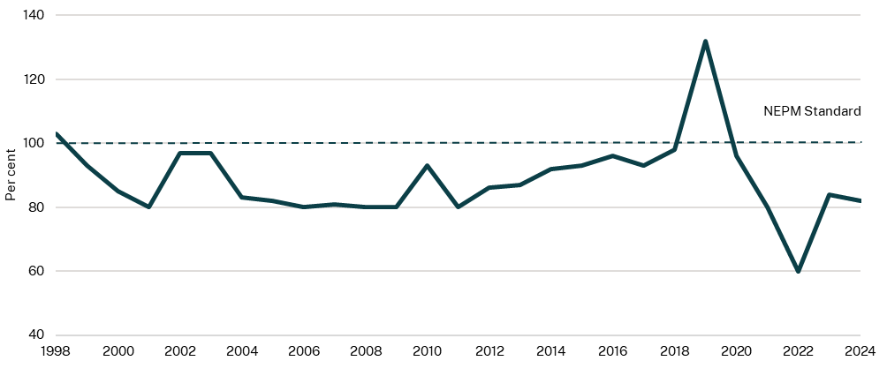

Source: DCCEEW, 2025

1. Climate change and adaptation

It is important that climate change and its impacts on the environment and the wellbeing of the people of New South Wales are monitored. This will ensure that informed decisions can be made to adapt to the impacts of climate change to reduce or avoid harm.

Ensuring people can access essential services like electricity is important to ensure the wellbeing of the people of New South Wales in the face of a changing environment.

### NSW greenhouse gas emissions

*The Climate Change (Net Zero Future) Act 2023* (NSW)legislates a whole-of-government climate action plan to achieve a 50 per cent reduction in emissions by 2030, and 70 per cent reduction by 2035 compared to 2005 levels, and net zero by 2050. This indicator shows inventoried (actual) emissions up to 2023.

Emissions in 2023 were 114.5 megatonnes, representing 25.2 per cent of the national total and a 32.3 per cent reduction compared to levels in 1990 (Chart 9.3). The larger proportion of energy production coming from renewables and the reduction of coal-fired sources have contributed to the fall in emissions over time. While population growth and the use of transport has increased, improved fuel efficiencies of vehicles and structural shifts across the economy have helped to bring emissions down (DCCEEW, 2025).

1. Greenhouse gas emissions (CO2 equivalent), NSW

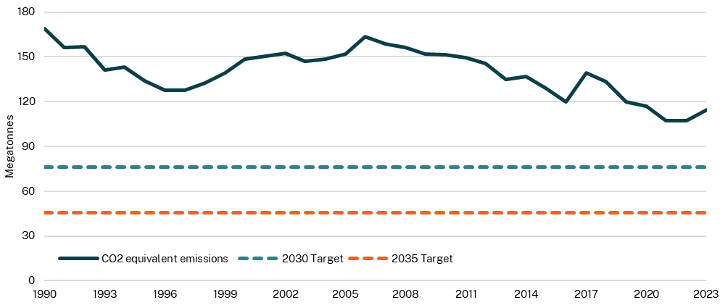

Source: DCCEEW, 2025

### Energy security

A safe and stable supply of energy is important for supporting all sectors of the economy. The Energy Security Target assesses whether forecast firm electricity generation capacity is sufficient to meet New South Wales’ maximum consumer demand in summer, with a reserve to account for the unexpected loss of the two largest generating units in the state, for the next 10 years. Firm capacity includes the capacity from generation, storage, interconnector, and demand flexibility sources likely to be available to supply NSW electricity customers during times of summer peak demand (DCCEEW, 2025).

The 2025-26 Budget includes:

* $2.1 billion over the next four years in the Transmission Acceleration Facility, primarily to support the five Renewable Energy Zones at Central-West Orana, New England, Hunter‑Central Coast, Illawarra and South West
* $1 billion in seed funding for NSW’s Energy Security Corporation, to unlock private investment for vital storage and firming projects in New South Wales.

The 2024 Energy Security Target shows NSW levels being sufficient until a shortfall of 488 megawatts in 2027-28 (Chart 9.4). This is a result of the potential expected retirement of the Eraring Power Station in August 2027 before new transmission and generation projects come online. Following the delivery of new transmission infrastructure, firm capacity is expected to return to surplus by 2032-33. In 2033-34 a second potential shortfall of 2,013 megawatts is forecast if the Vales Point and Bayswater Power Stations retire.

Without additional investment in new capacity, in periods of forecast shortfall, there is a higher risk of load shedding during peak summer periods if there are significant unplanned outages. The forecasts, however, do not include the recent commitment to allocate a minimum of 900 megawatts of dispatchable capacity to New South Wales under the Capacity Investment Scheme Tender 3, and the new 2034 long duration storage minimum objective added to the *Electricity Infrastructure Investment Act 2020* (NSW) in November 2024 (DCCEEW, 2025). Both the commitment and the new long duration storage minimum objective aim to address shortfalls to the Energy Security Target and ensure a reliable and secure electricity supply.

1. Forecast surplus or shortfall to the Energy Security Target, NSW

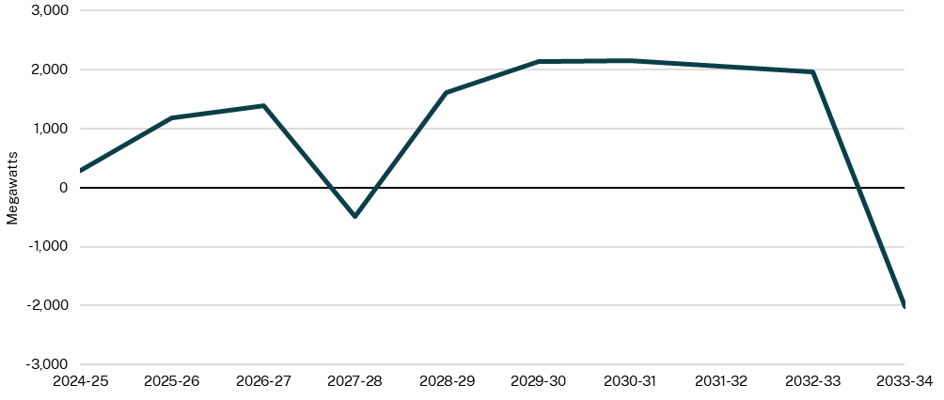

Source: DCCEEW, 2025

### Resource recovery rate

Reducing, reusing and recycling waste means that less material ends up in landfill reducing the environmental impact of waste disposal including reducing greenhouse gas emissions.

The resource recovery rate measures the proportion of total waste that is allocated to waste reuse, recycling or energy recovery. Higher recovery rates mean less material ends up in landfill. In 2022-23, the rate increased by 1 percentage point from 2021-22 to 66.0 per cent (Chart 9.5). Overall, the rate has remained stable while waste generation has continued to increase since 2015. The NSW Waste and Sustainable Materials Strategy 2041 aims to achieve an overall 80 per cent target by 2030. The NSW Environment Protection Authority (EPA) is undertaking a review of the waste levy – the key economic driver for recycling – to better understand and address the factors preventing the recycling rate increasing (DCCEEW, 2025).

1. Resource recovery rate, NSW

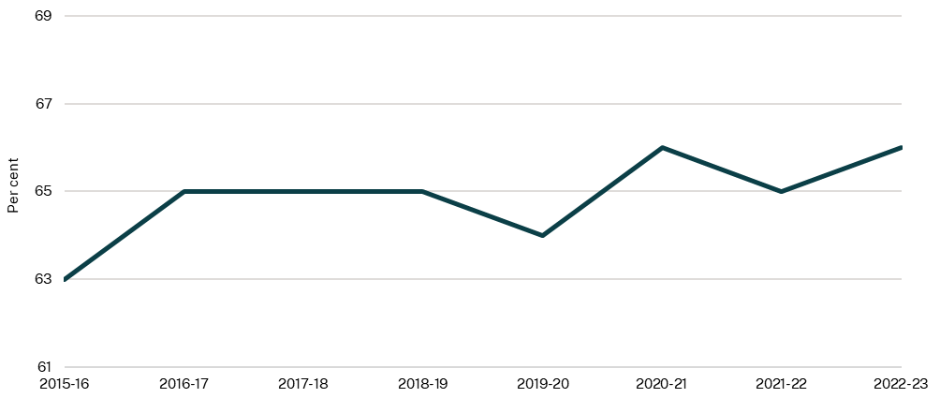

Source: DCCEEW, 2025

1. Land and water conservation and management

The conservation of our land and water ensures that our natural resources are available for future generations. As the population and economy grow, land may need to be cleared to accommodate this. Protecting high ecological value land is critical to protect the unique biodiversity of New South Wales.

### Land managed for the conservation of nature and heritage

Conservation supports the protection of threatened species, allows our natural resources to be used in an ecologically sustainable manner, and allows our environment to be enjoyed for generations to come.

The area of conserved number of hectares of national parks, private land, Indigenous Protected Areas and marine parks and aquatic reserves has grown steadily by an average of 2.4 per cent annually since 1998 to over 8.6 million hectares as of the start of 2025 (Chart 9.6). National parks and reserves totalled 7.7 million hectares in 2025. The total private land under conservation was 576,500 hectares in 2025 which includes land administered by both the NSW Biodiversity Conservation Trust and the Nature Markets and Offsets Division. There were 348,800 hectares of marine parks and aquatic reserves and 37,900 hectares of Indigenous Protected Areas under conservation as of 2024.

1. Hectares of land managed for the conservation of nature and heritage, NSW

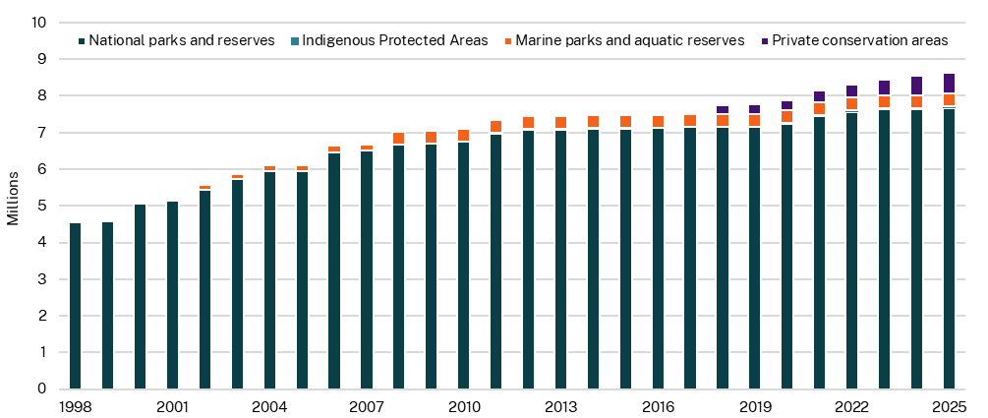

Source: DCCEEW, 2025

### Response to biosecurity threats

Effective biosecurity risk management is important for the protection of New South Wales’ primary industries, economy and environment. It impacts regional livelihoods, tourism, and the quality and affordability of the broader community’s food supply. There are also impacts on the NSW economy when export earnings are affected (Department of Primary Industries and Regional Development (DPIRD), 2025).

Reported high-risk pests, weeds and disease that were assessed as able to be eradicated had response measures initiated within 45 minutes for animal biosecurity, and within 24 hours for plant biosecurity and invasive species — which NSW Government’s biosecurity experts regard as an early and effective response. Examples of response measures include full removal or containment of the biosecurity risk (DPIRD, 2025).

The number of high-risk eradicable biosecurity threats in New South Wales has risen by around two-and-a-half times from 2019-20 to 2023-24 (Chart 9.7). The 90.0 per cent increase in 2023-24 relative to 2022-23 was largely due to imported red fire ants. The number of high‑risk eradicable biosecurity threats is anticipated to continue increasing. New South Wales is predicted to face ongoing annual increases of 10.0 per cent in coming years, although an increase of 28.0 per cent is projected for 2024-25, which can be partly attributed to the increased awareness of high pathogenicity avian influenza (HPAI) in New South Wales (DPIRD, 2025).

The 2025-26 Budget is providing $100.0 million over four years to sustain critical biosecurity functions to meet statutory obligations, including emergency response and detection and diagnostic capabilities to mitigate risks to communities, primary industries, and the environment.

1. Biosecurity threats responded to promptly, NSW

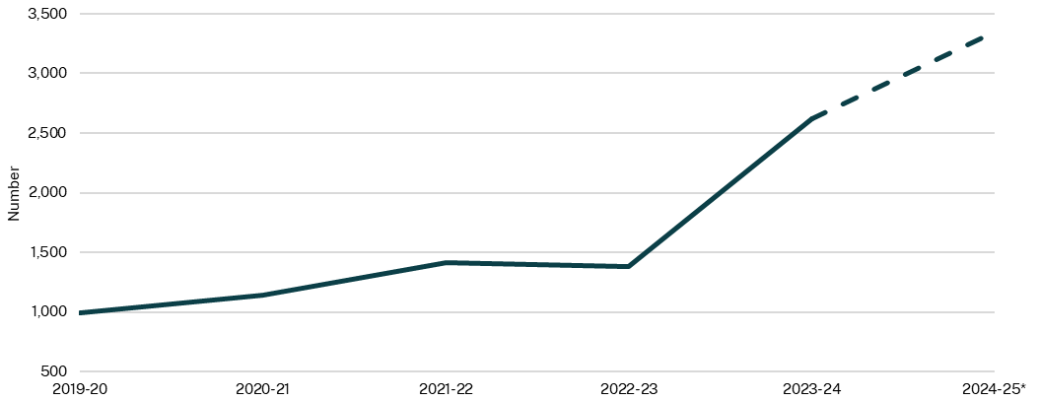

Source: DPIRD, 2025

Note: Data for 2024-25 is a projection.

### Biodiversity

This indicator measures ecosystem health in three ways: the proportion of ecosystem diversity expected to persist into the future (ecosystem persistence), the condition of terrestrial vegetation as a proportion compared to the pre-industrial era (ecological condition), and the landscape’s ability to support wildlife movement as a proportion compared to the pre‑industrial era (ecological carrying capacity). Healthy ecosystems rely on the ability of flora and fauna to forage, disperse and migrate to habitats that can support them and that will survive into the future.

Ecosystem persistence, ecological condition and ecological carrying capacity were relatively stable between 2007 and 2017, but declined in 2020 from 78.0 per cent to 74.0 per cent, 43.0 per cent to 40.0 per cent and 32.0 per cent to 29.0 per cent, respectively (Chart 9.8). This decline is associated with the degradation, fragmentation or loss of unique native habitat types due to the aftermath of the ‘Black Summer’ bushfires. The ‘Black Summer’ bushfire season was the worst New South Wales has ever experienced (NSW Rural Fire Service, 2021) with an estimated over 5.5 million hectares burnt and more than a billion animals killed, burnt or displaced in New South Wales (NSW Environment Protection Authority (EPA), 2021).

1. Biodiversity, NSW

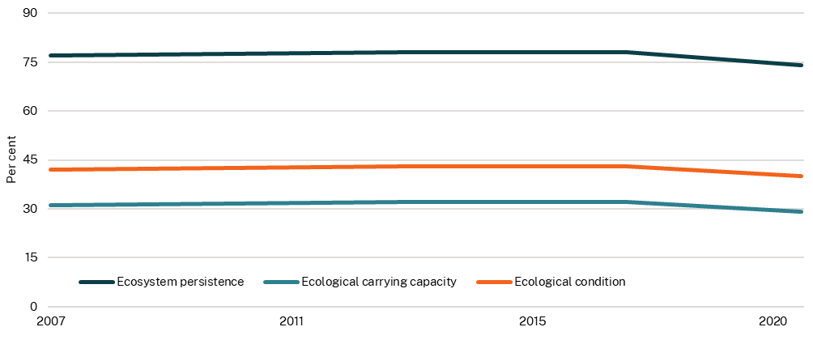

Source: DCCEEW, 2025

### Land clearing area

Native vegetation is a valuable environmental asset that is foundational in ensuring a sustainable environment, community and industry for the people of New South Wales. Land clearing area measures the amount of native vegetation cleared in New South Wales, broken down by woody (hard vegetation like trees or shrubs) and non-woody vegetation (soft vegetation like grass). Woody and non-woody vegetation comprise approximately 49.8 per cent (39,900,000 ha) and 19.0 per cent (15,200,000 ha) of NSW’s land area respectively (NSW EPA, 2021). Native vegetation is a valuable environmental asset that is foundational in ensuring a sustainable environment, community and industry for the people of New South Wales.

In 2022, about 21,100 and 24,100 hectares of woody and non-woody vegetation, respectively were cleared (Chart 9.9). The amount of land cleared has trended downwards from a total of 102,200 hectares across both categories in 2018 to 45,300 hectares in 2022. This represents a reduction of 55.7 per cent over five years.

1. Land clearing area in hectares, NSW

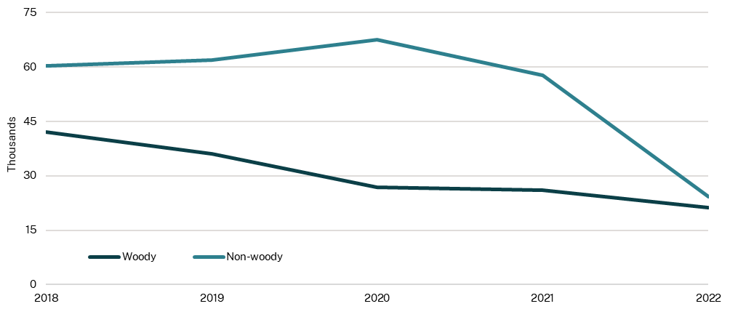

Source: DCCEEW, 2025

### Water quality

Clean water supports drinking supplies, recreational activities, and plant and aquatic life. It also ensures the productivity and safety of agriculture, which relies on water for irrigation and livestock (DCCEEW, n.d.). Water quality is measured using the Water Quality Index, which rates monitored sites as good, moderate or poor. This indicator shows the proportion of monitoring sites in New South Wales with different ratings. Water quality is significantly impacted by the environment, particularly natural disasters such as drought, bushfires and floods.

The proportion of monitored sites with 'Good' water quality has decreased after 2018, with only 16.0 per cent reporting 'Good' water quality in 2024 (Chart 9.10). In most catchments, water quality was impacted by droughts in 2018 and 2019, and flooding in 2020, 2021 and 2023. Catchments in some areas were heavily impacted by bushfires during 2019 and 2020, which, coupled with floods, drove a reduction in water quality.

The 2025-26 Budget will invest:

* $3.0 million for the installation of new pumps to improve water quality for Coogee storm water and divert stormwater flows
* $2.7 million to provide critical and meaningful Local Water Utilities reforms
* $0.9 million over four years for the Dam Safety Committee in NSW to continue the monitoring and regulation of dams across New South Wales
* $24.6 million for water efficiency programs including the Greater Sydney Water Efficiency Program and Regional Leakage Reduction Program.

1. Water quality, NSW

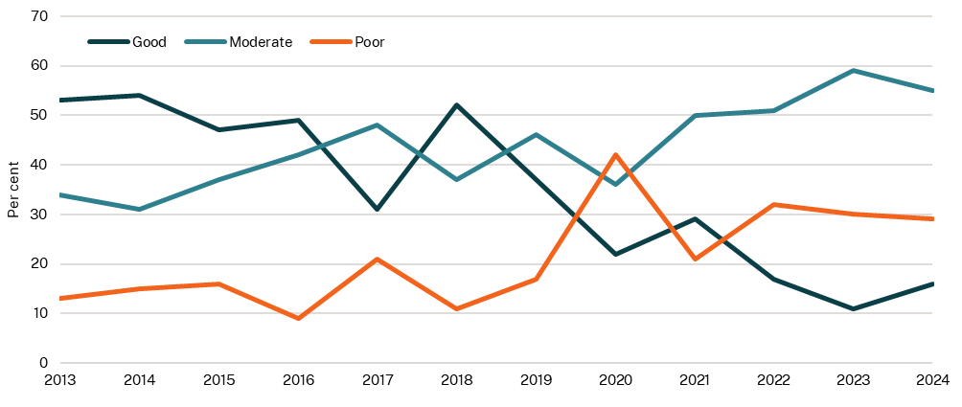

Source: DCCEEW, 2025