**2025-26**

**Agency Financial Statements**

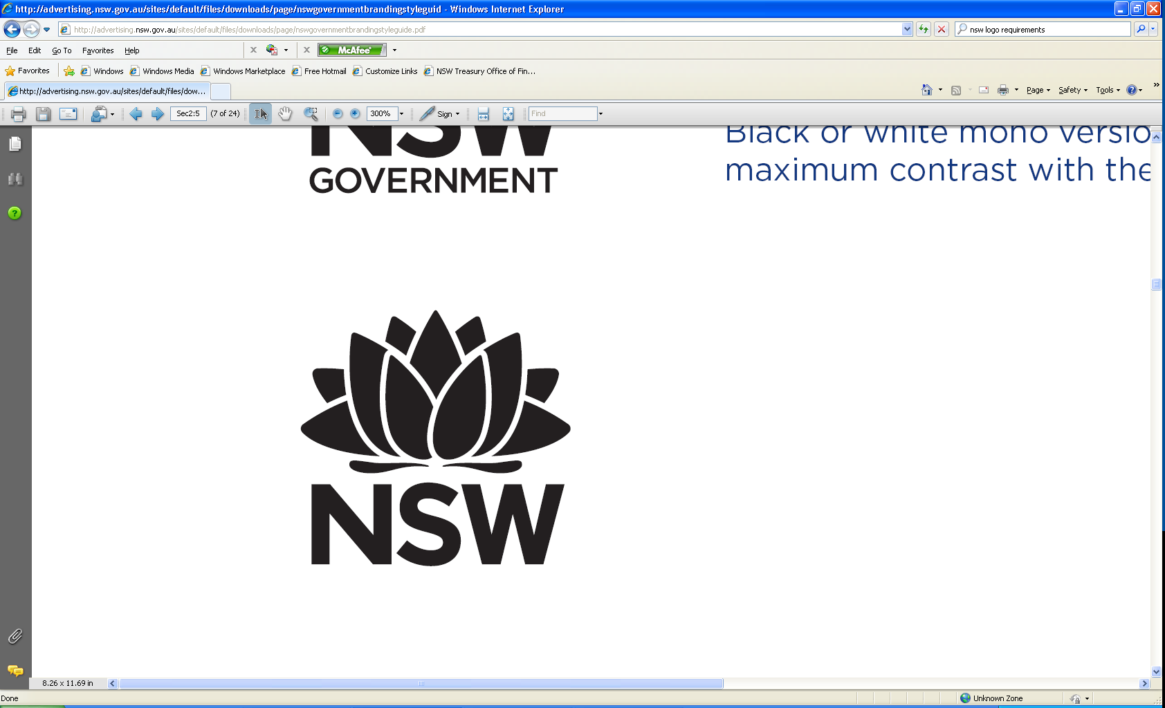

**Budget Paper No. 4**

Circulated by The Hon. Daniel Mookhey MLC, Treasurer

TABLE OF CONTENTS

About this Budget Paper i

**Chapter 1: Cabinet**

1.1 Agency Expense Summary 1 - 1

1.2 Financial Statements 1 - 2

The Cabinet Office 1 - 2

Parliamentary Counsel’s Office 1 - 5

***Special Offices***

Independent Pricing and Regulatory Tribunal 1 - 8

**Chapter 2: Climate Change, Energy, the Environment and Water**

2.1 Agency Expense Summary 2 - 1

2.2 Financial Statements 2 - 2

Department of Climate Change, Energy, the Environment and Water 2 - 2

Energy Corporation of New South Wales 2 - 5

Energy Security Corporation 2 - 8

Environment Protection Authority 2 - 11

Environmental Trust 2 - 14

Natural Resources Access Regulator 2 - 17

Biodiversity Conservation Trust of NSW 2 - 20

Water Administration Ministerial Corporation 2 - 23

**Chapter 3: Communities and Justice**

3.1 Agency Expense Summary 3 - 1

3.2 Financial Statements 3 - 2

Department of Communities and Justice 3 - 2

Corrective Services NSW 3 - 5

Crown Solicitor’s Office 3 - 8

Fire and Rescue NSW 3 - 11

Legal Aid Commission of New South Wales 3 - 14

New South Wales Crime Commission 3 - 17

NSW Police Force 3 - 20

NSW Rural Fire Service 3 - 23

NSW State Emergency Service 3 - 26

Aboriginal Housing Office 3 - 29

Home Purchase Assistance Fund 3 - 32

Multicultural NSW 3 - 35

NSW Trustee and Guardian 3 - 38

***Special Offices***

Judicial Commission of New South Wales 3 - 41

Office of the Children's Guardian 3 - 44

Office of the Director of Public Prosecutions 3 - 47

**Chapter 4: Creative Industries, Tourism, Hospitality and Sport**

4.1 Agency Expense Summary 4 - 1

4.2 Financial Statements 4 - 2

Department of Creative Industries, Tourism, Hospitality and Sport 4 - 2

Independent Liquor and Gaming Authority 4 - 5

Office of Sport 4 - 8

Art Gallery of New South Wales 4 - 11

Australian Museum 4 - 14

Destination NSW 4 - 17

Museums of History NSW 4 - 20

Museum of Applied Arts and Sciences 4 - 23

NSW Independent Casino Commission 4 - 26

State Records Authority NSW 4 - 29

State Library of New South Wales 4 - 32

**Chapter 5: Customer Service**

5.1 Agency Expense Summary 5 - 1

5.2 Financial Statements 5 - 2

Department of Customer Service 5 - 2

Information and Privacy Commission 5 - 5

Service NSW 5 - 8

Long Service Corporation 5 - 11

New South Wales Government Telecommunications Authority 5 - 14

Office of the Independent Review Officer 5 - 17

Rental Bond Board 5 - 20

SafeWork NSW 5 - 23

State Insurance Regulatory Authority 5 - 26

**Chapter 6: Education**

6.1 Agency Expense Summary 6 - 1

6.2 Financial Statements 6 - 2

Department of Education 6 - 2

NSW Childcare and Economic Opportunity Fund Board 6 - 5

NSW Education Standards Authority 6 - 8

TAFE Commission 6 - 11

**Chapter 7: Health**

7.1 Agency Expense Summary 7 - 1

7.2 Financial Statements 7 - 2

Ministry of Health 7 - 2

Health Care Complaints Commission 7 - 5

Mental Health Commission of New South Wales 7 - 8

**Chapter 8: Planning, Housing and Infrastructure**

8.1 Agency Expense Summary 8 - 1

8.2 Financial Statements 8 - 2

Department of Planning, Housing and Infrastructure 8 - 2

Royal Botanic Gardens and Domain Trust 8 - 5

Sydney Olympic Park Authority 8 - 8

Western Parkland City Authority 8 - 11

Centennial Park and Moore Park Trust 8 - 14

Greater Sydney Parklands Trust 8 - 17

Hunter and Central Coast Development Corporation 8 - 20

Lands Administration Ministerial Corporation 8 - 23

Luna Park Reserve Trust 8 - 26

Planning Ministerial Corporation 8 - 29

Property and Development NSW 8 - 32

Western Sydney Parklands Trust 8 - 35

**Chapter 9: Premier**

9.1 Agency Expense Summary 9 - 1

9.2 Financial Statements 9 - 2

Premier’s Department 9 - 2

Natural Resources Commission 9 - 5

NSW Reconstruction Authority 9 - 8

***Special Offices***

Public Service Commission 9 - 11

**Chapter 10: Primary Industries and Regional Development**

10.1 Agency Expense Summary 10 - 1

10.2 Financial Statements 10 - 2

Department of Primary Industries and Regional Development 10 - 2

New South Wales Rural Assistance Authority 10 - 5

Regional Growth NSW Development Corporation 10 - 8

Local Land Services 10 - 11

NSW Food Authority 10 - 14

**Chapter 11: Transport**

11.1 Agency Expense Summary 11 - 1

11.2 Financial Statements 11 - 2

Transport for NSW 11 - 2

Sydney Metro 11 - 5

Office of Transport Safety Investigations 11 - 8

**Chapter 12: Treasury**

12.1 Agency Expense Summary 12 - 1

12.2 Financial Statements 12 - 2

Treasury 12 - 2

Infrastructure NSW 12 - 5

NSW Self Insurance Corporation 12 - 8

Alpha Distribution Ministerial Holding Corporation 12 - 11

Electricity Assets Ministerial Holding Corporation 12 - 14

Electricity Retained Interest Corporation – Ausgrid 12 - 17

Electricity Retained Interest Corporation – Endeavour Energy 12 - 20

Electricity Transmission Ministerial Holding Corporation 12 - 23

Epsilon Distribution Ministerial Holding Corporation 12 - 26

Liability Management Ministerial Corporation 12 - 29

Ports Assets Ministerial Holding Corporation 12 - 32

Port Botany Lessor Ministerial Holding Corporation 12 - 35

Port Kembla Lessor Ministerial Holding Corporation 12 - 38

Port of Newcastle Lessor Ministerial Holding Corporation 12 - 41

Workers' Compensation (Dust Diseases) Authority 12 - 44

**Chapter 13: The Legislature**

13.1 Agency Expense Summary 13 - 1

13.2 Financial Statements 13 - 2

The Legislature 13 - 2

**Chapter 14: Integrity Agencies**

14.1 Agency Expense Summary 14 - 1

14.2 Financial Statements 14 - 2

Audit Office of New South Wales 14 - 2

Independent Commission Against Corruption 14 - 5

Law Enforcement Conduct Commission 14 - 8

New South Wales Electoral Commission 14 - 11

Ombudsman's Office 14 - 14